Supplementary Material
Supplementary Tab 1. Excluded studies and reasons of exclusion.
Not meta-analyzable data | No outcomes of interest | Not MCI Criteria
- Babilonia, 2018  - Baik, 2022  - Durcan, 2023  - Garçia, 2019  - Kantarci, 2021  - Leko, 2016  - Mc Ardle, 2020  - Mutlay, 2023 | - Barba, 2023  - Bonanni, 2015  - Bousiges, 2015  - Bussè, 2018  - Blanc, 2015  - Blanc, J. Colloby et al. 2016  - Blanc, Roquert et al., 2016  - Cagnin, Bussè, Gardini et al., 2015  - Ciafone, 2022  - Donaghy, 2018  - Donaghy, 2020  - Donaghy, 2022  - Ferman, 2013  - Galvin, 2021  - Hamilton, 2020  - Kantarci, 2016  - Kondo, 2016  - Massa, 2022  - Nedelska, Boeve et al., 2019  - Nedelska, Miyagawa et al., 2019  - O'Caoimh, 2019  - Padovani, 2021  - Payne, 2022  - Perani, 2014  - Quadalti, 2023  - Querry, 2023  - Roberts, Durcan et al., 2018  - Rossi, 2021  - Silva-Rodríguez, 2023  - ShuaiLiu, 2022  - Thomas, 2018  - Thomas, 2021  - Thomas, 2022  - Van De Beek, 2020 | - Cagnin, Bussè et al., 2015  - Ge, 2023  - Hamilton, 2022  - Jicha, 2010  - Kim, 2018  - Mellengaard 2023  - Needelska, 2018  - Olichney, 2005  - Reesink, 2010

Supplementary Tab. 2 Case-control studies: characteristics of included studies
Case Control Studies
Author, year | Country | Setting | Age at baseline | SD [9] | % of females | Criteria for MCI | Criteria for MCI-AD | Criteria for MCI-DLB | Total MCI (sample size) | N MCI-AD | N MCI-DLB
Bousiges (2016) | France | Outpatients | 67.59 | 8.3 | 44.6 | Petersen, DSM 5 | Albert, Dubois, McKhann | McKeith, DSM 5 | 74 | 39 | 35
Bousiges (2017) | France | Outpatients | 69.33 | 8.23 | 50.8 | Petersen | Albert, Dubois | McKeith, DSM 5 | 189 | 132 | 57
Bousiges (2020) | France | Outpatients | 68.12 | 8.9 | 50 | CDR | Albert, Dubois, McKhann | McKeith | 84 | 33 | 51
Chiba (2018) | Japan | Outpatients | 73.18 | 5.68 | 53 | NIA-AA criteria | McKhann | McKeith | 17 | 8 | 9
Donaghy (2017) | United Kingdom | Outpatients | 76.47 | 7.29 | 38.96 | Albert | McKhann | McKeith | 57 | 21 | 36
Donaghy (2023) | United Kingdom | Outpatients | 75.7 | 7.54 | 39.67 | NIA-AA criteria | NIA-AA criteria | McKeith | 121 | 51 | 70
Galvin (2015) | USA | Outpatients | 76.39 | 8.89 | 53.52 | CDR | Albert, Dubois | McKeith | 71 | 57 | 14
Roberts (2021) | United Kingdom | Outpatients | 75.71 | 7.25 | 31.25 | NIA-AA criteria | Albert | McKeith | 144 | 57 | 87
Total | Europe (n=6); Asia (n=1)  USA (n=1) | Outpatients (n=8) | 72.54 | 8.74 | 45.22 | Albert (n=1); Petersen (n=1); Petersen,DSM V (n=1); CDR (n=2); NIA-AA (n=3) | Albert, Dubois (n=2); McKhann (n=2); Albert, Dubois, Mckhann (n=2); Albert (n=1); NIA-AA criteria (n=1) | McKeith, DSM 5 (n= 2) ; McKeith (n=6) | 757 | 398 | 359

Supplementary Tab 3 Cohort study: characteristics of included study
Cohort Studies
Author, year | Country | Setting | Follow up (years) | Age at baseline | SD [9] | % of females | Criteria for MCI | Criteria for MCI-AD | Criteria for MCI-DLB | Total MCI (sample size) | N MCI-AD | N MCI-DLB
Schumacher (2020) | United Kingdom | Outpatients | Three years | 75.37 | 7.04 | 33.33 | NIA-AA criteria | Albert | McKeith | 75 | 36 | 39
Total | Europe (n=1) | Outpatients (n=1) | Three years (1) | 75.37 | 7.04 | 33.33 | NIA-AA (n=1) | Albert (n=1) | McKeith (n=1) | 75 | 36 | 39

Supplementary Tab. 4 Case-Control studies: data extraction
Tool used | Cut-off | Sensitivity% | Specificity% | AUC | 95% CI low | 95% CI high | Sample size | SE
T-tau
Bousiges (2016) | >443 | 76.9 | 100 | 0.93 | 0.84 | 0.98 | 74 | 0.008
Bousiges (2017) | >443 | 73.5 | 94.7 | 0.91 | 0.86 | 0.94 | 189 | 0.002
Bousiges (2020) | > 371 | 81.8 | 88.2 | 0.89 | 0.81 | 0.95 | 84 | 0.007
Ph-tau
Bousiges (2016) | >62 | 92.3 | 94.3 | 0.94 | 0.86 | 0.98 | 74 | 0.006
Bousiges (2017) | >62 | 88.6 | 91.2 | 0.93 | 0.89 | 0.97 | 189 | 0.002
Bousiges (2020) | > 60 | 87.9 | 92.2 | 0.92 | 0.84 | 0.97 | 84 | 0.007
Aβ40
Bousiges (2016) | >9546 | 77.8 | 79.2 | 0.76 | 0.6 | 0.88 | 42 | 0.021
Bousiges (2017) | >9546 | 83.3 | 75.8 | 0.8 | 0.71 | 0.88 | 93 | 0.008
Bousiges (2020) | > 9563 | 75 | 78.6 | 0.75 | 0.6 | 0.87 | 44 | 0.020
Aβ42/Aβ40
Bousiges (2016) | ≤0.05 | 88.9 | 100 | 0.95 | 0.83 | 0.99 | 42 | 0.012
Bousiges (2017) | ≤0.05 | 78.3 | 100 | 0.95 | 0.88 | 0.98 | 93 | 0.005
Bousiges (2020) | ≤0.05 | 81.3 | 96.4 | 0.94 | 0.82 | 0.99 | 44 | 0.012
T-Tau + Ph-Tau + Aβ42/Aβ40
Bousiges (2016) | > 0,5 | 94.4 | 100 | 0.95 | 0.83 | 0.99 | 42 | 0.012
Bousiges (2017) | > 0.5 | 93.3 | 93.3 | 0.97 | 0.91 | 1 | 93 | 0.004
Bousiges (2020) | > 0.5 | 87.5 | 100 | 0.95 | 0.84 | 0.99 | 44 | 0.011
Aβ42
Bousiges (2016) | ≤730 | 84.6 | 71.4 | 0.84 | 0.74 | 0.92 | 74 | 0.010
Bousiges (2017) | ≤626 | 68.2 | 79 | 0.76 | 0.69 | 0.82 | 189 | 0.004
Bousiges (2020) | ≤ 838 | 81.8 | 76.5 | 0.83 | 0.73 | 0.9 | 84 | 0.009
T-Tau + Phospho-Tau + Aβ42
Bousiges (2016) | > 0.5 | 89.7 | 97.1 | 0.95 | 0.87 | 0.99
Bousiges (2017) | > 0.6 | 86.4 | 93 | 0.93 | 0.89 | 0.97 | 189 | 0.002
Bousiges (2020) | > 0.5 | 81.8 | 96.1 | 0.93 | 0.86 | 0.98 | 84 | 0.006
α-synuclein
Bousiges (2020) | > 139 | 81.8 | 76.5 | 0.83 | 0.73 | 0.9 | 84
T-Tau + Phospho-Tau + Aβ42/Aβ40+α-synuclein
Bousiges (2020) | > 0.51 | 87.5 | 100 | 0.95 | 0.83 | 0.99 | 44
T-Tau + Phospho-Tau + Aβ42+ α-synuclein
Bousiges (2020) | > 0.48 | 84.9 | 92.2 | 0.95 | 0.88 | 0.98 | 84
LBRCS/ 10-point symptoms scale
Galvin (2015) | >3 | 94.2 | 78.2 | 0.94 | 0.9 | 0.97 | 71 | 0.004
Donaghy (2017) | >3 | 62 | 100 | 0.81 | 0.69 | 0.93 | 57 | 0.016
Donaghy (2023) | >3 | 59 | 97 | 0.91 | 0.84 | 0.98 | 121 | 0.006
10-point symptoms scale > 2
Donaghy (2017) | >2 | 83 | 100 | 0,91 | 0.83 | 0.99 | 57
Donaghy (2023) | >2 | 76 | 90 | 0,91 | 0.84 | 0.98 | 121
10-point symptoms scale >1
Donaghy (2017) | >1 | 90 | 84 | 0.87 | 0.75 | 0.99 | 57
Donaghy (2023) | >1 | 83 | 83 | 0.91 | 0.84 | 0.98 | 121
123I-IMP-SPECT- derived CIS ratio
Chiba (2018) |  | 77.78 | 75 | 0.72 | 0.4 | 0.9 | 17
123I-FP-CT-.SPECT
Roberts (2021) |  | 66 | 88 | 0.76 | 0.68 | 0.84 | 144
FDG PET-derivet CIS ratio
Chibas (2018) |  | 77.78 | 100 | 0.95 | 0.75 | 0.99 | 17

Supplementary Tab. 5 Cohort study: data extraction
Tool used | Cut-off | Sensitivity% | Specificity% | AUC | 95% CI low | 95% CI high
EEG frequency bands: Delta power
Schumacher (2020) | 21.9 | 23 | 89 | 0.54 | 0.41 | 0.67
EEG frequency bands: Theta power
Schumacher (2020) | 10.7 | 33 | 89 | 0.60 | 0.47 | 0.73
EEG frequency bands: Pre-alpha power
Schumacher (2020) | 28.1 | 56 | 83 | 0.68 | 0.56 | 0.81
EEG frequency bands: Alpha power
Schumacher (2020) | 20.5 | 41 | 97 | 0.66 | 0.53 | 0.78
EEG frequency bands: Beta power
Schumacher (2020) | 19 | 61 | 81 | 0.71 | 0.59 | 0.83
EEG frequency bands: Theta/alpha ratio
Schumacher (2020) | 0.56 | 49 | 83 | 0.64 | 0.51 | 0.77
EEG frequency bands: DF, all electrodes
Schumacher (2020) | 7.1 | 51 | 86 | 0.70 | 0.58 | 0.82
EEG frequency bands: DF, occipital electrodes
Schumacher (2020) | 7,1 | 51 | 86 | 0.69 | 0.57 | 0.81

Supplementary Tab. 6 Quality assessment of the studies included [10]
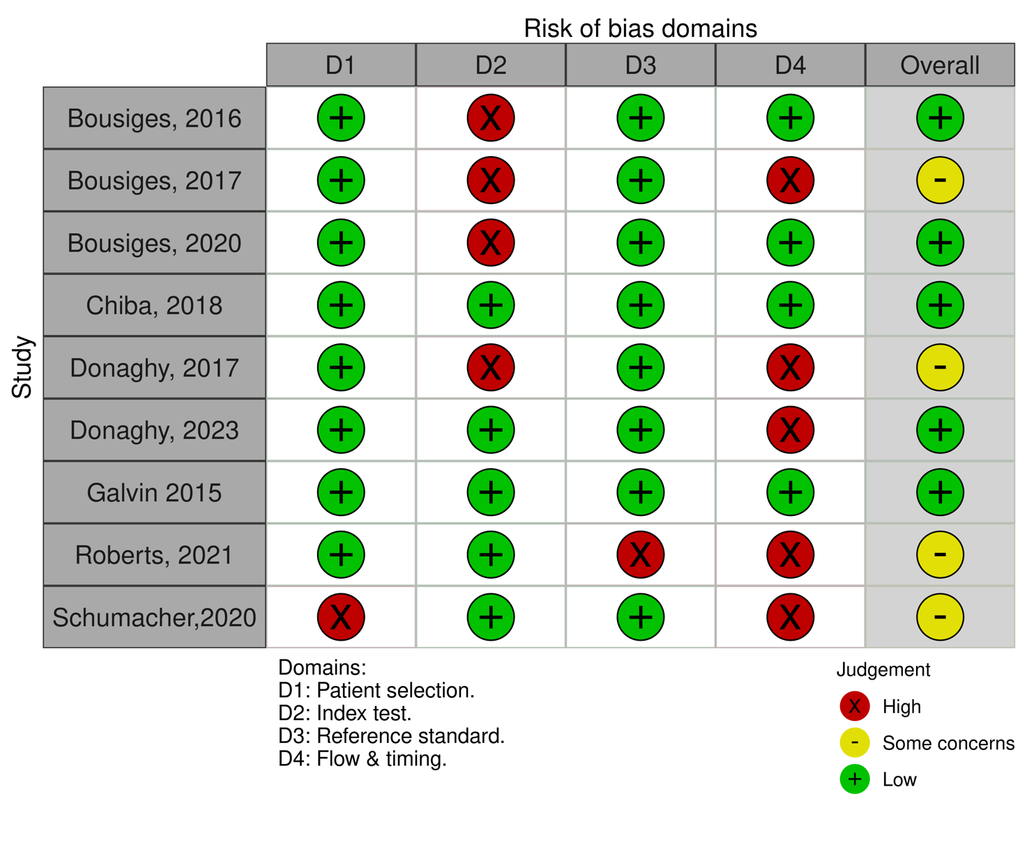

Supplementary Fig. 1 Forest plot T-Tau
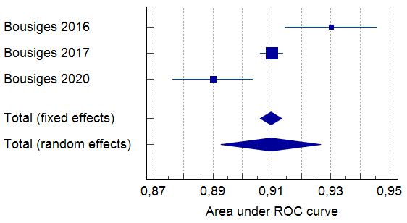
Supplementary Fig. 2 Forest plot phospho-tau
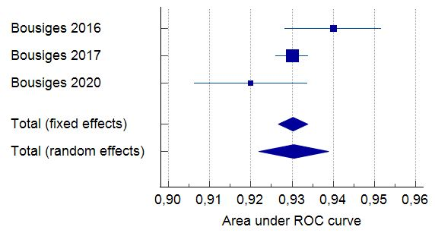

Supplementary Fig. 3 Forest plot Aβ42
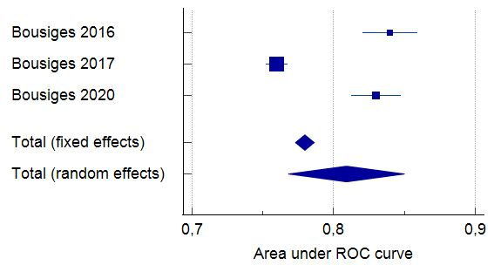
Supplementary Fig. 4 Forest plot T-tau + phospho-tau+ Aβ42
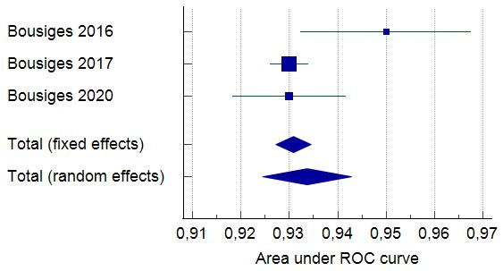

Supplementary Fig. 5 Forest plot Aβ40
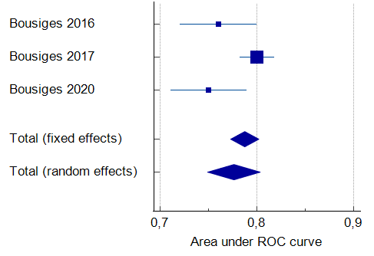
Supplementary Fig. 6 Forest plot Aβ42/Aβ40

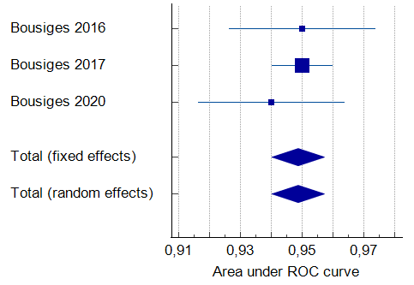

Supplementary Fig. 7 Forest plot T-tau + phospho-tau+ Aβ42/Aβ40
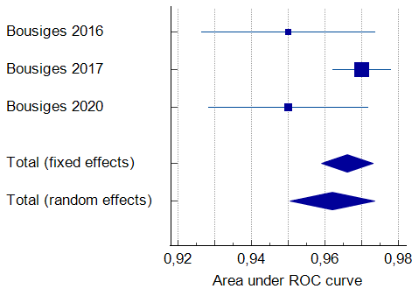
Supplementary Fig. 8 Forest plot LBCRS/10-PSS

