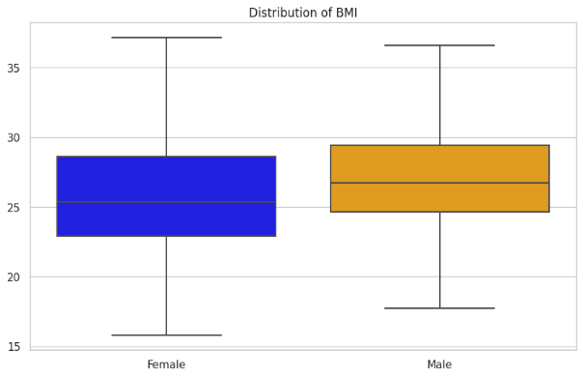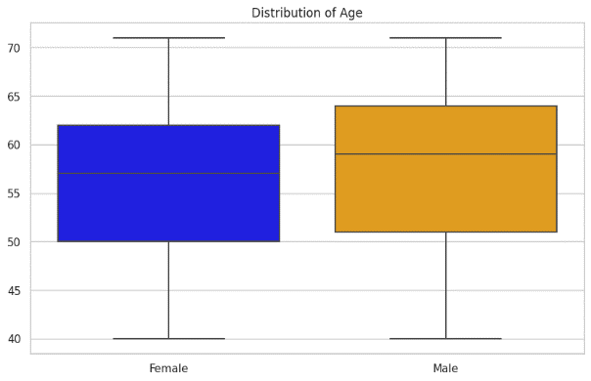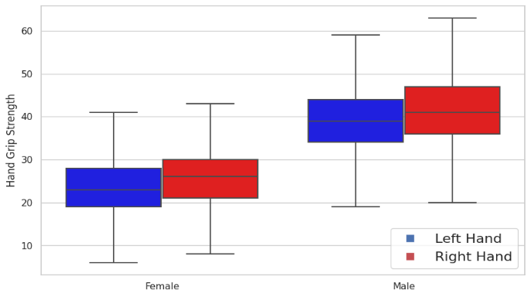

Figure A.1. Data distributions for both genders for hand grip strength, age, and BMI (N=14,161)
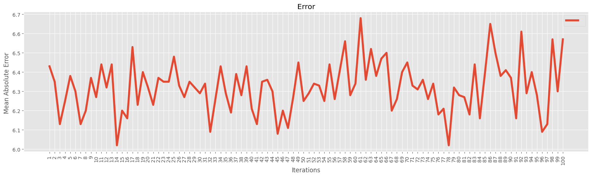
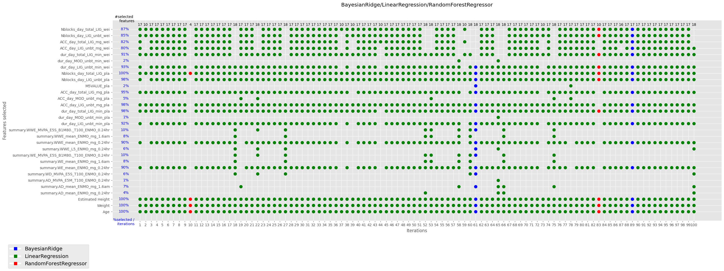
Figure A.2. MAE and hand grip strength parameters selected over all iterations (male)
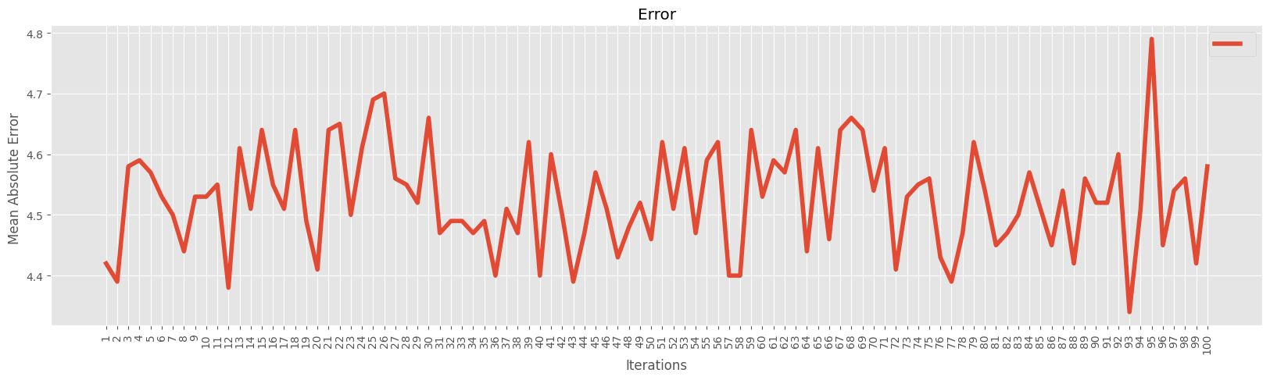
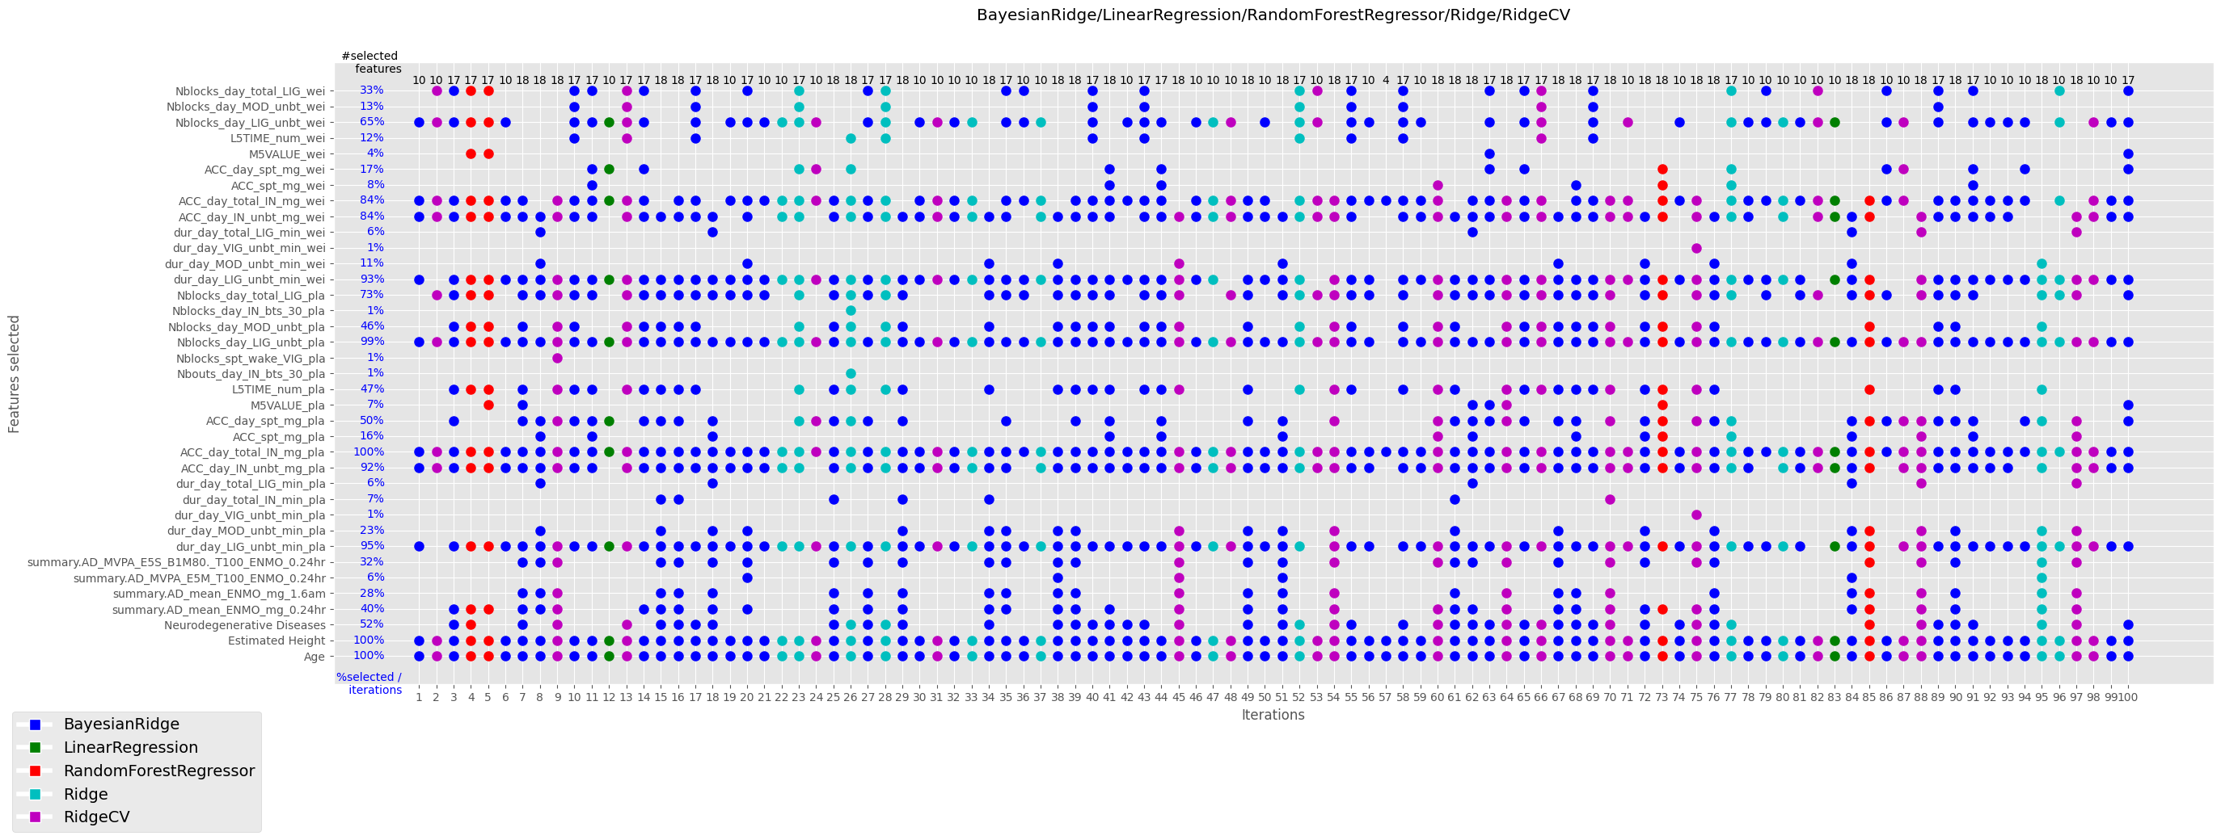
Figure A.3. MAE and hand grip strength parameters selected over all iterations (female)
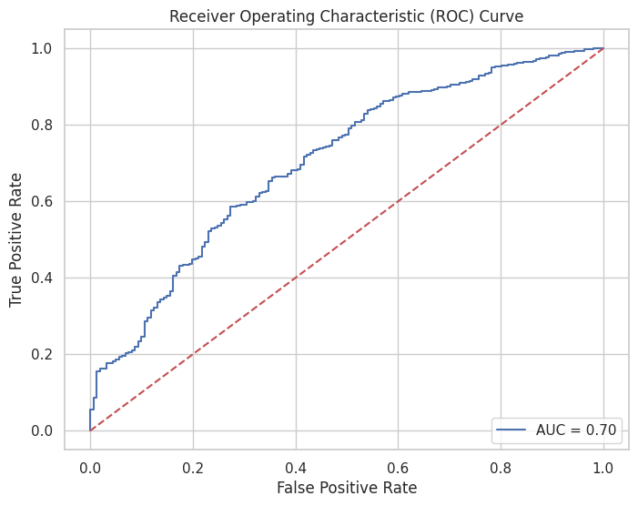
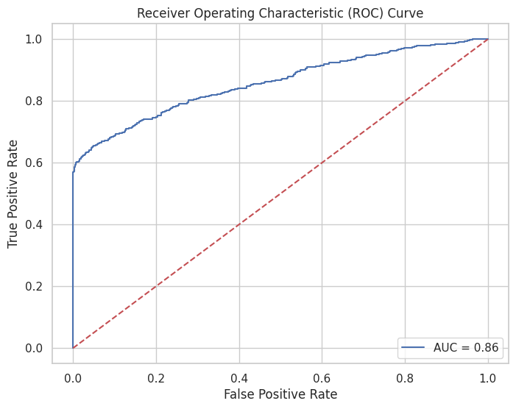
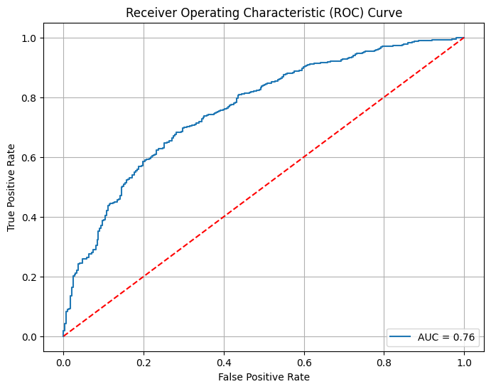
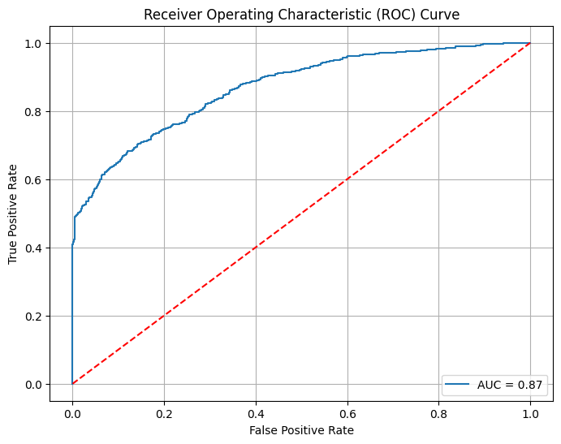
Figure A.4: ROC curves for frailty classification of males using a T-score of -2 (top left), males using a T-score of -1 (top right), females using a T-score of -2 (bottom left), and females using a T-score of -1 (bottom right)

