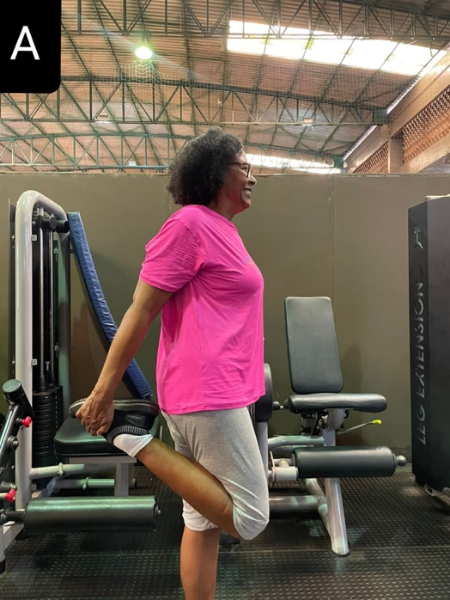
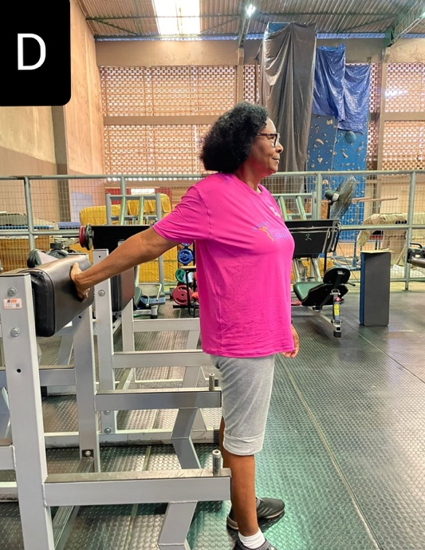
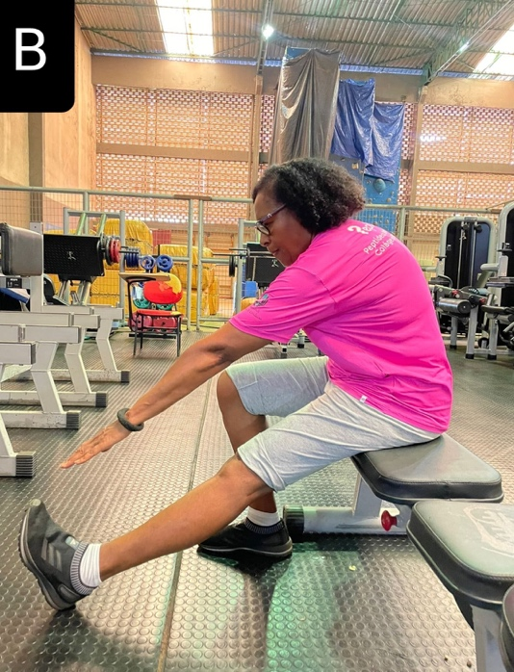

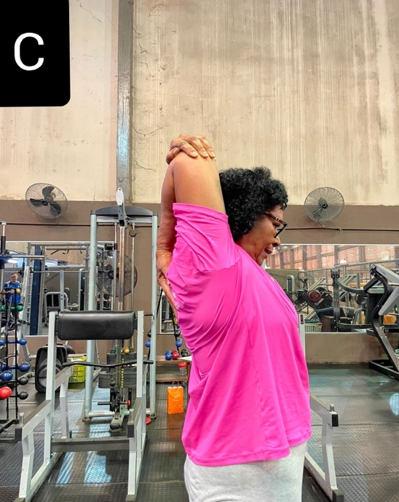

Supplementary material 1. Illustration on how the stretching of the quadriceps (A), hamstrings (B), triceps brachii (C), and biceps brachii (D) was done.

