Supplementary Figures

Journal: Aging Clinical and Experimental Research

Plasma Biomarkers in Patients with Age-related Sarcopenia: A Proteomic Exploration and Experimental Validation

Qinqing Lin¹², Kangyong Li³⁴, Liwei Li¹, Lichang Guan¹, Yingtong Zeng³, Dake Cai³, Jing Zhou¹³*, Lishu Xu¹⁵*

1 Department of Geriatric Gastroenterology, Guangdong Provincial People's Hospital (Guangdong Academy of Medical Sciences), Southern Medical University, Guangzhou, China.
2 Shantou University Medical College, Shantou, Guangdong, China.
3 Department of Pharmacy, Guangdong Provincial People's Hospital (Guangdong Academy of Medical Sciences), Southern Medical University, Guangzhou, China.
4 Guangzhou University of Chinese Medicine, Guangzhou, China.
5 Guangdong Provincial Institute of Geriatrics, Guangdong Provincial People's Hospital (Guangdong Academy of Medical Sciences), Southern Medical University, Guangzhou, China.

*Correspondence to
Lishu Xu, xulishu@gdph.org.cn
Jing Zhou, zhoujing@gdph.org.cn

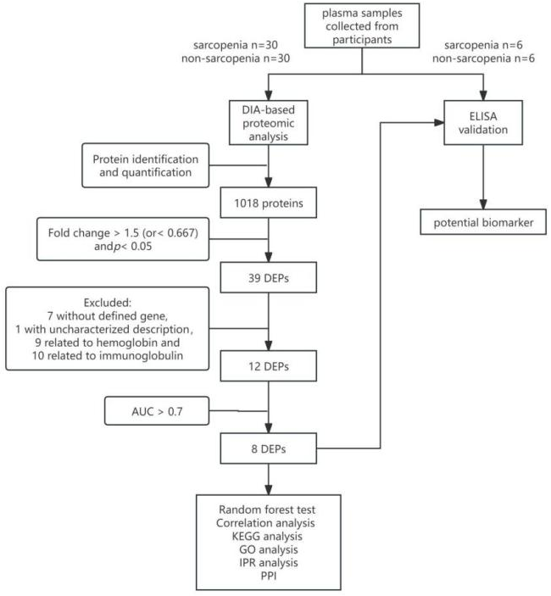
Supplementary Figure 1. Flowchart of the study design for sarcopenia biomarker screening and validation. GO: Gene Ontology; KEGG: Kyoto Encyclopedia of Genes and Genomes; KOG: Eukaryotic Orthologous Groups; PPI: protein-protein interaction; AUC: area under the curve.
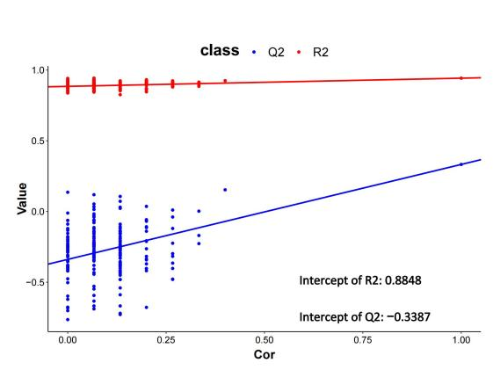

Supplementary Figure 2. PLS-DA validation model through 200 permutation tests.

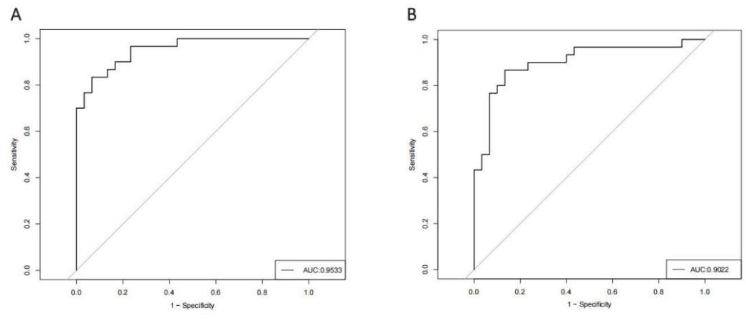
Supplementary Figure 3. (A) ROC analysis of 8 selected proteins; (B) ROC analysis of IGFBP2 in combination with PON3.
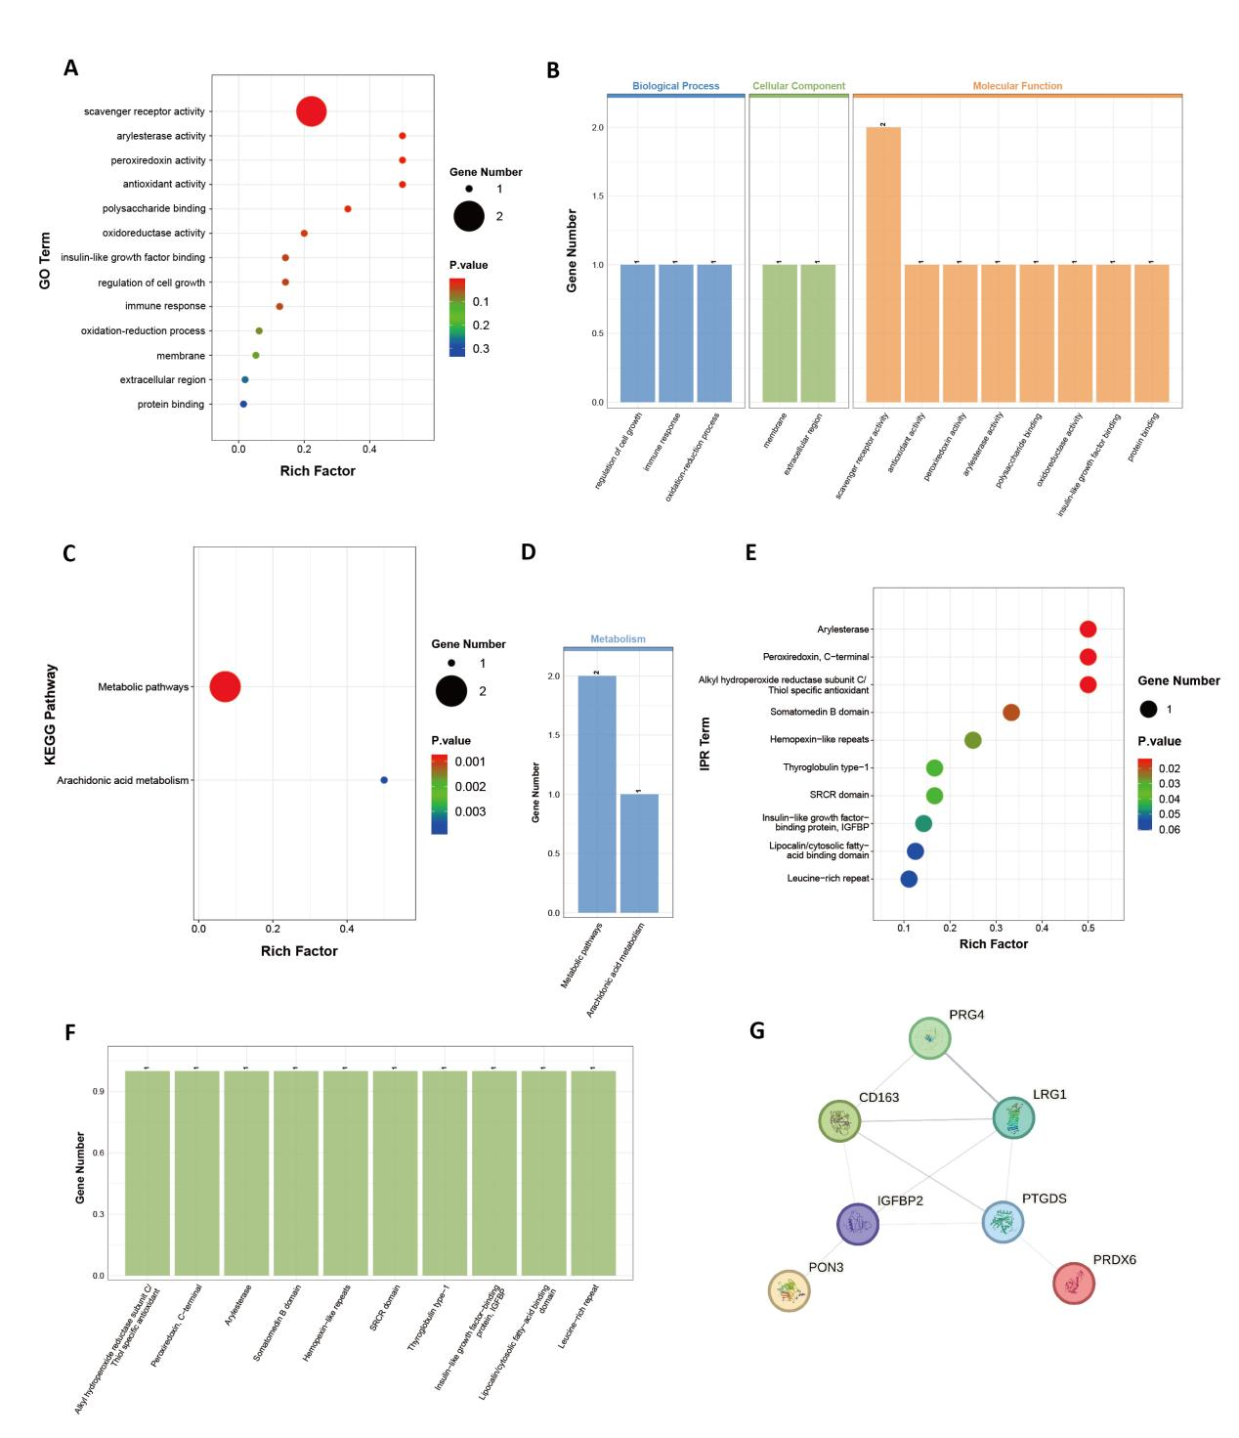
Supplementary Figure 4. Functional analysis and Protein-protein interaction network analysis. GO functional enrichment analysis presented in scatter plot (A) and bar chart (B). KEGG pathway analysis presented in scatter plot (C) and bar chart (D). IPR analysis presented in scatter plot (E) and bar chart (F). The size of the circle represented the number of DEPs in the GO/KEGG/IPR term. The color of the circle represented the p-value for the enrichment degree. SRCR, scavenger receptor cysteine-rich. (G) Protein-protein interaction network analysis. Nodes were filled with the known or predicted three-dimensional structures of the proteins. Edges represented protein-protein associations. Confidence (i.e. the strength of data support) was represented by the thickness of association line. Minimum required interaction score was set as confidence of 0.150.

