Temporal association between chronic pain and frailty occurrence, and the modifiable role of a healthy lifestyle in Chinese middle-aged and older population: a community based, prospective cohort study

Chao Li, Na Zeng, Fu-Shan Xue

Table S1. Components of Constructed 29-Item Frailty Index
Item number | Item definition | Scoring b
1 | Self-reported difficulties in bathing because of a physical, mental, emotional or memory problem. | Yes=1.00; No=0.00
2 | Self-reported difficulties in dressing because of a physical, mental, emotional or memory problem. | Yes=1.00; No=0.00
3 | Self-reported difficulties in getting in/out of bed because of a physical, mental, emotional or memory problem. | Yes=1.00; No=0.00
4 | Self-reported difficulties in walking around the house because of a physical, mental, emotional or memory problem. | Yes=1.00; No=0.00
5 | Self-reported difficulties in eating because of a physical, mental, emotional or memory problem. | Yes=1.00; No=0.00
6 | Self-reported difficulties in finishing daily activities of using the toilet because of a physical, mental, emotional or memory problem. | Yes=1.00; No=0.00
7 | Total number (0-5) of self- reported difficulties in finishing daily activities including bathing, dressing, eating, getting in/out of bed, walking around the house. | Any difficulties=1.00;  No difficulties=0.00
8 | Self-reported difficulties in shopping because of a physical, mental, emotional or memory problem. | Yes=1.00; No=0.00
9 | Self-reported difficulties in preparing hot meal because of a physical, mental, emotional or memory problem. | Yes=1.00; No=0.00
10 | Self-reported difficulties in taking prescribed medications because of a physical, mental, emotional or memory problem. | Yes=1.00; No=0.00
11 | Self-reported difficulties in managing money because of a physical, mental, emotional or memory problem. | Yes=1.00; No=0.00

12 | Self-reported difficulties in getting up from a chair because of a physical, mental, emotional or memory problem. | Yes=1.00; No=0.00
13 | Self-reported difficulties in climbing several flights of stairs because of a physical, mental, emotional or memory problem. | Yes=1.00; No=0.00
14 | Self-reported difficulties in lifting or carrying weights over 10 pounds because of a physical, mental, emotional or memory problem. | Yes=1.00; No=0.00
15 | Self-reported difficulties in walking one block because of a physical, mental, emotional or memory problem. | Yes=1.00; No=0.00
16 | Self-reported rating of health status. | Poor=1.00;  Fair=0.75;  Good=0.50;  Very Good=0.25; Excellent=0.00
17 | Change in self-reported rating of health status. | Worse=1.00; Better/Same=0.00
18 | Feeling that everything is an effort much of time. | Yes=1.00; No=0.00
19 | Feeling depressed much of time. | Yes=1.00; No=0.00
20 | Feeling happy much of time. | No=1.00; Yes=0.00
21 | Feeling lonely much of time. | Yes=1.00; No=0.00
22 | Feeling that could not get going much of time. | Yes=1.00; No=0.00
23 | Self-reported diagnosis of hypertension by physician. | Yes=1.00; No=0.00
24 | Self-reported diagnosis of stroke by physician. | Yes=1.00; No=0.00
25 | Self-reported diagnosis of cancer by physician. | Yes=1.00; No=0.00
26 | Self-reported diagnosis of diabetes by physician. | Yes=1.00; No=0.00
27 | Self-reported diagnosis of arthritis by physician. | Yes=1.00; No=0.00
28 | Self-reported diagnosis of chronic lung disease by physician. | Yes=1.00; No=0.00
29 | Cognitive status, based on combination of self-reported diagnosis, and cognition score. | Dementia=1.00; Cognitive impairment but not demented=0.50;  Cognitive healthy=0.00
a Item definition was based on self-reported information or objective measurements or both.
b The frailty index was calculated as the sum of scoring divided by the total number of items.

Table S2. Subgroup analysis of the association between baseline pain and the risk of frailty by residential area
 | Non-pain | Pain | P values
Participants living in urban area (N=5819)
No. of participants | 4147 | 1672
No. of frailty | 850 | 335
Follow-up, person-years | 27167.23 | 10560.36
Follow-up, years | 6.92 (6.90-7.00) | 6.92 (6.90-7.00)
Hazard ratio for frailty (95% CI, P values)
Unadjusted | reference | 1.03 (0.90-1.17) | 0.8373
Adjusted model 1 | reference | 1.02 (0.90-1.16) | 0.7703
Adjusted model 2 | reference | 1.03 (0.91-1.17) | 0.6594
Adjusted model 3 | reference | 1.05 (0.92-1.20) | 0.4564
Participants living in rural area (N =7782)
No. of participants | 5288 | 2494
No. of frailty | 1290 | 881
Follow-up, person-years | 38419.15 | 27545.43
Follow-up, years | 6.90 (6.90-7.00) | 6.90 (6.90-7.00)
Hazard ratio for frailty (95% CI, P values)
Unadjusted | reference | 1.18 (1.05-1.31) | 0.0023
Adjusted model 1 | reference | 1.16 (1.05-1.31) | 0.0047
Adjusted model 2 | reference | 1.16 (1.03-1.31) | 0.0058
Adjusted model 3 | reference | 1.16 (1.03-1.31) | 0.0067
Data were present as median (interquartile range) except for specially stated.
Model 1 was adjusted for age and sex; model 2, additionally adjusted for education levels, average household incomes, marital status,
status of smoking and alcohol intake; model 3 further include sleep duration and body mass index.

Table S3. Sensitivity analysis regarding risk of frailty with baseline pain status.
Pain status | Incident frailty | Participants | HR (95%CI) | P values
Sensitivity analysis 1: competing risk model for pain at baseline
Pain | 1216 | 4166 | 1.04 (1.02-1.05) | <0.001
Non pain | 2140 | 9435 | reference
Sensitivity analysis 2: exclude those who developed frailty in first 2 years.
Pain | 848 | 3678 | 1.04 (1.01-1.15) | 0.023
Non pain | 2076 | 9255 | reference

Table S4. Mediation analysis of chronic pain, healthy lifestyle and frailty.

Model | Direct effect | Indirect effect | Proportion mediated | Mediated effect P value
Overall population | 0.17 (0.082-0.25) | 0.0053 (0.00098-0.01) | 2.97% | 0.014
Male | 0.17 (0.074-0.26) | 0.0087 (0.0021-0.02) | 4.99% | 0.008
Female | 0.14 (0.011-0.26) | 0.0091 (0.00097-0.02) | 5.93% | 0.032
Middle-aged adults | 0.20 (0.10-0.30) | 0.0046 (0.00047-0.01) | 2.09% | 0.03
Older adults | 0.088 (-0.074-0.25) | 0.0059 (-0.0028-0.02) | 4.12% | 0.21

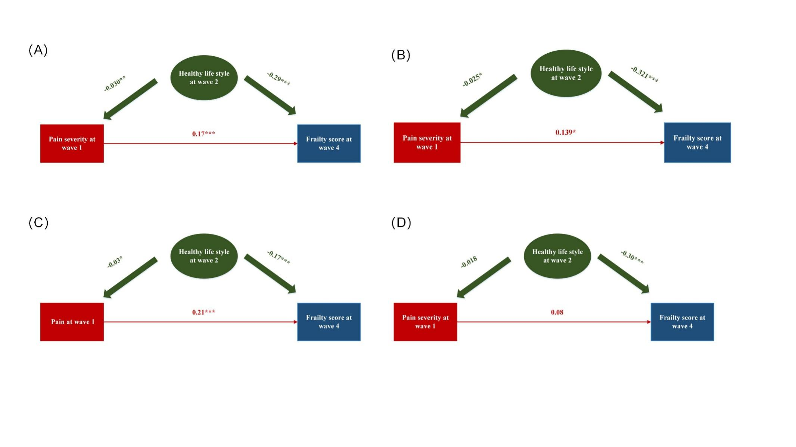
Figure S1. Healthy lifestyle at wave 2 potentially mitigated the adverse impact chronic pain have on frailty at wave 4. (A) In males; (B) In females; (C) In middle-aged participants and (D) In older participants.

