Supplemental Material

- eTable 1. Chronic diseases and their corresponding systematic classifications.
- eTable 2. Characteristics of healthy participants and prevalence of chronic disease in 2015.
- eTable 3. Characteristics of included and excluded participants in 2011
- eTable 4. Model fit and diagnostic criteria for competing latent class models in 2011.
- eTable 5. Model fit and diagnostic criteria for competing latent class models in 2013.
- eTable 6. Model fit and diagnostic criteria for competing latent class models in 2015.
- eTable 7. O/E rates in the five identified multimorbidity clusters in 2011.
- eTable 8. Exclusivity rates in the five identified multimorbidity clusters in 2011.
- eTable 9. O/E rates in the five identified multimorbidity clusters in 2013.
- eTable 10. Exclusivity rates in the five identified multimorbidity clusters in 2013.
- eTable 11. O/E rates in the five identified multimorbidity clusters in 2015.
- eTable 12. Exclusivity rates in the five identified multimorbidity clusters in 2015.
- eFigure 1. Flowchart of the sampling process.
- eFigure 2. Association between excess rate of chronic disease cumulative characteristics and all-cause mortality by multimorbidity pattern combinations.
- eFigure 3. Associations between multimorbidity cluster progression and all-cause mortality risk among non-imputed datasets.
- eFigure 4. Associations between multimorbidity cluster progression and all-cause mortality risk with physical activity in the fully adjusted model.

eTable 1. Chronic diseases and their corresponding systematic classifications
Affected Body Systems | Chronic Disease Conditions
Diseases of the Circulatory System | Hypertension, Heart problems, Stroke, Dyslipidemia
Diseases of the Endocrine System | Diabetes/high blood sugar
Cancers | Cancer or malignant tumor
Diseases of the Respiratory System | Chronic lung disease, Asthma
Musculoskeletal conditions | Arthritis or rheumatism
Diseases of the Digestive System | Liver disease, Stomach or other digestive disease
Diseases of the Genitourinary System | Kidney disease
Mental Health Disorders | Emotional/nervous/psychiatric problem, Memory-related disease

eTable 2. Characteristics of participants without the 14 NCDs from 2011 to 2015 and prevalence of chronic disease in 2015
Characteristicst | Total | P value
Characteristicst | N (%)
participants | 1844 | -
Age（years） |  | ＜0.001
≤65 | 1387(75.2) | ＜0.001
＞65 | 457(24.8) | ＜0.001
Sex |  | ＜0.020
Male | 972(52.7) | ＜0.020
Female | 872(47.3) | ＜0.020
Hukou Regions |  | ＜0.001
Rural | 1535(82.6) | ＜0.001
Urban | 309(17.4) | ＜0.001
Education |  | ＜0.001
Illiterate | 454(24.6) | ＜0.001
≤Elementary school | 686(37.2) | ＜0.001
≥Middle school | 704(38.2) | ＜0.001
Marital status |  | ＜0.001
Unmarried/unpartnered | 235(12.7) | ＜0.001
Married/partnered | 1609(87.3) | ＜0.001
Smoking status |  | ＜0.001
Current smoker | 629(34.0) | ＜0.001
None-smoker | 1215(66.0) | ＜0.001
Alcohol consumption |  | ＜0.001
Drink alcohol last year | 725(39.3) | ＜0.001
No alcohol last year | 1119(60.6) | ＜0.001

eTable3：Characteristics of included and excluded participants in 2011
Characteristic | Included Chronic¹  N = 7,144² | Excluded Chronic¹  N = 15,092² | Included No-Chronic¹  N = 1,844² | Excluded No-Chronic¹  N = 1,506² | p-value³
Age (years) | 59.53 (9.22) | 58.14 (11.35) | 56.64 (9.11) | 57.52 (9.32) | <0.001
Missing | 0 | 8,053 | 0 | 0
Gender |  |  |  |  | <0.001
Male | 3,354 (47%) | 7,237 (48%) | 972 (53%) | 771 (51%)
Female | 3,790 (53%) | 7,847 (52%) | 872 (47%) | 735 (49%)
Missing | 0 | 8 | 0 | 0
Hukou Regions |  |  |  |  | <0.001
Urban | 1,811 (25%) | 2,024 (28%) | 309 (17%) | 251 (17%)
Rural | 5,333 (75%) | 5,155 (72%) | 1,535 (83%) | 1,250 (83%)
Missing | 0 | 7,913 | 0 | 5
Education |  |  |  |  | <0.001
Illiterate | 2,060 (29%) | 3,315 (22%) | 454 (25%) | 427 (28%)
≤Elementary school | 2,943 (41%) | 7,007 (46%) | 686 (37%) | 585 (39%)
≥Middle school | 2,141 (30%) | 4,770 (32%) | 704 (38%) | 494 (33%)
Marital status |  |  |  |  | <0.001
Married/partnered | 5963 (84%) | 6,199 (41%) | 1,609 (87%) | 1,341 (89%)
Unmarried/unpartnered | 1181 (16%) | 8,893 (59%) | 235 (12.7%) | 165 (11%)
Smoking status |  |  |  |  | <0.001
None-smoker | 5270 (74%) | 4,984 (73%) | 1,215 (66%) | 942 (67%)
Current smoker | 1874 (26%) | 1,829 (27%) | 629 (34%) | 469 (33%)
Missing | 0 | 8,279 | 0 | 95
Alcohol consumption |  |  |  |  | <0.001
No alcohol last year | 4,915 (69%) | 4,838 (68%) | 1,119 (61%) | 915 (62%)
Drink alcohol last year | 2,229 (31%) | 2,259 (32%) | 725 (39%) | 567 (38%)
Missing | 0 | 7,995 | 0 | 24
Number of  chronic conditions | 2.00  (2.00, 4.00) | 0.00  (0.00, 1.00) | 0 | 1.00  (1.00, 2.00) | <0.001
¹Included Chronic – Individuals included in the following analyses with chronic conditions in 2011; Excluded Chronic – Individuals excluded from the CHARLS data with chronic conditions in 2011; Included No-Chronic – Individuals included in the following analyses as the non-NCD reference group; Excluded No-Chronic – Excluded individuals with no chronic conditions in 2011 but developed chronic conditions in 2013 or 2015.
²Mean (SD); n (%); Median (Q1, Q3)
³Kruskal-Wallis rank sum test; Pearson's Chi-squared test

eTable 4. Model fit and diagnostic criteria for competing latent class models in 2011
cluster | AIC |  |  | BIC |  |  | Chisq |  |  | Gsq
cluster | min | max | average | min | max | average | min | max | average | min | max | average
3 | 65738 | 66108 | 65807 | 66040 | 66410 | 66110 | 28821 | 2222685 | 838927 | 4322 | 4692 | 4391
4 | 65156 | 65881 | 65335 | 65562 | 66287 | 65741 | 26156 | 1089737 | 252451 | 3711 | 4435 | 3889
5 | 64733 | 65305 | 64896 | 65241 | 65814 | 65405 | 28004 | 666669 | 78464 | 3257 | 3829 | 3420
6 | 64455 | 65266 | 64566 | 65067 | 65878 | 65178 | 25022 | 85894 | 55988 | 2949 | 3760 | 3060
7 | 64243 | 64994 | 64304 | 64958 | 65709 | 65019 | 20758 | 82632 | 44583 | 2707 | 3458 | 2768
8 | 64105 | 64960 | 64204 | 64923 | 65778 | 65022 | 23339 | 84348 | 52673 | 2539 | 3394 | 2638
9 | 64006 | 64358 | 64082 | 64928 | 65279 | 65003 | 23930 | 343420 | 46740 | 2410 | 2762 | 2486
10 | 63887 | 64100 | 64000 | 64911 | 65124 | 65024 | 16026 | 126636 | 35350 | 2261 | 2474 | 2374

eTable 5. Model fit and diagnostic criteria for competing latent class models in 2013
cluster | AIC |  |  | BIC |  |  | Chisq |  |  | Gsq
cluster | min | max | average | min | max | average | min | max | average | min | max | average
3 | 70224 | 70635 | 70270 | 70527 | 70938 | 70573 | 21953 | 7594775 | 784554 | 4370 | 4781 | 4416
4 | 69734 | 70278 | 69770 | 70140 | 70683 | 70176 | 20707 | 1496753 | 157081 | 3850 | 4393 | 3885
5 | 69246 | 69706 | 69353 | 69754 | 70215 | 69862 | 21010 | 996255 | 47676 | 3331 | 3791 | 3439
6 | 69054 | 69501 | 69138 | 69666 | 70113 | 69750 | 19692 | 44282 | 37290 | 3109 | 3557 | 3193
7 | 68879 | 69446 | 68926 | 69594 | 70161 | 69641 | 19605 | 44189 | 29914 | 2905 | 3472 | 2952
8 | 68796 | 69027 | 68818 | 69614 | 69845 | 69636 | 19604 | 54136 | 28678 | 2792 | 3022 | 2813
9 | 68675 | 69393 | 68737 | 69596 | 70314 | 69658 | 10961 | 45905 | 28348 | 2640 | 3358 | 2702
10 | 68604 | 68772 | 68668 | 69628 | 69797 | 69692 | 14514 | 58205 | 27746 | 2539 | 2708 | 2603

eTable 6. Model fit and diagnostic criteria for competing latent class models in 2015.
cluster | AIC |  |  | BIC |  |  | Chisq |  |  | Gsq
cluster | min | max | average | min | max | average | min | max | average | min | max | average
3 | 79948 | 80005 | 79973 | 80250 | 80307 | 80275 | 35367 | 268357 | 165841 | 4678 | 4735 | 4703
4 | 79389 | 79818 | 79393 | 79795 | 80223 | 79799 | 26215 | 498291 | 30935 | 4089 | 4518 | 4094
5 | 79220 | 79319 | 79237 | 79729 | 79828 | 79746 | 22929 | 28777 | 25638 | 3891 | 3989 | 3907
6 | 79076 | 79163 | 79106 | 79688 | 79775 | 79718 | 21995 | 35811 | 25500 | 3716 | 3803 | 3746
7 | 78957 | 79084 | 79002 | 79672 | 79799 | 79717 | 19071 | 36581 | 24685 | 3567 | 3694 | 3612
8 | 78855 | 79059 | 78914 | 79673 | 79877 | 79732 | 15369 | 40035 | 23969 | 3435 | 3640 | 3494
9 | 78762 | 79010 | 78806 | 79683 | 79931 | 79728 | 15215 | 35698 | 21364 | 3312 | 3560 | 3357
10 | 78706 | 78993 | 78752 | 79730 | 80018 | 79777 | 14656 | 34878 | 20132 | 3226 | 3513 | 3273

eTable 7. O/E rates in the five identified multimorbidity clusters in 2011
chronic disease condition | Resp | Compx | Arth | Digst | Cardm
Hypertension | 0.50 | 2.03 | 0.51 | 0.38 | 1.77
Diabetes/high blood sugar | 0.20 | 2.99 | 0.17 | 0.23 | 2.03
Cancer or malignant tumor | 0.28 | 3.94 | 0.00 | 0.70 | 1.56
Chronic lung disease | 6.57 | 2.28 | 0.00 | 0.04 | 0.03
Heart problems | 0.71 | 4.26 | 0.28 | 0.45 | 1.29
Stroke | 0.30 | 3.60 | 0.38 | 0.23 | 1.69
Emotional/nervous/psychiatric problem | 0.76 | 2.19 | 0.52 | 0.54 | 1.51
Arthritis or rheumatism | 0.69 | 1.66 | 2.01 | 0.96 | 0.20
Dyslipidemia | 0.12 | 3.44 | 0.21 | 0.42 | 1.79
Liver disease | 0.80 | 2.55 | 0.21 | 1.23 | 1.15
Kidney disease | 0.90 | 2.58 | 0.61 | 1.05 | 0.93
Stomach or other digestive disease | 0.68 | 2.06 | 0.00 | 3.12 | 0.11
Asthma | 5.73 | 2.37 | 0.35 | 0.09 | 0.03
Memory-related disease | 0.34 | 4.17 | 0.38 | 0.26 | 1.51
Note. Participants were divided into five patterns based on conditions at baseline: osteoarticular multimorbidity (“Arth”), cardiometabolic multimorbidity (“Cardm”)， multisystem complex pattern (“Compx”)， digestive multimorbidity (“Digst”)， and respiratory multimorbidity (“Resp”).

eTable 8. Exclusivity rates in the five identified multimorbidity clusters in 2011
chronic disease condition | Resp | Compx | Arth | Digst | Cardm
Hypertension | 0.06 | 0.16 | 0.13 | 0.09 | 0.57
Diabetes/high blood sugar | 0.02 | 0.23 | 0.04 | 0.05 | 0.65
Cancer or malignant tumor | 0.03 | 0.30 | 0.00 | 0.16 | 0.50
Chronic lung disease | 0.80 | 0.17 | 0.00 | 0.01 | 0.01
Heart problems | 0.09 | 0.33 | 0.07 | 0.10 | 0.41
Stroke | 0.04 | 0.28 | 0.09 | 0.05 | 0.54
Emotional/nervous/psychiatric problem | 0.09 | 0.17 | 0.13 | 0.12 | 0.48
Arthritis or rheumatism | 0.09 | 0.13 | 0.50 | 0.22 | 0.06
Dyslipidemia | 0.02 | 0.26 | 0.05 | 0.10 | 0.57
Liver disease | 0.10 | 0.20 | 0.05 | 0.28 | 0.37
Kidney disease | 0.11 | 0.20 | 0.15 | 0.24 | 0.30
Stomach or other digestive disease | 0.08 | 0.16 | 0.00 | 0.72 | 0.04
Asthma | 0.70 | 0.18 | 0.09 | 0.02 | 0.01
Memory-related disease | 0.04 | 0.32 | 0.09 | 0.06 | 0.49
Note: Participants were divided into five patterns based on conditions at baseline: osteoarticular multimorbidity (“Arth”), cardiometabolic multimorbidity (“Cardm”), multisystem complex pattern (“Compx”), digestive multimorbidity (“Digst”), and respiratory multimorbidity (“Resp”).

eTable 9. O/E rates in the five identified multimorbidity clusters in 2013
chronic disease condition | Arth | Compx | Digst | Resp | Cardm
Hypertension | 0.52 | 1.87 | 0.40 | 0.55 | 1.72
Diabetes/high blood sugar | 0.22 | 2.76 | 0.24 | 0.19 | 1.94
Cancer or malignant tumor | 0.13 | 4.47 | 0.59 | 0.08 | 1.30
Chronic lung disease | 0.00 | 2.08 | 0.00 | 5.93 | 0.07
Heart problems | 0.26 | 3.61 | 0.47 | 0.71 | 1.27
Stroke | 0.37 | 3.27 | 0.24 | 0.14 | 1.70
Emotional/nervous/psychiatric problem | 0.45 | 2.22 | 0.65 | 0.79 | 1.39
Arthritis or rheumatism | 1.95 | 1.55 | 0.96 | 0.78 | 0.25
Dyslipidemia | 0.23 | 3.15 | 0.39 | 0.21 | 1.70
Liver disease | 0.23 | 2.97 | 1.04 | 0.89 | 1.00
Kidney disease | 0.65 | 2.84 | 0.96 | 0.87 | 0.79
Stomach or other digestive disease | 0.00 | 2.04 | 2.93 | 0.79 | 0.13
Asthma | 0.26 | 2.26 | 0.00 | 5.37 | 0.06
Memory-related disease | 0.35 | 3.37 | 0.19 | 0.37 | 1.62
Note: Participants were divided into five patterns based on conditions at baseline: osteoarticular multimorbidity (“Arth”), cardiometabolic multimorbidity (“Cardm”), multisystem complex pattern (“Compx”), digestive multimorbidity (“Digst”), and respiratory multimorbidity (“Resp”).

eTable 10. Exclusivity rates in the five identified multimorbidity clusters in 2013
chronic disease condition | Arth | Compx | Digst | Resp | Cardm
Hypertension | 0.12 | 0.18 | 0.09 | 0.07 | 0.54
Diabetes/high blood sugar | 0.05 | 0.26 | 0.05 | 0.03 | 0.61
Cancer or malignant tumor | 0.03 | 0.42 | 0.13 | 0.01 | 0.41
Chronic lung disease | 0.00 | 0.19 | 0.00 | 0.78 | 0.02
Heart problems | 0.06 | 0.34 | 0.11 | 0.09 | 0.40
Stroke | 0.09 | 0.31 | 0.05 | 0.02 | 0.54
Emotional/nervous/psychiatric problem | 0.10 | 0.21 | 0.15 | 0.10 | 0.44
Arthritis or rheumatism | 0.45 | 0.15 | 0.22 | 0.10 | 0.08
Dyslipidemia | 0.05 | 0.29 | 0.09 | 0.03 | 0.53
Liver disease | 0.05 | 0.28 | 0.24 | 0.12 | 0.31
Kidney disease | 0.15 | 0.27 | 0.22 | 0.11 | 0.25
Stomach or other digestive disease | 0.00 | 0.19 | 0.66 | 0.10 | 0.04
Asthma | 0.06 | 0.21 | 0.00 | 0.71 | 0.02
Memory-related disease | 0.08 | 0.32 | 0.04 | 0.05 | 0.51
Note: Participants were divided into five patterns based on conditions at baseline: osteoarticular multimorbidity (“Arth”), cardiometabolic multimorbidity (“Cardm”), multisystem complex pattern (“Compx”), digestive multimorbidity (“Digst”), and respiratory multimorbidity (“Resp”).

eTable 11. O/E rates in the five identified multimorbidity clusters in 2015
chronic disease condition | Compx | Resp | Digst | Arth | Cardm
Hypertension | 1.68 | 0.65 | 0.45 | 0.57 | 1.71
Diabetes/high blood sugar | 2.64 | 0.22 | 0.28 | 0.25 | 1.93
Cancer or malignant tumor | 2.55 | 0.17 | 1.02 | 0.35 | 1.21
Chronic lung disease | 2.36 | 4.69 | 0.64 | 0.02 | 0.18
Heart problems | 3.01 | 0.97 | 0.64 | 0.18 | 1.24
Stroke | 2.93 | 0.25 | 0.08 | 0.63 | 1.82
Emotional/nervous/psychiatric problem | 2.86 | 0.81 | 1.14 | 0.72 | 0.55
Arthritis or rheumatism | 1.45 | 0.79 | 1.05 | 1.68 | 0.51
Dyslipidemia | 2.56 | 0.26 | 0.43 | 0.00 | 1.93
Liver disease | 3.22 | 0.82 | 1.26 | 0.25 | 0.60
Kidney disease | 3.28 | 0.68 | 1.15 | 0.60 | 0.54
Stomach or other digestive disease | 1.86 | 0.47 | 2.22 | 0.09 | 0.29
Asthma | 2.87 | 5.18 | 0.06 | 0.49 | 0.15
Memory-related disease | 3.48 | 0.48 | 0.18 | 0.58 | 1.50
Note: Participants were divided into five patterns based on conditions at baseline: osteoarticular multimorbidity (“Arth”), cardiometabolic multimorbidity (“Cardm”), multisystem complex pattern (“Compx”), digestive multimorbidity (“Digst”), and respiratory multimorbidity (“Resp”).

eTable 12. Exclusivity rates in the five identified multimorbidity clusters in 2015
chronic disease condition | Resp | Compx | Arth | Digst | Cardm
Hypertension | 0.15 | 0.07 | 0.14 | 0.10 | 0.54
Diabetes/high blood sugar | 0.24 | 0.03 | 0.08 | 0.05 | 0.61
Cancer or malignant tumor | 0.23 | 0.02 | 0.31 | 0.06 | 0.38
Chronic lung disease | 0.22 | 0.53 | 0.19 | 0.00 | 0.06
Heart problems | 0.27 | 0.11 | 0.19 | 0.03 | 0.39
Stroke | 0.27 | 0.03 | 0.02 | 0.11 | 0.57
Emotional/nervous/psychiatric problem | 0.26 | 0.09 | 0.34 | 0.13 | 0.17
Arthritis or rheumatism | 0.13 | 0.09 | 0.32 | 0.30 | 0.16
Dyslipidemia | 0.23 | 0.03 | 0.13 | 0.00 | 0.61
Liver disease | 0.29 | 0.09 | 0.38 | 0.05 | 0.19
Kidney disease | 0.30 | 0.08 | 0.35 | 0.11 | 0.17
Stomach or other digestive disease | 0.17 | 0.05 | 0.67 | 0.02 | 0.09
Asthma | 0.26 | 0.59 | 0.02 | 0.09 | 0.05
Memory-related disease | 0.32 | 0.05 | 0.05 | 0.10 | 0.47
Note: Participants were divided into five patterns based on conditions at baseline: osteoarticular multimorbidity (“Arth”), cardiometabolic multimorbidity (“Cardm”), multisystem complex pattern (“Compx”), digestive multimorbidity (“Digst”), and respiratory multimorbidity (“Resp”).

eFigure 1. Flowchart of the sampling process
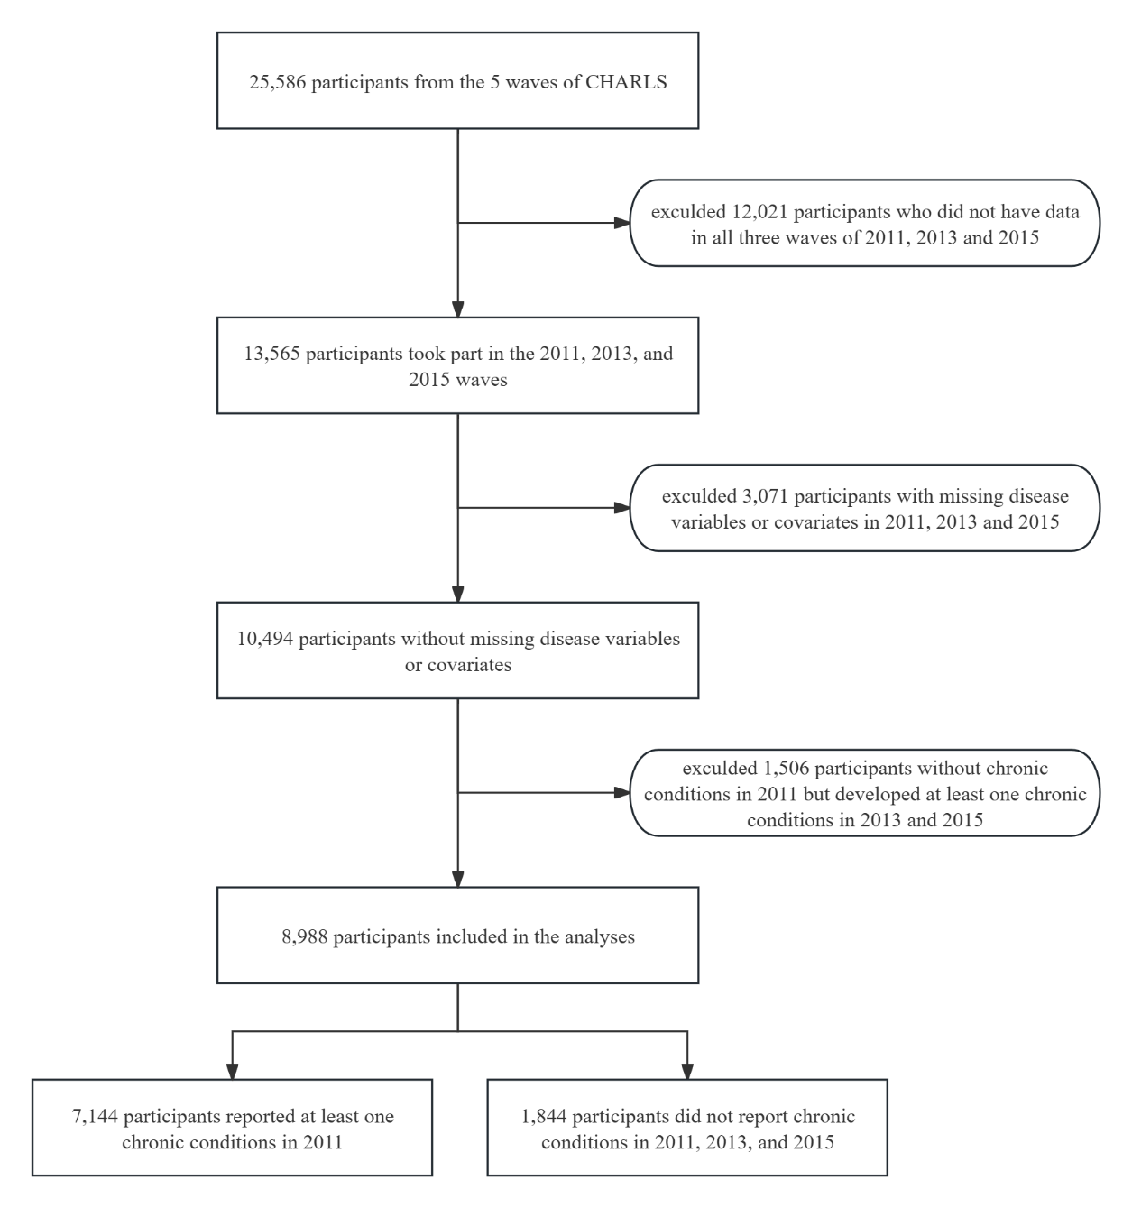

eFigure 2. Association between excess rate of chronic disease cumulative characteristics and all-cause mortality by multimorbidity pattern combinations
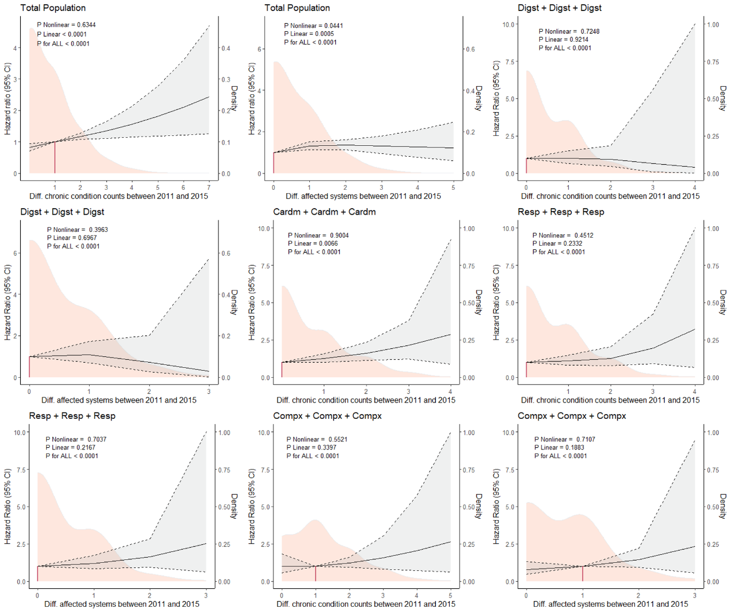
Note: Participants were divided into five patterns based on conditions at baseline: osteoarticular multimorbidity (“Arth”), cardiometabolic multimorbidity (“Cardm”), multisystem complex pattern (“Compx”), digestive multimorbidity (“Digst”), and respiratory multimorbidity (“Resp”). Solid black line: Estimated hazard ratio (HR) with 95% confidence interval (CI) shaded in gray. Orange density curve: Distribution of the predictor variable in the study population. Fully-adjusted model was adjusted for all controllers. *P＜0.1, **P＜0.05, ***P＜0.001.

eFigure 3. Associations between multimorbidity cluster progression and all-cause mortality risk among non-imputed datasets
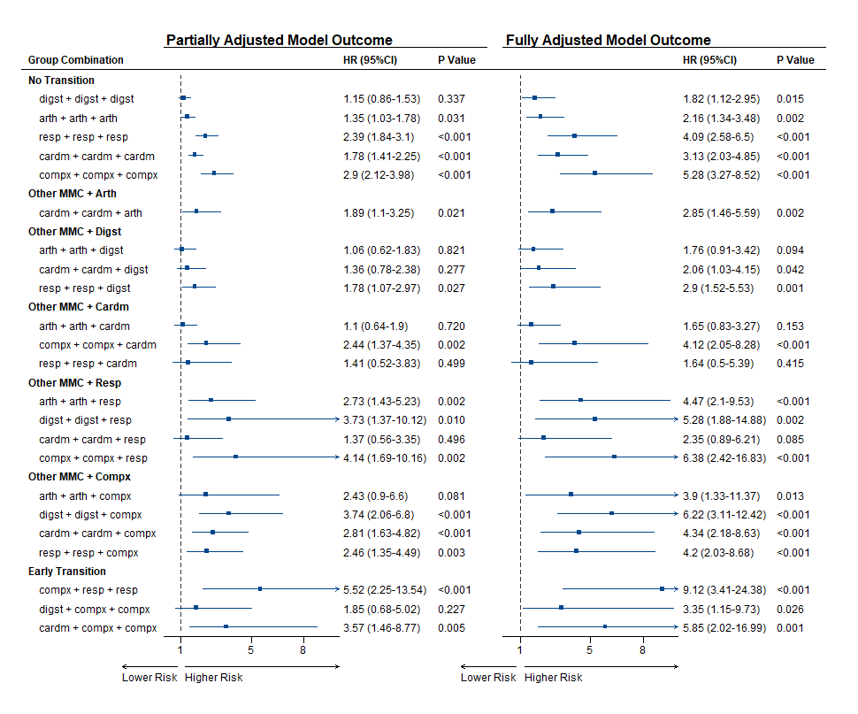
Note: Participants were divided into five patterns based on conditions at baseline: osteoarticular multimorbidity (“Arth”), cardiometabolic multimorbidity (“Cardm”), multisystem complex pattern (“Compx”), digestive multimorbidity (“Digst”), and respiratory multimorbidity (“Resp”).

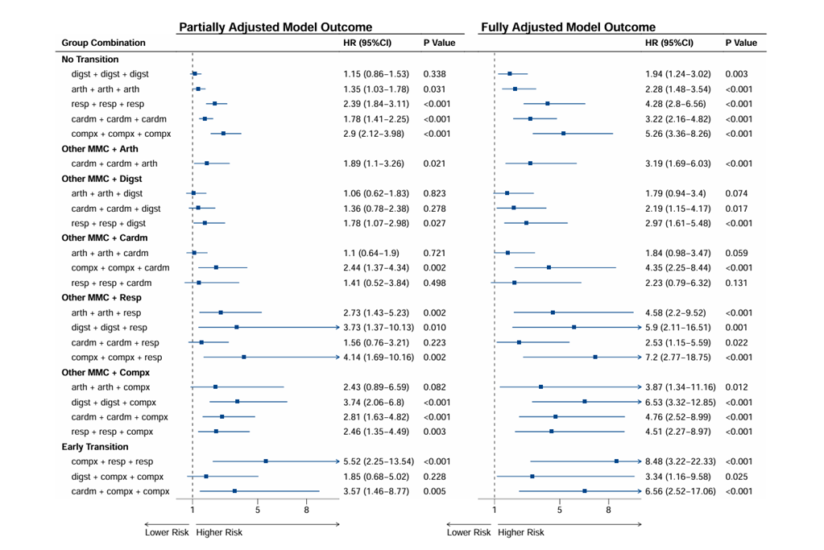
eFigure 4. Associations between multimorbidity cluster progression and all-cause mortality risk with physical activity in the fully adjusted model.
Note: Participants were divided into five patterns based on conditions at baseline: osteoarticular multimorbidity (“Arth”), cardiometabolic multimorbidity (“Cardm”), multisystem complex pattern (“Compx”), digestive multimorbidity (“Digst”), and respiratory multimorbidity (“Resp”).

