Supplementary File
Figure S1 Flowchart of study participant selection process.
Figure S2 Nonlinear association between risk of incident dementia and eBMD after imputation for missing data.

Table S1 Code used by UK Biobank for diagnosing all-cause dementia.
Table S2 APOE SNP alleles and frequency of APOE genotypes (N=131,030).
Table S3 Proportion of missing values for each variable.
Table S4 Cohort characteristics by eBMD tertiles.
Table S5 Risk of incident dementia according to eBMD tertile for imputed dataset.
Table S6 Cox proportional-hazards models investigating the association between eBMD and incident dementia among different age groups (60-65 and over 65).
Table S7 Cox proportional-hazards models investigating the association between eBMD and incident dementia among follow-up time groups (0-5y, 5-10y and over 10-y).
Table S8 Risk of incident dementia according to eBMD tertiles with serum phosphate level as additional covariate (N = 114357).
Table S9 C-index from Cox regression models using eBMD for incident dementia discrimination.

Figure S1 Flowchart of study participant selection process.

Participants in the UK Biobank with baseline eBMD data (N= 488,223)

Excluded:
- Participants aged <60 years (n=276,637)
- Participants with prevalent dementia (n=160)

Participants with complete covariate data
n=131,030 (61.97%)

Participants with ≥1 missing covariate data
n=80,396 (38.03%)

Multiple Imputation Analysis
n=211,426

Final analyses
n=131,030

Figure S2 Nonlinear association between risk of incident dementia and eBMD after imputation for missing data.
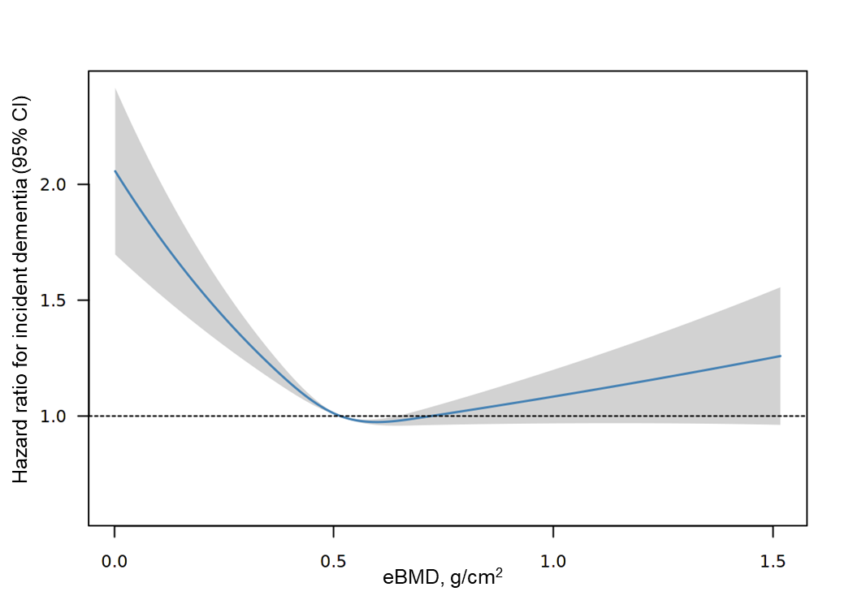
HRs were the average value for 40 imputed datasets. The reference value (HR = 1; horizontal dash line) was set at the median of eBMD (0.518 g/cm²). There were Shaded area represents 95% confidence intervals. There were 203,268 non-incident dementia and 8,158 dementia cases in each imputed dataset. Cox model was fully adjusted for age, sex, APOE genetic risk and additional covariates including body mass index, education level, ethnicity, socioeconomic status, smoking status, alcohol intake status, physical activity level, chronic conditions.

Table S1 Code used by UK Biobank for diagnosing all-cause dementia.
Disease | ICD-9 codes | ICD-10 codes | Self-Reported codes
AD | 331.0 | F00, F00.0, F00.1, F00.2, F00.9, G30, G30.0, G30.1, G30.8, G30.9 | Field 20002  Code 1263
VD | 290.4 | F01, F01.0, F01.1, F01.2, F01.3, F01.8, F01.9, I67.3 | Field 20002  Code 1263
FTD | 331.1 | F02.0, G31.0 | Field 20002  Code 1263
Other types of dementia | 290.2, 290.3, 291.2, 294.1, 331.2, 331.5 | A81.0, F02, F02.1, F02.2, F02.3, F02.4, F02.8, F03, F05.1, F10.6, G31.1, G31.8 | Field 20002  Code 1263
Abbreviations: ICD, International Classification of Diseases; AD, Alzheimer disease; VD, vascular dementia; FTD, frontotemporal dementia.

Table S2 APOE SNP alleles and frequency of APOE genotypes (N=131,030).
APOE variant | SNP alleles
APOE variant | rs429358 | rs7412
ε1 | C | T
ε2 | T | T
ε3 | T | C
ε4 | C | C

APOE risk | APOE Genotype | rs429358 | rs7412 | Count, n. (%)
High | ε4ε4 | CC | CC | 3138 (2.39%)
High | ε3ε4 | TC | CC | 30806 (23.51%)
High | ε2ε4 | TC | TC | 3286* (2.51%)
High | ε1ε3 | CT | TC | 3286* (2.51%)
Natural | ε3ε3 | TT | CC | 76930 (58.71%)
Low | ε2ε3 | TT | TC | 16115 (12.30%)
Low | ε2ε2 | TT | TT | 707 (0.54%)
Low | ε2ε2/ε1ε1/ε1ε2† | untyped | TT | 48 (0.04%)
Unsure‡ | Cases with genotypes of uncertain risk (ε1ε4) or without SNP data
*Ambiguous genotypes, ε2ε4 and ε1ε3, were coded as ε2ε4 since the ε1 allele is too rare.
†rs429358 is untyped and rs7412=TT, these cases could be ε2ε2, ε1ε1 or ε1ε2 and were coded as ε2ε2 since the ε1 allele is too rare.
‡Participants with uncertain APOE status were assigned to “Unsure” and were excluded from main analyses.

Table S3 Proportion of missing values for each variable.
Variables | Missing rate (%)
APOE genetic risk | 17.43
BMI | 0.19
Ethnicity | 0.37
Education | 1.36
Socioeconomic status | 0.08
Smoking status | 0.60
Alcohol intake | 0.21
Physical activity | 22.12
Chronic conditions | 0.89

Overall proportion for missing values was 38.03%, and therefor 40 imputations were used for imputation analyses.
Table S4 Cohort characteristics by eBMD tertiles.
 | Lowest tertile | Medium tertile | Highest tertile
Dementia cases/Total | 1,599/43,742 | 1,461/43,765 | 1,512/43,523
Age, median (IQR), y | 64 (62 to 67) | 64 (62 to 66) | 64 (62 to 66)
Sex, No. (%)
Female | 30,022 (68.6) | 22,553 (51.5) | 15,656 (36.0)
Male | 13,720 (31.4) | 21,212 (48.5) | 27,867 (64.0)
BMI*, median (IQR), kg/m² | 26.02  (23.61 to 28.91) | 26.89  (24.54 to 29.71) | 27.12  (24.81 to 29.94)
APOE allele status, No. (%)
High risk | 12,423 (28.4) | 12,448 (28.4) | 12,359 (28.4)
Neural risk | 25,821 (59.0) | 25,640 (58.6) | 25,469 (58.5)
Low risk | 5,498 (12.6) | 5,677 (13.0) | 5,695 (13.1)
Education†, No. (%)
Higher | 18,010 (41.2) | 19,142 (43.7) | 20,130 (46.3)
Secondary | 14,994 (34.3) | 14,494 (33.1) | 9,744 (22.4)
Vocational/Other | 10,738 (24.5) | 10,129 (23.1) | 13,649 (31.4)
Ethnicity, No. (%)
White | 42,791 (97.8) | 42,485 (97.1) | 41,792 (96.0)
Non-white | 951 (2.2) | 1,280 (2.9) | 1,731 (4.0)
Socioeconomic status quintile‡
1 (least deprived) | 8,972 (20.5) | 9,283 (21.2) | 9,697 (22.3)
2 - 4 | 26,384 (60.3) | 26,683(61.0) | 26,536 (61.0)
5 (most deprived) | 8,386 (19.2) | 7,799 (17.8) | 7,290 (16.7)
Smoking status, No. (%)
Never | 22,463 (51.4) | 21,817 (49.9) | 21,802 (50.1)
Previous | 17,870 (40.9) | 18,991 (43.4) | 19,026 (43.7)
Current | 3,409 (7.8) | 2,957 (6.8) | 2,695 (6.2)
Alcohol intake status, No. (%)
Never | 2,116 (4.8) | 1,847 (4.2) | 1,548 (3.6)
Previous | 1,596 (3.6) | 1,408 (3.2) | 1,261 (2.9)
Current | 40,030 (91.5) | 40,510 (92.6) | 40,714 (93.5)
Physical activity level, No. (%)
Low (<150 min/week) | 6,770(15.5) | 6,558 (15.0) | 5,832 (13.4)
High (≥150 min/week) | 36,972 (84.5) | 37,207 (85.0) | 37,691 (86.6)
Chronic Conditions, No. (%)
Stroke | 885 (2.0) | 827 (1.9) | 882 (2.0)
Diabetes | 1,994 (4.6) | 2,728 (6.2) | 3,240 (7.4)
Hypertension | 13,930 (31.8) | 15,406 (35.2) | 15,856 (36.4)
Arthritis | 7,990 (18.3) | 7,711 (17.6) | 7,752 (17.8)
Rheumatoid arthritis | 858 (2.0) | 582 (1.3) | 459 (1.1)
Chronic Condition Present§, No. (%) | 20,213 (46.2) | 21,291 (48.6) | 21,830 (50.2)
eBMD, median (IQR), g/cm² | 0.409 (0.368 to 0.440) | 0.518 (0.493 to 0.545) | 0.649 (0.607 to 0.716)

Note: Percentages may not add up to 100 due to rounding.
Abbreviations: APOE, apolipoprotein E; eBMD, estimated bone mineral density; IQR, interquartile range.
*BMI: body mass index, calculated as weight in kilograms divided by height in meters squared.
†Education: higher education defined as college/university degree or other professional qualification; secondary education defined as first and second/final stage of secondary education; vocational education/other defined work-related practical qualifications and other qualifications.
‡Socioeconomic status: classified based on Townsend deprivation index, quintiles 1 as least deprived, quintile 2–4 and quintile 5 as most deprived, combining information on social class, employment, car availability, and housing.
§Chronic condition present indicate that a physician had diagnosed at least one of the chronic conditions, including stroke, diabetes, hypertension, arthritis (identified by ICD-10 M15-M1) and rheumatoid arthritis (identified by ICD-10 M05/M06).

Table S5 Risk of incident dementia according to eBMD tertiles for imputed dataset.
 | eBMD by tertile
 | Lowest tertile  (<0.464 g/cm²) | Medium tertile  (0.464-<0.570 g/cm²) | Highest tertile  (≥0.570 g/cm²) |  | Per SD decrease
Incident dementia
No. of cases | 2913 | 2554 | 2691 |  | 8158
Person-years | 1016886 | 1023889 | 1023588 |  | 3064363
Cases per 1000 person-years | 2.86 | 2.49 | 2.63 |  | 2.67
Minimally adjusted model*
HR (95% CI) | 1.18 (1.12-1.25) | 1 [Reference] | 1.02 (0.96-1.07) |  | 1.57 (1.33-1.85)
P value | <.001 |  | .59 |  | <.001
Fully adjusted model†
HR (95% CI) | 1.17 (1.11-1.23) | 1 [Reference] | 1.02 (0.97-1.08) |  | 1.47 (1.25-1.73)
P value | <.001 |  | .42 |  | <.001

Abbreviations: HR, hazard ratio; eBMD, estimated bone mineral density. SD, standard deviation.
Bold font corresponds to significant P value threshold.
*Adjusted for age, sex and APOE genetic risk status.
†Adjusted for age, sex, APOE genetic risk and additional covariates including body mass index, education level, ethnicity, socioeconomic status, smoking status, alcohol intake status, physical activity level, chronic conditions.

Table S6 Cox proportional hazards models investigating the association between eBMD and incident dementia among different age groups (60-65 and over 65).
 | No. of Cases of  Dementia/Person-Years | Cases per 1000 person-years | Hazard Ratio  (95% CI) | Fully adjusted  P Value
60-65 years old
Lowest tertile | 699/423664 | 1.65 | 1.11 (1.00-1.24) | .048
Medium tertile | 668/436443 | 1.53 | 1 [Reference]
Highest tertile | 656/433860 | 1.51 | 0.96 (0.86-1.06) | .41
over 65 years old
Lowest tertile | 900/214132 | 4.20 | 1.12 (1.12-1.23) | .02
Medium tertile | 793/204905 | 3.87 | 1 [Reference]
Highest tertile | 865/203905 | 4.20 | 1.07 (0.97-1.18) | .18

Bold font corresponds to significant P value threshold.
Cox model was fully adjusted for age, sex, APOE genetic risk and additional covariates including body mass index, education level, ethnicity, socioeconomic status, smoking status, alcohol intake status, physical activity level, chronic conditions.

Table S7 Cox proportional hazards models investigating the association between eBMD and incident dementia among follow-up time groups (0-5y, 5-10y and over 10-y).
 | No. of Cases of  Dementia/Person-Years | Cases per 1000 person-years | Hazard Ratio  (95% CI) | Fully adjusted  P Value
0-5 years follow-up
Lowest tertile | 121/216292 | 0.56 | 1.41 (1.07-1.87) | .016
Medium tertile | 87/216619 | 0.40 | 1 [Reference]
Highest tertile | 111/215415 | 0.52 | 1.22 (0.92-1.62) | .16
>5 to 10 years follow-up
Lowest tertile | 1478/419869 | 3.52 | 1.13 (1.00-1.27) | .06
Medium tertile | 1374/421555 | 3.26 | 1 [Reference]
Highest tertile | 1401/419029 | 3.34 | 1.02 (0.90-1.15) | .79
Over 10 years follow-up
Lowest tertile | 916/615305 | 1.49 | 1.06 (0.99-1.10) | .21
Medium tertile | 874/620464 | 1.41 | 1 [Reference]
Highest tertile | 884/617532 | 1.43 | 1.00 (0.91-1.10) | .96

Bold font corresponds to significant P value threshold.
Cox model was fully adjusted for age, sex, APOE genetic risk and additional covariates including body mass index, education level, ethnicity, socioeconomic status, smoking status, alcohol intake status, physical activity level, chronic conditions.

Table S8 Risk of incident dementia according to eBMD tertiles with serum phosphate level as additional covariate (N = 114,357‡).
 | eBMD by tertile
 | Lowest tertile  (<0.468 g/cm²) |  | Medium tertile  (0.468-<0.573 g/cm²) |  | Highest tertile  (≥0.573 g/cm²) |  | Per SD decrease
Incident dementia
No. of cases | 1,393 |  | 1,275 |  |  | 1,330 |  | 3,998
Person-years | 554,858 |  | 641,348 |  |  | 557,578 |  | 1,753,784
Cases per 1000 person-years | 2.51 |  | 2.27 |  |  | 2.39 |  | 2.27
Minimally adjusted model*
HR (95% CI) | 1.14 (1.06-1.23) |  | 1 [Reference] |  |  | 1.02 (0.94-1.10) |  | 1.44 (1.13-1.82)
P value | <.001 |  |  |  |  | .67 |  | .002
Fully adjusted model†
HR (95% CI) | 1.12 (1.04-1.21) |  | 1 [Reference] |  |  | 1.03 (0.95-1.11) |  | 1.34 (1.05-1.69)
P value | .003 |  |  |  |  | .47 |  | .016

Abbreviations: HR, hazard ratio; eBMD, estimated bone mineral density. SD, standard deviation.
Bold font corresponds to significant P value threshold.
‡16,673 individuals were excluded due to missing serum phosphate data.
*Adjusted for age, sex and APOE genetic risk status.
†Adjusted for age, sex, APOE genetic risk and additional covariates including body mass index, education level, ethnicity, socioeconomic status, smoking status, alcohol intake status, physical activity level, chronic conditions and serum phosphate level.

Table S9 C-index from Cox regression models using eBMD for incident dementia discrimination.
Base model* | Predictor | C-index |  | P Value†
Base model* | Predictor | Base | Base + Predictor | P Value†
Age + Sex | eBMD | 0.592 (0.583-0.600) | 0.593 (0.584-0.602) | <.001
Age + Sex + APOE | eBMD | 0.694 (0.685-0.703) | 0.695 (0.686-0.703) | <.001

Results for max available follow-up time are given in this table.
*Base models were adjusted for covariates including body mass index, education level, ethnicity, socioeconomic status, smoking status, alcohol intake status, physical activity level, chronic conditions.
†P values were calculated using the z-score test.

