Supplementary Table S1. Sensitivity analysis of relationship between LAP and cognitive impairment in female.
lnLAP | Model 1 |  |  |  | Model 2
lnLAP | OR | 95%CI | P |  | OR | 95%CI | P
Continuous | 2.097 | 1.104-3.983 | 0.024 |  | 2.064 | 1.097-3.883 | 0.025
Categories
Group1 | Ref |  |  |  | Ref
Group 2 | 2.271 | 0.697-7.398 | 0.174 |  | 2.240 | 0.700-7.162 | 0.174
Group 3 | 4.257 | 1.155-15.692 | 0.030 |  | 4.098 | 1.135-14.79 | 0.031
Model 1, adjusted for age, sex, education, smoking, drinking, lack of exercise, hypertension, dyslipidemia, diabetes, stroke and lipid-lowering drugs use;
Model 2, after winsorized, adjusted for age, sex, education, smoking, drinking, lack of exercise, hypertension, dyslipidemia, and diabetes.

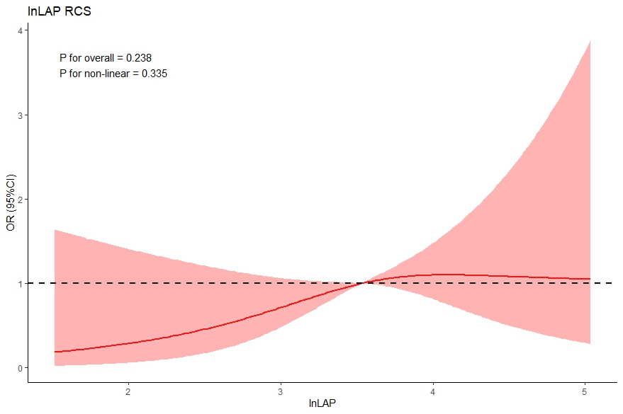
Supplementary Figure S1. Restricted cubic spline for the relation between lnLAP and cognitive impairment. Solid red line showed predicted value of odds ratio for cognitive impairment, and Shade dare as indicate 95% confidence intervals.

