Supplementary Information
Tables
Table S1 Correlations between whole body BMD and BMD in different body regions.
Table S2 The relationships between telomere length indicators and subtotal BMD
Table S3. Subgroup analysis of relationship between telomere and total bone BMD.
Table S4. Sensitivity analysis of mediation (the effect of telomere between physical activity and BMD).

Figure Captions
Figure S1. Flow chat of the inclusion and exclusion process of the participants
Figure S2 The associations between physical activity and BMD

Table S1 Correlations between whole body BMD and BMD in different body regions.
 | Pearson Correlation Coefficient
Left leg | 0.92
Right leg | 0.92
Thoracic spine | 0.84
Lumbar spine | 0.80
Head | 0.72
Right arm | 0.88
Left arm | 0.88
Left rib | 0.84
Right rib | 0.83
Pelvic | 0.88
Trunk bone | 0.94

Table S2 The relationships between telomere length indicators and subtotal BMD
 | Subtotal BMD
TL indicators | Model 1 |  | Model2 |  | Model3
 | β（95%CI） | p | β（95%CI） | P | β（95%CI） | p
HorvathTelo
Q1 | Ref |  | Ref |  | Ref
Q2 | 0.025  （0.004,0.046） | 0.02* | 0.035  （0.022,0.049） | <0.01* | 0.025  （0.012,0.039） | <0.01*
Q3 | 0.039  （0.019,0.060） | <0.01* | 0.062  （0.049,0.076） | <0.01* | 0.051  （0.040,0.063） | <0.01*
Q4 | 0.053  （0.030,0.075） | <0.01* | 0.084  （0.065,0.103） | <0.01* | 0.071  （0.053,0.089） | <0.01*
P for trend | <0.01* |  | <0.01* |  | <0.01*
HorvathTeloAccel
Q1 | Ref |  | Ref |  | Ref
Q2 | -0.004  （-0.030,0.022） | 0.74 | 0.023  （0.004,0.042） | 0.02* | 0.012  （-0.006,0.030） | 0.18
Q3 | -0.020  （-0.045,0.005） | 0.12 | 0.023  （0.004,0.042） | 0.02* | 0.017  （-0.001,0.035） | 0.06
Q4 | -0.035  (-0.063,-0.006） | 0.01* | 0.022  （0.003,0.042） | 0.02* | 0.016  （-0.002,0.034） | 0.09
P for trend | <0.01* |  | 0.03* |  | 0.07
TeloMean
Q1 | Ref |  | Ref |  | Ref
Q2 | 0.024  （-0.000,0.049） | 0.05 | 0.024  （0.002,0.047） | 0.04 | 0.020  （0.000,0.040） | 0.05*
Q3 | 0.021  （-0.003,0.046） | 0.09 | 0.036  （0.016,0.056） | <0.01* | 0.033  （0.015,0.050） | <0.01*
Q4 | 0.017  （-0.005,0.039） | 0.13 | 0.031  （0.015,0.047） | <0.01* | 0.026  （0.013,0.039） | <0.01*
P for trend | 0.21 |  | <0.01* |  | <0.01*
TeloMeanAccel
Q1 | Ref |  | Ref |  | Ref
Q2 | -0.006  （-0.025,0.012） | 0.49 | 0.004  （-0.011,0.020） | 0.55 | 0.012  （-0.003,0.028） | 0.11
Q3 | -0.011  （-0.031,0.009） | 0.28 | 0.003  （-0.014,0.021） | 0.70 | 0.008  （-0.007,0.023） | 0.27
Q4 | -0.016  （-0.033,0.001） | 0.06 | 0.004  （-0.009,0.017） | 0.54 | 0.008  （-0.005,0.020） | 0.20
P for trend | 0.07 |  | 0.66 |  | 0.41
Model 1 served as the crude model, Model 2 was adjusted for age, race, and gender, and Model 3 was further adjusted for BMI and education level.

Table S3 Subgroup analysis of relationship between telomere and total bone BMD.
BMD | HorvathTelo |  | HorvathTeloAccel |  | TeloMean |  | TeloMeanAccel
BMD | β (95%CI) | P | β(95%CI) | P | β(95%CI) | p | β(95%CI) | P
Gender
Male | 0.065  (0.033, 0.097) | <0.01* | 0.044  (0.006, 0.082) | 0.03* | 0.038  (-0.002,0.079) | 0.06 | 0.017  (-0.028,0.061) | 0.45
Female | 0.132  (0.097,0.168) | <0.01* | 0.027  (-0.012,0.066) | 0.17 | 0.046  (-0.008,0.099) | 0.09 | -0.006  (-0.051,0.039) | 0.79
Age
<65 | 0.051  (0.015,0.086) | <0.01* | 0.024  (-0.013,0.060) | 0.19 | 0.005  (-0.048,0.059) | 0.83 | -0.003  (-0.057,0.051) | 0.90
≥65 | 0.079  (0.042,0.117) | <0.01* | 0.038  (0.001,0.075) | 0.04* | 0.054  (0.023,0.084) | <0.01* | 0.032  (0.003,0.061) | 0.03*
Weight
BMI<28 | 0.118  (0.087,0.148) | <0.01* | 0.037  (0.005,0.071) | 0.03* | 0.062  (0.020,0.105) | <0.01* | 0.014  (-0.025,0.052) | 0.47
BMI≥28 | 0.075  (0.039,0.112) | <0.01* | 0.025  (-0.010,0.061) | 0.15 | 0.019  (-0.024,0.062) | 0.37 | -0.012  (-0.058,0.034) | 0.59

Table S4 Sensitivity analysis of TL-Mediated Association
 |  | Estimation | 95% CI | p
HorvathTelo | IE | 0.0034 | 0.0023,0.0045 | <0.05
HorvathTelo | DE | 0.0136 | 0.0079,0.0193 | <0.05
HorvathTelo | TE | 0.0170 | 0.0113,0.0227 | <0.05
HorvathTelo | Prop. | 20.0% | 14%,30% | <0.05
HorvathTeloAccel | IE | 0.0003 | 0.0000,0.0006 | <0.05
HorvathTeloAccel | DE | 0.0167 | 0.0111,0.0223 | <0.05
HorvathTeloAccel | TE | 0.0170 | 0.0114,0.0226 | <0.05
HorvathTeloAccel | Prop. | 1.5% | 0.1%,5% | <0.05
Telomean | IE | 0.0007 | 0.0002，0.0012 | <0.05
Telomean | DE | 0.0135 | 0.0077,0.0193 | <0.05
Telomean | TE | 0.0143 | 0.0086,0.0200 | <0.05
Telomean | Prop. | 5.0% | 1.3%,11% | <0.05
Adjusted by race, gender, BMI, education level, and total calcium intake.
IE: indirect effect; DE: direct effect; TE: total effect; Prop.: the rate of mediation in total effect.

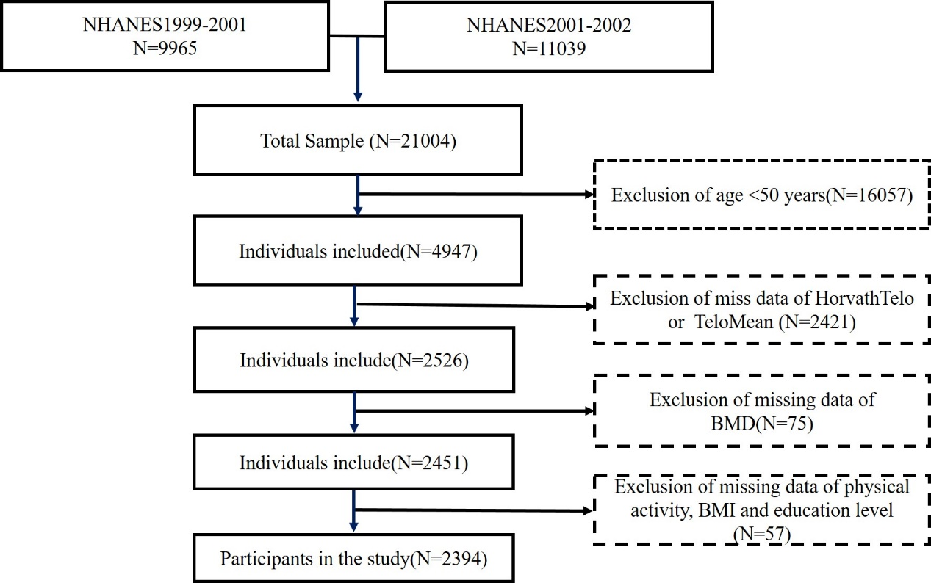
Figure S1. Flow chat of the inclusion and exclusion process of the participants.

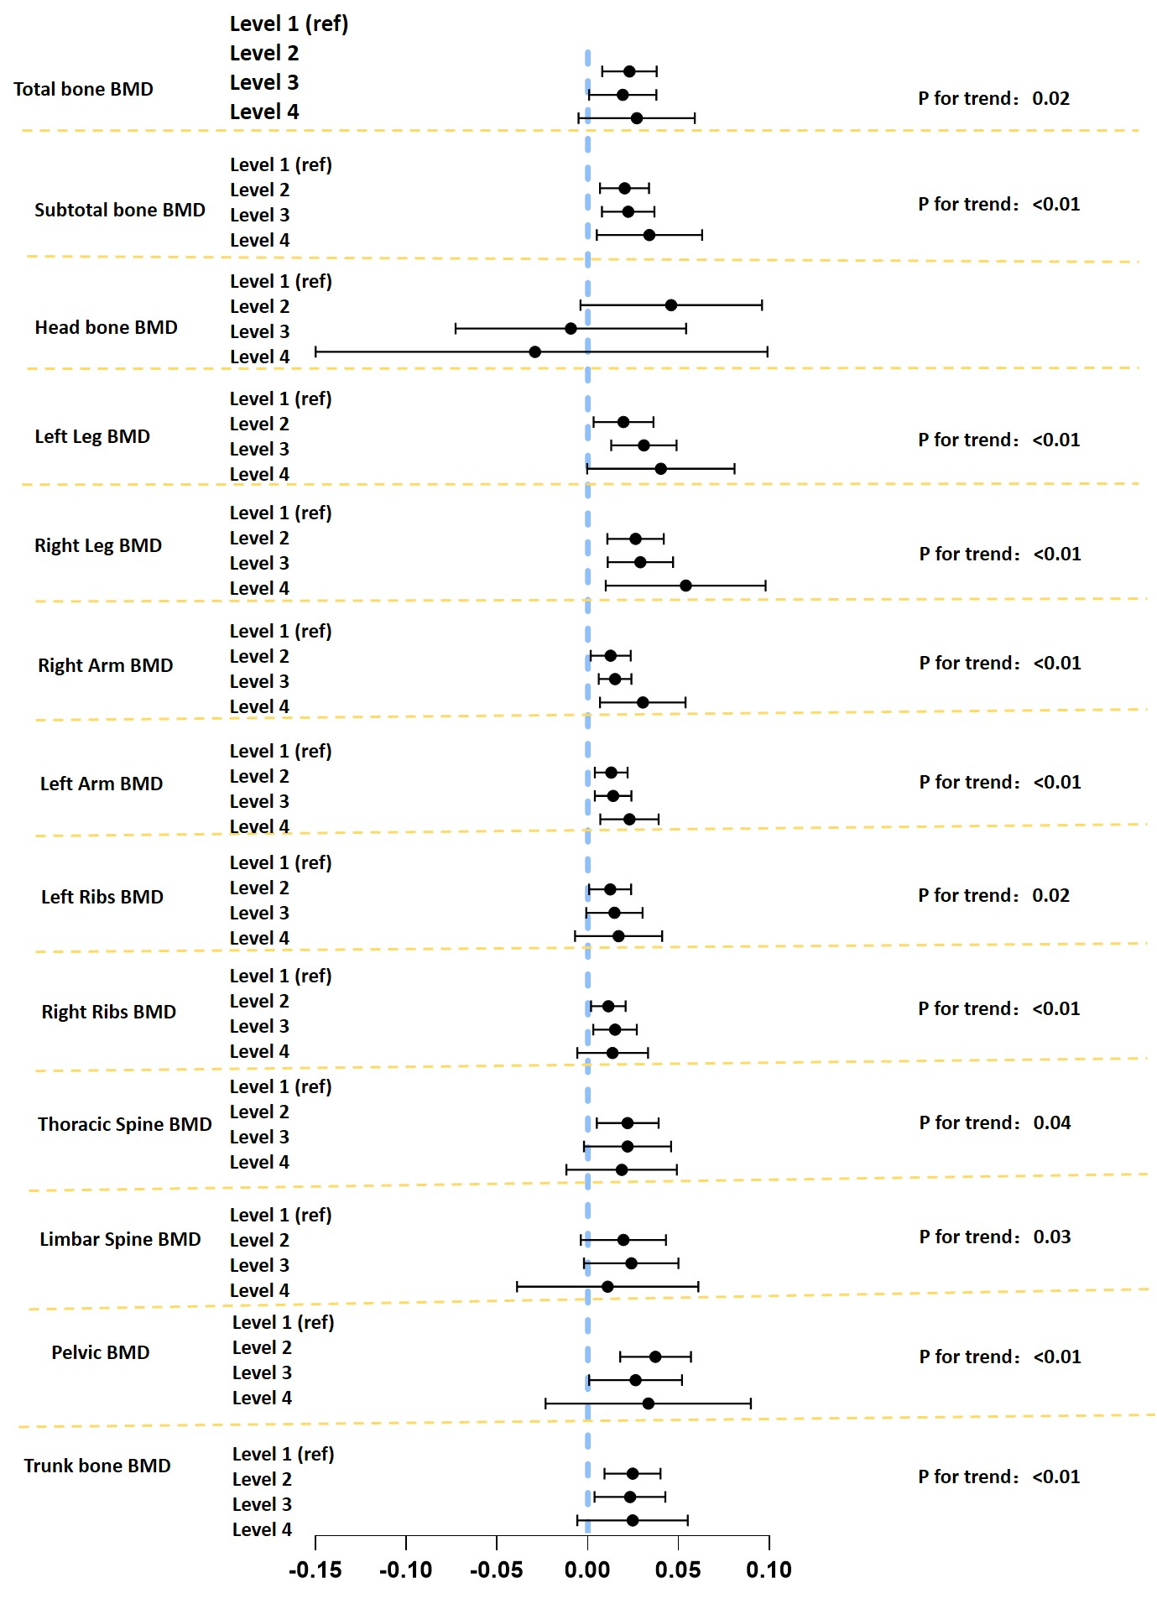
Figure S2 The associations between physical activity and BMD

