Supplementary Fig. 1. Geographic distribution of the frequency of long-term care facilities residents involved in the Prescription Day LTCFs 2024
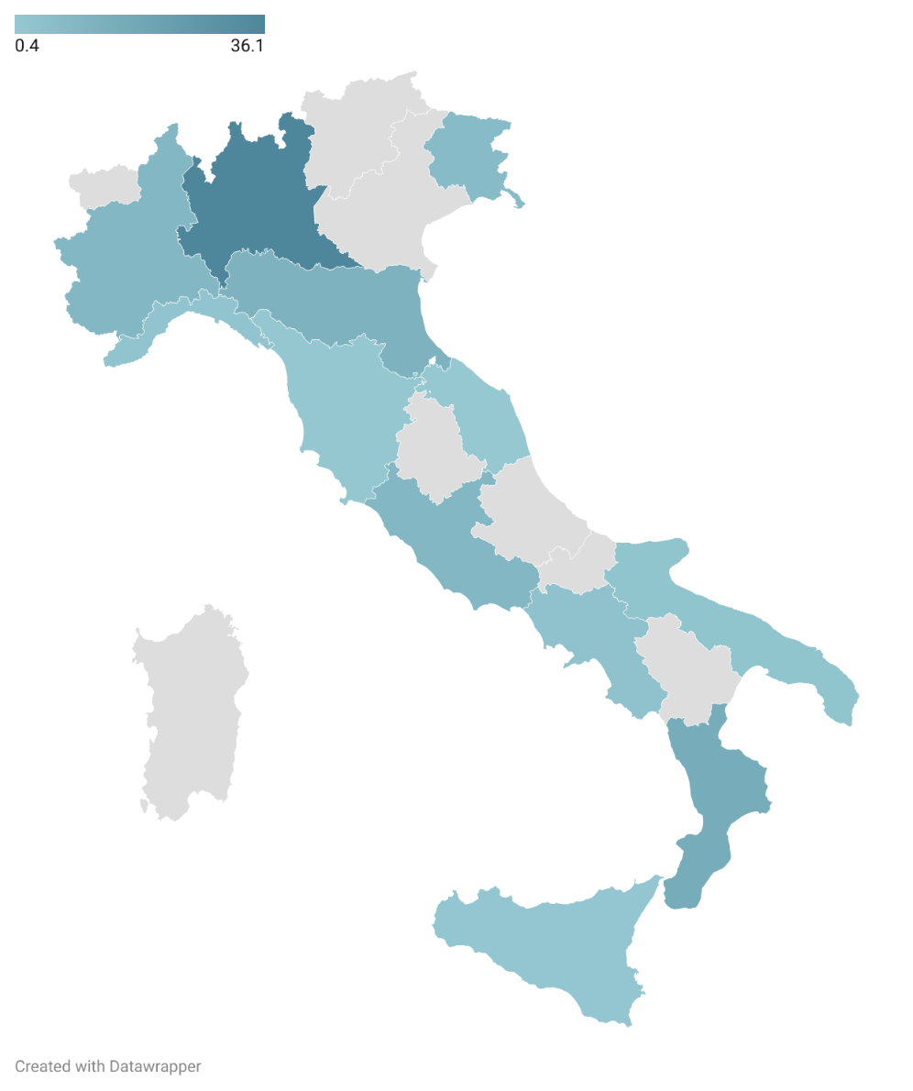

Notes. Blue color intensity corresponds to the frequency of residents involved in the study across Italian regions. Grey areas indicate regions with no participating facilities.

Supplementary Fig. 2: patterns of missing data in participants without dementia. Prevalence is calculated among participants without dementia. Only patterns with a prevalence ≥ 2.0% are shown. Red = missing data.

Pattern n. | N (%) | Median SMD  (IQR) | Demographics |  | ADLs | Frailty NH | Acute Conditions | Adherence | Compliance | Dysphagia presence/diagnosis | PEG tube or NG tube
1 | 541 (15.9) | 0.07  (0.03-0.21)
2 | 363 (10.7) | 0.11  (0.06-0.25)
3 | 136 (4.0) | 0.15  (0.06-0.24)
TOTAL MISSING VALUES: |  |  |  | 23 | 626 | 820 | 0 | 0 | 0 | 169 | 127

SMD: standardized mean difference; ADL: activities of daily living; Frailty NH: frailty nursing home scale; PEG: percutaneous endoscopic gastrostomy, NG: naso-gastric

