Article title: The association of anticoagulant use and hospitalization for hemorrhagic stroke among older adults aged 75 or older: A propensity score-matched study
Journal name: Aging Clinical and Experimental Research
Author names:
Seigo Mitsutake¹, Koki Ono², Masahiro Akishita³, Takumi Hirata¹
Affiliations:
¹Human Care Research Team, Tokyo Metropolitan Institute for Geriatrics and Gerontology, Tokyo, Japan
²Department of Preventive Medicine and Public Health, Keio University School of Medicine, Tokyo, Japan
³Tokyo Metropolitan Institute for Geriatrics and Gerontology, Tokyo, Japan
E-mail address of the corresponding author: t_hirata@tmig.or.jp
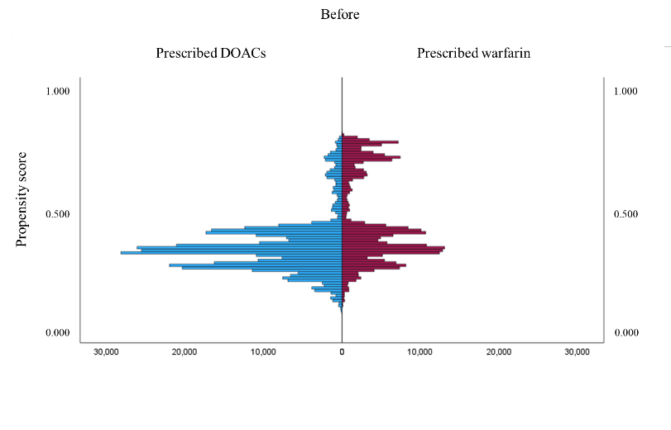

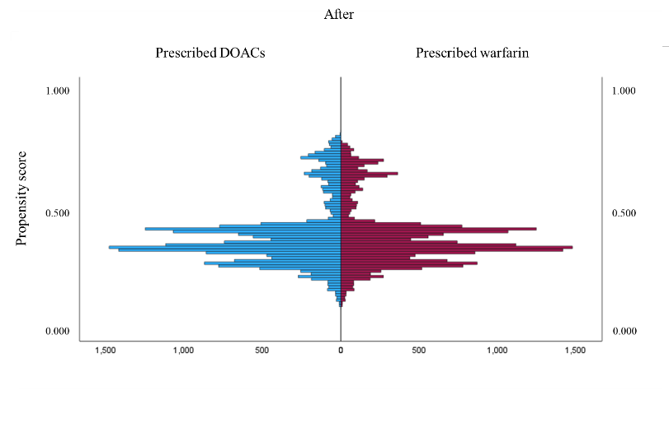

Abbreviations: DOACs, Direct Oral Anticoagulants; PS, propensity scores

Supplemental figure 1: The plot of PS among patient prescribed DOACs and those prescribed warfarin before and after PS matching

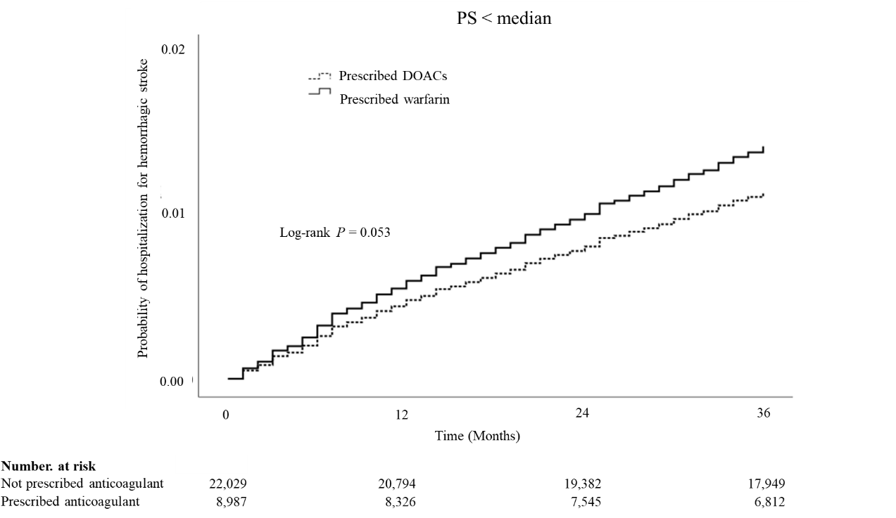
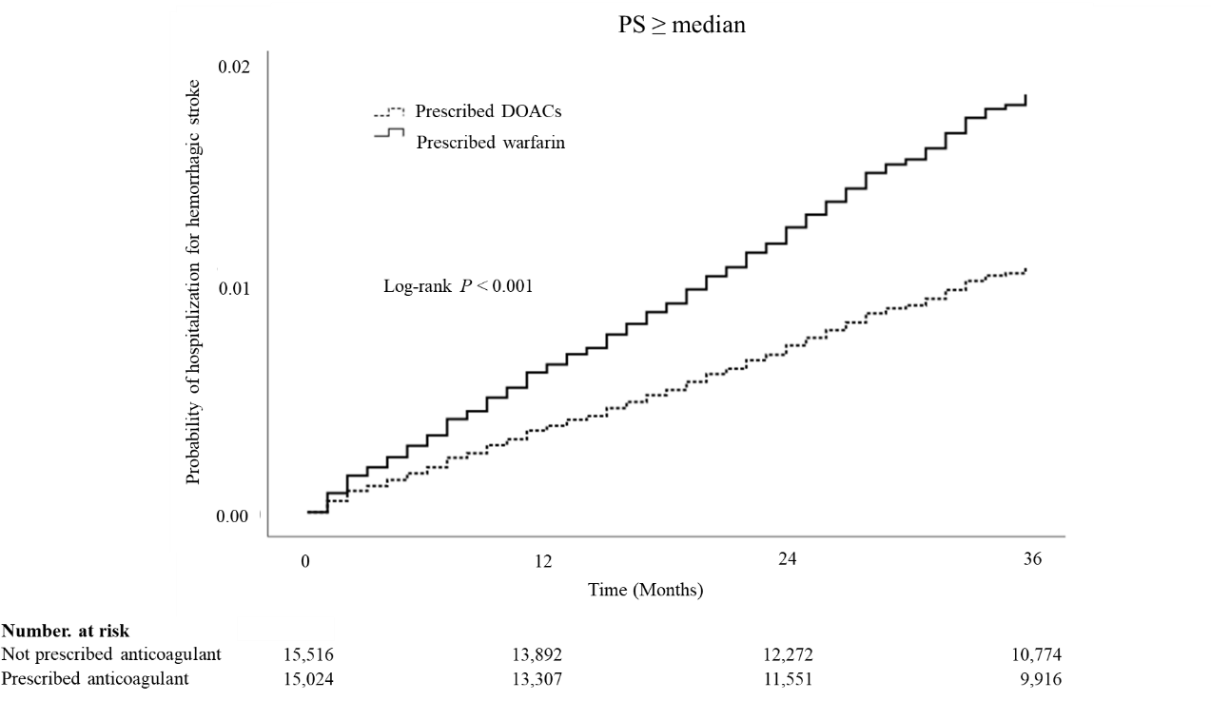
Abbreviations: DOACs, Direct Oral Anticoagulants; PS, propensity scores

Supplemental figure 2: Kaplan-Meier survival curves for hospitalization for hemorrhagic stroke between patient prescribed warfarin and DOACs stratified by the median of PS

Supplemental table 1. Definitions of anticoagulant prescription
Drug name | ATC code | The first 7-digits of the NHI Drug Code | NHI listing date
Warfarin | B01AA03 | 3332001 | February 1, 1978 [1]
Dabigatran | B01AE07 | 3339001 | March 11, 2011 [2]
Rivaroxaban | B01AF01 | 3339003 | April 17, 2012 [3]
Apixaban | B01AF02 | 3339004 | February, 2013 [4]
Edoxaban | B01AF03 | 3339002 | July 19, 2011 [5]
Abbreviations; ATC, Anatomical Therapeutic Chemical; NHI, National health insurance
The first 7 digits of the NHI Drug Code represent the medical classification number (4 digits) and route of administration and ingredients (3 digits)
References
1. Eisai Co., Ltd. Warfarin (warfarin potassium) tablets and granules: Interview Form. Revised November 2023. https://pins.japic.or.jp/pdf/medical_interview/IF00006213.pdf. Japanese (August 22, 2025, last accessed)
2. Boehringer Ingelheim Japan. Pradaxa (dabigatran etexilate) capsules: Interview Form. Revised June 2025. https://bij-kusuri.jp/products/files/pxa_cap75_if.pdf. Japanese (August 22, 2025, last accessed)
3. Bayer Yakuhin, Ltd. Xarelto (rivaroxaban) tablets: Interview Form. Revised September 6, 2023. https://pharma-navi.bayer.jp/sites/g/files/vrxlpx9646/files/2023-09/XAR_IVF_20230906.pdf. Japanese (August 22, 2025, last accessed)
4. Pfizer Japan Inc.; Bristol-Myers Squibb. Eliquis (apixaban) tablets: Interview Form. Revised 2025. https://pins.japic.or.jp/pdf/medical_interview/IF00008586.pdf. Japanese (August 22, 2025, last accessed)
5. Daiichi Sankyo Co., Ltd. Lixiana (edoxaban) tablets: Interview Form. https://www.koizumi-generic-drug-information-research-2nd-ver.com/wp-content/uploads/2021/11/%E3%83%AA%E3%82%AF%E3%82%B7%E3%82%A2%E3%83%8A%E9%8C%A0%EF%BC%91%EF%BC%95%EF%BD%8D%EF%BD%87_1_1.pdf. Japanese (August 22, 2025, last accessed)

Supplemental table 2. Comparisons of characteristics between patients prescribed and not prescribed anticoagulants after PS matching, stratified by patients with and without AF
 | Patients with AF |  |  |  |  |  |  |  |  |  | Patients without AF
 | With anticoagulant, n=54,101 |  | Without anticoagulant, n=22,333 |  |  | With anticoagulant, n=22,003 |  | Without anticoagulant, n=22,003 |  |  | With anticoagulant, n=12,815 |  | Without anticoagulant, n=627,848 |  |  | With anticoagulant, n=12,812 |  | Without anticoagulant, n=12,812
 | n | % | n | % | ASD | n | % | n | % | ASD | n | % | n | % | ASD | n | % | n | % | ASD
Sex
Male | 28,297 | 52.3 | 9,794 | 43.9 | 0.17* | 10,026 | 45.6 | 9,766 | 44.4 | 0.02 | 5,382 | 42.0 | 231,064 | 36.8 | 0.11* | 5,382 | 42.0 | 5,362 | 41.9 | <0.01
Female | 25,804 | 47.7 | 12,539 | 56.1 |  | 11,977 | 54.4 | 12,237 | 55.6 |  | 7,433 | 58.0 | 396,784 | 63.2 |  | 7,430 | 58.0 | 7,450 | 58.1
Age, mean (SD) | 82.8 (5.3) |  | 84.4 (6.0) |  | 0.27* | 85.3 (5.6) |  | 84.2 (5.9) |  | 0.19* | 82.9 (5.5) |  | 82.2 (5.6) |  | 0.12* | 82.9 (5.5) |  | 82.9 (5.5) |  | <0.01
Number of Charlson comorbidities
Nil | 3,270 | 6.0 | 1,583 | 7.1 | 0.04 | 2,143 | 9.7 | 1,534 | 7.0 | 0.10* | 939 | 7.3 | 140,394 | 22.4 | 0.43* | 936 | 7.3 | 920 | 7.2 | 0.01
1-2 | 21,691 | 40.1 | 9,033 | 40.4 | 0.01 | 10,511 | 47.8 | 8,850 | 40.2 | 0.15* | 5,088 | 39.7 | 311,776 | 49.7 | 0.20* | 5,088 | 39.7 | 5,107 | 39.9 | <0.01
3 or more | 29,140 | 53.9 | 11,717 | 52.5 | 0.03 | 9,349 | 42.5 | 11,619 | 52.8 | 0.21* | 6,788 | 53.0 | 175,678 | 28.0 | 0.53* | 6,788 | 53.0 | 6,785 | 53.0 | <0.01
Hypertension
No | 5,345 | 9.9 | 3,068 | 13.7 | 0.12* | 3,762 | 17.1 | 2,867 | 13.0 | 0.11* | 1,783 | 13.9 | 169,740 | 27.0 | 0.33* | 1,780 | 13.9 | 1,729 | 13.5 | 0.01
Yes | 48,756 | 90.1 | 19,265 | 86.3 |  | 18,241 | 82.9 | 19,136 | 87.0 |  | 11,032 | 86.1 | 458,108 | 73.0 |  | 11,032 | 86.1 | 11,083 | 86.5
IS/TIA
No | 37,881 | 70.0 | 16,951 | 75.9 | 0.13* | 16,253 | 73.9 | 16,646 | 75.7 | 0.04 | 9,401 | 73.4 | 539,727 | 86.0 | 0.32* | 9,398 | 73.4 | 9,409 | 73.4 | <0.01
Yes | 16,220 | 30.0 | 5,382 | 24.1 |  | 5,750 | 26.1 | 5,357 | 24.3 |  | 3,414 | 26.6 | 88,121 | 14.0 |  | 3,414 | 26.6 | 3,403 | 26.6
VTE
No | 51,510 | 95.2 | 21,945 | 98.3 | 0.17* | 21,561 | 98.0 | 21,615 | 98.2 | 0.02 | 9,829 | 76.7 | 622,724 | 99.2 | 0.74* | 9,829 | 76.7 | 9,829 | 76.7 | <0.01
Yes | 2,591 | 4.8 | 388 | 1.7 |  | 442 | 2.0 | 388 | 1.8 |  | 2,986 | 23.3 | 5,124 | 0.8 |  | 2,983 | 23.3 | 2,983 | 23.3
Health checkup
No | 51,614 | 95.4 | 21,187 | 94.9 | 0.03 | 20,062 | 91.2 | 20,883 | 94.9 | 0.15* | 12,323 | 96.2 | 580,281 | 92.4 | 0.16* | 12,320 | 96.2 | 12,336 | 96.3 | 0.01
Yes | 2,487 | 4.6 | 1,146 | 5.1 |  | 1,941 | 8.8 | 1,120 | 5.1 |  | 492 | 3.8 | 47,567 | 7.6 |  | 492 | 3.8 | 476 | 3.7
Long-term care
No | 35,936 | 66.4 | 14,089 | 63.1 | 0.07 | 13,136 | 59.7 | 13,949 | 63.4 | 0.08 | 7,686 | 60.0 | 468,204 | 74.6 | 0.32* | 7,683 | 60.0 | 7,736 | 60.4 | 0.01
Yes | 18,165 | 33.6 | 8,244 | 36.9 |  | 8,867 | 40.3 | 8,054 | 36.6 |  | 5,129 | 40.0 | 159,644 | 25.4 |  | 5,129 | 40.0 | 5,076 | 39.6
PS, mean (SD) | 0.72(0.08) |  | 0.68(0.09) |  | 0.40* | 0.67(0.08) |  | 0.69(0.08) |  | 0.17* | 0.11(0.16) |  | 0.02(0.04) |  | 0.75* | 0.11(0.16) |  | 0.11(0.16) |  | <0.01
Abbreviations: PS, propensity score; ASD, absolute standardized difference; SD, standard deviation; IS, ischemic stroke; TIA, transient ischemic attack; VTE, venous thromboembolism; AF, atrial fibrillation.
a: ASD > 0.1 was marked with *.
Supplemental table 3. Hospitalization for hemorrhagic stroke during follow-up period between patients prescribed and not prescribed anticoagulant after PS matching, stratified by patients with and without AF
 |  | Hospitalization for hemorrhagic stroke
 | Total, N | N | PM | Incidence | Adjusted HRª | 95％ CI
Patients with AF, n = 46,006ª
Not prescribed anticoagulant | 22,003 | 200 | 654,329 | 305.7 | 1.00
Prescribed anticoagulant | 22,003 | 255 | 668,870 | 381.2 | 1.23 | (1.02–1.48)
Patients without AF, n = 25,624
Not prescribed anticoagulant | 12,812 | 118 | 407,259 | 289.7 | 1.00
Prescribed anticoagulant | 12,812 | 167 | 396,072 | 421.6 | 1.45 | (1.15–1.84)
Abbreviations: PS, propensity score; AF, atrial fibrillation; PM, person-months; Incidence, incidence of hospitalization for hemorrhagic stroke per one million person-months; HR, Hazard ratio; CI, confidence interval
a: Adjusted HR: HR adjusted for covariates (age, number of Charlson comorbidities, prevalence of hypertension, annual health checkups, and PS)

Supplemental table 4. Comparisons of characteristics between patients prescribed warfarin and DOACs among patients prescribed one anticoagulant (n=61,556) after and before PS matching
 | Before PS matched patients |  |  |  |  | After PS matched patients
 | Prescribed warfarin, n=24,011 |  | Prescribed DOACs, n=37,545 |  |  | Prescribed warfarin, n=19,713 |  | Prescribed DOACs, n=19,713
 | N | % | N | % | ASD | N | % | N | % | ASD
Sex
Male | 12,985 | 54.1 | 18,081 | 48.2 | 0.12* | 9,962 | 50.5 | 9,882 | 50.1 | <0.01
Female | 11,026 | 45.9 | 19,464 | 51.8 |  | 9,751 | 49.5 | 9,831 | 49.9
Age, mean (SD) | 83.0 (5.4) |  | 82.7 (5.3) |  | 0.05 | 83.0 (5.5) |  | 83.1 (5.4) |  | 0.01
Number of Charlson comorbidities
Nil | 1,195 | 5.0 | 2,818 | 7.5 | 0.11* | 1,163 | 5.9 | 1,018 | 5.2 | 0.03
1-2 | 8,793 | 36.6 | 16,248 | 43.3 | 0.14* | 7,716 | 39.1 | 7,488 | 38.0 | 0.03
3 or more | 14,023 | 58.4 | 18,479 | 49.2 | 0.19* | 10,834 | 55.0 | 11,207 | 56.9 | 0.04
Hypertension
No | 2,293 | 9.5 | 4,400 | 11.7 | 0.07 | 2,151 | 10.9 | 2,057 | 10.4 | 0.01
Yes | 21,718 | 90.5 | 33,145 | 88.3 |  | 17,562 | 89.1 | 17,656 | 89.6
IS/TIA
No | 17,217 | 71.7 | 26,698 | 71.1 | 0.01 | 13,921 | 70.6 | 14,615 | 74.1 | 0.06
Yes | 6,794 | 28.3 | 10,847 | 28.9 |  | 5,792 | 29.4 | 5,098 | 25.9
VTE
No | 22,330 | 93.0 | 34,327 | 91.4 | 0.06 | 18,032 | 91.5 | 18,122 | 91.9 | 0.02
Yes | 1,681 | 7.0 | 3,218 | 8.6 |  | 1,681 | 8.5 | 1,591 | 8.1
AF
No | 8,144 | 33.9 | 4,295 | 11.4 | 0.56* | 3,846 | 19.5 | 3,802 | 19.3 | 0.01
Yes | 15,867 | 66.1 | 33,250 | 88.6 |  | 15,867 | 80.5 | 15,911 | 80.7
Health checkup
No | 23,097 | 96.2 | 35,693 | 95.1 | 0.06 | 18,871 | 95.7 | 18,949 | 96.1 | 0.02
Yes | 914 | 3.8 | 1,852 | 4.9 |  | 842 | 4.3 | 764 | 3.9
Long-term care
No | 15,712 | 65.4 | 24,707 | 65.8 | 0.01 | 12,725 | 64.6 | 12,714 | 64.5 | 0.02
Yes | 8,299 | 34.6 | 12,838 | 34.2 |  | 6,988 | 35.4 | 6,999 | 35.5
PS, mean (SD) | 0.45 (0.18) |  | 0.35 (0.12) |  | 0.67* | 0.39 (0.13) |  | 0.39 (0.14) |  | 0.02
Abbreviations: DOACs, Direct Oral Anticoagulants; PS, propensity score; ASD, absolute standardized difference; SD, standard deviation; IS, ischemic stroke; TIA, transient ischemic attack; VTE, venous thromboembolism; AF, atrial fibrillation.
a: ASD > 0.1 was marked with *.

Supplemental table 5. Comparisons of characteristics between patients prescribed warfarin or DOACs among patients who were not prescribed anticoagulant during baseline periods, but prescribed one anticoagulant during follow-up periods (n=36,469) before and after PS matching
 | Before PS matched patients |  |  |  |  |  | After PS matched patients
 | Prescribed warfarin, n=4,623 |  |  | Prescribed DOACs, n=31,846 |  |  | Prescribed warfarin, n=4,623 |  |  | Prescribed DOACs, n=4,623
 | N | % |  | N | % | ASD | N | % |  | N | % | ASD
Sex
Male | 2,083 | 45.1 |  | 11,880 | 37.3 | 0.16* | 2,083 | 45.1 |  | 2,105 | 45.5 | 0.01
Female | 2,540 | 54.9 |  | 19,966 | 62.7 |  | 2,540 | 54.9 |  | 2,518 | 54.5
Age, mean (SD) | 82.6 (5.6) |  | 82.6 (5.3) |  |  | 0.01 | 82.6 (5.6) |  | 82.6 (5.5) |  |  | 0.01
Number of Charlson comorbidities
Nil | 662 | 14.3 |  | 5,951 | 18.7 | 0.12* | 662 | 14.3 |  | 668 | 14.4 | <0.01
1-2 | 1,927 | 41.7 |  | 15,637 | 49.1 | 0.15* | 1,927 | 41.7 |  | 1,918 | 41.5 | <0.01
3 or more | 2,034 | 44.0 |  | 10,258 | 32.2 | 0.24* | 2,034 | 44.0 |  | 2,037 | 44.1 | <0.01
Hypertension
No | 870 | 18.8 |  | 6,530 | 20.5 | 0.04 | 870 | 18.8 |  | 858 | 18.6 | 0.01
Yes | 3,753 | 81.2 |  | 25,316 | 79.5 |  | 3,753 | 81.2 |  | 3,765 | 81.4
IS/TIA
No | 3,761 | 81.4 |  | 26,927 | 84.6 | 0.09 | 3,761 | 81.4 |  | 3,783 | 81.8 | 0.05
Yes | 862 | 18.6 |  | 4,919 | 15.4 |  | 862 | 18.6 |  | 840 | 18.2
VTE
No | 4,546 | 98.3 |  | 31,402 | 98.6 | 0.02 | 4,546 | 98.3 |  | 4,571 | 98.9 | 0.05
Yes | 77 | 1.7 |  | 444 | 1.4 |  | 77 | 1.7 |  | 52 | 1.1
AF
No | 4,106 | 88.8 |  | 28,375 | 89.1 | 0.01 | 4,106 | 88.8 |  | 4,132 | 89.4 | 0.02
Yes | 517 | 11.2 |  | 3,471 | 10.9 |  | 517 | 11.2 |  | 491 | 10.6
Health checkup
No | 4,376 | 94.7 |  | 29,575 | 92.9 | 0.07 | 4,376 | 94.7 |  | 4,363 | 94.4 | 0.01
Yes | 247 | 5.3 |  | 2,271 | 7.1 |  | 247 | 5.3 |  | 260 | 5.6
Long-term care
No | 3,252 | 70.3 |  | 23,368 | 73.4 | 0.07 | 3,252 | 70.3 |  | 3,264 | 70.6 | 0.01
Yes | 1,371 | 29.7 |  | 8,478 | 26.6 |  | 1,371 | 29.7 |  | 1,359 | 29.4
PS, mean (SD) | 0.14 (0.04) |  |  | 0.13 (0.03) |  | 0.30* | 0.14 (0.04) |  |  | 0.14 (0.04) |  | <0.01
Abbreviations: PS, propensity score; ASD, absolute standardized difference; SD, standard deviation; IS, ischemic stroke; TIA, transient ischemic attack; VTE, venous thromboembolism; AF, atrial fibrillation.
a: ASD > 0.1 was marked with *.

Supplemental table 6. Hospitalization for hemorrhagic stroke during follow-up period between patients prescribed warfarin and DOACs among patients who were not prescribed anticoagulant during baseline periods after PS matching
 |  | Hospitalization for hemorrhagic stroke
 | Total, N | N | PM | Incidence | HR | 95％ CI
Prescribed DOACs | 4,623 | 41 | 154,514 | 265.3 | 1.00
Prescribed warfarin | 4,623 | 47 | 145,527 | 323.0 | 1.17 | (0.77–1.78)
Abbreviations: PS, propensity score; AF, atrial fibrillation; PM, person-months; Incidence, incidence of hospitalization for hemorrhagic stroke per one million person-months; HR, Hazard ratio; CI, confidence interval

