Supplementary file

Agreement Between Bioelectrical Impedance Analysis and Equation-Derived Estimates of Appendicular Skeletal Muscle in Acutely Hospitalized Multiethnic Older Patients

Yang Liu¹, Tan Li Feng², Reshma Aziz Merchant^{1,3}

¹Yong Loo Lin School of Medicine, National University of Singapore, Singapore
²Healthy Aging Program, Alexandra Hospital, Singapore
³Division of Geriatric Medicine, Department of Medicine, National University Hospital, Singapore

In addition to the main analyses based on the total sample (n=295), we conducted a sensitivity analysis restricted to Chinese participants (n=224), who represented the largest ethnic group in our cohort, to assess the robustness of the findings.
Table S1. Main characteristics of Chinese participants
 | Male (n=105) | Female (n=119) | P-value*
Sociodemographic characteristics
Age (yrs), mean (SD) | 76.4 (6.6) | 78.6 (6.4) | 0.013
Age group
60- | 19 (18.1%) | 10 (8.4%) | 0.028
70- | 54 (51.4%) | 56 (47.1%)
80- | 32 (30.5%) | 53 (44.5%)
Marital status
Married | 81 (77.1%) | 98 (82.4%) | 0.33
Unmarried | 24 (22.9%) | 21 (17.6%)
Educational status
Low | 50 (47.6%) | 62 (52.1%) | 0.48
Medium | 40 (38.1%) | 46 (38.7%)
High | 15 (14.3%) | 11 (9.2%)
Employment status
Employed | 17 (16.2%) | 3 (2.5%) | <0.001
Retired | 80 (76.2%) | 96 (80.7%)
Other inactive | 8 (7.6%) | 20 (16.8%)
Main caregiver
Self | 58 (55.2%) | 58 (48.7%) | 0.014
Spouse | 30 (28.6%) | 21 (17.6%)
Child | 9 (8.6%) | 26 (21.8%)
Helper and others | 8 (7.6%) | 14 (11.8%)
Body composition and functional measures
Weight (kg), mean (SD) | 63.0 (11.4) | 52.4 (9.2) | <0.001
Height (m), mean (SD) | 1.6 (0.1) | 1.5 (0.1) | <0.001
BMI (kg/m²), mean (SD) | 23.4 (3.9) | 22.4 (3.9) | 0.056
Obesity | 40 (38.1%) | 32 (26.9%) | 0.73
Non-obesity | 65 (61.9%) | 87 (73.1%)
HGS (kg), mean (SD) | 20.8 (7.7) | 14.4 (4.6) | <0.001
Low HGS | 88 (83.8%) | 95 (79.8%) | 0.44
Normal HGS | 17 (16.2%) | 24 (20.2%)
BCM (kg), mean (SD) | 30.6 (5.9) | 23.4 (4.5) | <0.001
Phase Angle (°), mean (SD) | 5.9 (2.1) | 5.5 (1.7) | 0.100
ASM (kg), mean (SD)
BIA measured | 21.6 (5.2) | 15.6 (4.3) | <0.001
COCONUT formula | 20.1 (2.5) | 10.8 (2.6) | <0.001
Furushima formula | 20.3 (3.7) | 13.4 (1.7) | <0.001
ASMI (kg/m²), mean (SD)
BIA measured | 8.0 (1.8) | 6.6 (1.6) | <0.001
COCONUT formula | 7.5 (1.0) | 4.6 (1.1) | <0.001
Furushima formula | 7.6 (1.2) | 5.7 (0.6) | <0.001
P values were calculated by Pearson's chi-squared for categorical variables, or by two sample t test for continuous variables.
Abbreviations: ASM: appendicular skeletal muscle mass, ASMI: appendicular skeletal muscle mass index, BCM: Body Cell Mass

Bland-Altman analysis in the Chinese ethnic group yielded results consistent with those observed in the total sample.
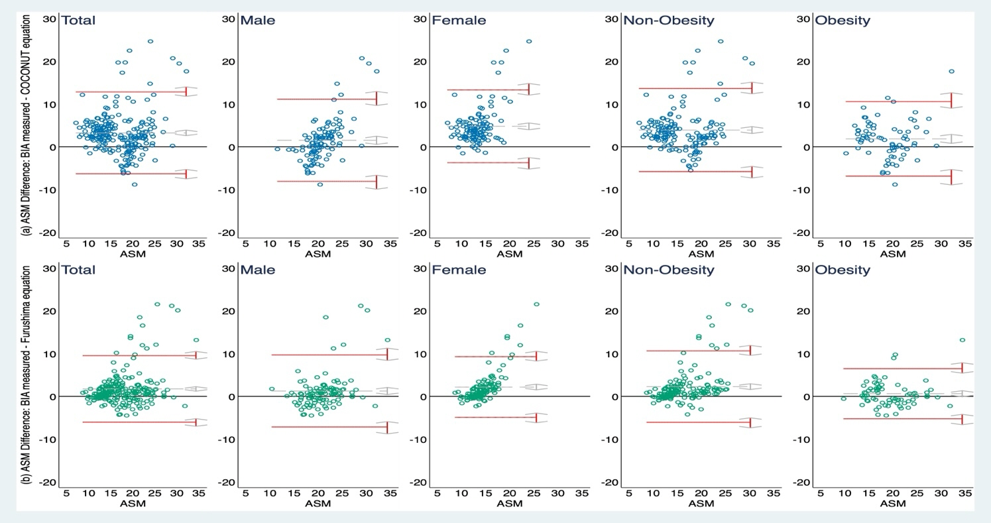
Fig S1. Bland-Altman plots of BIA-measured and equation-derived ASM by gender and obesity status among Chinese ethnic group
Difference: BIA-measured ASM minus equation-derived ASM (kg)
Upper panels (blue): COCONUT equation; lower panels (green): Furushima equation.
Table S2. Concordance and Bland-Altman agreement between BIA-measured and equation-derived ASM (kg) by BMI categories
Subgroup | BIA-measured ASM vs. COCONUT equation-derived ASM |  |  |  | BIA-measured ASM vs. Furushima equation-derived ASM
Subgroup | Lin’s CCC | Difference (Average) | 95% Limits of Agreement |  | Lin’s CCC | Difference (Average) | 95% Limits of Agreement
Total(n=295) | 0.538 | 3.030 | [-6.562, 12.623] |  | 0.696 | 1.557 | [-5.959, 9.074]
Underweight (n=32) | 0.547 | 4.170 | [-6.185, 14.524] |  | 0.368 | 3.494 | [-7.564, 14.553]
Normal weight (n=157) | 0.420 | 3.681 | [-5.957, 13.318] |  | 0.609 | 1.929 | [-5.570, 9.428]
Obese (n=106) | 0.626 | 1.723 | [-7.077, 10.523] |  | 0.862 | 0.421 | [-4.904, 5.746]
BIA: Bioelectrical Impedance Analysis; Lin’s CCC: Lin’s Concordance Correlation Coefficient
Direction of differences: Positive mean differences indicate higher BIA-measured ASM than equation-derived ASM (BIA − equation > 0).
95% Limits of Agreement was calculated by Bland-Altman approach.

Underweight participants (n = 32) demonstrated relatively higher concordance for COCONUT (CCC = 0.547) but with large mean differences and wide limits of agreement (bias 4.17 kg; LOA -6.19 to 14.52 kg), while Furushima showed particularly low concordance (CCC = 0.368; bias 3.49 kg). Normal-weight individuals exhibited low concordance for both equations. Obese participants (n = 106) showed the highest agreement, especially for the Furushima equation (CCC = 0.862; bias 0.42 kg). Results involving underweight participants should be interpreted cautiously given the small subgroup size.

Table S3. Agreement for low ASMI (AWGS 2019) classification by BMI categories
 | Observed agreement (%) | Cohen’s Kappa (κ) | AUC (95%CI)
Total(n=295)
BIA vs. COCONUT Equation | 55.25 | 0.17 | 0.62 [0.56, 0.68]
BIA vs. Furushima Equation | 76.27 | 0.48 | 0.78 [0.73, 0.84]
Underweight (n=32)
BIA vs. COCONUT Equation | 71.88 | 0.32 | 0.64 [0.49, 0.79]
BIA vs. Furushima Equation | 62.50 | 0.00 | 0.50 [0.50, 0.50]
Normal weight (n=157)
BIA vs. COCONUT Equation | 42.68 | 0.04 | 0.53 [0.46, 0.61]
BIA vs. Furushima Equation | 68.79 | 0.39 | 0.75 [0.68, 0.81]
Obese (n=106)
BIA vs. COCONUT Equation | 68.87 | 0.02 | 0.51 [0.36, 0.67]
BIA vs. Furushima Equation | 91.51 | 0.28 | 0.59 [0.46, 0.73]

For low-ASMI classification, underweight participants showed modest observed agreement but unstable κ and AUC estimates (e.g., κ = 0.32 and AUC 0.64 for COCONUT; κ = 0.00 and AUC 0.50 for Furushima), reflecting both prevalence imbalance and limited sample size. Agreement remained low to fair in the normal-weight group, whereas obese participants demonstrated the strongest performance with the Furushima equation (observed agreement 91.5%; κ = 0.28). Due to the small number of underweight individuals, subgroup findings for this category should be viewed as exploratory.

STROBE Statement—Checklist of items that should be included in reports of cross-sectional studies
 | Item No | Page No. | Recommendation
Title and abstract | 1 | 2 | (a) Indicate the study’s design with a commonly used term in the title or the abstract
Title and abstract | 1 | 2 | (b) Provide in the abstract an informative and balanced summary of what was done and what was found
Introduction
Background/rationale | 2 | 3-4 | Explain the scientific background and rationale for the investigation being reported
Objectives | 3 | 4 | State specific objectives, including any prespecified hypotheses
Methods
Study design | 4 | 4 | Present key elements of study design early in the paper
Setting | 5 | 4 | Describe the setting, locations, and relevant dates, including periods of recruitment, exposure, follow-up, and data collection
Participants | 6 | 4 | (a) Give the eligibility criteria, and the sources and methods of selection of participants
Variables | 7 | 4-5 | Clearly define all outcomes, exposures, predictors, potential confounders, and effect modifiers. Give diagnostic criteria, if applicable
Data sources/ measurement | 8* | 4-5 | For each variable of interest, give sources of data and details of methods of assessment (measurement). Describe comparability of assessment methods if there is more than one group
Bias | 9 | NA | Describe any efforts to address potential sources of bias
Study size | 10 | 4-5 | Explain how the study size was arrived at
Quantitative variables | 11 | 5-6 | Explain how quantitative variables were handled in the analyses. If applicable, describe which groupings were chosen and why
Statistical methods | 12 | 5-6 | (a) Describe all statistical methods, including those used to control for confounding
Statistical methods | 12 | 6 | (b) Describe any methods used to examine subgroups and interactions
Statistical methods | 12 | 5 | (c) Explain how missing data were addressed
Statistical methods | 12 | NA | (d) If applicable, describe analytical methods taking account of sampling strategy
Statistical methods | 12 | 6 | (e) Describe any sensitivity analyses
Results
Participants | 13* | 6 | (a) Report numbers of individuals at each stage of study—eg numbers potentially eligible, examined for eligibility, confirmed eligible, included in the study, completing follow-up, and analysed
Participants | 13* | - | (b) Give reasons for non-participation at each stage
Participants | 13* | - | (c) Consider use of a flow diagram
Descriptive data | 14* | 7 | (a) Give characteristics of study participants (eg demographic, clinical, social) and information on exposures and potential confounders
Descriptive data | 14* |  | (b) Indicate number of participants with missing data for each variable of interest
Outcome data | 15* | 7 | Report numbers of outcome events or summary measures
Main results | 16 | 8-9 | (a) Give unadjusted estimates and, if applicable, confounder-adjusted estimates and their precision (eg, 95% confidence interval). Make clear which confounders were adjusted for and why they were included
Main results | 16 | 9 | (b) Report category boundaries when continuous variables were categorized
Main results | 16 | NA | (c) If relevant, consider translating estimates of relative risk into absolute risk for a meaningful time period
Other analyses | 17 | Supplementary file | Report other analyses done—eg analyses of subgroups and interactions, and sensitivity analyses
Discussion
Key results | 18 | 10 | Summarise key results with reference to study objectives
Limitations | 19 | 12 | Discuss limitations of the study, taking into account sources of potential bias or imprecision. Discuss both direction and magnitude of any potential bias
Interpretation | 20 | 11 | Give a cautious overall interpretation of results considering objectives, limitations, multiplicity of analyses, results from similar studies, and other relevant evidence
Generalisability | 21 | 12 | Discuss the generalisability (external validity) of the study results
Other information
Funding | 22 | 13 | Give the source of funding and the role of the funders for the present study and, if applicable, for the original study on which the present article is based

*Give information separately for exposed and unexposed groups.

Note: An Explanation and Elaboration article discusses each checklist item and gives methodological background and published examples of transparent reporting. The STROBE checklist is best used in conjunction with this article (freely available on the Web sites of PLoS Medicine at http://www.plosmedicine.org/, Annals of Internal Medicine at http://www.annals.org/, and Epidemiology at http://www.epidem.com/). Information on the STROBE Initiative is available at www.strobe-statement.org.

