Supplemental Online Content

Supplemental Online Content 1
eTable 1 PRISMA Network Meta-Analysis Checklist. 2
eTable 2 Search strategy. 7
eTable 3 The definition and diagnosis of sarcopenia. 9
eTable 4 Evaluation of the inconsistency by node-splitting model for CRP. 11
eTable 5 Evaluation of the inconsistency by node-splitting model for IGF-1. 12
eTable 6 GRADE certainty rating of treatment options in all main outcomes. 13
eFigure 1 Interval plot comparing the efectiveness of the treatments on CRP. A: Nutrition; B: Control; C: Resistance; D: Resistance and aerobic; E: Combined exercise and nutrition; F: Combined exercise; G: Resistance and nutrition. 14
eFigure 2 Interval plot comparing the efectiveness of the treatments on IGF-1. A: Nutrition; B: Control; C: Resistance; D: Aerobic; E: Resistance and aerobic; F: Resistance and nutrition; G: Combined exercise and nutrition; H: Combined exercise. 15
eFigure 3 Local inconsistency test results for CRP. A: Nutrition; B: Control; C: Resistance; D: Resistance and aerobic; E: Combined exercise and nutrition; F: Combined exercise; G: Resistance and nutrition. 16
eFigure 4 Local inconsistency test results for IGF-1.A: Nutrition; B: Control; C: Resistance; D: Aerobic; E: Resistance and aerobic; F: Resistance and nutrition; G: Combined exercise and nutrition; H: Combined exercise. 17
eFigure 5 The ranking of interventions for CRP in the network meta-analysis. (A) The ranking of all the interventions; (B) The cumulative probability plots and surface under the cumulative ranking curve of each intervention. 18
eFigure 6 The ranking of interventions for IGF-1 in the network meta-analysis. (A) The ranking of all the interventions; (B) The cumulative probability plots and surface under the cumulative ranking curve of each intervention. 19
eFigure 7 Comparison-adjusted funnel plot for each outcome in this network meta-analysis for CRP. A: Nutrition; B: Control; C: Resistance; D: Resistance and aerobic; E: Combined exercise and nutrition; F: Combined exercise; G: Resistance and nutrition. 20
eFigure 8 Comparison-adjusted funnel plot for each outcome in this network meta-analysis for IGF-1. A: Nutrition; B: Control; C: Resistance; D: Aerobic; E: Resistance and aerobic; F: Resistance and nutrition; G: Combined exercise and nutrition; H: Combined exercise. 21

eTable 1 PRISMA Network Meta-Analysis Checklist.
Section/Topic | Item # | Checklist Item | Reported on Page #
TITLE
Title | 1 | Identify the report as a systematic review incorporating a network meta-analysis (or related form of meta-analysis). | √
ABSTRACT
Structured summary | 2 | Provide a structured summary including, as applicable:  Background: main objectives  Methods: data sources; study eligibility criteria, participants, and interventions; study appraisal; and synthesis methods, such as network meta-analysis.  Results: number of studies and participants identified; summary estimates with corresponding confidence/credible intervals; treatment rankings may also be discussed. Authors may choose to summarize pairwise comparisons against a chosen treatment included in their analyses for brevity.  Discussion/Conclusions: limitations; conclusions and implications of findings.  Other: primary source of funding; systematic review registration number with registry name. | √
INTRODUCTION
Rationale | 3 | Describe the rationale for the review in the context of what is already known, including mention of why a network meta-analysis has been conducted. | √
Objectives | 4 | Provide an explicit statement of questions being addressed, with reference to participants, interventions, comparisons, outcomes, and study design (PICOS). | √
METHODS
Protocol and registration | 5 | Indicate whether a review protocol exists and if and where it can be accessed (e.g., Web address); and, if available, provide registration information, including registration number. | √
Eligibility criteria | 6 | Specify study characteristics (e.g., PICOS, length of follow-up) and report characteristics (e.g., years considered, language, publication status) used as criteria for eligibility, giving rationale. Clearly describe eligible treatments included in the treatment network, and note whether any have been clustered or merged into the same node (with justification). | √
Information sources | 7 | Describe all information sources (e.g., databases with dates of coverage, contact with study authors to identify additional studies) in the search and date last searched. | √
Search | 8 | Present full electronic search strategy for at least one database, including any limits used, such that it could be repeated. | √
Study selection | 9 | State the process for selecting studies (i.e., screening, eligibility, included in systematic review, and, if applicable, included in the meta-analysis). | √
Data collection process | 10 | Describe method of data extraction from reports (e.g., piloted forms, independently, in duplicate) and any processes for obtaining and confirming data from investigators. | √
Data items | 11 | List and define all variables for which data were sought (e.g., PICOS, funding sources) and any assumptions and simplifications made. | √
Geometry of the network | S1 | Describe methods used to explore the geometry of the treatment network under study and potential biases related to it. This should include how the evidence base has been graphically summarized for presentation, and what characteristics were compiled and used to describe the evidence base to readers. | √
Risk of bias within individual studies | 12 | Describe methods used for assessing risk of bias of individual studies (including specification of whether this was done at the study or outcome level), and how this information is to be used in any data synthesis. | √
Summary measures | 13 | State the principal summary measures (e.g., risk ratio, difference in means). Also describe the use of additional summary measures assessed, such as treatment rankings and surface under the cumulative ranking curve (SUCRA) values, as well as modified approaches used to present summary findings from meta-analyses. | √
Planned methods of analysis | 14 | Describe the methods of handling data and combining results of studies for each network meta-analysis. This should include, but not be limited to:  - Handling of multi-arm trials;  - Selection of variance structure;  - Selection of prior distributions in Bayesian analyses; and  - Assessment of model fit. | √
Assessment of Inconsistency | S2 | Describe the statistical methods used to evaluate the agreement of direct and indirect evidence in the treatment network(s) studied. Describe efforts taken to address its presence when found. | √
Risk of bias across studies | 15 | Specify any assessment of risk of bias that may affect the cumulative evidence (e.g., publication bias, selective reporting within studies). | √
Additional analyses | 16 | Describe methods of additional analyses if done, indicating which were pre-specified. This may include, but not be limited to, the following:  - Sensitivity or subgroup analyses;  - Meta-regression analyses;  - Alternative formulations of the treatment network; and  - Use of alternative prior distributions for Bayesian analyses (if applicable). | √
RESULTS
Study selection | 17 | Give numbers of studies screened, assessed for eligibility, and included in the review, with reasons for exclusions at each stage, ideally with a flow diagram. | √
Presentation of network structure | S3 | Provide a network graph of the included studies to enable visualization of the geometry of the treatment network. | √
Summary of network geometry | S4 | Provide a brief overview of characteristics of the treatment network. This may include commentary on the abundance of trials and randomized patients for the different interventions and pairwise comparisons in the network, gaps of evidence in the treatment network, and potential biases reflected by the network structure. | √
Study characteristics | 18 | For each study, present characteristics for which data were extracted (e.g., study size, PICOS, follow-up period) and provide the citations. | √
Risk of bias within studies | 19 | Present data on risk of bias of each study and, if available, any outcome level assessment. | √
Results of individual studies | 20 | For all outcomes considered (benefits or harms), present, for each study: 1) simple summary data for each intervention group, and 2) effect estimates and confidence intervals. Modified approaches may be needed to deal with information from larger networks. | √
Synthesis of results | 21 | Present results of each meta-analysis done, including confidence/credible intervals. In larger networks, authors may focus on comparisons versus a particular comparator (e.g. placebo or standard care), with full findings presented in an appendix. League tables and forest plots may be considered to summarize pairwise comparisons. If additional summary measures were explored (such as treatment rankings), these should also be presented. | √
Exploration for inconsistency | S5 | Describe results from investigations of inconsistency. This may include such information as measures of model fit to compare consistency and inconsistency models, P values from statistical tests, or summary of inconsistency estimates from different parts of the treatment network. | √
Risk of bias across studies | 22 | Present results of any assessment of risk of bias across studies for the evidence base being studied. | √
Results of additional analyses | 23 | Give results of additional analyses, if done (e.g., sensitivity or subgroup analyses, meta-regression analyses, alternative network geometries studied, alternative choice of prior distributions for Bayesian analyses, and so forth). | √
DISCUSSION
Summary of evidence | 24 | Summarize the main findings, including the strength of evidence for each main outcome; consider their relevance to key groups (e.g., healthcare providers, users, and policy-makers). | √
Limitations | 25 | Discuss limitations at study and outcome level (e.g., risk of bias), and at review level (e.g., incomplete retrieval of identified research, reporting bias). Comment on the validity of the assumptions, such as transitivity and consistency. Comment on any concerns regarding network geometry (e.g., avoidance of certain comparisons). | √
Conclusions | 26 | Provide a general interpretation of the results in the context of other evidence, and implications for future research. | √
FUNDING
Funding | 27 | Describe sources of funding for the systematic review and other support (e.g., supply of data); role of funders for the systematic review. This should also include information regarding whether funding has been received from manufacturers of treatments in the network and/or whether some of the authors are content experts with professional conflicts of interest that could affect use of treatments in the network. | √

Abbreviations:
PICOS: population, intervention, comparators, outcomes, study design.

eTable 2 Search strategy.
Order | Search terms | Number
1 | "sarcopenia"[MeSH Terms] OR "sarcopenia"[All Fields] OR "sarcopenia s"[All Fields] OR "sarcopenic"[All Fields] OR ("muscular atrophy"[MeSH Terms] OR ("muscular"[All Fields] AND "atrophy"[All Fields]) OR "muscular atrophy"[All Fields]) | 50,935
2 | "exercise"[MeSH Terms] OR "exercise"[All Fields] OR "exercises"[All Fields] OR "exercise therapy"[MeSH Terms] OR ("exercise"[All Fields] AND "therapy"[All Fields]) OR "exercise therapy"[All Fields] OR "exercising"[All Fields] OR "exercise s"[All Fields] OR "exercised"[All Fields] OR "exerciser"[All Fields] OR "exercisers"[All Fields] OR ("exercise therapy"[MeSH Terms] OR ("exercise"[All Fields] AND "therapy"[All Fields]) OR "exercise therapy"[All Fields]) OR ("exercise"[MeSH Terms] OR "exercise"[All Fields] OR ("physical"[All Fields] AND "activity"[All Fields]) OR "physical activity"[All Fields]) OR ("resistance training"[MeSH Terms] OR ("resistance"[All Fields] AND "training"[All Fields]) OR "resistance training"[All Fields]) OR ("nutrition s"[All Fields] OR "nutritional status"[MeSH Terms] OR ("nutritional"[All Fields] AND "status"[All Fields]) OR "nutritional status"[All Fields] OR "nutrition"[All Fields] OR "nutritional sciences"[MeSH Terms] OR ("nutritional"[All Fields] AND "sciences"[All Fields]) OR "nutritional sciences"[All Fields] OR "nutritional"[All Fields] OR "nutritionals"[All Fields] OR "nutritions"[All Fields] OR "nutritive"[All Fields]) OR ("nutritional support"[MeSH Terms] OR ("nutritional"[All Fields] AND "support"[All Fields]) OR "nutritional support"[All Fields] OR ("nutrition"[All Fields] AND "therapy"[All Fields]) OR "nutrition therapy"[All Fields] OR "nutrition therapy"[MeSH Terms]) OR ("dietary supplements"[MeSH Terms] OR ("dietary"[All Fields] AND "supplements"[All Fields]) OR "dietary supplements"[All Fields] OR ("dietary"[All Fields] AND "supplement"[All Fields]) OR "dietary supplement"[All Fields]) OR ("dietary proteins"[MeSH Terms] OR ("dietary"[All Fields] AND "proteins"[All Fields]) OR "dietary proteins"[All Fields] OR ("dietary"[All Fields] AND "protein"[All Fields]) OR "dietary protein"[All Fields]) OR ("supplemental"[All Fields] OR "supplementating"[All Fields] OR "supplementation"[All Fields] OR "supplementation s"[All Fields] OR "supplementations"[All Fields] OR "supplemention"[All Fields]) | 1,983,170
3 | "randomized controlled trial"[Publication Type] OR "randomized controlled trials as topic"[MeSH Terms] OR "randomized controlled trial"[All Fields] OR "randomised controlled trial"[All Fields] OR ("random allocation"[MeSH Terms] OR ("random"[All Fields] AND "allocation"[All Fields]) OR "random allocation"[All Fields] OR "randomization"[All Fields] OR "randomized"[All Fields] OR "random"[All Fields] OR "randomisation"[All Fields] OR "randomisations"[All Fields] OR "randomise"[All Fields] OR "randomised"[All Fields] OR "randomising"[All Fields] OR "randomizations"[All Fields] OR "randomize"[All Fields] OR "randomizes"[All Fields] OR "randomizing"[All Fields] OR "randomness"[All Fields] OR "randoms"[All Fields]) OR ("placeboes"[All Fields] OR "placebos"[MeSH Terms] OR "placebos"[All Fields] OR "placebo"[All Fields]) | 1,713,873
4 | 1 AND 2 AND 3 | 1,995

eTable 3 The definition and diagnosis of sarcopenia.
Definition | Year | Diagnosis | Cut-off points | Classification
EWGSOP | 2010 | Grip strength  Gait speed  Muscle mass | M < 30 kg, F < 20 kg;  < 0.8 m/s;  SMI: M < 8.87 kg/m², F < 6.42 kg/m² | Sarcopenia: low muscle mass plus low grip strength or slow gait speed  Severe sarcopenia: low muscle mass plus low grip strength and slow gait speed
EWGSOP2 | 2019 | Grip strength  Gait speed  Muscle mass | M < 27 kg, F < 16 kg;  < 0.8 m/s;  ASMI: M < 7.0 kg/m², F < 5.5 kg/m² | Sarcopenia: low grip strength and a low muscle mass  Severe sarcopenia: low grip strength and a low muscle mass + low gait speed
AWGS | 2014 | Handgrip strength  Gait speed  Muscle mass | M < 26 kg, F < 18 kg;  < 0.8 m/s;  DXA: M < 7.0 kg/m², F < 5.4 kg/m²  or BIA: M < 7.0 kg/m², F < 5.7 kg/m² | Sarcopenia: Low handgrip strength and/or low gait speed + muscle mass
AWGS2019 | 2019 | Handgrip strength  Physical performance  Muscle mass | M < 28 kg, F < 18 kg;  6-metre walk < 1.0 m/s;  or 5-m chair stand test ≥ 12 s;  or SPPB ≤ 9;  DXA: M < 7.0 kg/m², F < 5.4 kg/m²  or BIA: M < 7.0 kg/m², F < 5.7 kg/m² | Possible sarcopenia: Handgrip strength or Physical performance  Sarcopenia: Low muscle mass + low handgrip strength OR Low physical performance  Severe sarcopenia: Low muscle mass + low handgrip strength AND Low physical performance
IWGS | 2011 | Handgrip strength  Gait speed  Muscle mass | -  < 1.0 m/s  DXA: M < 7.23 kg/m², F < 5.67 kg/m² | Sarcopenia: Low muscle mass + Low physical performance
FNIH | 2014 | Handgrip strength  Lean mass | M < 26 kg, F < 16 kg  Appendicular lean mass adjusted for BMI: M < 0.789, F < 0.512 | Sarcopenia: Low lean mass + low handgrip strength
Abbreviations:
EWGSOP: The European Working Group on Sarcopenia in Older People; AWGS: The Asian Working Group for Sarcopenia; IWGS: International Working Group on Sarcopenia; FNIH: Foundation for the National Institute of Health; SMI: skeletal muscle mass index; ASMI: Appendicular skeletal muscle mass index; BIA: Bioelectrical impedance analysis; DXA: Dual-energy X-ray absorpometry; BMI: body mass index; M: male; F: female.

Comparisons | Direct |  | Indirect |  | Difference |  |  | ι²
Comparisons | SMD | SE | SMD | SE | SMD | SE | p | ι²
A vs. B | 0.38 | 0.32 | 3.01 | 1.23 | -2.62 | 1.27 | 0.53 | 0.88
A vs. C | 0.13 | 1.05 | 0.68 | 0.88 | -0.55 | 1.37 | 0.68 | 1.03
A vs. E | 0.13 | 0.75 | 0.01 | 0.99 | 0.12 | 1.24 | 0.92 | 1.04
A vs. F | -0.18 | 0.93 | -3.22 | 1.03 | 3.04 | 1.38 | 0.30 | 0.89
A vs. G | 0.51 | 1.06 | 0.40 | 0.78 | 0.11 | 1.32 | 0.93 | 1.03
B vs. C | -0.01 | 0.76 | -0.33 | 1.12 | 0.32 | 1.35 | 0.81 | 1.03
B vs. D | 0.19 | 0.72 | -1.13 | 44.74 | 1.33 | 44.74 | 0.97 | 0.98
B vs. E | -0.07 | 0.53 | -2.73 | 1.29 | 2.66 | 1.39 | 0.06 | 0.90
B vs. F | -2.54 | 0.83 | -1.06 | 1.69 | -1.47 | 1.88 | 0.43 | 1.02
B vs. G | -0.02 | 0.63 | -0.52 | 1.21 | 0.49 | 1.36 | 0.72 | 1.03
C vs. G | 0.06 | 0.76 | -0.24 | 1.31 | 0.31 | 1.52 | 0.83 | 1.03
E vs. F | -0.02 | 0.79 | -4.24 | 1.09 | 4.21 | 1.35 | 0.32 | 0.76

eTable 4 Evaluation of the inconsistency by node-splitting model for CRP.
Abbreviations:
A: Nutrition; B: Control; C: Resistance; D: Resistance and aerobic; E: Combined exercise and nutrition; F: Combined exercise; G: Resistance and nutrition.

Comparisons | Direct |  | Indirect |  | Difference |  |  | ι²
Comparisons | SMD | SE | SMD | SE | SMD | SE | p | ι²
A vs. B | -0.41 | 0.22 | -0.98 | 0.83 | 0.57 | 0.86 | 0.51 | 0.43
A vs. C | -0.21 | 0.51 | -0.19 | 0.41 | -0.01 | 0.66 | 0.98 | 0.45
A vs. F | -3.4 | 0.49 | -0.98 | 0.90 | 0.64 | 1.03 | 0.53 | 0.43
A vs. G | 0.35 | 0.57 | -0.19 | 0.51 | 0.55 | 0.77 | 0.47 | 0.44
A vs. H | 0.39 | 0.53 | -1.01 | 0.94 | 1.41 | 1.09 | 0.19 | 0.40
B vs. C | 0.20 | 0.26 | 0.84 | 0.99 | -0.64 | 1.03 | 0.53 | 0.43
B vs. D | 0.21 | 0.55 | -0.95 | 1.11 | 1.16 | 1.25 | 0.35 | 0.42
B vs. E | 0.65 | 0.55 | -0.51 | 1.11 | 1.16 | 1.25 | 0.35 | 0.42
B vs. F | -0.34 | 0.44 | 0.75 | 0.73 | -1.11 | 0.86 | 0.19 | 0.38
B vs. G | 0.36 | 0.34 | 1.77 | 1.04 | -1.41 | 1.09 | 0.19 | 0.40
B vs. H | 0.11 | 0.51 | 1.53 | 0.86 | -1.42 | 1.02 | 0.16 | 0.38
C vs. D | -0.50 | 0.55 | 0.65 | 1.11 | -1.16 | 1.25 | 0.35 | 0.42
C vs. E | -0.06 | 0.55 | 1.09 | 1.11 | -1.16 | 1.25 | 0.35 | 0.42
C vs. F | -0.13 | 0.49 | -0.88 | 0.96 | 0.75 | 1.08 | 0.48 | 0.43
G vs. H | 0.03 | 0.57 | -0.21 | 1.29 | 0.25 | 1.42 | 0.86 | 0.45

eTable 5 Evaluation of the inconsistency by node-splitting model for IGF-1.
Abbreviations:
A: Nutrition; B: Control; C: Resistance; D: Aerobic; E: Resistance and aerobic; F: Resistance and nutrition; G: Combined exercise and nutrition; H: Combined exercise.

eTable 6 GRADE certainty rating of treatment options in all main outcomes.
Interventions | CRP | IGF-1
Combined exercise | ⊕⊕⊝⊝^{b,d} | ⊕⊕⊕⊝^{d}
Nutrition | ⊕⊕⊕⊝^{b} | ⊕⊕⊝⊝^{b,d}
Combined exercise and nutrition | ⊕⊕⊕⊝^{b} | ⊕⊕⊝⊝^{c,d}
Resistance | ⊕⊕⊝⊝^{b,c} | ⊕⊕⊝⊝^{b,d}
Aerobic | - | ⊕⊕⊕⊝^{d}
Resistance and nutrition | ⊕⊕⊝⊝^{b,d} | ⊕⊕⊝⊝^{b,d}
Resistance and aerobic | ⊕⊕⊕⊝^{c} | ⊕⊕⊕⊝^{d}
Abbreviations:
ª Certainty of evidence is graded as follows: High: ⊕⊕⊕⊕; Moderate: ⊕⊕⊕⊝; Low: ⊕⊕⊝⊝; and Very low: ⊕⊝⊝⊝;
^{b} Network contribution of high risk of bias ≥ 50%;
^{c} There is significant difference between direct and indirect estimates;
^{d} 95% confidence interval is wide and imprecise;
^{e} Test for publication bias is statistically significant;
GRADE: Grading of Recommendations, Assessment, Development and Evaluations.

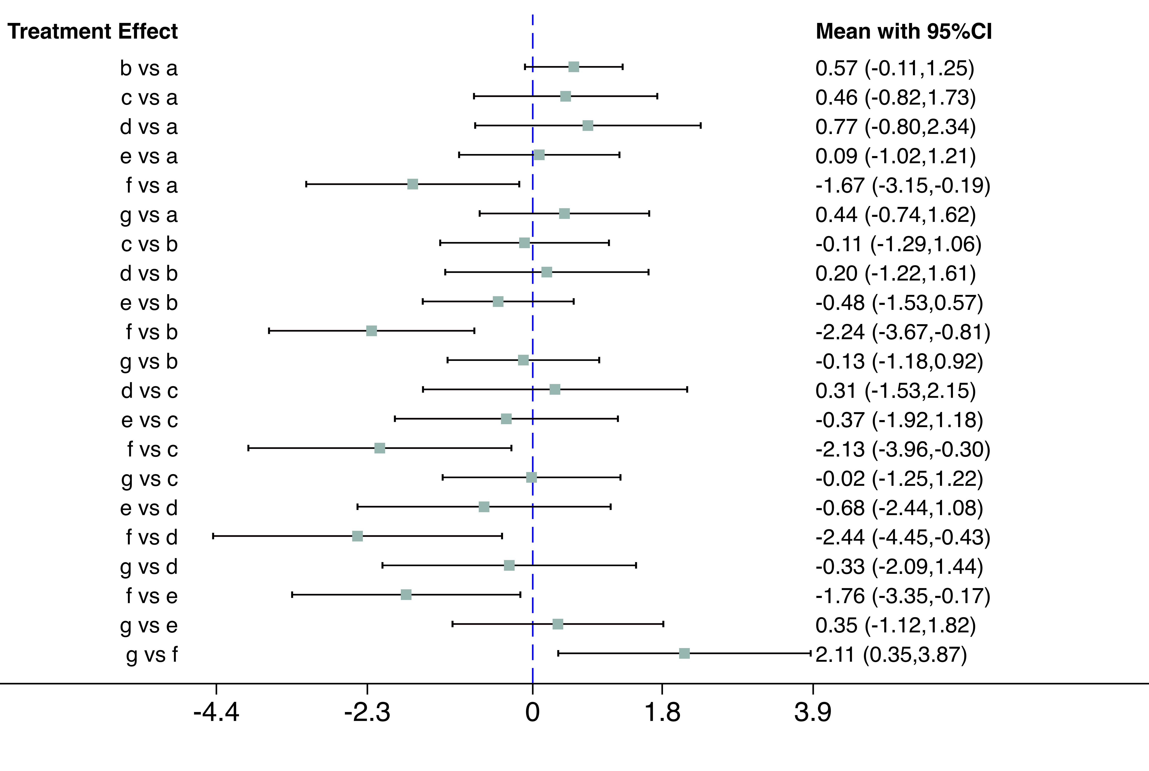

eFigure 1 Interval plot comparing the efectiveness of the treatments on CRP. A: Nutrition; B: Control; C: Resistance; D: Resistance and aerobic; E: Combined exercise and nutrition; F: Combined exercise; G: Resistance and nutrition.

eFigure 2 Interval plot comparing the efectiveness of the treatments on IGF-1. A: Nutrition; B: Control; C: Resistance; D: Aerobic; E: Resistance and aerobic; F: Resistance and nutrition; G: Combined exercise and nutrition; H: Combined exercise.

eFigure 3 Local inconsistency test results for CRP. A: Nutrition; B: Control; C: Resistance; D: Resistance and aerobic; E: Combined exercise and nutrition; F: Combined exercise; G: Resistance and nutrition.

eFigure 4 Local inconsistency test results for IGF-1.A: Nutrition; B: Control; C: Resistance; D: Aerobic; E: Resistance and aerobic; F: Resistance and nutrition; G: Combined exercise and nutrition; H: Combined exercise.

A
Treatment | SUCRA | PrBest | MeanRank
Nutrition | 64.9 | 0.7 | 3.1
Control | 27.9 | 0.0 | 5.3
Resistance | 37.6 | 1.0 | 4.7
Resistance and aerobic | 25.9 | 0.8 | 5.4
Combined exercise and nutrition | 56.0 | 0.9 | 3.6
Combined exercise | 99.0 | 95.9 | 1.1
Resistance and nutrition | 38.6 | 0.6 | 4.7

B
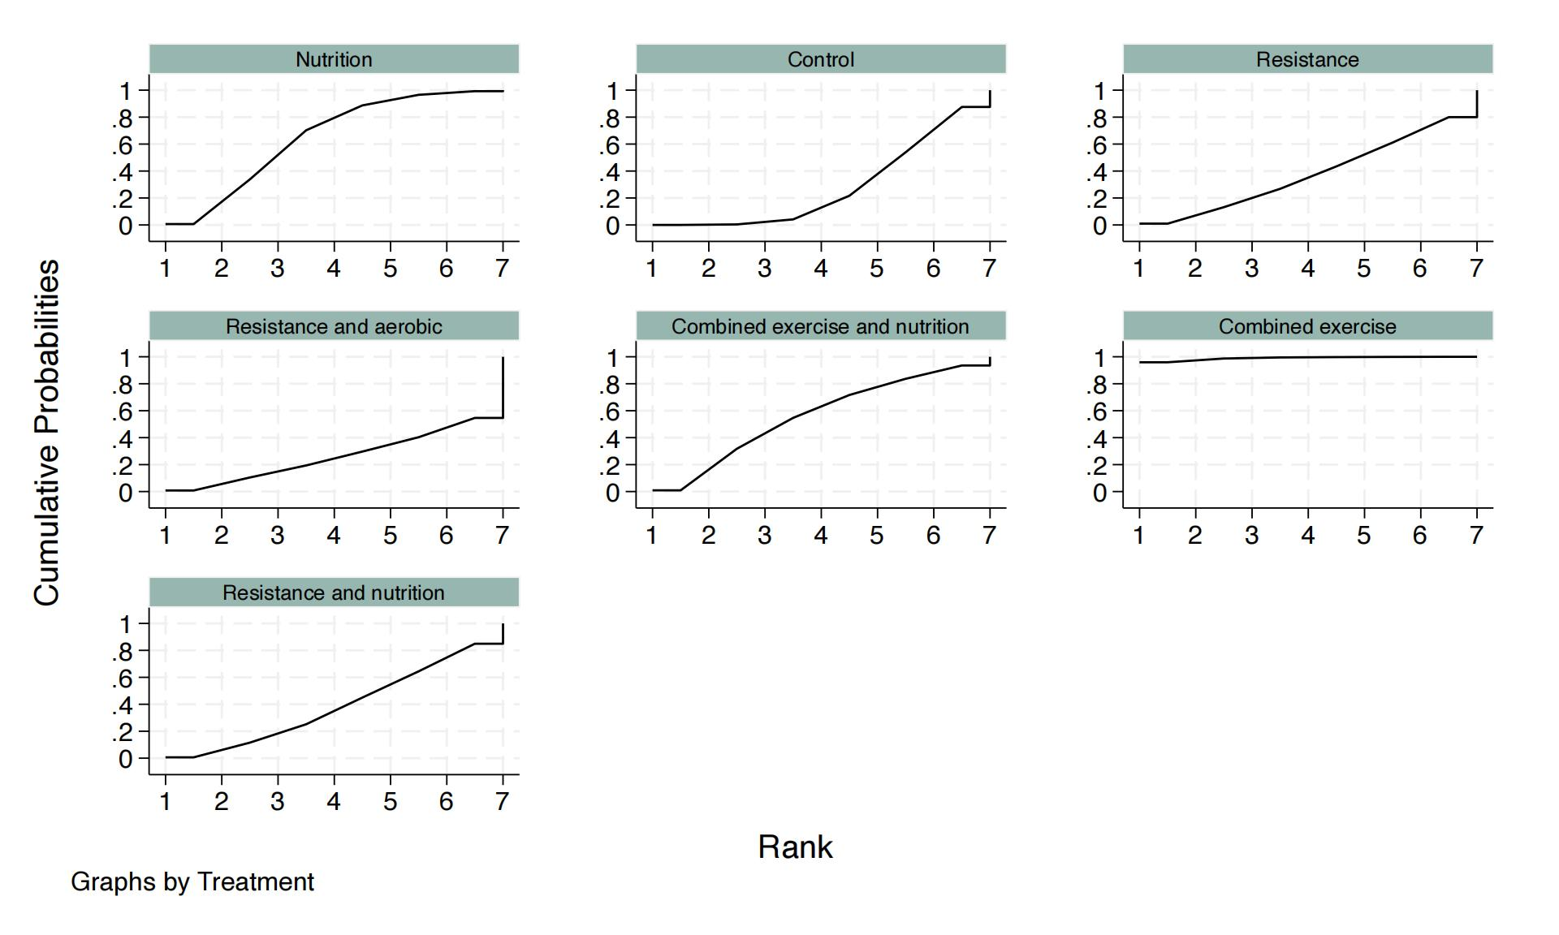

eFigure 5 The ranking of interventions for CRP in the network meta-analysis. (A) The ranking of all the interventions; (B) The cumulative probability plots and surface under the cumulative ranking curve of each intervention.

A
Treatment | SUCRA | PrBest | MeanRank
Nutrition | 71.6 | 24.0 | 3.0
Control | 23.4 | 0.0 | 6.4
Resistance | 49.9 | 3.5 | 4.5
Aerobic | 30.2 | 4.5 | 5.9
Resistance and aerobic | 61.9 | 25.1 | 3.7
Resistance and nutrition | 26.6 | 2.5 | 6.1
Combined exercise and nutrition | 69.3 | 11.9 | 3.1
Combined exercise | 67.0 | 28.4 | 3.3

B
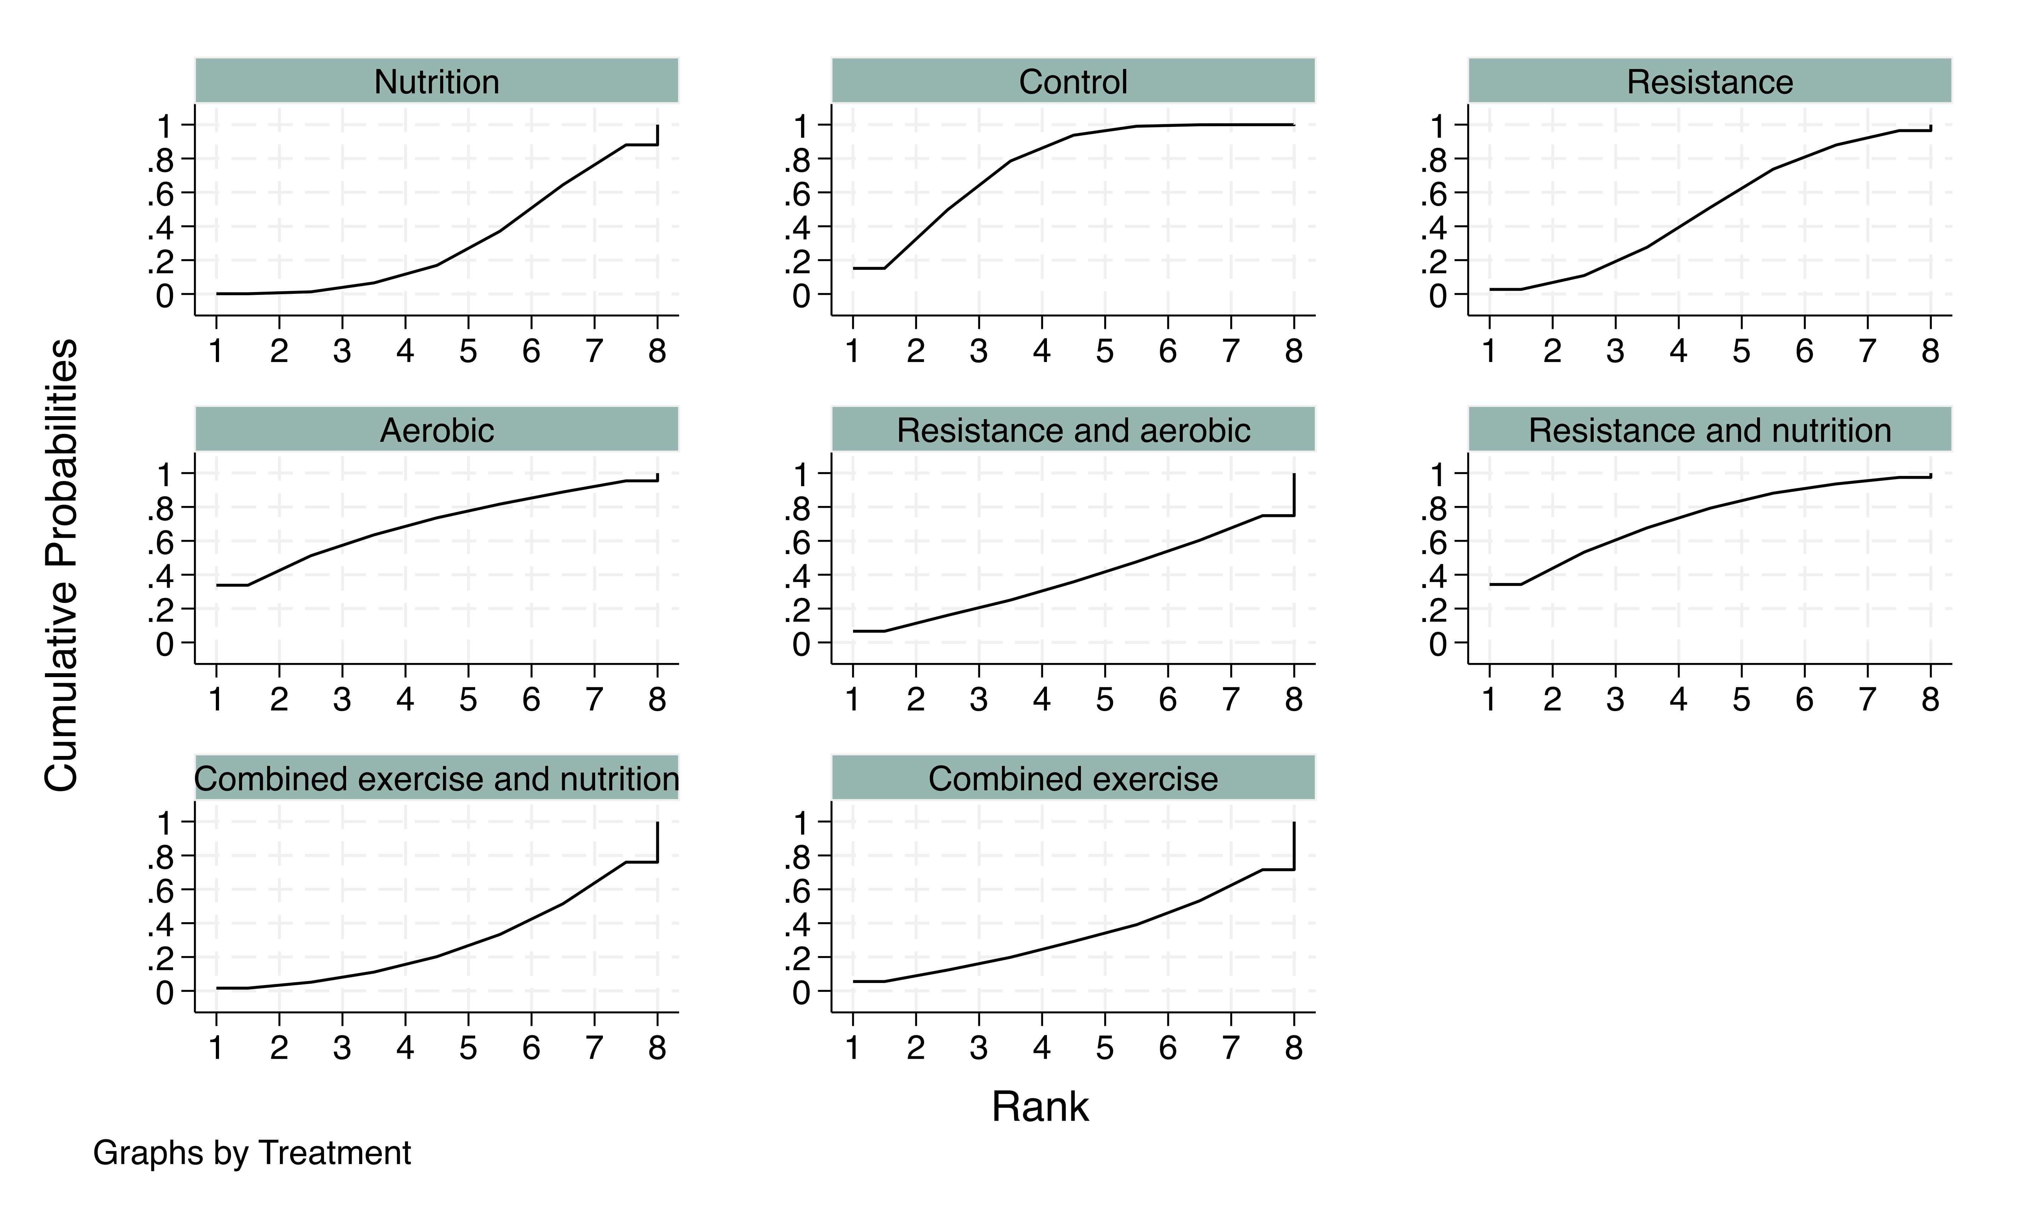

eFigure 6 The ranking of interventions for IGF-1 in the network meta-analysis. (A) The ranking of all the interventions; (B) The cumulative probability plots and surface under the cumulative ranking curve of each intervention.

eFigure 7 Comparison-adjusted funnel plot for each outcome in this network meta-analysis for CRP. A: Nutrition; B: Control; C: Resistance; D: Resistance and aerobic; E: Combined exercise and nutrition; F: Combined exercise; G: Resistance and nutrition.

eFigure 8 Comparison-adjusted funnel plot for each outcome in this network meta-analysis for IGF-1. A: Nutrition; B: Control; C: Resistance; D: Aerobic; E: Resistance and aerobic; F: Resistance and nutrition; G: Combined exercise and nutrition; H: Combined exercise.

