Supplementary File 4. Risk of bias
Effects of Task-Oriented Training on Balance, Gait, and Fall in Older Adults: A Systematic Review and Meta-Analysis
Wenping Zhang ª, Wenjing Zhang ^{c}, Guoxiu Zu ^{d}, Mingyang Yao ^{b}, Jiawei Li ^{b}, Yifei Jin ª , Liduan Wang ^{a*},JiqinTang ^{b*}

ª School of Rehabilitation Medicine
Shandong Second Medical University
Weifang, China
^{b} School of Rehabilitation Medicine
Shandong University of Traditional Chinese Medicine
Jinan, China

^{c} Department of Neurology
Yiyuan County Traditional Chinese Medicine Hospital
Zibo, China

^{d} Department of Traditional Chinese Medicine
Shandong University of Traditional Chinese Medicine
Jinan, China.

Corresponding Author: JiqinTang
School of Rehabilitation Medicine
Shandong University of Traditional Chinese Medicine
Jinan, China, 250355
Email: tangjiqin0312@163.com

Liduan Wang, PhD
School of Rehabilitation Medicine
Shandong Second Medical University
Weifang, China, 261053
Email: wangliduan@sdsmu.edu.cn

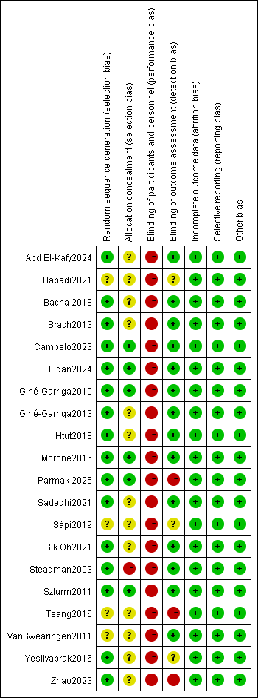
(a)

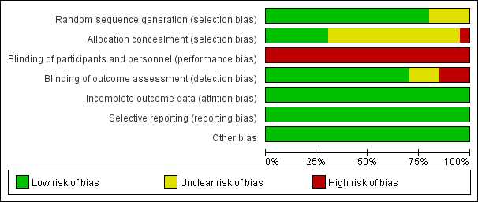
(b)

Fig. 1 Risk of bias in the included studies. (a) risk of bias in the individual studies; (b) risk of bias summary

