Supplementary Data

Supplement to: Trajectory of frailty among the older people in a community setting: a cohort study from the Shizuoka Kokuho Database

Table of contents
Supplementary Figure 1. Flow diagram of the enrolment of the study cohort
Supplementary Table 1. List of deficits included in the electronic Frailty Index (eFI)
Supplementary Figure 2. Timeline of the 12-month look-back period and frailty assessment periods
Supplementary Figure 3. Distribution of electronic Frailty Index (eFI) scores at each assessment time point
Supplementary Table 2. Baseline characteristics among individuals aged ≥85 years
Supplementary Figure 4. Crude frailty transitions over 6 years
Supplementary Table 3. Cumulative numbers of deaths and loss to follow-up by baseline frailty status and assessment year
Supplementary Table 4. Weight diagnostics for IPCW used in Sankey diagrams
Supplementary Figure 5A. IPC-weighted frailty transitions in women
Supplementary Figure 5B. IPC-weighted frailty transitions in men
Supplementary Figure 6A. IPC-weighted frailty transitions by baseline frailty status in women
Supplementary Figure 6B. IPC-weighted frailty transitions by baseline frailty status in men

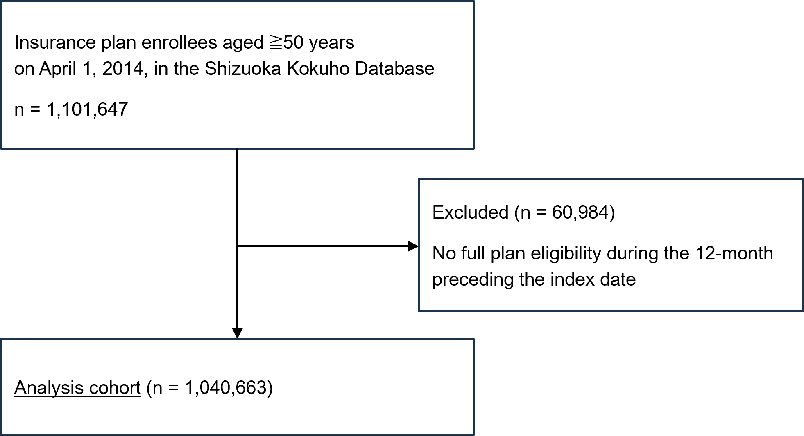Supplementary Figure 1. Flow diagram of the enrolment of the study cohort

Supplementary Table 1. List of deficits included in the electronic Frailty Index (eFI)
Deficits
Activity limitation | Ischaemic heart disease
Anaemia and haematinic deficiency | Memory and cognitive problems
Arthritis | Mobility and transfer problems
Atrial fibrillation | Osteoporosis
Cerebrovascular disease | Parkinsonism and tremor
Chronic kidney disease | Peptic ulcer
Diabetes | Peripheral vascular disease
Dizziness | Polypharmacy
Dyspnoea | Requirement for care
Falls | Respiratory disease
Foot problems | Skin ulcer
Fragility fracture | Sleep disturbance
Hearing impairment | Social vulnerability
Heart failure | Thyroid disease
Heart valve disease | Urinary incontinence
Housebound | Urinary system disease
Hypertension | Visual impairment
Hypotension/syncope | Weight loss and anorexia

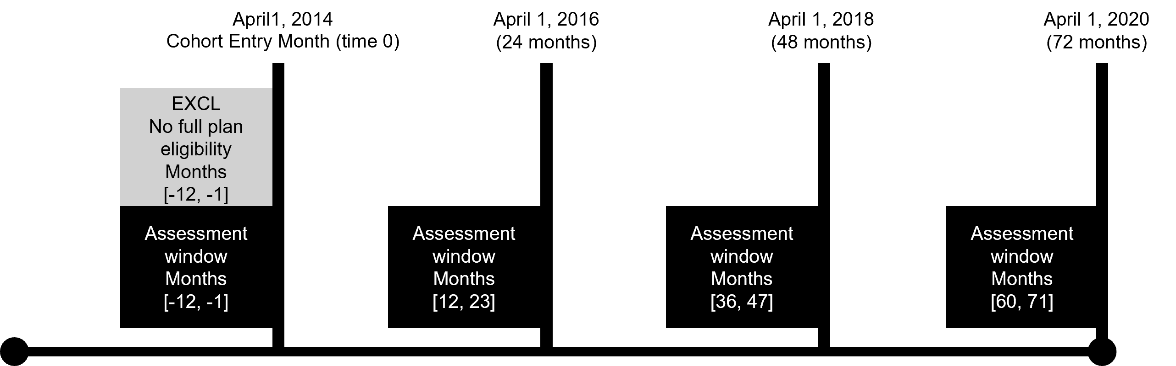
Supplementary Figure 2. Timeline of the 12-month look-back period and frailty assessment periods

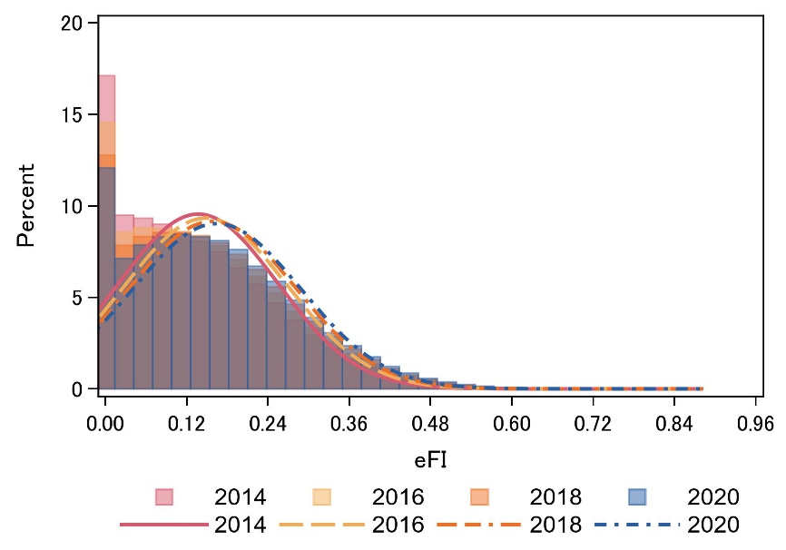
Supplementary Figure 3. Distribution of electronic Frailty Index (eFI) scores at each assessment time point

Supplementary Table 2. Baseline characteristics among individuals aged ≥85 years
Characteristics |  |  | Frailty category
 | Total, n (%) |  | Fit, n (%) |  | Mild frailty, n (%) |  | Moderate frailty, n (%) |  | Severe frailty, n (%)
 | 156,019 | (100) | 41,867 | (100) | 54,618 | (100) | 40,673 | (100) | 18,861 | (100)
Women, n (%) | 107,624 | (69.0) | 28,052 | (67.0) | 37,579 | (68.8) | 28,514 | (70.1) | 13,273 | (70.4)
Deficits in the electronic Frailty Index, n (%)
Activity limitation | 16,136 | (1.3) | 668 | (0.6) | 3,471 | (0.9) | 5,617 | (1.2) | 6,380 | (2.1)
Anaemia and haematinic deficiency | 39,385 | (3.2) | 3,096 | (3.0) | 11,807 | (3.0) | 14,292 | (3.2) | 10,190 | (3.4)
Arthritis | 56,787 | (4.5) | 5,382 | (5.1) | 18,908 | (4.8) | 20,531 | (4.5) | 11,966 | (4.0)
Atrial fibrillation | 34,643 | (2.8) | 2,207 | (2.1) | 9,876 | (2.5) | 13,104 | (2.9) | 9,456 | (3.2)
Cerebrovascular disease | 59,691 | (4.8) | 5,360 | (5.1) | 19,082 | (4.9) | 21,719 | (4.8) | 13,530 | (4.5)
Chronic kidney disease | 15,162 | (1.2) | 829 | (0.8) | 3,731 | (0.9) | 5,594 | (1.2) | 5,008 | (1.7)
Diabetes | 70,645 | (5.7) | 8,162 | (7.8) | 24,425 | (6.2) | 24,143 | (5.3) | 13,915 | (4.7)
Dizziness | 38,419 | (3.1) | 1,347 | (1.3) | 9,061 | (2.3) | 15,705 | (3.5) | 12,306 | (4.1)
Dyspnoea | 2,427 | (0.2) | 105 | (0.1) | 412 | (0.1) | 897 | (0.2) | 1,013 | (0.3)
Foot problems | 14,510 | (1.2) | 1,179 | (1.1) | 4,361 | (1.1) | 5,162 | (1.1) | 3,808 | (1.3)
Fragility fracture | 25,221 | (2.0) | 2,549 | (2.4) | 7,255 | (1.8) | 8,885 | (2.0) | 6,532 | (2.2)
Hearing impairment | 15,142 | (1.2) | 1,509 | (1.4) | 4,215 | (1.1) | 5,499 | (1.2) | 3,919 | (1.3)
Heart failure | 61,018 | (4.9) | 4,359 | (4.2) | 18,901 | (4.8) | 23,204 | (5.1) | 14,554 | (4.9)
Heart valve disease | 15,819 | (1.3) | 616 | (0.6) | 3,615 | (0.9) | 6,082 | (1.3) | 5,506 | (1.8)
Housebound | 2,662 | (0.2) | 75 | (0.1) | 417 | (0.1) | 907 | (0.2) | 1,263 | (0.4)
Hypertension | 111,491 | (8.9) | 15,763 | (15.1) | 42,605 | (10.8) | 35,553 | (7.9) | 17,570 | (5.9)
Hypotension/syncope | 34,506 | (2.8) | 1,081 | (1.0) | 7,674 | (2.0) | 14,132 | (3.1) | 11,619 | (3.9)
Ischaemic heart disease | 45,254 | (3.6) | 2,601 | (2.5) | 13,236 | (3.4) | 17,577 | (3.9) | 11,840 | (4.0)
Memory and cognitive problems | 46,478 | (3.7) | 5,930 | (5.7) | 15,121 | (3.8) | 15,382 | (3.4) | 10,045 | (3.4)
Mobility and transfer problems | 16,136 | (1.3) | 668 | (0.6) | 3,471 | (0.9) | 5,617 | (1.2) | 6,380 | (2.1)
Osteoporosis | 48,681 | (3.9) | 4,105 | (3.9) | 15,842 | (4.0) | 17,770 | (3.9) | 10,964 | (3.7)
Parkinsonism and tremor | 11,228 | (0.9) | 606 | (0.6) | 2,976 | (0.8) | 4,272 | (0.9) | 3,374 | (1.1)
Peptic ulcer | 91,851 | (7.3) | 8,051 | (7.7) | 33,201 | (8.4) | 33,281 | (7.3) | 17,318 | (5.8)
Peripheral vascular disease | 30,414 | (2.4) | 1,512 | (1.4) | 8,084 | (2.1) | 11,855 | (2.6) | 8,963 | (3.0)
Polypharmacy | 94,477 | (7.6) | 5,267 | (5.0) | 36,066 | (9.2) | 35,373 | (7.8) | 17,771 | (5.9)
Requirement for care | 2,662 | (0.2) | 75 | (0.1) | 417 | (0.1) | 907 | (0.2) | 1,263 | (0.4)
Respiratory disease | 64,101 | (5.1) | 6,770 | (6.5) | 20,931 | (5.3) | 22,630 | (5.0) | 13,770 | (4.6)
Skin ulcer | 17,345 | (1.4) | 1,528 | (1.5) | 4,860 | (1.2) | 6,076 | (1.3) | 4,881 | (1.6)
Sleep disturbance | 49,802 | (4.0) | 3,106 | (3.0) | 15,751 | (4.0) | 18,965 | (4.2) | 11,980 | (4.0)
Social vulnerability | 245 | (0.0) | 18 | (0.0) | 75 | (0.0) | 74 | (0.0) | 78 | (0.0)
Thyroid disease | 15,827 | (1.3) | 1,100 | (1.1) | 4,102 | (1.0) | 5,738 | (1.3) | 4,887 | (1.6)
Urinary incontinence | 9,911 | (0.8) | 554 | (0.5) | 2,440 | (0.6) | 3,680 | (0.8) | 3,237 | (1.1)
Urinary system disease | 27,672 | (2.2) | 2,243 | (2.1) | 7,691 | (2.0) | 9,947 | (2.2) | 7,791 | (2.6)
Visual impairment | 42,151 | (3.4) | 5,205 | (5.0) | 14,009 | (3.6) | 14,578 | (3.2) | 8,359 | (2.8)
Weight loss and anorexia | 21,979 | (1.8) | 1,045 | (1.0) | 5,032 | (1.3) | 8,134 | (1.8) | 7,768 | (2.6)

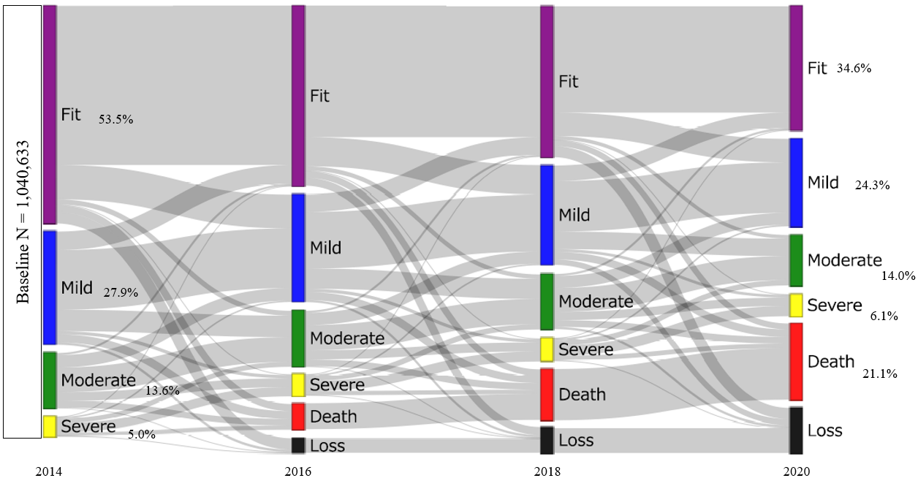
Supplementary Figure 4. Crude frailty transitions over 6 years

Supplementary Table 3. Cumulative numbers of deaths and loss to follow-up by baseline frailty status and assessment year
 |  | Cumulative number of deaths |  | Cumulative number of participants lost to follow-up
 |  | N | (%) | N | (%)
2016 | All | 66,108 |  | 37,622
 | Fit | 18,214 | (27.6) | 28,755 | (76.4)
 | Mild | 20,579 | (31.1) | 6,069 | (16.1)
 | Moderate | 16,759 | (25.4) | 2,120 | (5.6)
 | Severe | 10,556 | (16.0) | 678 | (1.8)
2018 | All | 131,643 |  | 66,137
 | Fit | 39,084 | (29.7) | 50,174 | (75.9)
 | Mild | 42,157 | (32.0) | 11,124 | (16.8)
 | Moderate | 32,241 | (24.5) | 3,736 | (5.6)
 | Severe | 18,161 | (13.8) | 1,103 | (1.7)
2020 | All | 195,018 |  | 116,224
 | Fit | 60,270 | (30.9) | 84,064 | (72.3)
 | Mild | 63,427 | (32.5) | 23,021 | (19.8)
 | Moderate | 46,647 | (23.9) | 7,286 | (6.3)
 | Severe | 24,674 | (12.7) | 1,853 | (1.6)

Supplementary Table 4. Weight diagnostics for IPCW used in Sankey diagrams
Stage | N used in Sankey | Sum of weights | Mean | SD | Min | Median | Max
2014 | 1,003,041 | 1,003,056.0 | 1 | 0.008 | 0.967 | 1.002 | 1.0083
2016 | 1,003,041 | 1,003,056.0 | 1 | 0.008 | 0.967 | 1.002 | 1.0083
2018 | 908,418 | 908,478.0 | 1 | 0.008 | 0.963 | 1.001 | 1.0101
2020 | 792,796 | 792,887.0 | 1 | 0.008 | 0.962 | 1.001 | 1.0126

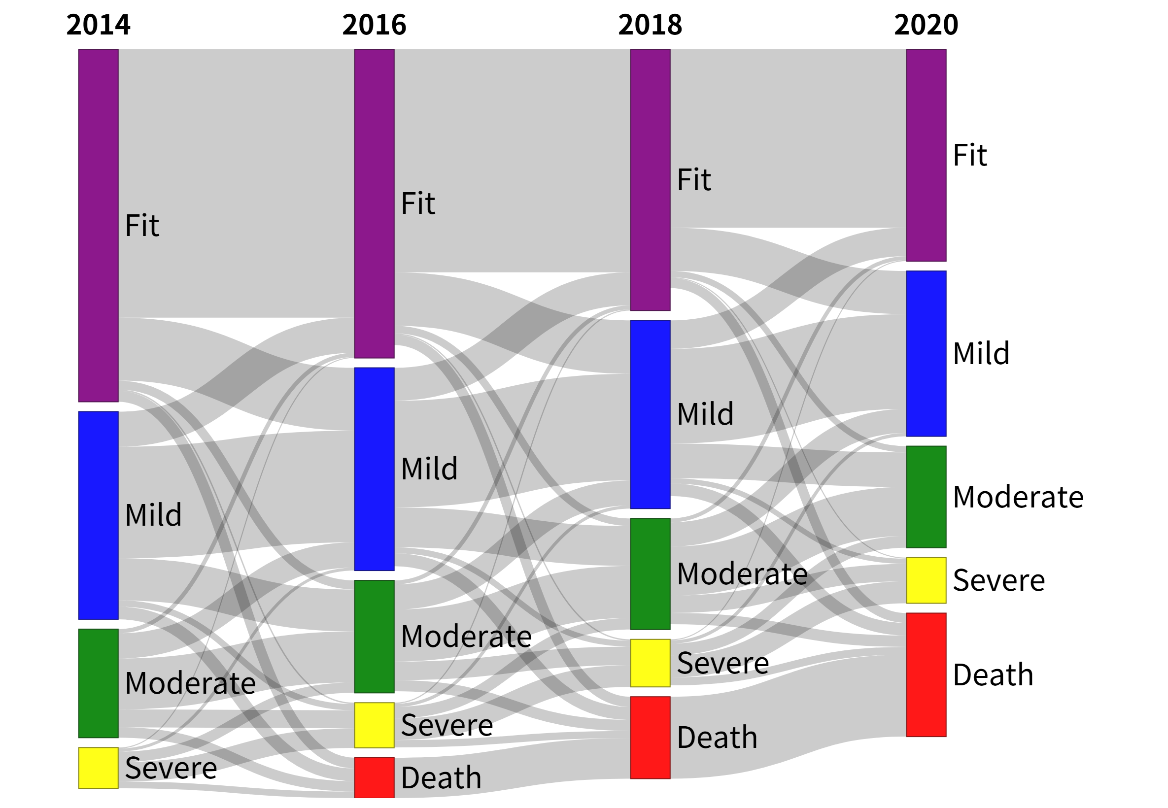
Supplementary Figure 5A. IPC-weighted frailty transitions in women
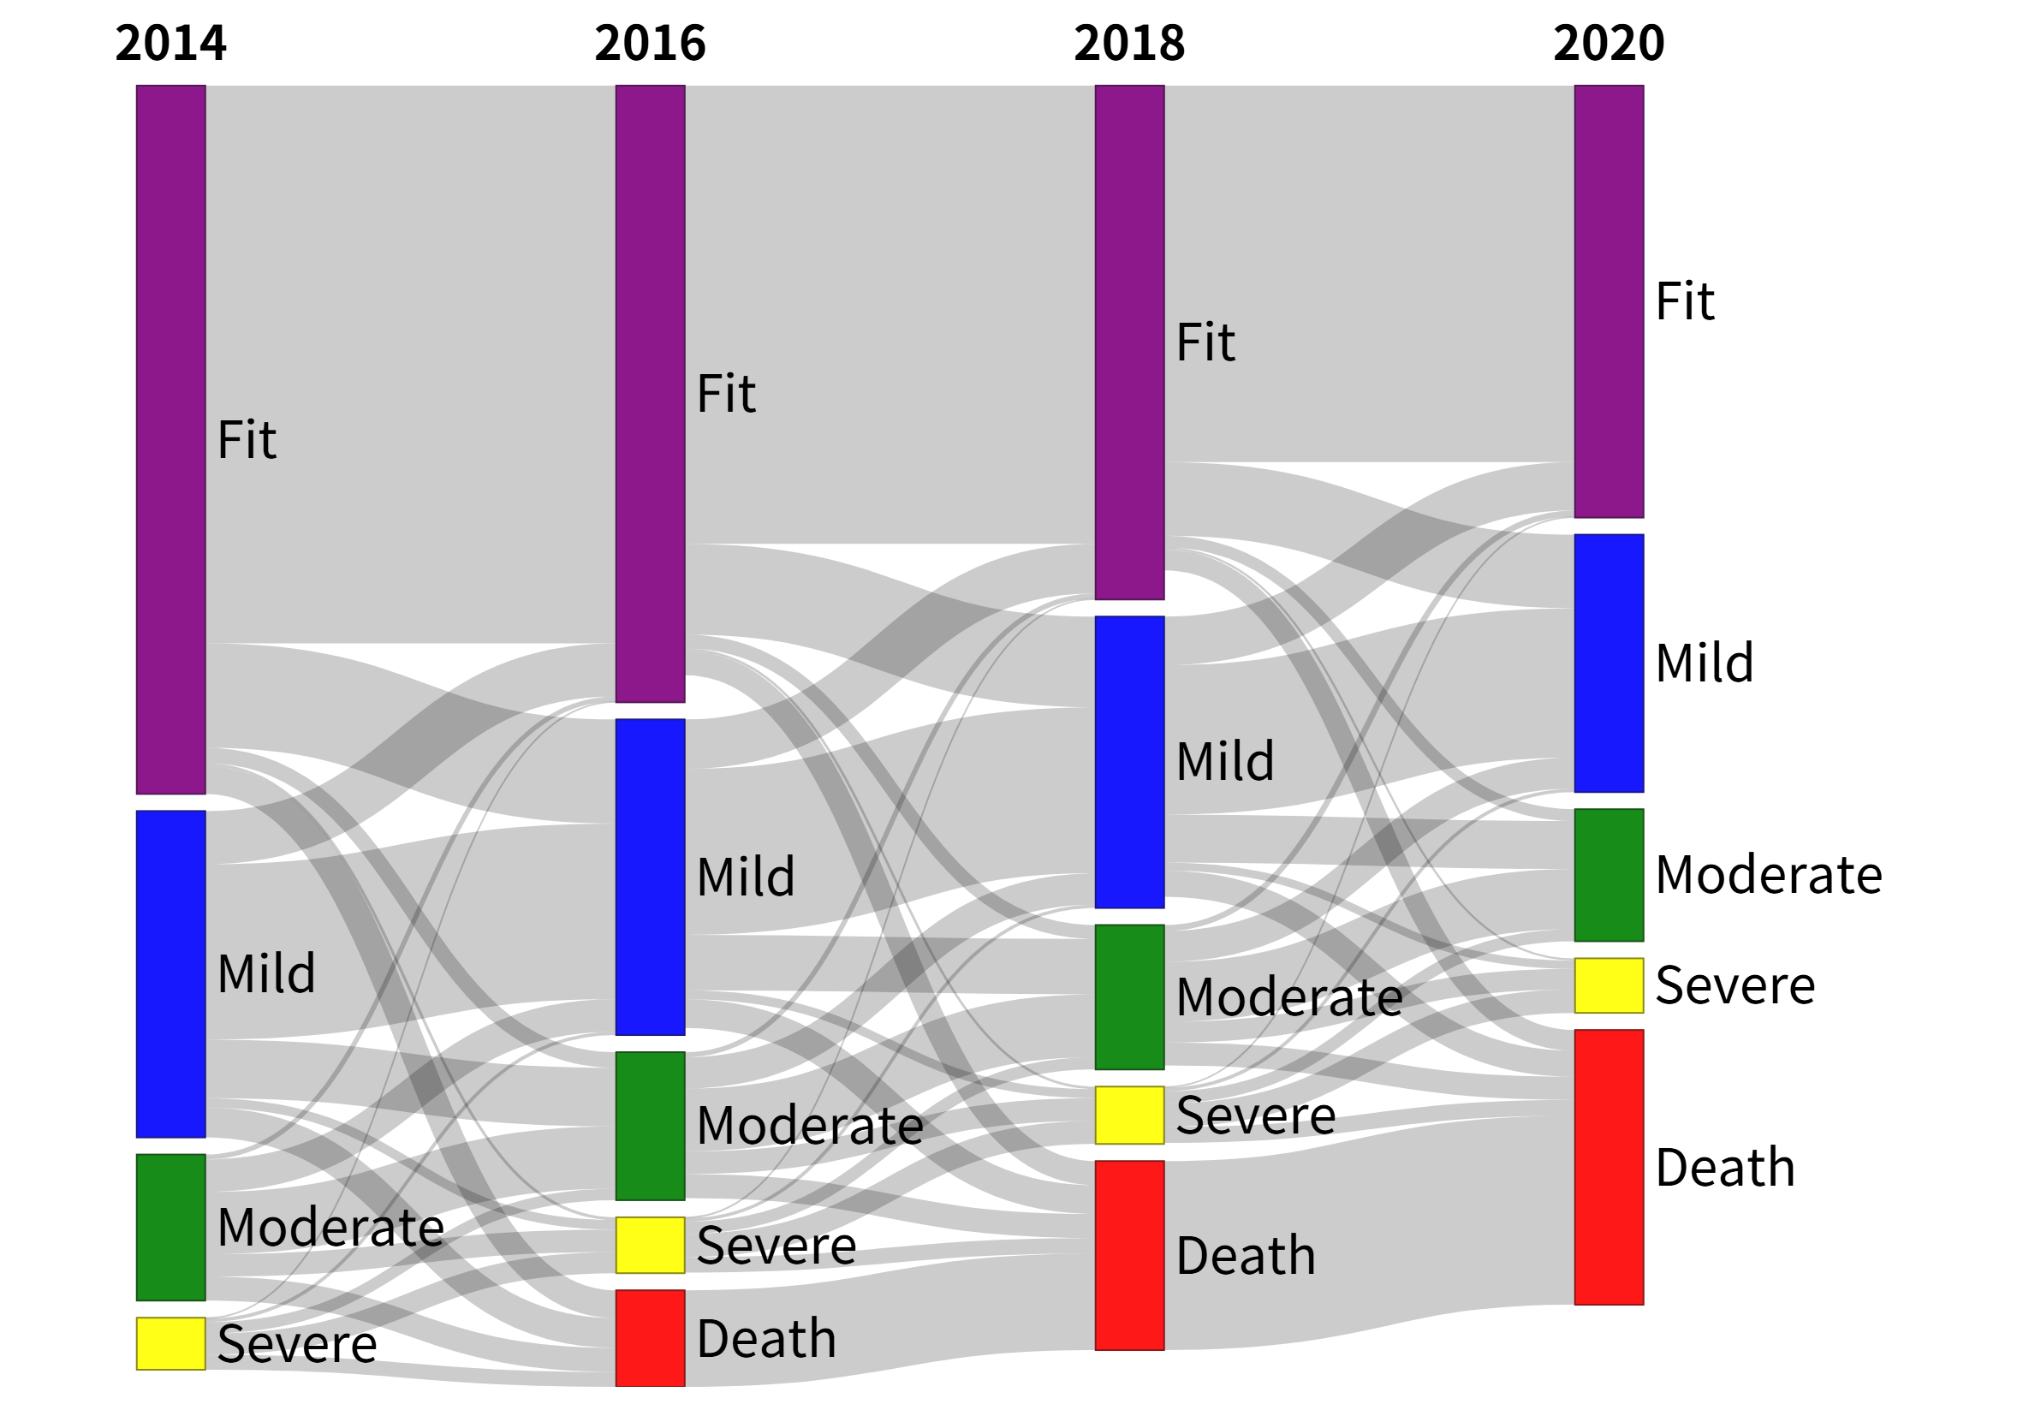
Supplementary Figure 5B. IPC-weighted frailty transitions in men
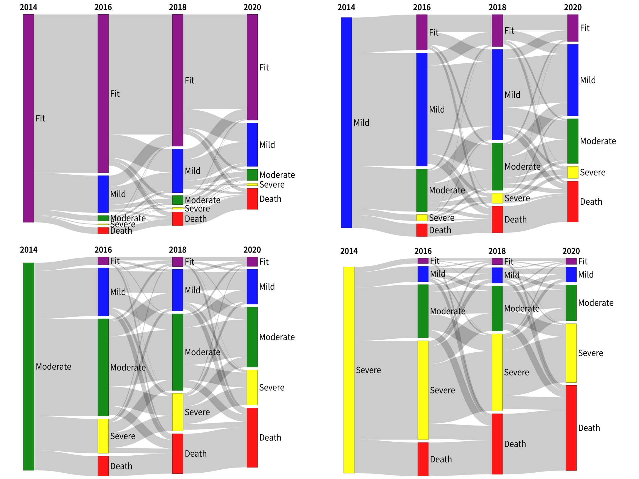
Supplementary Figure 6A. IPC-weighted frailty transitions by baseline frailty status in women
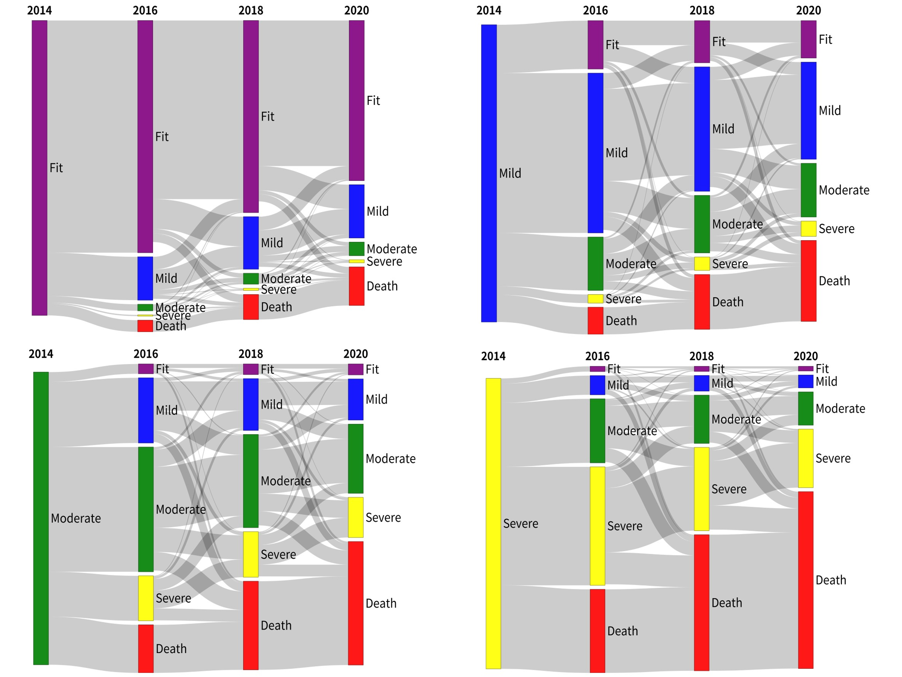
Supplementary Figure 6B. IPC-weighted frailty transitions by baseline frailty status in men

