Supplementary Materials
Table S1. Items included in the frailty index
Domain | Original variable | FI variable | Variable type | Coding rule | Missing rate
General health | Self-rated health | fi_shlt | Ordinal | Coded as (self-rated health – 1) / 4; range 0–1 | 0.210
Psychological status | Depressive symptoms (CESD) | fi_depression | Binary | Depressed = 1, otherwise = 0 | 0.263
Comorbidity | Hypertension | fi_hibpe | Binary | Physician-diagnosed = 1, no = 0 | 0.209
Comorbidity | Diabetes | fi_diabe | Binary | Physician-diagnosed = 1, no = 0 | 0.209
Comorbidity | Chronic lung disease | fi_lunge | Binary | Physician-diagnosed = 1, no = 0 | 0.209
Comorbidity | Heart disease | fi_hearte | Binary | Physician-diagnosed = 1, no = 0 | 0.209
Comorbidity | Stroke / TIA | fi_stroke | Binary | Physician-diagnosed = 1, no = 0 | 0.209
Psychological status | Psychiatric / mental disorder | fi_psyche | Binary | Physician-diagnosed = 1, no = 0 | 0.209
Comorbidity | Arthritis / rheumatic disease | fi_arthre | Binary | Physician-diagnosed = 1, no = 0 | 0.209
Physical function | Difficulty walking one block | fi_walk1a | Binary | Yes = 1, no = 0 | 0.217
Physical function | Difficulty walking several blocks | fi_walksa | Binary | Yes = 1, no = 0 | 0.224
ADL | Difficulty walking across room | fi_walkra | Binary | Yes = 1, no = 0 | 0.210
Physical function | Difficulty rising from chair | fi_chaira | Binary | Yes = 1, no = 0 | 0.211
Physical function | Difficulty climbing 1 flight of stairs | fi_clim1a | Binary | Yes = 1, no = 0 | 0.230
Physical function | Difficulty climbing several flights | fi_climsa | Binary | Yes = 1, no = 0 | 0.267
Physical function | Difficulty bending/kneeling/crouching | fi_stoopa | Binary | Yes = 1, no = 0 | 0.221
Physical function | Difficulty lifting > 10 pounds | fi_lifta | Binary | Yes = 1, no = 0 | 0.234
Fine motor | Difficulty picking up a dime | fi_dimea | Binary | Yes = 1, no = 0 | 0.211
Upper extremity | Difficulty raising arms above shoulder | fi_armsa | Binary | Yes = 1, no = 0 | 0.213
Upper extremity | Difficulty pushing/pulling large objects | fi_pusha | Binary | Yes = 1, no = 0 | 0.248
ADL | Difficulty dressing | fi_dressa | Binary | Yes = 1, no = 0 | 0.210
ADL | Difficulty bathing | fi_batha | Binary | Yes = 1, no = 0 | 0.210
ADL | Difficulty eating | fi_eata | Binary | Yes = 1, no = 0 | 0.210
ADL | Difficulty getting in/out of bed | fi_beda | Binary | Yes = 1, no = 0 | 0.210
ADL | Difficulty using toilet | fi_toilta | Binary | Yes = 1, no = 0 | 0.211
IADL | Difficulty managing money | fi_moneya | Binary | Yes = 1, no = 0 | 0.239
IADL | Difficulty using telephone | fi_phonea | Binary | Yes = 1, no = 0 | 0.213
IADL | Difficulty taking medications | fi_medsa | Binary | Yes = 1, no = 0 | 0.210
IADL | Difficulty preparing hot meals | fi_mealsa | Binary | Yes = 1, no = 0 | 0.245
IADL | Difficulty shopping for groceries | fi_shopa | Binary | Yes = 1, no = 0 | 0.235
Geriatric syndrome | Urinary incontinence | fi_urii | Binary | Yes = 1, no = 0 | 0.212
Oral health | Edentulism (no teeth) | fi_noteeth | Binary | Yes = 1, no = 0 | 0.209
Symptoms | Chronic pain | fi_painfr | Binary | Yes = 1, no = 0 | 0.210
Note: The FI was constructed using 33 deficit items across 7 domains: general health, psychological status, comorbidities, physical function, activities of daily living (ADL), instrumental activities of daily living (IADL), and geriatric syndromes. Items with > 30% missing data were excluded. Participants with < 80% of non-missing items were classified as missing FI.
Table S2. Univariable Cox regression results for continuous FI
Variable | HR (95% CI) | P
FI | 7.781 (5.197–11.649) | < 0.001
Abbreviations: HR, hazard ratio; CI, confidence interval.

Table S3. Univariable Cox regression results for FI categories
Variable | HR (95% CI) | P
FI group Pre-frail | 1.462 (1.217–1.757) | < 0.001
FI group Frail | 2.188 (1.837–2.605) | < 0.001
Reference group: Non-frail. Abbreviations: HR, hazard ratio; CI, confidence interval.

Table S4. Multivariable Cox regression results for continuous FI
Variable | HR (95% CI) | P
FI | 5.794 (2.921–11.493) | < 0.001
Age | 1.067 (1.058–1.076) | < 0.001
Sex: Male | 0.764 (0.656–0.890) | < 0.001
Race: Other | 1.250 (0.824–1.895) | 0.294
Race: White | 1.110 (0.899–1.371) | 0.331
Smoking status: Never/Former | 0.748 (0.637–0.878) | < 0.001
Alcohol consumption: Yes | 0.921 (0.794–1.068) | 0.277
Education: High School or Less | 1.354 (1.074–1.707) | 0.010
Education: Some College | 1.237 (1.021–1.499) | 0.030
Hypertension: Yes | 0.953 (0.819–1.110) | 0.538
Diabetes: Yes | 1.140 (0.953–1.363) | 0.152
COPD: Yes | 1.402 (1.124–1.747) | 0.003
Heart Disease: Yes | 1.121 (0.949–1.323) | 0.179
Psychiatric Conditions: Yes | 1.014 (0.818–1.258) | 0.898
Rheumatic Conditions: Yes | 0.825 (0.700–0.974) | 0.023
Urban-Rural Classification: Suburban | 1.059 (0.878–1.277) | 0.550
Urban-Rural Classification: Urban | 0.856 (0.729–1.006) | 0.059
Pain: Yes | 0.967 (0.812–1.152) | 0.711
Adjusted for Age, Sex, Race, Smoking status, Alcohol consumption, Education, Hypertension, Diabetes, COPD, Heart Disease, Psychiatric Conditions, Rheumatic Conditions, Urban-Rural Classification, and Pain. The HR for FI corresponds to a 1.0-unit increase in FI and is shown only for statistical completeness; clinically interpretable estimates per 0.01-unit FI increase are reported in the main text.

Table S5. Sensitivity analysis after excluding participants diagnosed in 2020
Variable | HR (95% CI) | P
FI | 5.774 (2.913–11.445) | < 0.001
Age | 1.066 (1.057–1.075) | < 0.001
Sex: Male | 0.765 (0.657–0.891) | < 0.001
Race: Other | 1.246 (0.822–1.890) | 0.301
Race: White | 1.106 (0.896–1.366) | 0.347
Smoking status: Never/Former | 0.748 (0.637–0.879) | < 0.001
Alcohol consumption: Yes | 0.922 (0.795–1.070) | 0.286
Education: High School or Less | 1.354 (1.074–1.707) | 0.010
Education: Some College | 1.237 (1.021–1.499) | 0.030
Hypertension: Yes | 0.952 (0.818–1.109) | 0.530
Diabetes: Yes | 1.139 (0.952–1.363) | 0.154
COPD: Yes | 1.392 (1.117–1.735) | 0.003
Heart Disease: Yes | 1.122 (0.950–1.325) | 0.174
Psychiatric Conditions: Yes | 1.011 (0.815–1.253) | 0.924
Rheumatic Conditions: Yes | 0.825 (0.699–0.974) | 0.023
Urban-Rural Classification: Suburban | 1.060 (0.879–1.278) | 0.544
Urban-Rural Classification: Urban | 0.857 (0.729–1.007) | 0.061
Pain: Yes | 0.967 (0.812–1.151) | 0.703
Adjusted for Age, Sex, Race, Smoking status, Alcohol consumption, Education, Hypertension, Diabetes, COPD, Heart Disease, Psychiatric Conditions, Rheumatic Conditions, Urban-Rural Classification, and Pain.

Table S6. Proportional hazards assumption test for the main Cox model
Variable | Chi-square | df | P value
FI | 1.627 | 1 | 0.202
Age | 10.697 | 1 | 0.001
Sex | 0.262 | 1 | 0.609
Race | 0.137 | 2 | 0.934
Smoking status | 0.017 | 1 | 0.896
Alcohol consumption | 0.832 | 1 | 0.362
Education | 0.417 | 2 | 0.812
Hypertension | 3.375 | 1 | 0.066
Diabetes | 4.308 | 1 | 0.038
COPD | 0.357 | 1 | 0.550
Heart Disease | 5.755 | 1 | 0.016
Psychiatric Conditions | 0.071 | 1 | 0.791
Rheumatic Conditions | 1.048 | 1 | 0.306
Urban-Rural Classification | 3.130 | 2 | 0.209
Pain | 0.090 | 1 | 0.764
GLOBAL | 27.832 | 18 | 0.065
P values were obtained from Schoenfeld residual-based tests.

Table S7. Proportional hazards assumption test for the sensitivity Cox model
Variable | Chi-square | df | P value
FI | 1.850 | 1 | 0.174
Age | 12.186 | 1 | < 0.001
Sex | 0.253 | 1 | 0.615
Race | 0.134 | 2 | 0.935
Smoking status | 0.018 | 1 | 0.895
Alcohol consumption | 0.894 | 1 | 0.344
Education | 0.479 | 2 | 0.787
Hypertension | 3.522 | 1 | 0.061
Diabetes | 4.303 | 1 | 0.038
COPD | 0.498 | 1 | 0.481
Heart Disease | 5.979 | 1 | 0.014
Psychiatric Conditions | 0.091 | 1 | 0.763
Rheumatic Conditions | 1.189 | 1 | 0.276
Urban-Rural Classification | 3.171 | 2 | 0.205
Pain | 0.078 | 1 | 0.780
GLOBAL | 29.786 | 18 | 0.040
P values were obtained from Schoenfeld residual-based tests.

Table S8. Comparison of included vs excluded participants / missing-data assessment
Characteristic | level | Excluded (n = 16587) | Included (n = 1882) | p | test | SMD
n |  | 16587 | 1882
Age, years |  | 68.08 (11.35) | 67.14 (8.54) | < 0.001 |  | 0.094
Sex | Female | 9946 (60.0) | 945 (50.2) | < 0.001 |  | 0.197
 | Male | 6641 (40.0) | 937 (49.8)
Race | Black | 2345 (14.1) | 258 (13.7) | 0.030 |  | 0.078
 | Other | 859 (5.2) | 69 (3.7)
 | White | 13381 (80.7) | 1555 (82.6)
 |  | 2 (0.0) | 0 (0.0)
Smoking status | Current | 9274 (55.9) | 1188 (63.1) | < 0.001 |  | 0.194
 | Never/Former | 7157 (43.1) | 694 (36.9)
 |  | 156 (0.9) | 0 (0.0)
Alcohol consumption | No | 8459 (51.0) | 835 (44.4) | < 0.001 |  | 0.137
 | Yes | 8121 (49.0) | 1047 (55.6)
 |  | 7 (0.0) | 0 (0.0)
Education | College or Higher | 3344 (20.2) | 451 (24.0) | < 0.001 |  | 0.117
 | High School or Less | 3792 (22.9) | 360 (19.1)
 | Some College | 9447 (57.0) | 1071 (56.9)
 |  | 4 (0.0) | 0 (0.0)
Hypertension | No | 7514 (45.3) | 840 (44.6) | 0.598 |  | 0.013
 | Yes | 9073 (54.7) | 1042 (55.4)
Diabetes | No | 13375 (80.6) | 1559 (82.8) | 0.023 |  | 0.057
 | Yes | 3212 (19.4) | 323 (17.2)
COPD | No | 15116 (91.1) | 1716 (91.2) | 0.979 |  | 0.002
 | Yes | 1471 (8.9) | 166 (8.8)
Heart disease | No | 12603 (76.0) | 1454 (77.3) | 0.229 |  | 0.030
 | Yes | 3984 (24.0) | 428 (22.7)
Psychiatric conditions | No | 13982 (84.3) | 1639 (87.1) | 0.002 |  | 0.080
 | Yes | 2605 (15.7) | 243 (12.9)
Rheumatic conditions | No | 7100 (42.8) | 808 (42.9) | 0.935 |  | 0.003
 | Yes | 9487 (57.2) | 1074 (57.1)
Pain | No | 10867 (65.5) | 1254 (66.6) | 0.125 |  | 0.064
 | Yes | 5690 (34.3) | 628 (33.4)
 |  | 30 (0.2) | 0 (0.0)

Table S9. Incremental predictive value of frailty index (FI) for all-cause mortality
Metric | Estimate | SE | 95% CI | P value
C-index (Baseline model) | 0.682 | 0.010 | 0.661–0.702 | —
C-index (Full model + FI) | 0.689 | 0.010 | 0.669–0.709 | —
ΔC-index (Full – Baseline) | 0.007 | 0.003 | 0.002–0.013 | 0.023
Abbreviations: CI, confidence interval; SE, standard error. ΔC-index represents the difference in Harrell’s concordance index between the full model (including FI) and the baseline model (excluding FI). Confidence intervals were estimated using bootstrap resampling. The baseline model included age, sex, race/ethnicity, education, residential setting, smoking status, alcohol consumption, hypertension, diabetes, chronic obstructive pulmonary disease, heart disease, psychiatric disorders, rheumatic disease, and persistent pain, whereas the full model additionally included FI.
Table S10. Age ≥ 65 years. All models weighted by HRS respondent sampling weights.
Model | HR | 95% CI | P value
Model 1 (Unadjusted) | 1.026 | 1.020–1.031 | < 0.001
Model 2 (Adjusted for age, sex, race) | 1.025 | 1.019–1.031 | < 0.001
Model 3 (Fully adjusted) | 1.017 | 1.008–1.026 | < 0.001
Note. HR = hazard ratio; CI = confidence interval. Model 1 is unadjusted. Model 2 is adjusted for age, sex, and race/ethnicity. Model 3 is additionally adjusted for education, residential setting, smoking status, alcohol consumption, hypertension, diabetes, chronic obstructive pulmonary disease, heart disease, psychiatric disorders, rheumatic disease, and persistent pain. All hazard ratios correspond to a 0.01-unit increment in the frailty index. All Cox models were weighted using HRS respondent-level sampling weights. P values are from Cox proportional hazards models.
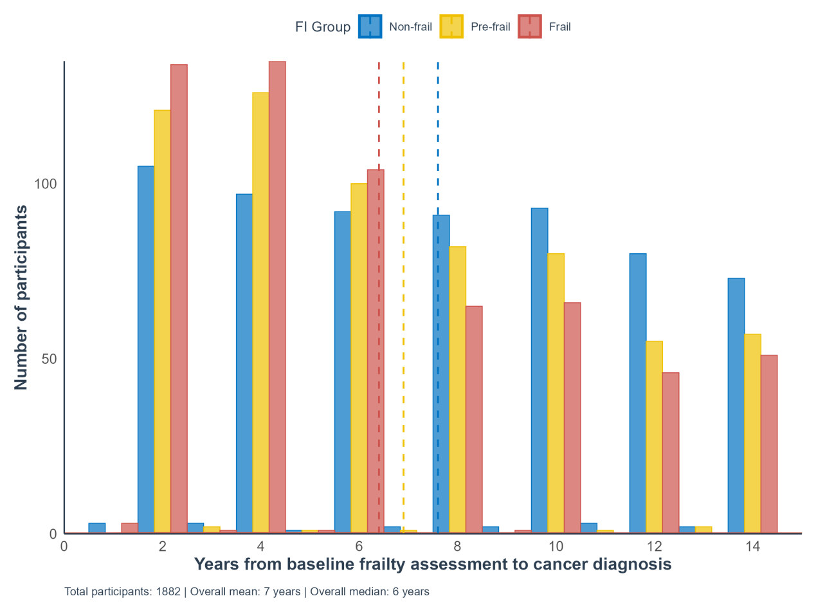
Figure S1. Distribution of the interval between baseline frailty assessment and cancer diagnosis, stratified by frailty index (FI) group.
The histogram shows the distribution of years from baseline frailty assessment to cancer diagnosis among 1882 included participants, stratified by FI status (Non-frail: FI ≤ 0.10, Pre-frail: 0.10 < FI ≤ 0.21, Frail: FI > 0.21). The dashed lines represent the mean interval for each group. The overall mean and median interval were 7 years and 6 years, respectively. This figure illustrates the temporal separation between baseline frailty assessment and cancer diagnosis and the distribution of the interval across frailty groups.
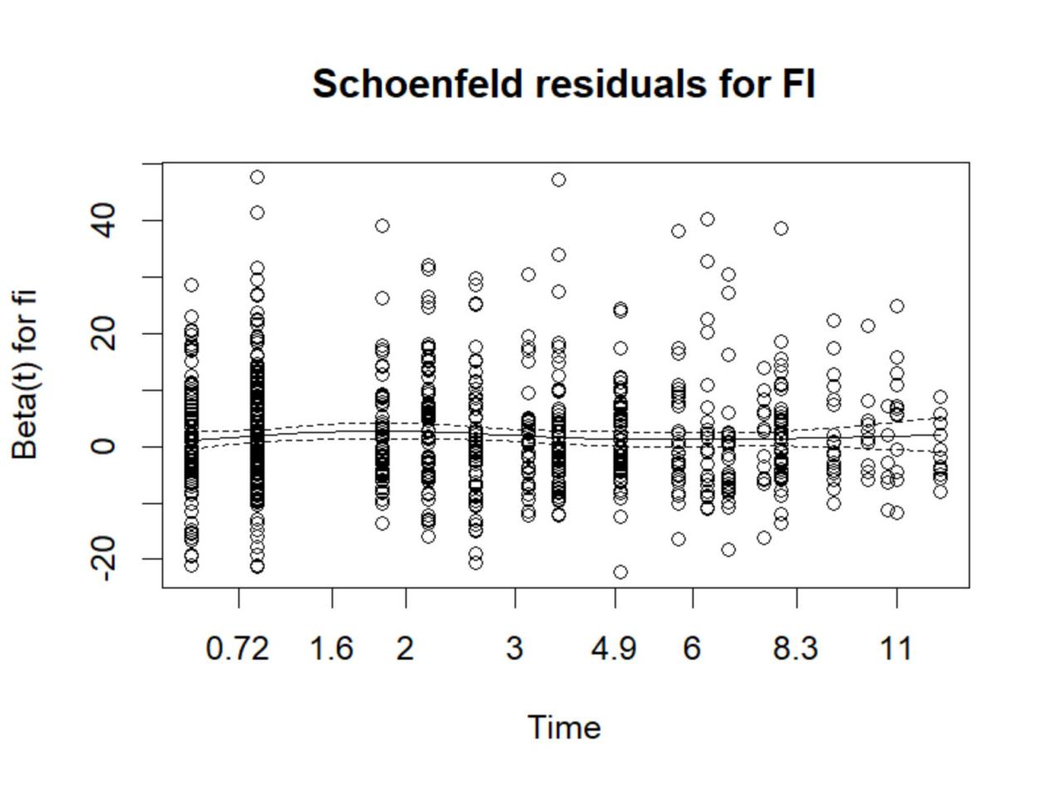
Figure S2. Schoenfeld residual plot for the frailty index (FI) in the main Cox proportional hazards model.
The plot shows the time-varying coefficient (β(t)) for FI across follow-up, with the solid line representing the smoothed fit of residuals and dashed lines indicating the associated confidence bands. The horizontal trend of β(t) confirms that the proportional hazards assumption is satisfied for FI (Schoenfeld test P > 0.05, as shown in Table S6).
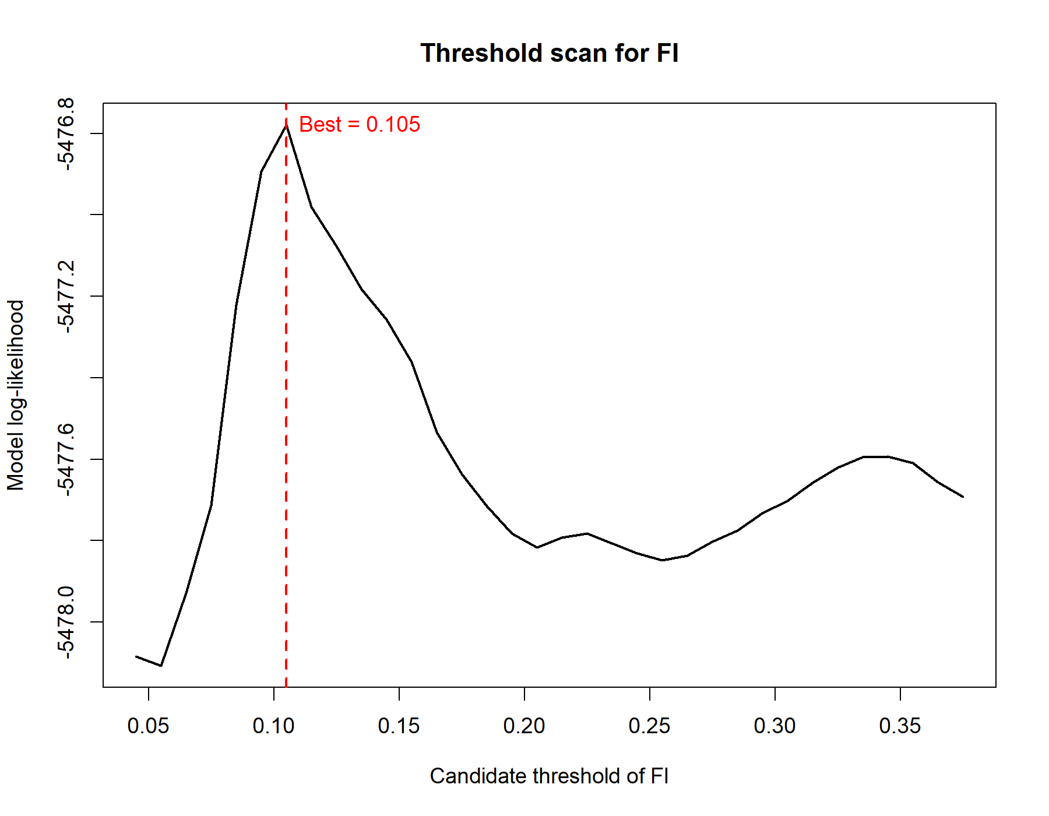
Figure S3. Threshold scan across candidate frailty index cut-off values. The plot shows model log-likelihood across a range of potential FI thresholds. This analysis was exploratory and was used to inform assessment of alternative threshold definitions.
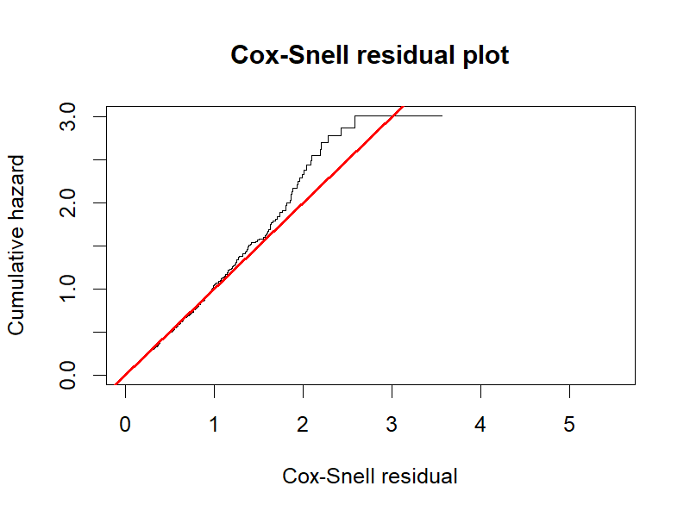
Figure S4. Cox-Snell residual plot for assessing overall model fit. The cumulative hazard of the Cox-Snell residuals is plotted against the residuals themselves. The close alignment of the observed step function (black line) to the diagonal reference line of unit slope (red line) indicates that the overall fit of the final Cox model is adequate.
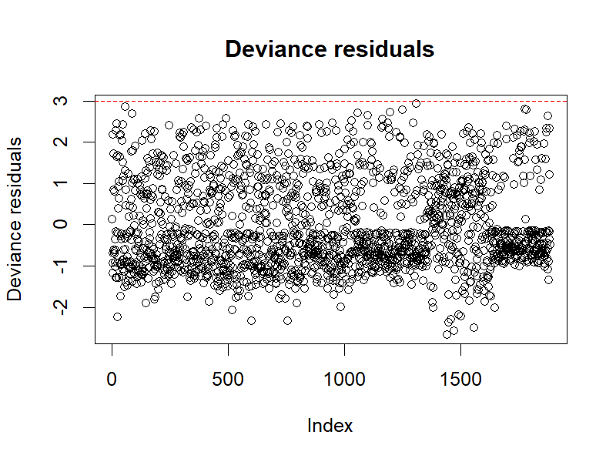
Figure S5. Index plot of deviance residuals. The plot displays deviance residuals for each observation in the dataset. The symmetrical distribution of residuals around zero, with no extreme outliers beyond the range of ± 3, suggests no influential observations that unduly affect the model estimates.
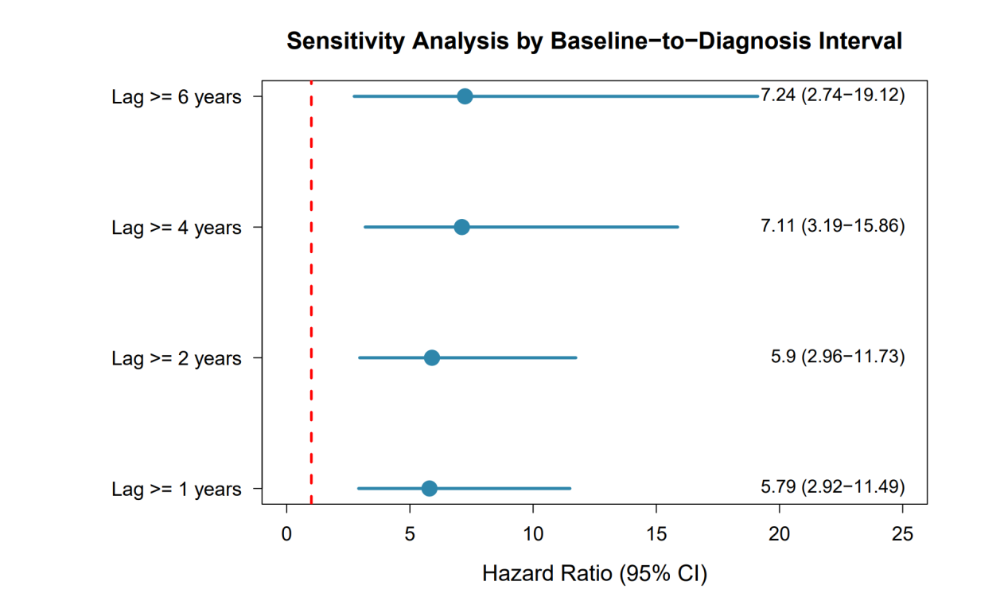
Figure S6. Sensitivity analysis by baseline-to-diagnosis interval. The forest plot shows HRs and 95% CIs for the association between prediagnostic FI and post-diagnosis mortality, across subgroups with minimum lags of 1, 2, 4, and 6 years. All models were adjusted for key confounders. The red dashed line (HR = 1) represents no effect. Associations were directionally consistent across all lag-defined subgroups, including those with a ≥ 6-year lag, supporting the robustness of the findings and reducing concern about reverse causation.

