9.APPENDIX
Prevalence, Correlates and Impact of Geriatric Syndromes: A Systematic Review and Meta-Analysis
- Supplementary Table S 1: Database search strategies.
Databases | Results | Search details
PubMed | 2,298 | ("Geriatric Assessment" OR "Frail Elderly" OR "Accidental Falls" OR "Cognition Disorders" OR "Malnutrition" OR "Urinary Incontinence" OR "Depression" OR "Activities of Daily Living") AND ("Older Population" OR "Elderly Health") AND ("Aged" OR "Aged, 80 and over") AND ("Prevalence" OR "QoL" OR "Patient Acceptance of Health Care" OR "Health Services/statistics and numerical data")
Scopus | 1,654 | (TITLE-ABS-KEY ("geriatric syndrome*" OR "frailty" OR "falls" OR "cognitive decline" OR "malnutrition" OR "urinary incontinence" OR "depression") AND TITLE-ABS-KEY ("older" OR "city" OR "metropolitan" OR "municipal") AND TITLE-ABS-KEY ("elderly" OR "older adults" OR "aged" OR "senior") AND TITLE-ABS-KEY ("prevalence" OR "epidemiology" OR "QoL" OR "HCU"))
EMBASE | 460 | allintitle: ("geriatric syndromes" OR "frailty" OR "falls" OR "depression") AND ("older" OR "city") AND ("elderly" OR "older adults")
Web of Science | 184 | TS=("geriatric syndrome*" OR "frailty" OR "falls" OR "cognitive impairment" OR "functional decline") AND TS=("older" OR "older population") AND TS=("elderly" OR "older people" OR "aged 60") AND TS=("prevalence" OR "QoL" OR "hospitalization")

2. Supplementary Table S 2: Detailed Characteristics of the 57 included studies.
S.No. | Author (s) | Journal | YOP | Study setting | Study duration | Sample size | Study participants and age | Study design | Prevalence of Geriatric Syndromes | Assessment tool | Impact[Quality of Life (Qol)and Health Care Utilization(HCU)]
1 | Wang et al. | Sci Rep | 2024 | China (Chengdu) | Oct 2022 – Mar 2023 | 706 | Community-dwelling, ≥60 years | Cross-sectional | Polypharmacy (58.5%), Malnutrition (43.1%), Multimorbidity (42.1%), Frailty (34.3%), Falls (5.1%) | FRAIL scale, MNA-SF, GDS-15, MMSE | NR
2 | Liberman et al). | J Pain Res | 2018 | Israel | 2014 – 2015 | 419 | Community-dwelling, ≥65 years | Cross-sectional | Chronic pain (55.2%), Falls (38.4%), Functional decline (ADL/IADL impairment) | BPI, Self-report, Katz ADL | QoL: Pain interference with mood and sleep was recorded.
3 | Cheung et al. | BMC Geriatr | 2018 | Hong Kong | 2011 – 2012 | 2,618 | community-dwelling, ≥60 years | Cross-sectional | Any syndrome (75.3%), Multimorbidity (41.8%), IADL disability (22.5%) | GDS, MMSE, Cardiovascular Risk | QoL: Assessed via functional disability (IADL) and pain impact.
4 | Topcu et al. | Front Med | 2024 | Türkey | Oct 2020 – Oct 2022 | 218 | Cancer outpatients, ≥65 years | Cross-sectional | Frailty (54.4%), Insomnia (46.3%), Malnutrition (36%), Incontinence (36.2%), Depression (27.6%) | CGA, ECOG-PS, Tinetti, GDS | NR
5 | Allain et al. | Malawi Med J | 2014 | Malawi (Blantyre) | Dec 2011 – Jan 20  12 | 98 | clinic attendees, ≥60 years | Cross-sectional | Memory loss (66.3%), Falls (40.8%), TUG >16s (29.8%), Urinary incontinence (24.5%) | AMT, TUG | NR
6 | He et al. | Aging Clin Exp Res | 2025 | China (Zhejiang) | 2019 – 2023 | 685 | Rural/Community, ≥60 years | Prospective Cohort | Malnutrition risk (34.3%), Frailty (32.9%), Sarcopenia (21.1%), Falls (17.6%) | MNA-SF, FRAIL scale, AWGS 2019 | NR
7 | Tkacheva et al | Clin Interv Aging | 2018 | Russia (Moscow) | 2014 – 2015 | 1,220 | community clinics, ≥65 years | Cross-sectional | Visual/hearing impairment (58.3%), Cognitive impairment (58.2%), Mood disorder (46.0%) | CGA, VNP, MMSE, GDS-15 | NR
8 | Imaoka et al. | Prev Med Rep | 2021 | Japan | 2018 – 2019 | 335 | Community-dwelling, ≥65 years | Cross-sectional | Pre-frailty (50.4%), Depressive symptoms (28.1%), Sarcopenia (13.1%), Frailty (8.1%) | GDS-15, AWGS 2019, Fried Phenotype | NR
9 | Ong et al. | J Frailty Aging | 2022 | Singapore | 2017 – 2019 | 229 | community, ≥60 years | Cross-sectional | Pre-frailty (44.5%), Falls (21%), Anorexia (16.6%), Cognitive impairment (CMMSE <24) | SFS-8, CMMSE, FAB, Fried Phenotype | Poor QoL (EQ-5D index <0.881) in 12.2% overall; 40% in frail/impaired group.
10 | Sugie et al. | Geriatr Gerontol Int | 2020 | Japan (Tokyo) | 2016 – 2017 | 67 | outpatients, ≥65 years | Pre-post Intervention | Chronic pain (82%), Pre-frailty (61%), Incontinence (51%), Edema (48%), Frailty (39%) | J-CHS Frailty, GDS-15, MNA-SF | QoL: Physical QoL (SF-8) improved significantly (40.8 → 42.7) after intervention
11 | Essomba et al. | Pan Afr Med J | 2020 | Cameroon (Yaoundé) | 2019 | 104 | hospital outpatients, ≥55 years | Cross-sectional | Any syndrome (67.3%), IADL disability (37.5%), Sarcopenia (26.2%), Cognitive impairment (20.2%) | Katz ADL, Lawton IADL, SARC-F | NR
12 | Bello-Chavolla | Rev Invest Clin | 2017 | Mexico (Mexico City) | 2017 | 135 | community, ≥70 years | Cross-sectional | Cognitive impairment (14.1%), Frailty (Associated with cognition) | MMSE, IST, Fried Phenotype | NR
13 | Kwon et al. | Japanese Journal of Geriatric | 2007 | Japan (Tokyo) | 2007 | 1,784 | community, ≥70 years | Cross-sectional | Falls, Incontinence, Depression, Undernutrition (Prevalence not specified in abstract) | TMIG Index, Self-report | NR
14 | Su et al. | BMC Geriatrics | 2025 | Taiwan | June 2018 to September 2018 | 160 | Hospital inpatients, ≥65 years | Observational | High burden of ADL disability, frailty, pain, and depression (Used for prediction model) | EQ-5D-3L, CCI, Self-report | NR
15 | Chao et al. | Clinical Interventions in Aging | 2016 | Taiwan | 2009–2013 | 847 | Dialysis patients, >20 years | Prospective Cohort | Frailty, Polypharmacy, Malnutrition (Associated with low medication adherence) | Clinical Frailty Scale, Serum Albumin | NR
16 | Kim et al. | Japanese Journal of Geriatrics) | 2008 | Japan (Tokyo) | 01-11-2006 | 925 | community women, ≥70 years | Cross-sectional | Urinary incontinence (Higher in obese), Pain, Falls, IADL disability | Body Composition, IADL Scale | NR
17 | Wu et al. | BMC Geriatr | 2024 | China (Multi-region) | Jan – Dec 2022 | 5,318 | Mixed Settings (69%) & Rural, ≥65 years | Cross-sectional | Falls (62.0%), Dementia (55.1%), Malnutrition (54.7%), Frailty (40.5%) | GS Awareness Scale | NR
18 | Sanford et al. | PLoS ONE | 2020 | USA (Missouri) | 2015 – 2019 | 11,344 | Mixed settings, ≥65 years | Cross-sectional | frailty 31.4%, sarcopenia 47.9%, risk of weight loss 36.7%, dementia 23.4%, MCI+dementia 46.0% | RGA (FRAIL, SARC-F, SNAQ, RCS) | NR
19 | Croize-Pourcelet et al. | Aging Clin Exp Res | 2022 | France (Marseille) | Oct 2020 – Jan 2021 | 22 | Centenarians, ≥100 years | Observational | Polypharmacy (86.4%), Cognitive impairment (45.5%), Malnutrition (40.9%) | MMSE, ADL, GDS | HCU- Healthcare: Hospitalizations were lower in nursing homes; ER visit rates were similar.
20 | Chiu et al). | Int J Environ Res | 2019 | Taiwan | 2011 – 2012 | 2,345 | Community-dwelling, ≥65 years | Longitudinal Cohort | Incontinence, falls, pain, and frailty (Predictive of hospitalization/ER visits) | TLSA Questionnaire, ADL/IADL | The presence of GS significantly predicted future hospital and ER visits with good accuracy (AUC 0.70–0.77).
21 | Couture et al. | Can Geriatr J | 2022 | Canada (Montreal) | Mar – Jul 2020 | 429 | hospitalized (COVID-19), ≥70 years | Retrospective | Delirium (29%), Falls (15%), Functional decline (14%) [at presentation] | Clinical Classification, CCI | HCU: Mean hospital length of stay was 21 days (aged ≥70); in-hospital mortality 32%.
22 | Badrkhahan et al. | Scientific Reports | 2023 |  | BEHP second wave/phase II; data from second phase, reported elsewhere as Sept 2015–Feb 2018 | 2,392 | Community-dwelling adults aged >60 years; mean age 70.13 years; 51.37% female | Cross-sectional analysis of a prospective population-based cohort | Frailty: 8.07%; pre-frailty: 46.76%; cognitive dysfunction: 53.74%; urinary incontinence: 27.40%; immobility: 5.32%; mild/moderate/severe depression: 16.48%, 5.61%, 4.17%; mild malnutrition: 1.62% | Fried phenotype, Frailty Index, Mini-Cog, PHQ-9, MNA, Katz ADL, Lawton IADL, TUG/SPPB, incontinence assessment | QoL/HCU not directly reported; predictors of frailty reported
  Iran;
  Bushehr;
  community-dwelling older adults
23 | Cigolle et al | Annals of Internal Medicine | 2007 | USA; Health and Retirement Study | HRS 2000 wave | 11,093 | Adults aged ≥65 years | Cross-sectional analysis of nationally representative survey data | ≥1 geriatric condition: 49.9%; one condition: 30.4%; two conditions: 12.4%; ≥3 conditions: 7.1%; cognitive impairment: 7.3%; injurious falls: 9.6%; incontinence requiring pads: 12.7%; low BMI: 2.9%; dizziness: 13.4%; vision impairment: 8.0%; hearing impairment: 25.7% | HRS survey; modified Telephone Interview for Cognitive Status/proxy memory assessment; self-reported falls, incontinence, BMI, dizziness, vision and hearing impairment | Strong association with ADL dependency; adjusted RR 2.1 for one condition, 3.6 for two conditions, and 6.6 for ≥3 conditions
24 | Rausch et al). | JAMDA | 2022 | Netherlands,Community pooling | 2006 – 2013 | 9094 | Community-based, ≥65 years | Longitudinal Cohort | ≥1 GS: 44.7%; hearing impairment: 26.7%; vision impairment: 19.2%; frailty: 4.7%; incontinence: 2.9%; depressive symptoms: 2.5%; falls: 0.5% | Lifelines questionnaire; M.I.N.I. depression items; modified Fried frailty criteria; self-reported falls, incontinence, vision and hearing impairment | HCU/impact: ≥1 GS predicted incident chronic health conditions; adjusted HR 1.27; cardiovascular disease HR 1.42; diabetes HR 1.53
25 | Rosso et al. | J Am Geriatr Soc | 2013 | USA (Multi-center) | 1994 – 1998 | 29,544 | Community women, ≥65 years | Longitudinal Cohort | Urinary incontinence (29.3%), Hearing impairment (29.2%), Polypharmacy (22.0%), Falls (11.3%) | Self-report (WHI instruments) | NR
26 | Mueller et al. | BMC Geriatr | 2018 | Switzerland | 2013 – 2014 | 85 | Urbanprimary care, ≥70 years | Prospective Diagnostic | Hearing impairment (~50%), Cognitive impairment, Mood impairment | BAT, CGA | NR
27 | Dartigueset al. | J Nutr Health Aging | 2021 | France (Bordeaux) | 2009 – 2018 | 630 | community, ≥75 years | Longitudinal Cohort | 82% had ≥2 syndromes/diseases (Frailty, dementia, dependency, depression commonly co-occur) | Fried, DSM-IV, CES-D, ADL | More Hospitalization and Institutionalization
28 | Moon et al. | Ann Geriatr Med Res | 2019 | South Korea | 2017 | 10,299 | National sample, ≥65 years | Cross-sectional | Polypharmacy, falls, visual/hearing impairment (Higher in Diabetes Mellitus group) | MMSE-DS, ADL/IADL, SGDS | No validated tool but increase hospital interaction and more CKD and CVD highlighted
29 | Baré et al. | BMJ Open | 2021 | Spain | 2016 – 2018 | 740 | hospital inpatients, ≥65 years | Prospective Cohort | Polypharmacy (79.9%), Frailty (61.8%), Chronic pain, Immobility | CGA, Charlson Index | HCU: High utilization observed; 69.6% of participants reported healthcare contact in the previous 3 months.
30 | Brown et al. | J Health Care Poor | 2013 | USA (Boston) | 2008 – 2010 | 250 | Older homeless, ≥50 years | Cross-sectional | Falls (53.4%), Sensory impairment (49.1%), Incontinence (49.6%), Depression (39.8%) | MMSE, PHQ-9, Fried Phenotype | HCU Indirectly assessed via high clinic visits and insurance coverage; no explicit utilization rates reported.
31 | Huisingh-Scheetz et al | J Gerontol B | 2014 | USA (National) | 2005 – 2011 | 3,005 | Community-dwelling, 57-85 years | Longitudinal | Fractures (23.1%), Frailty (11.4%), Falls (9.4%) | NSHAP (Modified Fried), ADL | NR
32 | Li et al. | Geriatric Nursing | 2025 | Taiwan | Not reported | 386 | Community (Daycare), ≥60 years | Cross-sectional | Cognitive impairment (43.1%), Malnutrition (35.7%), Frailty (30.4%), Incontinence (29.6%) | MNA, GDS-SF, MMSE, ICIQ-UI SF | Meaning in life" was analyzed as a vital QoL component; syndromes significantly reduced this sense of purpose.
33 | Hu et al. | Geriatric Nursing | 2025 | China (Zhejiang) | 1 Sept–31 Dec 2018 | 2,575 | Community/Institution (Disabled), ≥60 years | Network Analysis | Chronic pain (Common), Polypharmacy (26-44%) | Self-report, Professional survey | NR
34 | Huang et al. | JAMDA | 2017 | Taiwan | 2003 – 2007 | 2,744 | Community-dwelling, ≥65 years | Retrospective Cohort | Any syndrome (44.9%), Pain (52.8%), Cognitive impairment (26.3%), Depression (24.8%) | TLSA Survey, CES-D, SPMSQ
35 | Shyu et al. | J Nutr Health Aging | 2024 | Taiwan | 2018 – 2023 | 1,141 | Hospitalized older adults, ≥65 years | Retrospective | Frailty (85.2%), Malnutrition risk (78.8%), Low handgrip (69.4%), Cognitive impairment (40.5%) | CGA, EQ-5D, Bedside Oral Exam | QoL: Decreased Quality of Life (lower EQ-5D index and VAS scores).HCU Increased healthcare utilization (prolonged length of stay and higher in-hospital mortality).
36 | Cheng et al. | Geriatric Nursing | 2025 | Australia (Sydney) | Jun – Sep 2023 | 408 | community, ≥60 years | Cross-sectional | Depression (34.3%), Cognitive impairment (23.5%), Frailty (16.2%) | AD8, FRAIL Scale, GDS-5 | NR
37 | She et al. | JAMDA | 2019 | China (Shandong) | 2014 – 2016 | 1,497 | Mixed setting (Urban and Rural)community, ≥60 years | Cross-sectional | Multimorbidity (68.9%), Functional dependence (22.5%), Depressive symptoms (17.8%) | GDS-15, EQ-5D-3L | QoL: Decreased Quality of Life (lower SF-12 scores). Functional dependence and depression were identified as key mediators worsening QoL
38 | Chen et al. (2021) | The Journal of Nutrition, Health & Aging | 2021 | Singapore; community-based HOPE cohort |  | 292 | Community-dwelling older adults with metabolic syndrome, aged ≥65 years | Cross-sectional population study | Pre-frailty: 40.4%; frailty: 7.2%; depressive symptoms: 4.1% | FRAIL scale, EQ-5D, functional assessment, Timed Up and Go, and hand-grip strength | Frailty was associated with poorer EQ-5D mobility, usual activities and pain scores, as well as poorer perceived health. HCU was not reported.
39 | Noguchi N et al. | Australasian Journal on Ageing | 2016 | Sydney, Australia) | 2005-07 | 1705 | Community-dwelling men, aged ≥70 years | Cross-sectional analysis of the CHAMP cohort (baseline) | Frailty (CHS/Fried phenotype) 9.5%; pre-frailty 40.7%; Frailty Index-defined frailty (≥0.25) 23.1%; multimorbidity 69.3%; polypharmacy 37.7%; IADL dependence 23.7%; recurrent falls 8.5%; urinary incontinence 7.2%; dementia 5.5%; poor mobility 5.8%. | CHS/Fried phenotype and Frailty Index (Rockwood); Falls- self-report (≥2 falls/year); Incontinence -ICIQ; Dementia-clinical/standardised diagnosis; Mobility- needing help walking; Polypharmacy -≥5 medications; FunctionIADL scale; Physical activity- PASE | NR
40 | Sankar et al. | Indian J Comm Med | 2025 | India (Puducherry) | 2019 | 404 | Urban & Rural, ≥60 years | Cross-sectional | Incontinence (: 91.9%), Pain (: 85.1%), Depression (: 29.7%) | MNA, GDS-15, Barthel Index | QoL: Decreased Quality of Life. Functional limitations (Barthel/IADL) significantly reduced overall geriatric well-being (WHOQOL-BREF).
41 | Pengpid & Peltzer | Geriatrics | 2021 | India; national community-dwelling sample; LASI Wave 1 | 2017 – 2018 | 31,477 | Community-dwelling adults aged ≥60 years | Cross-sectional | No geriatric condition: 44.3%; one condition: 32.7%; two: 15.9%; ≥3: 7.1%; underweight: 26.9%; dizziness: 14.5%; impaired vision: 13.7%; impaired hearing: 9.6%; impaired cognition: 9.3%; major depressive disorder: 8.2%; injurious falls: 5.7%; incontinence: 4.0%; ADL dependency: 7.4% | LASI Survey Instruments | QoL: Decreased Life satisfaction (LASI scale) was strongly negatively impacted by GS and multimorbidity.  HCU Significant association multimorbidity and higher healthcare usage patterns.
42 | Kumar et al. | WHO SE Asia JPH | 2021 | India (Delhi-NCR) | Jul – Dec 2021 | 131 | Urban Old-Age Homes, ≥60 years | Cross-sectional | Low vision (69.5%), Depression (62.6%), Cognitive impairment (46.6%), Hearing loss (20.6%) | ICT-BRIEF 30, GDS-5, Mini-Cog | Reduced QOL
43 | Bulut et al. | Clinical Interventions in Aging | 2018 | Turkey | 2013 – 2017 | 2,816 | Urban outpatient clinic, ≥60 years | Retrospective | Polypharmacy (54.5%), Incontinence (47.6%), Depression (35.1%), Falls (33.6%) | CGA, GDS, MMSE | NR
44 | R et al. | WJARR | 2023 | India (Vellore) | 2023 | 200 | hospital wards, ≥60 years | Cross-sectional | Sleep disturbance (74.5%), Urinary symptoms (70%), Mobility impairment (61.5%), Depression (55%) | CGA, MNA | NR
45 | Soundararajan et al. | Int J Med Res | 2017 | India (Coimbatore) | Jun – Aug 2016 | 60 | field practice, ≥60 years | Cross-sectional | Visual distolderce (86.7% in malnourished), Depression (60% in malnourished) | MNA, Mini-Cog, GDS, Barthel | QoL: Decreased.Malnutrition was associated with poorer functional status and mobility (Barthel Index: 83.5 vs 90.7, P<0.01) and mobility (GUGT: 2.16 vs 1.36, P<0.001).
46 | Möller et al. | Eur J Ageing | 2022 | Sweden (Stockholm) | 2006 – 2010 | 6,700 | community, ≥65 years | Longitudinal | Insomnia (59.9%), Functional dependence (37.2%), Incontinence (28.1%) | Self-report postal questionnaire | Increased HCU GS associated with 1.53x higher hospitalization rates, 1.33x more outpatient visits, and 1.66x longer hospital length of stay.
47 | Katipoglu et al. | Eur Geriatr Med | 2025 | Türkiye (Balıkesir) | 2023 – 2024 | 5,018 | Community-dwelling, ≥80 years | Prospective Cohort | High burden of geriatric syndromes linked to HCU | CGA, MNA-SF, Mini-Cog, GDS-15 | Increased HCU Higher multimorbidity was associated with greater acute-care utilization, including inpatient and emergency admissions.
48 | Anzaldi et al. | BMC Geriatr | 2017 | USA (Massachusetts) | 2011 – 2013 | 18,341 | community (Medicare), ≥65 years | Retrospective Cohort | Falls, Walking difficulty, Weight loss (Higher in frail patients) | NLP of EHR, Claims data | Increased HCU Frailty was associated with greater healthcare utilization, including higher hospitalization, emergency-visit, and readmission rates.
49 | Piotrowicz K et al. | Aging | 2016 | Poland; nationwide community-dwelling population | 2007 – 2011 | 3471 | Community-dwelling older adults, aged 65–104 | Cross-sectional | Vision impairment 41.6%; mood disorders (depression) 27.2%; hearing impairment 21.9%; cognitive impairment 20.7%; falls 17.3%; functional dependence 17.1%; incontinence 5.9%; malnutrition 1.5% | Cognitive — MMSE (≤23/30); Depression/mood — assessment tool per protocol; Falls — self-report; Incontinence — ADL bowel/bladder item; Functional dependence — IADL (<21/24); Malnutrition — albumin; Vision & hearing — functional screening | NR
50 | Kim et al. | Arch Gerontol | 2011 | Japan | 2007 – 2008 | 61 | community, ≥70 years | Randomized Trial | Baseline: Incontinence (45%), Fear of falling (55%) (Reduced after exercise) | TMIG Index, Tinetti POMA | QOL:The 6-month management program significantly improved physical function scores (10.3 → 11.6, p<0.05) and reduced fear of falling (55% → 32%).
51 | Yang et al. | Arch Gerontol | 2015 | Taiwan | 2003 – 2011 | 2,415 | Community-dwelling, ≥65 years | Cross-sectional | Pain (52.8%), Cognitive impairment (26.3%), Depression (24.8%), Incontinence (14.5%) | TLSA Survey, CES-D, SPMSQ | QoL: Decreased.Life Satisfaction Index (LSI) scores dropped significantly as syndrome burden increased (7.47 for 0 syndromes vs 6.57 for ≥4 syndromes). Depression showed the strongest reported association with lower life satisfaction.
52 | Doležalová et al. | Healthcare | 2021 | Czech Republic | 2019 – 2020 | 498 | Mixed settings, ≥60 years | Cross-sectional | Frailty (50.4%), Poor nutrition (30.1%), Sarcopenia risk (26.5%) | Tilburg Frailty, SARC-F, MNA | QoL: Decreased Frailty and sarcopenia were associated with lower Physical (score 62.1) and Psychological (score 70.8) domain scores, while social/environmental domains were less affected.
53 | Tshitenge et al. | Texila Int J PH | 2024 | Botswana | 2021 | 414 | Community-dwelling, ≥65 years | Cross-sectional | IADL impairment (79.2%), Nutrition risk (63.0%), Depression (57.2%), Frailty (47.1%) | BAT for CGA, WHOQOL-BREF | QoL: Decreased PQLI.Physical health scores were significantly lower (44%) compared to psychological (55%) and social (57%) domains, indicating a stronger association of geriatric-syndrome burden with the physical-health domain.
54 | Schönenberg et al. | Eur Geriatr Med | 2025 | Germany | Feb 2023 – Aug 2024 | 666 | Inpatients/Outpatients | Cross-sectional | Mobility problems, Falls, and Pain (Most frequent syndromes) | Patient Questionnaire, WHOQOL-BREF | Higher syndrome burden was associated with lower physical and mental Qo.
55 | van Seben et al. | Journal of the American Medical Directors Association | 2019 | Netherland | October 2015–June 2017 | 401 | Acutely hospitalized older adults; mean age 79.7±6.7 years | Prospective multicentre cohort | Fatigue 77.2%; functional impairment 62.3%; apathy 57.5%; mobility impairment 54.6%; fear of falling 40.6%; median of five geriatric syndromes per participant | MMSE, GDS-15, SNAQ, Katz ADL Index, numeric rating scales, walking-aid assessment and self-reported falls/incontinence. | NR
56 | Lee et al. | Heliyon | 2023 | Taiwan | 2010 – 2018 | 699 | Community-dwelling, 75.5 (mean) | Prospective Cohort | Polypharmacy, Falls, Frailty (Associated with QoL) | CASP-12, Fried Phenotype | Higher QoL (CASP-12 score) was associated with a significantly lower likelihood of developing syndromes and HCU
57 | Christos et al. . | Healthcare | 2023 | Greece | Mar – May 2019 | 301 | home-based care, ≥65 years | Cross-sectional | Frailty, Cognitive dysfunction, Depression (Prevalence not specified in abstract) | SHARE-Fi, MoCA, GDS, WHOQOL-BREF | Decrease in QoL

Abbreviations: NR:Not Reported ADL(Activities of Daily Living); AMT, Abbreviated Mental Test; AWGS, Asian Working Group for Sarcopenia; CES-D, Center for Epidemiologic Studies Depression Scale; CGA, Comprehensive Geriatric Assessment; GDS, Geriatric Depression Scale; IADL, Instrumental Activities of Daily Living; MMSE, Mini-Mental State Examination; MNA-SF, Mini Nutritional Assessment-Short Form; MoCA, Montreal Cognitive Assessment; PHQ-9, Patient Health Questionnaire-9; SARC-F, Sarcopenia Screening Tool; TUG, Timed Up and Go test; WHOQOL-BREF, World Health Organization Quality of Life (Brief Version).
Note: Sample sizes reflect the number of participants specifically analysed for geriatric syndromes.
3. Supplementary Table S3: Risk-of-bias assessment
# | Author (Year) | Country | D1 | D2 | D3 | D4 | D5 | D6 | D7 | D8 | D9 | Score (%) | Quality
1 | Wang et al. (2024) | China | Y | Y | Y | Y | Y | Y | Y | Y | Y | 100.0% | Good
2 | Liberman et al. (2018) | Israel | Y | Y | Y | Y | U | Y | Y | Y | Y | 88.9% | Good
3 | Cheung et al. (2018) | Hong Kong | Y | Y | Y | Y | U | Y | Y | Y | Y | 88.9% | Good
4 | Topcu et al. (2024) | Türkiye | Y | Y | Y | Y | U | Y | Y | Y | N | 77.8% | Good
5 | Allain et al. (2014) | Malawi | Y | Y | U | Y | U | Y | Y | Y | U | 66.7% | Moderate
6 | He et al. (2025) | China | Y | Y | Y | Y | U | Y | Y | Y | U | 77.8% | Good
7 | Tkacheva et al. (2018) | Russia | Y | Y | Y | Y | U | Y | Y | Y | U | 77.8% | Good
8 | Imaoka et al. (2021) | Japan | Y | Y | N | Y | U | Y | Y | Y | U | 66.7% | Moderate
9 | Ong et al. (2022) | Singapore | Y | Y | N | Y | U | Y | Y | Y | N | 66.7% | Moderate
10 | Sugie et al. (2020) | Japan | Y | Y | U | Y | U | Y | Y | Y | N | 66.7% | Moderate
11 | Essomba et al. (2020) | Cameroon | Y | Y | U | Y | U | Y | Y | Y | N | 66.7% | Moderate
12 | Bello-Chavolla et al. (2017) | Mexico | Y | Y | U | Y | U | Y | Y | Y | N | 66.7% | Moderate
13 | Kwon et al. (2007) | Japan | Y | Y | Y | U | N | Y | Y | Y | N | 66.7% | Moderate
14 | Su et al. (2025) | Taiwan | Y | Y | Y | Y | Y | Y | Y | Y | N | 88.9% | Good
15 | Chao et al. (2016) | Taiwan | Y | Y | Y | Y | Y | Y | Y | Y | N | 88.9% | Good
16 | Kim et al. (2008) | Japan | Y | Y | Y | Y | Y | Y | Y | Y | N | 88.9% | Good
17 | Wu et al. (2024) | China | Y | Y | Y | Y | Y | Y | Y | Y | N | 88.9% | Good
18 | Sanford et al. (2020) | USA | Y | Y | Y | Y | Y | Y | Y | Y | N | 88.9% | Good
19 | Croize-Pourcelet et al. (2022) | France | Y | Y | Y | Y | N | Y | Y | Y | N | 77.8% | Good
20 | Chiu et al. (2019) | Taiwan | Y | Y | U | Y | U | Y | Y | Y | N | 66.7% | Moderate
21 | Couture et al. (2022) | Canada | Y | Y | U | Y | U | Y | Y | Y | N | 66.7% | Moderate
22 | Badrkhahan et al. (2023) | Iran | Y | Y | Y | Y | Y | Y | Y | Y | U | 88.9% | Good
23 | Cigolle et al. (2007) | USA | Y | Y | Y | Y | Y | U | Y | Y | U | 77.8% | Good
24 | Rausch et al. (2022) | Netherlands | Y | Y | N | Y | U | Y | Y | Y | N | 66.7% | Moderate
25 | Rosso et al. (2013) | USA | Y | Y | N | Y | U | Y | Y | Y | N | 66.7% | Moderate
26 | Mueller et al. (2018) | Switzerland | Y | Y | Y | Y | U | Y | Y | Y | N | 77.8% | Good
27 | Dartigues et al. (2021) | France | Y | Y | Y | Y | Y | Y | Y | Y | Y | 100.0% | Good
28 | Moon et al. (2019) | South Korea | Y | Y | Y | Y | N | Y | Y | Y | Y | 88.9% | Good
29 | Bare et al. (2021) | Spain | Y | Y | U | Y | N | Y | Y | Y | Y | 77.8% | Good
30 | Brown et al. (2013) | USA | Y | Y | U | Y | N | Y | Y | Y | Y | 77.8% | Good
31 | Huisingh-Scheetz et al. (2014) | USA | Y | Y | U | Y | N | Y | Y | Y | Y | 77.8% | Good
32 | Li et al. (2025) | Taiwan | Y | Y | U | Y | Y | Y | Y | Y | Y | 88.9% | Good
33 | Hu et al. (2025) | China | Y | Y | U | Y | Y | Y | Y | Y | Y | 88.9% | Good
34 | Huang et al. (2017) | Taiwan | Y | Y | U | Y | Y | Y | Y | Y | Y | 88.9% | Good
35 | Shyu et al. (2024) | Taiwan | Y | Y | U | Y | Y | Y | Y | Y | Y | 88.9% | Good
36 | Cheng et al. (2025) | Australia | Y | Y | Y | Y | Y | Y | Y | Y | Y | 100.0% | Good
37 | She et al. (2019) | China | Y | Y | Y | Y | Y | Y | Y | Y | Y | 100.0% | Good
38 | Chen et al. (2021) | Singapore | Y | Y | Y | Y | Y | Y | Y | Y | Y | 100.0% | Good
39 | Noguchi et al. (2016) | Australia | Y | Y | Y | Y | Y | Y | Y | Y | U | 88.9% | Good
40 | Sankar et al. (2025) | India | Y | Y | Y | Y | Y | Y | Y | Y | Y | 100.0% | Good
41 | Pengpid & Peltzer (2021) | India | Y | Y | Y | Y | Y | Y | Y | Y | Y | 100.0% | Good
42 | Kumar et al. (2021) | India | Y | Y | Y | Y | N | Y | Y | Y | Y | 88.9% | Good
43 | Bulut et al. (2018) | Türkiye | Y | Y | Y | Y | Y | Y | Y | Y | Y | 100.0% | Good
44 | R/Suganya et al. (2023) | India | Y | Y | Y | Y | Y | Y | Y | Y | Y | 100.0% | Good
45 | Soundararajan et al. (2017) | India | Y | Y | Y | Y | N | Y | Y | U | N | 66.7% | Moderate
46 | Möller et al. (2022) | Sweden | Y | Y | Y | Y | Y | Y | Y | Y | Y | 100.0% | Good
47 | Katipoglu et al. (2025) | Türkiye | Y | Y | Y | Y | Y | Y | Y | Y | Y | 100.0% | Good
48 | Anzaldi et al. (2017) | USA | Y | Y | Y | Y | Y | Y | Y | Y | Y | 100.0% | Good
49 | Piotrowicz et al. (2016) | Poland | Y | Y | Y | Y | Y | Y | Y | Y | Y | 100.0% | Good
50 | Kim et al. (2011) | Japan | Y | Y | Y | Y | U | Y | Y | U | Y | 77.8% | Good
51 | Yang et al. (2015) | Taiwan | Y | Y | Y | Y | Y | Y | Y | N | Y | 88.9% | Good
52 | Doležalová et al. (2021) | Czech Republic | Y | Y | Y | Y | Y | Y | Y | N | Y | 88.9% | Good
53 | Tshitenge et al. (2024) | Botswana | Y | Y | Y | Y | N | Y | Y | N | Y | 77.8% | Good
54 | Schönenberg et al. (2025) | Germany | Y | Y | Y | Y | N | Y | Y | N | Y | 77.8% | Good
55 | van Seben et al. (2019) | Netherlands | Y | Y | Y | Y | Y | Y | Y | Y | U | 88.9% | Good
56 | Lee et al. (2023) | Taiwan | Y | Y | Y | Y | N | Y | Y | N | Y | 77.8% | Good
57 | Christos et al. (2023) | Greece | Y | Y | Y | Y | Y | Y | Y | Y | Y | 100.0% | Good
Note: Risk of bias was assessed using the JBI Critical Appraisal Checklist for Prevalence Studies. Each item was rated Y (Yes, criterion met), U (Unclear), or N (No, not met), shown in green, yellow, and red, respectively. D1–D9 correspond to: sample frame appropriate to the target population (D1); appropriate sampling of participants (D2); adequate sample size (D3); detailed description of study subjects and setting (D4); sufficient coverage of the identified sample in the analysis (D5); valid methods for identifying the condition (D6); standard, reliable measurement across all participants (D7); appropriate statistical analysis (D8); and adequate response rate or appropriate management of a low response rate (D9). The score is the percentage of "Yes" responses [(Yes ÷ 9) × 100], with studies rated Good (≥70%), Moderate (50–69%), or Poor (<50%). Overall, 45 studies were rated Good and 12 Moderate, with none at high risk of bias (n = 57). Good → Low risk, Moderate → Some concerns, Poor → High risk
4. Supplementary Table S4. Comparison of the primary DerSimonian–Laird analysis and the alternative binomial-normal GLMM sensitivity analysis
Geriatric syndrome | k | N | DerSimonian–Laird pooled prevalence, % (95% CI) | DL 95% prediction interval | Binomial-normal GLMM pooled prevalence, % (95% CI) | GLMM 95% prediction interval
Cognitive impairment | 12 | 66,444 | 27.1 (21.3–32.9) | 3.7–50.4 | 24.2 (16.5–34.2) | 4.2–69.8
Depression | 14 | 66,462 | 24.5 (20.0–29.0) | 5.4–43.6 | 20.4 (12.9–30.8) | 2.4–73.2
Polypharmacy | 5 | 43,368 | 29.7 (16.1–43.4) | 0.0–83.7 | 24.2 (10.0–48.0) | 0.5–95.5
Frailty | 10 | 17,717 | 19.7 (14.3–25.1) | 0.0–40.4 | 16.2 (9.7–25.8) | 2.0–65.3
Falls | 14 | 105,186 | 13.4 (10.2–16.6) | 0.0–26.9 | 10.6 (6.3–17.1) | 1.1–56.3
Note: The DerSimonian–Laird random-effects model applied to raw proportions constituted the primary analysis. The binomial-normal generalized linear mixed model with a logit link was conducted as an alternative-model sensitivity analysis. Estimates from the GLMM were calculated on the logit scale and back-transformed to percentages. Where exact numerators were unavailable, event counts were derived from the reported prevalence and corresponding denominator. k, number of studies; N, total number of participants; CI, confidence interval; PI, prediction interval; DL, DerSimonian–Laird; GLMM, generalized linear mixed model.

5. Supplementary Table S5. Reported correlates of geriatric syndromes
Study | Population and outcome | Factors associated with the outcome | Adjustment status | Decision
Badrkhahan et al., 2023 | Community-dwelling older adults; frailty | Low physical activity: OR 31.73 (18.44–54.60); cancer: OR 3.28 (1.27–8.44); depression: OR 2.42 (1.97–2.98); polypharmacy: OR 2.26 (1.30–3.95); age: OR 1.11 per year (1.08–1.14); greater BMI and waist circumference; lower MNA score. Male sex was protective, OR 0.63 (0.42–0.93), indicating greater odds among women. | Adjusted multivariable model | Retain as adjusted community evidence. Do not pool because other studies did not report comparable adjusted estimates.
He et al., 2025 | Rural community cohort; sarcopenia, malnutrition risk, frailty and falls | Fewer than 10 teeth without dentures was associated with sarcopenia: OR 3.25 (1.68–6.28); malnutrition risk: OR 3.64 (2.06–6.44); frailty: OR 2.41 (1.36–4.26); and falls: OR 2.01 (1.06–3.83), compared with ≥21 teeth. | Adjusted for age, sex, education, alcohol use, smoking and chronic diseases | Retain as comparatively strong longitudinal evidence for poor oral health.
Wang et al., 2024 | Community-dwelling older adults; coexistence of ≥2 geriatric syndromes | Residence, older age, marital status, BMI category and self-rated health were independently associated with multiple geriatric syndromes. Poor or fair self-rated health had OR 2.46 (1.52–3.99). The authors reported a higher burden among rural, older and unmarried participants. | Adjusted logistic regression | Retain, but report direction rather than comparing the ORs directly because reference-category coding differed across variables.
Bello-Chavolla et al., 2017 | Community-dwelling older adults with type 2 diabetes; cognitive impairment | Urinary incontinence: OR 13.09 (2.12–80.84); frailty: OR 4.12 (0.75–22.74). Depression, falls and diabetic nephropathy did not remain independently significant. | Adjusted logistic regression | Retain cautiously. Confidence intervals were extremely wide, and the reported frailty P value appears inconsistent with its CI.
Brown et al., 2013 | Older homeless adults; total number of geriatric syndromes | Lower than high-school education, diabetes, arthritis, alcohol- and drug-use problems, and difficulty with one or more activities of daily living were associated with a higher syndrome count. | Multivariable regression | Retain only as specialized vulnerable-population evidence; do not generalize to ordinary community populations.
Soundararajan et al., 2017 | Small community sample; syndromes among malnourished versus normally nourished participants | Malnutrition was associated with higher prevalence of depression, cognitive impairment/dementia, visual disturbance, hearing loss, dizziness and functional dependence. Falls and urinary incontinence were not significantly different. | Crude group comparisons; n = 60 | Narrative evidence only. Directionality is uncertain because malnutrition may be either a determinant or consequence of the syndromes.
R et al. (2023). | Hospitalized older adults; geriatric syndrome burden | Age, BMI and previous hospitalization were significantly related to geriatric syndrome burden. | Bivariate χ², t test or ANOVA; no adjusted model | Narrative, hospital-specific evidence only.
Sankar et al., 2025 | Community-dwelling diabetic and nondiabetic older adults | Urban diabetes was strongly associated with polypharmacy, OR 10.15 (2.88–35.72). Most comparisons for cognitive impairment, falls and urinary incontinence were not significant. The text mentioned lower education, but education and income were not analysed sufficiently in an adjusted model. | Stratified crude comparisons; no multivariable adjustment | Narrative evidence only. Do not report education as an established independent determinant from this study.

6. Supplementary Table S6 Sub Group Analysis
Syndrome | Population subgroup | k | N | Pooled prevalence, % | 95% CI, % | I², % | τ² | P for subgroup difference
Cognitive impairment | General community/population-based | 9 | 53,745 | 24.2 | 16.9–31.4 | 99.7 | 0.0121 | 0.180
 | Selected/mixed community cohorts | 3 | 12,699 | 36.1 | 0.0–74.2 | 99.9 | 0.1129
Depression | General community/population-based | 12 | 64,950 | 24.4 | 19.8–28.9 | 99.7 | 0.0065 | 0.934
 | Selected/mixed community cohorts | 2 | 1,512 | 25.0 | 0.0–66.1 | 99.8 | 0.0876
Frailty | General community/population-based | 8 | 17,039 | 20.0 | 14.1–25.9 | 99.2 | 0.0070 | 0.829
 | Selected/mixed community cohorts | 2 | 678 | 18.7 | 0.0–41.3 | 98.5 | 0.0263
Falls | General community/population-based | 12 | 64,549 | 13.8 | 10.5–17.2 | 99.7 | 0.0034 | 0.424
 | Selected/mixed community cohorts | 2 | 40,637 | 10.5 | 8.8–12.1 | 96.1 | 0.0001
Polypharmacy | General community/population-based | 4 | 13,824 | 31.7 | 7.0–56.4 | 99.9 | 0.0635 | Not tested
 | Selected community cohort | 1 | 29,544 | 22.0 | 21.5–22.5 | Not applicable | Not applicable

7. Supplementary Figure S1A–E. Leave-one-out sensitivity analyses.
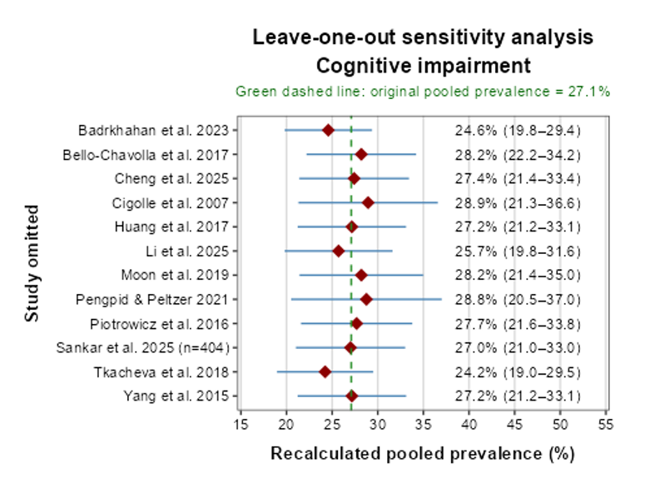A | 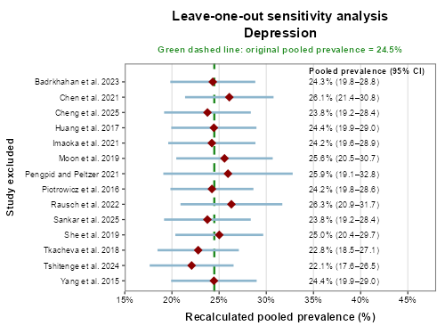B
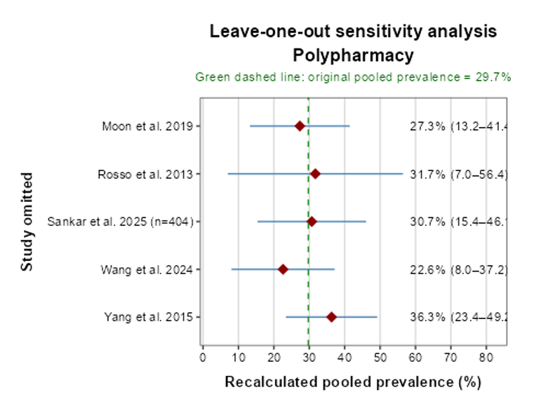 | 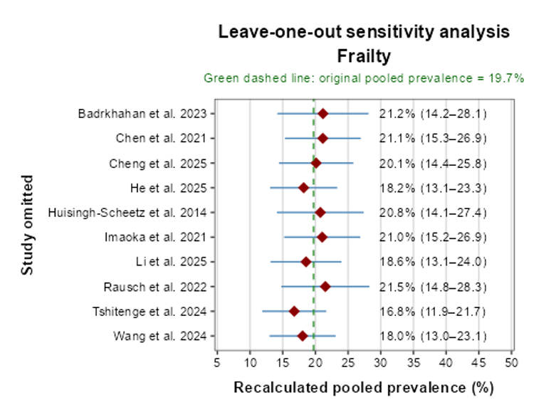
C | D
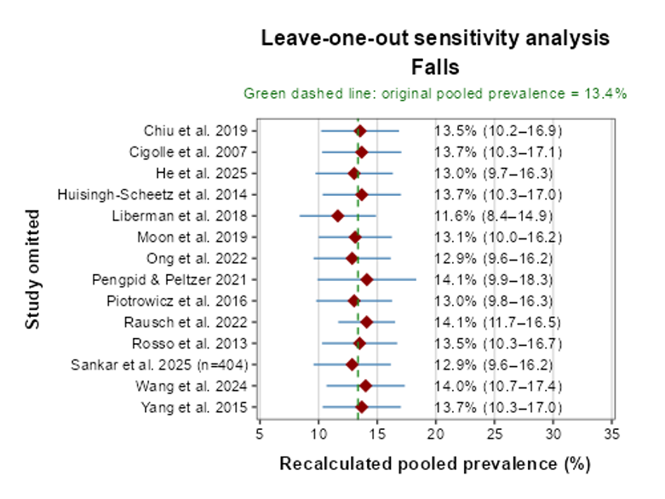
E
Supplementary Figure S1A–E. Leave-one-out sensitivity analyses of community-restricted pooled prevalence estimates. Panels present cognitive impairment (A), depression (B), polypharmacy (C), frailty (D), and falls (E). Each row shows the recalculated DerSimonian–Laird random-effects pooled prevalence after sequentially omitting the indicated study. Dark-red diamonds represent the recalculated pooled estimates, blue horizontal lines represent the corresponding 95% confidence intervals, and the green dashed vertical line indicates the original pooled prevalence before study exclusion. Estimates remained relatively stable for cognitive impairment, depression, frailty, and falls. Greater variation was observed for polypharmacy because only five studies contributed to that analysis.

8. Supplementary Figure S2A–D. Funnel plots
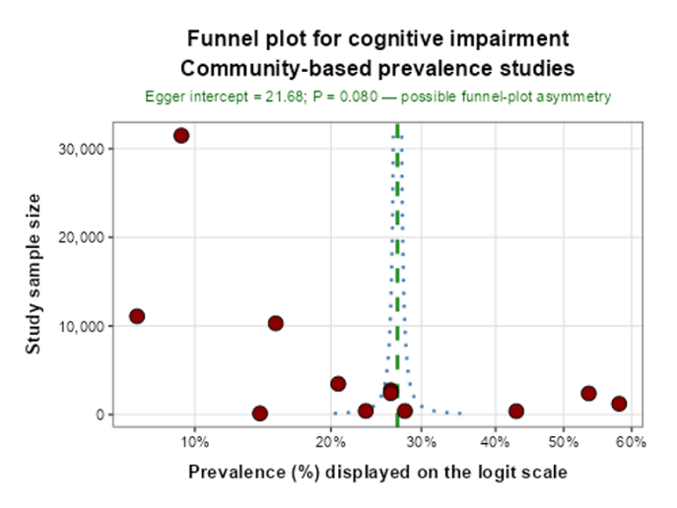 |  | 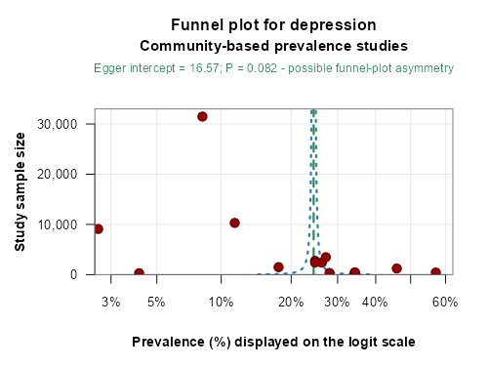
A |  | B
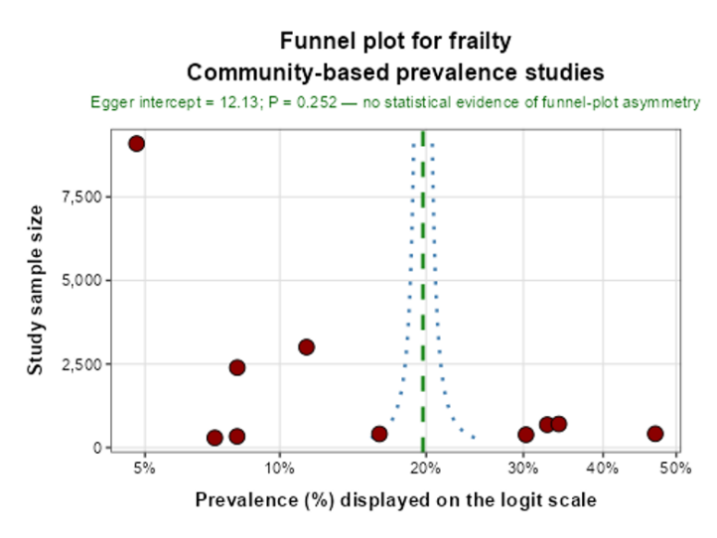 |  |  | 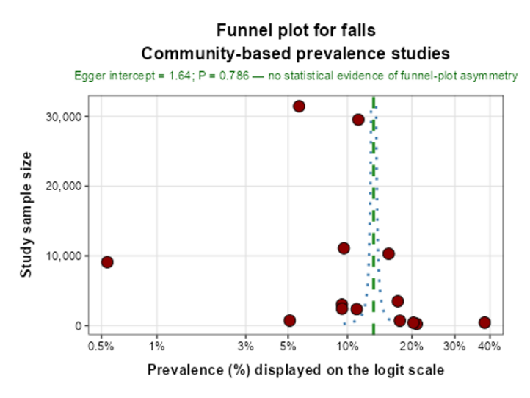
C | D
Supplementary Figure S2A–D. Funnel plots assessing small-study effects in community-restricted prevalence analyses. Separate plots are presented for cognitive impairment (A), depression (B), frailty (C), and falls (D). Dark-red circles represent individual study estimates, the green dashed vertical line represents the corresponding pooled prevalence estimate, and the blue dotted lines represent approximate 95% funnel limits. Prevalence is displayed as percentages on the logit scale along the horizontal axis, while study sample size is shown on the vertical axis. Egger’s regression suggested possible funnel-plot asymmetry for cognitive impairment and depression but showed no statistical evidence of asymmetry for frailty or falls. These findings were interpreted cautiously as possible small-study effects rather than definitive publication bias because substantial clinical and statistical heterogeneity remained. Polypharmacy was not assessed because fewer than 10 studies contributed to the analysis..

