Self-Designed Physical Activity Questionnaire for the Elderly (PASE)

(1) Self-Designed Physical Activity Questionnaire for the Elderly (PASE)
Please complete the following questionnaire based on your activities during the most typical week of the past month:
1. During the most typical week of the past month, how often did the patient engage in sitting activities, such as reading, watching TV, doing crafts, having tea, online shopping, playing cards, playing chess, etc.?
① Not at all ② Seldom (1-2 days/week) ③ Sometimes (3-4 days/week) ④ Often (5-7 days/week)
1a. What kind of sitting activities were done? (If none, skip to question 2) _______________________________________________________________________________________
1b. How much time was usually spent doing these sitting activities on a typical day?
① Less than 1 hour ② 1-2 hours ③ 2-4 hours ④ More than 4 hours

2. During the most typical week of the past month, how often did the patient walk outside the home or in the yard for any reason, for example, for fun or exercise, walking to buy groceries, taking a stroll, walking the dog, etc.?
① Not at all ② Seldom (1-2 days/week) ③ Sometimes (3-4 days/week) ④ Often (5-7 days/week)
2a. How much time was usually spent walking on a typical day? (If none, skip to question 3)
① Less than 1 hour ② 1-2 hours ③ 2-4 hours ④ More than 4 hours

3. During the most typical week of the past month, how often did the patient engage in light sports or recreational activities, such as Tai Chi, senior exercises, Yangge dancing, fishing, playing gateball, etc.?
① Not at all ② Seldom (1-2 days/week) ③ Sometimes (3-4 days/week) ④ Often (5-7 days/week)
3a. What light activities were usually done? (If none, skip to question 4) _______________________________________________________________________________________
3b. How much time was usually spent doing light sports or recreational activities on a typical day?
① Less than 1 hour ② 1-2 hours ③ 2-4 hours ④ More than 4 hours

4. During the most typical week of the past month, how often did the patient engage in moderate sports or recreational activities, such as ballroom dancing, kite flying, rollerblading, brisk walking, etc.?
① Not at all ② Seldom (1-2 days/week) ③ Sometimes (3-4 days/week) ④ Often (5-7 days/week)
4a. What moderate physical activities were usually done? (If none, skip to question 5) _______________________________________________________________________
4b. How much time was usually spent doing moderate sports or recreational activities on a typical day?
① Less than 1 hour ② 1-2 hours ③ 2-4 hours ④ More than 4 hours

5. During the most typical week of the past month, how often did the patient engage in strenuous sports or recreational activities, such as jogging, swimming, cycling, doubles badminton, square dancing, skiing, etc.?
① Not at all ② Seldom (1-2 days/week) ③ Sometimes (3-4 days/week) ④ Often (5-7 days/week)
5a. What strenuous physical activities were usually done? (If none, skip to question 6) _______________________________________________________________________
5b. How much time was usually spent doing strenuous sports or recreational activities on a typical day?
① Less than 1 hour ② 1-2 hours ③ 2-4 hours ④ More than 4 hours

6. During the most typical week of the past month, how often did the patient do any exercises specifically to increase muscle strength and endurance, such as weightlifting, push-ups, planks, etc.?
① Not at all ② Seldom (1-2 days/week) ③ Sometimes (3-4 days/week) ④ Often (5-7 days/week)
6a. What muscle strengthening exercises were usually done? (If none, skip to question 7) _____________________________________________________________________
6b. How much time was usually spent doing specific muscle strength and endurance training on a typical day?
① Less than 1 hour ② 1-2 hours ③ 2-4 hours ④ More than 4 hours

7. During the most typical week of the past month, did the patient do any light housework, such as dusting, cooking, washing dishes?
① No ② Yes

8. During the most typical week of the past month, did the patient do any heavy housework or move bulky items, for example, vacuuming, mopping floors, cleaning windows, hand-washing clothes, or carrying large water bottles?
① No ② Yes

9. During the most typical week of the past month, did the patient participate in any of the following activities?
a. Home repairs, such as fixing appliances ① Yes ② No
b. Lawn mowing, snow shoveling, or leaf raking ① Yes ② No
c. Watering plants ① Yes ② No
d. Caring for others, for example, children, a spouse/partner, or other adults ① Yes ② No

10. During the most typical week of the past month, did the patient do any paid work or volunteer activities? ① No ② Yes
10a. How many hours per week did the patient spend on paid work or volunteering? __________ hours (If none, skip to end)
10b. Which category best describes the level of physical activity required by the patient's job or volunteer work?
A. Mainly sitting with light arm movements (e.g., office worker, seated assembly line worker, etc.)
B. Sitting or standing with some walking (e.g., janitor, maintenance worker, food stall vendor, general office worker, etc.)
C. Walking, and handling materials generally lighter than 45 jin (approx. 22.5 kg or 50 lbs) (e.g., server, construction worker, etc.)
D. Walking and frequent heavy labor requiring handling materials heavier than 45 jin (approx. 22.5 kg or 50 lbs) (e.g., water delivery person, farm or general laborer, etc.)

Supplementary figure
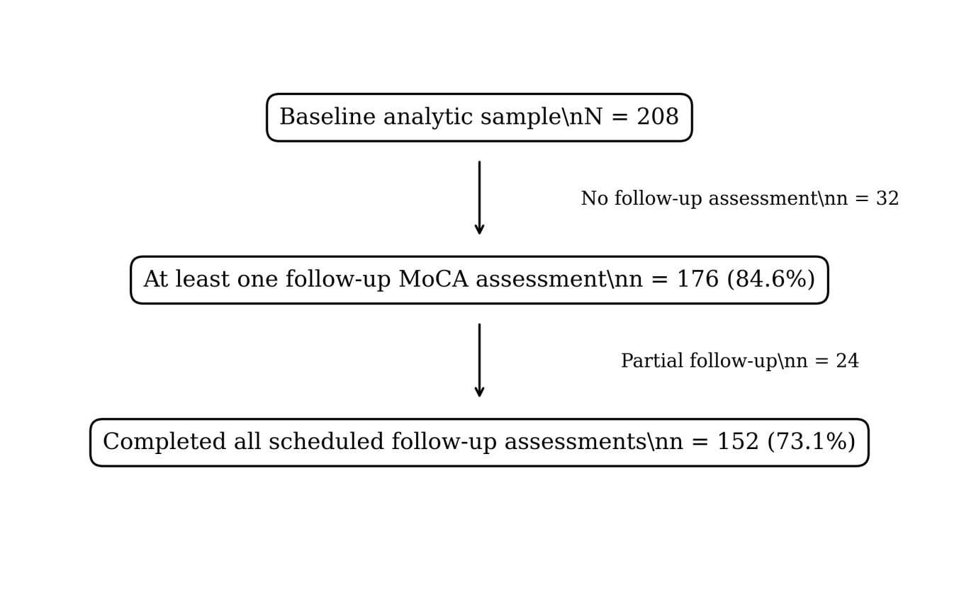
Figure S1. Participant flow through baseline and follow-up cognitive assessments. Follow-up intervals varied; therefore, counts are shown by completion status rather than fixed visit dates.

