Supplemental Material

Deconstructing the livestock manure digester and biogas controversy

Authors:

Allie Wainer^{1,2}*, David C. Love^{1,2}*, Brent F. Kim^{1,2}*, Jamie Harding^{1,2}, Qinfan Lyu ^{1,2}, D’Ann L. Williams^{1,2}, Christopher D. Heaney^{1,2,3,4,5}, Benjamin F. Hobbs^{1,6}, Keeve E. Nachman^{1-2,7}†

*Authors contributed equally.

Author Affiliations:

¹Department of Environmental Health and Engineering, Johns Hopkins University, Baltimore, MD, USA

²Johns Hopkins Center for a Livable Future, Johns Hopkins University, Baltimore, MD, USA

³Department of Epidemiology, Johns Hopkins University, Baltimore, MD, USA

⁴Department of International Health, Johns Hopkins University, Baltimore, MD, USA

⁵Community Science and Innovation for Environmental Justice Initiative, Johns Hopkins University, Baltimore, MD, USA

⁶Electric Power Innovation for a Carbon-free Economy Global Center, Johns Hopkins University, Baltimore, MD, USA

⁷Risk Sciences and Public Policy Institute, Johns Hopkins University, Baltimore, MD, USA

†Corresponding Author: Keeve E. Nachman, 615 North Wolfe Street, Room W7007, Baltimore, MD 21205-2179. Email: knachman@jhu.edu

Conflicts of Interest: The authors declare they have no conflicts of interest to disclose.

Table of Contents

Data availability

Which animal industries use manure digesters?

Table S1. Anaerobic manure digesters on livestock farms in the United States.

Figure S1. Number of anaerobic manure digesters at livestock operations in the United States, by status of operation.

Figure S2. Number of dairy cow anaerobic manure digesters in the United States by state, biogas end use, and digester type.

Figure S3. Map of anaerobic manure digesters at livestock operations in the United States.

Digester technologies

Figure S4. Covered lagoon manure digester schematic and in operation.

Figure S5. Plug flow manure digester schematic and in operation.

Figure S6. Complete mix manure digester schematic and in operation.

Methods

References

Data availability

Datasets and scripts used to create the figures in the manuscript and Excel Data Tables S2-S7 are available at a public GitHub repository: https://github.com/dave-love/biogas

Which animal industries use manure digesters?

Dairy waste digesters account for 84% of all manure digesters nationally in the AgSTAR database (Figure 2).¹ As of June 2024, there were 337 dairy digesters in operation, 48 dairy digesters under construction, and 13 digesters planned for 2025 and 2026 (Table S1).¹ From 2006 to 2013, many systems were built in Wisconsin, New York and Pennsylvania (Figures S2a, S3).¹ Early digesters were built on a mixture of small, medium and large farms, mainly generating biogas for on-site use as heat and electricity¹. Since 2016, new construction has shifted to California¹ due to renewable energy and methane reduction policies,² and targeted funding for manure digesters.³ Over a third (34%) of dairy manure digesters nationally are clustered in dairy-producing regions of California (mainly in Tulare, Merced, Kings, and Kern counties) (Figures S2a, S3).¹ Newer digesters in California are primarily covered manure lagoons (i.e., lined earthen basins for storing liquid manure) that produce compressed natural gas and pipeline gas that can be transmitted off-site for use (Figures S2b, S2c and Supplemental Material, heading “Covered lagoons”).¹

Swine waste digesters account for 11% of all manure digesters in the US.¹ As of June 2024, there were 43 swine waste digesters in operation and nine under construction.¹ Swine waste digesters are located in swine-producing regions of North Carolina (29%; n = 12) and Missouri (22%; n = 9) and sparsely distributed in 14 other states (Figure S3).¹ Two thirds of swine digesters are covered lagoons, which is consistent with most industrial-scale swine operations using manure lagoons.¹ Swine manure digesters mainly produce biogas for cogeneration, electricity and boiler/furnace fuel.¹ Recently, however, there has been a rise in the number of projects selling compressed natural gas, including six new digesters under construction in Wichita, Kansas.¹
Since early 2023, substantial plans for new manure digesters have been announced in the swine sector. For example, a joint venture of the Smithfield pork company and Dominion Energy utility company announced three biogas plants under development in Utah, North Carolina, and Virginia, two of which are centralized facilities accepting manure from 19 and 35 farms respectively.⁴
Manure digesters receive waste from an estimated 19.4% of all dairy cows and 2.8% of all swine in the US (Table S1).^{1,5} Manure digesters are being used by the largest dairy and swine operations, a conclusion based on reported estimates of herd sizes contributing to digesters¹ compared to national agriculture statistics (Table S1).⁵ Additionally, most digesters (93% of dairy digesters, 92% of swine digesters) are dedicated to a single farm. Fewer operations (8%) pool their waste together to feed a community or regional manure digester.¹

Currently, few farms raising other animal species have manure digesters; only eight poultry and four beef cattle manure digesters were reported in AgSTAR.¹ The reason for this is that beef cattle and poultry operations typically collect dry manure, which is a less suitable input for manure digesters. Since early 2023, however, CleanBay Renewables has shared plans to build 30 digesters for poultry manure in the US, starting with three approved projects in California, Maryland, and Delaware.⁶ These planned projects have yet to appear on the AgSTAR database.

More information about the different types of manure digesters is available in the Supplemental Material, heading “Digester technologies.”

Table S1. Anaerobic manure digesters on livestock farms in the United States.
Animal type | Number of digesters ª | Median herd size using digester  (interquartile range) ª | Total animals using digester (millions) ª | Total animal inventory  (millions) ^{b} | Percent of animals using digesters
Dairy cows | 385 | 3,010 (1,350-6,500) | 1.81 | 9.31 | 19.4%
Swine | 52 | 9,800 (5,125-29,700) | 2.10 | 73.8 | 2.8%
Mixed species | 11 | 2,200 (375-6,750) | 0.17 | na | na
Poultry | 8 | 155,000 (100,500-242,500) | 1.98 | 2,223 ^{c} | 0.09%
Beef cattle | 4 | 2,450 (2,133-3,125) | 0.011 | 29.2 | 0.04%
ª AgSTAR. Includes systems in operation and under construction using AgSTAR data from June 2024. Thirteen dairy manure digesters are planned for 2025 and 2026 which are not included in the total.
^{b} US Census of Agriculture 2022.⁵
^{c} Poultry includes broilers, layers, and turkeys

Figure S1. Number of anaerobic manure digesters at livestock operations in the United States by status of operation. Plots show the number of digesters newly under construction, brought into operation or shut down in a given year. Yearly bars do not include operations brought into operation in previous years that have remained in operation. Numerical data are provided in Supplemental Excel Table S4. Data source: EPA.¹

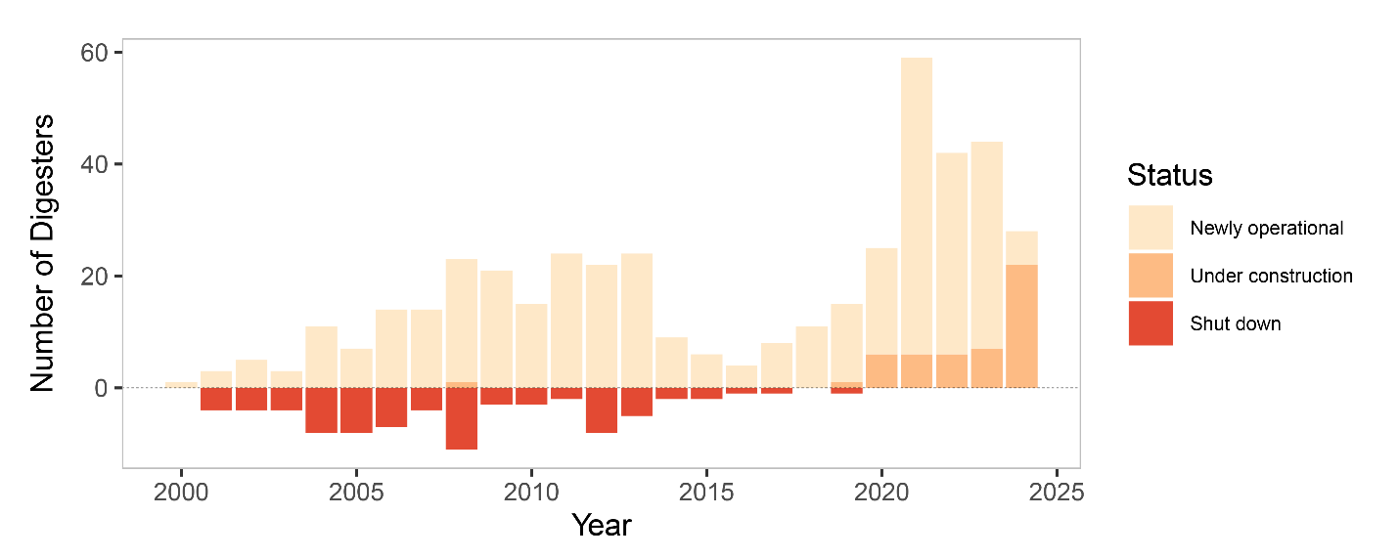

Figure S2. Numbers of dairy cow anaerobic manure digesters in the United States by a) state, b) biogas end use, and c) digester type. Includes systems in construction and in operation Abbreviations: CNG = Compressed natural gas, WI = Wisconsin, PA = Pennsylvania, NY = New York, CA = California. Numerical data are provided in Supplemental Excel Tables S5-S7. Data source: EPA.¹
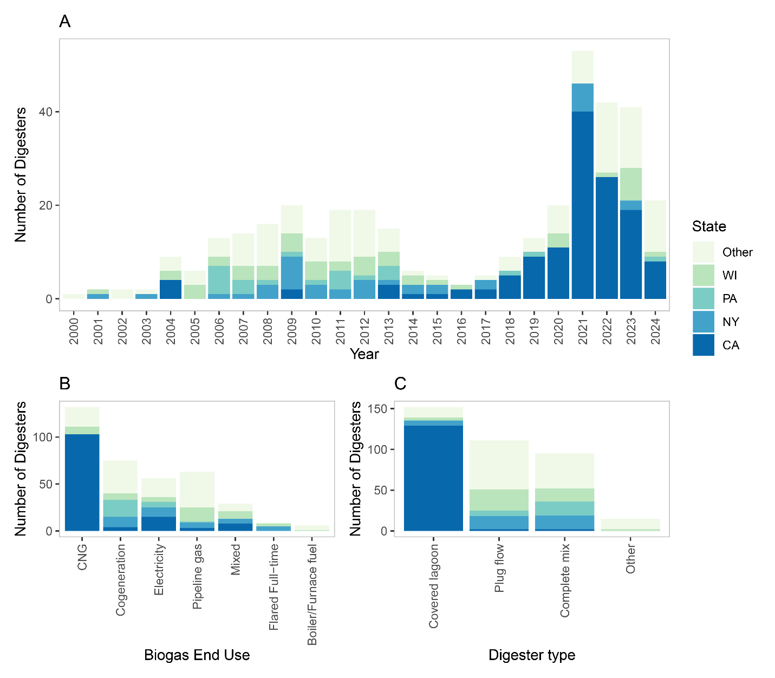

Figure S3. Map of anaerobic manure digesters at livestock operations in the United States. Digester projects are tracked by the AgSTAR program using publicly available and voluntary data. Source: EPA.¹
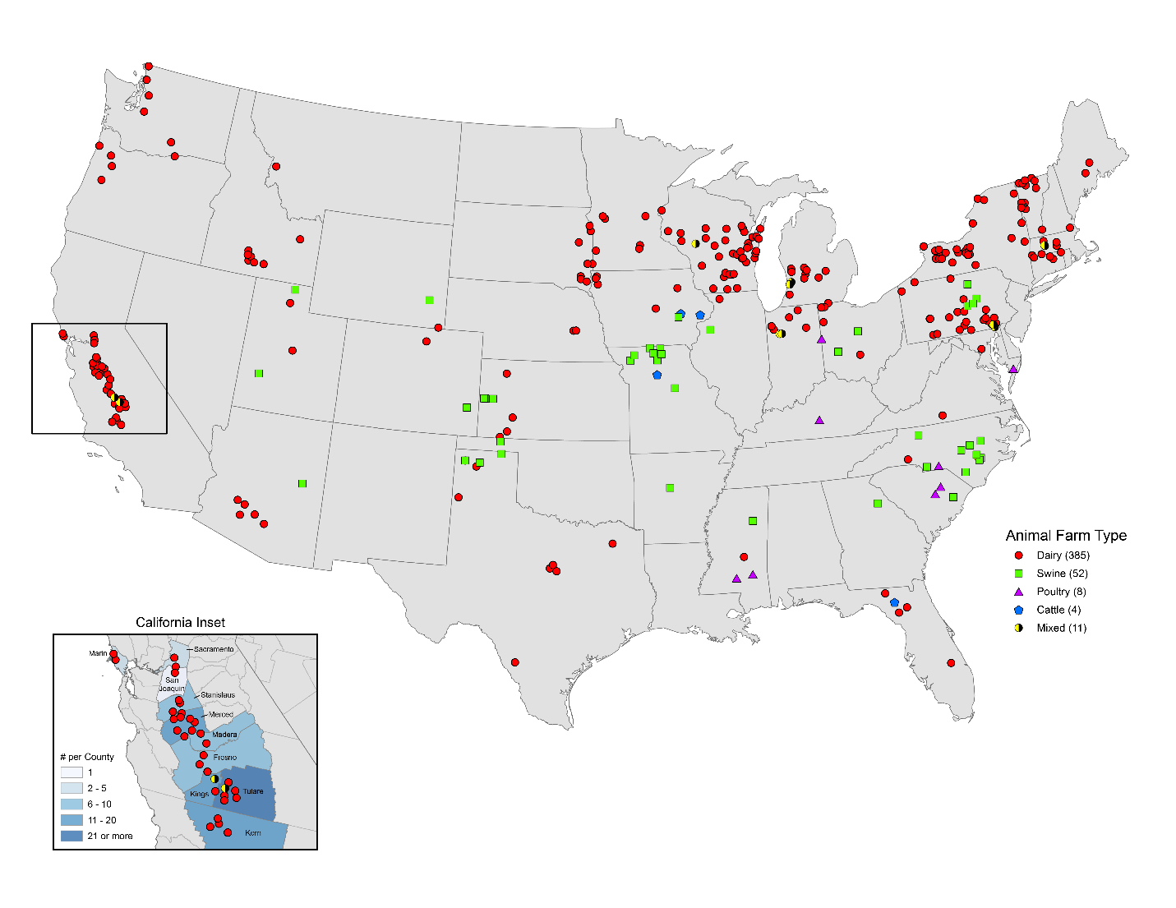

Digester technologies

The three main types of manure digesters used in the US are covered lagoons (41% of total), plug flow (28%), and complete mix digesters (24%), and the remaining 5% use other technologies.¹ The selection of digester technology depends on several factors including local climate, feedstock, manure management system (i.e., solid vs liquid manure collection), desired treatment times, planned biogas production, and available capital.⁷ Digesters operate at varying levels of efficiency at waste treatment and conversion of waste into biogas, which has implications for environmental and economic sustainability.
Covered lagoons
Covered lagoons are a retrofit to existing manure lagoons by adding a pond liner or gas-tight flexible geomembrane to trap biogas (Figure S4).⁷⁻⁹ Covered lagoons work well with manure that is mostly liquid (< 2% solids, as common in confined dairy and swine operations). Covered lagoons are less complex and costly to construct than other systems. They are considered “passive systems” and are not heated, which lowers biogas production during colder seasons. Digestion times for covered lagoons are 30-60 days. Covered lagoons can act as a stand-alone system or in tandem with a separate uncovered waste storage lagoon.

Plug flow digesters
Plug flow digesters are buried concrete, fiberglass, or metal tanks that are generally five times longer than wide and capped with an impermeable cover similar to a pond liner (Figure S5).⁷ A plug of manure is added which displaces the manure already in the system, and the effluent is drained into an uncovered lagoon. Plug flow digesters require solids to stay in suspension (10-20% solids) and work well with scraped manure management systems. Biogas production is improved if the system is mixed and heated. The digestion time in plug flow digesters is 15-30 days.

Complete mix digesters
In complete mix systems, manure is added to insulated cylindrical fiberglass, steel, or reinforced concrete tanks that are built above ground or partially buried, and biogas is trapped in an airtight dome (Figure S6).⁷ These systems are heated and continuously mixed to promote microbial activity. These digesters work with both scraped and washed manure management systems. The input liquid (2-5% solids) displaces an equal volume of liquid in the system, which is pumped or gravity-fed to an uncovered storage lagoon. Digestion times for complete mix systems are 10-30 days.

Biogas uses

Based on AgSTAR data, the main uses for biogas are compressed natural gas (29%), cogeneration of heat and electricity (20%), electricity (17%), pipeline gas (17%), boiler/furnace fuel (3%), flared full-time (3%), or mixed systems (11%).¹

Figure S4. Covered lagoon manure digester a) schematic and b) in operation. Photo source: https://www.epa.gov/agstar/anaerobic-system-design-and-technology

a)

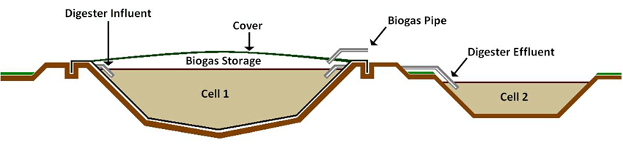
b)

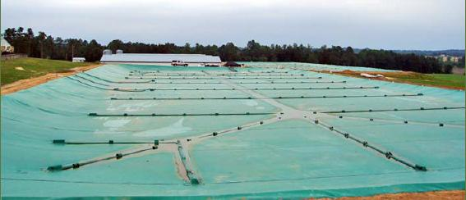

Figure S5. Plug flow manure digester a) schematic and b) in operation. Photo source: https://www.epa.gov/agstar/anaerobic-system-design-and-technology

a)
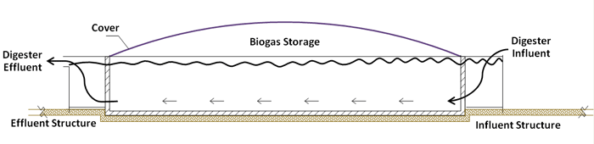
b)

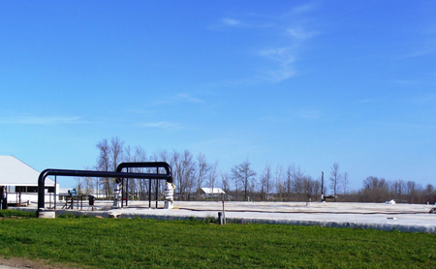

Figure S6. Complete mix manure digester a) schematic and b) in operation. Photo source: https://www.epa.gov/agstar/anaerobic-system-design-and-technology

a)
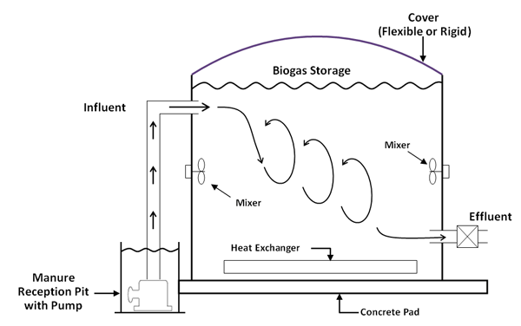

b)

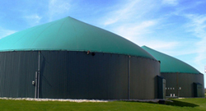

Methods

Characterization of manure digester adoption

To characterize manure digester adoption in the US livestock industry, we analyzed data from AgSTAR. The AgSTAR program is a collaboration between the US Environmental Protection Agency (US EPA) and the US Department of Agriculture (USDA) which maintains an active database of manure digesters.¹ AgSTAR staff proactively scan public information (including online news articles, press releases, technical support documentation for carbon registries or grant applications, developer websites, and permits) to identify digesters in the planning, development, construction and operational phases, as well as those that shut down. In response to requests from developers, the public facing version of the database only includes digesters in the construction phase and beyond. While AgSTAR cannot guarantee that all active digesters are included in the database, they believe that active systems are more likely than not to be included. The increased popularity of this technology, however, may mean that new digesters are less newsworthy and thus more likely to be missed by AgSTAR’s active tracking efforts and inadvertently excluded from the database (Nick Elger/AgSTAR, personal communication). The AgSTAR database was the primary source of information about trends in manure digester construction, operation, and closures. AgSTAR is currently the best available dataset in the US for manure digesters, however there are limitations, and we did not verify or augment this dataset. AgSTAR data and script to recreate the figures are available in a public GitHub repository.¹⁰

Identification of proponent and opponent claims

Proponent and opponent claims were identified using the Google search engine with the terms “benefits”, “biogas”, “biodigester”, “climate”, “environment justice”, “factory farm”, “livestock”, and “manure.” Relevant results were included if they were documents from non-profit organizations, academic centers, industry groups, or US government agencies; legislator letters; or regulatory comments submitted by non-profit organizations. Further claims were identified via references cited in the included sources. Additional proponent viewpoints were identified on websites of companies that design or build manure digesters, as listed in the AgSTAR database.

Identification of published evidence

To identify published evidence concerning manure digesters and associated themes, we conducted a non-systematic review using keyword searches in Google Scholar related to air, soil, and water pollutants; occupational health and safety hazards; environmental injustice for fenceline communities; economics; climate change; and energy infrastructure.

Estimation of digester retirement rate and expected facility lifetime

To determine the average annual rate of manure digester retirement due to failure, economic, or other reasons, we analyzed the AgSTAR database as of June 2024.¹ The database included both retired and operating facilities. Assuming a simple survival model in which the probability of still operating n years after installation is exp(-λn), and assuming that retirements of different facilities are statistically independent events leads to a likelihood function of:

ℒ = Π_{i=1,..,N} [W_{i}*exp(-λn_{i}) + (1- W_{i})*(1-exp(-λn_{i}))],

where N is the number of facilities; W_{i} = 1 if facility i is still operating when the database was compiled (2024), and W_{i} = 0 if it had been retired by that year; n_{i} = number of years between the year of installation of facility i and 2024; and λ = the annual retirement rate (in units of 1/year). Given the data described above, λ can be estimated by maximizing the likelihood function, yielding λ = 0.021/year.

REFERENCES

1. United States Environmental Protection Agency. Livestock Anaerobic Digester Database. Accessed: 26 February 2025. Available: https://www.epa.gov/agstar/livestock-anaerobic-digester-database
2. California Legislative Analyst's Office. Assessing California's Climate Policies—Agriculture. Accessed: 2 July 2024.
3. California Department of Food and Agriculture. California Department of Food and Agriculture Awards Nearly $102 Million for Dairy Methane Reduction Projects. Accessed: 2 July 2024. Available: https://www.cdfa.ca.gov/egov/press_releases/Press_Release.asp?PRnum=19-085
4. Align RNG. Projects. Accessed: 2 July 2024. Available: https://alignrng.com/projects.aspx
5. United States Department of Agriculture. Census of Agriculture - 2022 Census Volume 1, Chapter 1: U.S. National Level Data. Accessed: 15 July 2024. Available: https://www.nass.usda.gov/Publications/AgCensus/2022/Full_Report/Volume_1,_Chapter_1_US/
6. CleanBay Renewables. CleanBayRenewables at a Glance. Accessed: 2 July 2024. Available: https://mgaleg.maryland.gov/cmte_testimony/2023/ecm/14513_03072023_192614-610.pdf
7. Moss AR. Anaerobic Digesters: Designs. Accessed: 23 July 2024. Available: https://enst.umd.edu/sites/enst.umd.edu/files/files/documents/Extension/Anaerobic-Digest_Designs.pdf
8. Hamilton DW. Anaerobic Digestion of Animal Manures: Types of Digesters. Accessed: 23 July 2024. Available: https://enst.umd.edu/sites/enst.umd.edu/files/files/documents/Extension/Anaerobic-Digest_Designs.pdf
9. United States Environmental Protection Agency. Anaerobic System Design and Technology. Accessed: 23 July 2024. Available: https://www.epa.gov/agstar/anaerobic-system-design-and-technology
10. Love DC. GitHub- dave-love/biogas. Accessed: 26 February 2025. Available: https://github.com/dave-love/biogas

