Supplement Table 1. Summary of medication counts of by category, not exclusive
 | Medication Category
Number of medications | Insulin | Hypertension | Cholesterol Lowering
0 | 566 | 398 | 442
1 | 6 | 112 | 127
2 | 7 | 52 | 8
3+ | 0 | 17 | 2

Supplement Table 2. PB Pattern Library Definitions
Measure name (variable name) | Description | R package calculation
Total sedentary minutes (total_sed_min) | Total sedentary minutes | total_sed_min
Percent sedentary time of total time (sed_perc) | Percent of sedentary time of total wear time | total_sed_min / total_weartime_min
Mean sedentary breaks per day (sed_breaks_day) | Average of total sedentary bouts by number of days | n_sed_bouts / n_days
Median sedentary bout duration (median_bout_duration) | Median sedentary bout duration in minutes | bouts$lengths_min %>% stats::quantile(probs = 0.5)
Mean sedentary bout duration (mean_bout_duration) | Average sedentary duration in minutes | mean(bouts$lengths_min)
Bouts ≥ 30 min (hours_bouts_more_30min) | For bouts 30 minutes or longer, total time in hours | sum(ifelse(bouts$lengths_min >= 30, bouts$lengths_min, 0)) / 60
Frequency of sedentary bouts (sed_bout_frequency) | Sum of all minutes in sedentary bouts by number of days | total_sed_min / (n_days * 60)
Bout frequency (sed_bout_frequency) | Average sedentary bouts by total minutes of wear time | n_sed_bouts / total_weartime_min * 60

Supplement Table 3. Interaction term results from logistic regressions for cut point and CHAP sedentary measure associations (standardized odds ratios with 95% confidence intervals) with the outcome of Metabolic Syndrome, interaction terms with Hispanic/Latino. Likelihood ratio test p value is provided to compare each interaction model (e.g., Model 0b) to original model without interaction term (e.g., Model 0).
N=579 | Model 1b:  Covariates | LRT p | Model 2b:  Covariates  + % total sed + MVPA | LRT p
Mean breaks per day
Cut point*Hispanic/Latino | 1.15 (0.94, 1.41) | 0.17 | 1.08 (0.88, 1.33) | 0.45
CHAP*Hispanic/Latino | 1.02 (0.83, 1.25) | 0.87 | 0.97 (0.79, 1.19) | 0.77
Median bout duration
Cut point*Hispanic/Latino | 1.00 (0.81, 1.22) | 0.97 | 0.97 (0.78, 1.20) | 0.76
CHAP*Hispanic/Latino | 1.15 (0.93, 1.42) | 0.20 | 1.09 (0.88, 1.36) | 0.45
Hours in bouts ≥ 30 mins
Cut point*Hispanic/Latino | 0.93 (0.76, 1.14) | 0.47 | 0.90 (0.73, 1.11) | 0.32
CHAP*Hispanic/Latino | 1.05 (0.86, 1.28) | 0.63 | 1.00 (0.82, 1.23) | 0.98
Covariates: age, sex, Hispanic/Latino, education, any MetS medication, daily wear time

Supplement Figure 1. Correlations for sedentary time and patterns as measured by cutpoints.
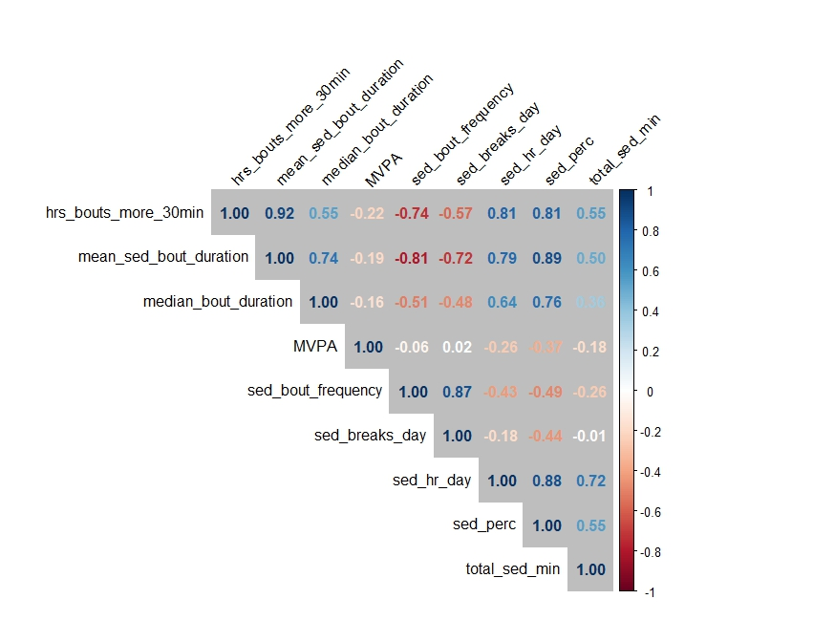

Supplement Figure 2. Correlations for sedentary time and patterns as measured by CHAP.
