SUPPLEMENTARY INFORMATION
Journal of Racial and Ethnic Health Disparities
Characteristics of Patients with Pulmonary Arterial Hypertension Receiving Selexipag in the SPHERE Registry by Race and Ethnicity
Harrison W. Farber, Murali M. Chakinala, Anna R. Hemnes, Kelly M. Chin, Kristin B. Highland, Vallerie V. McLaughlin, Lana D. Melendres-Groves, Michelle Cho, Gurinderpal Doad, Elham Fatehi, Michelle Han, Mohammad Rahman, Paul Strachan, Tobore Tobore, Nick H. Kim
Corresponding author: Harrison W. Farber, email: harrison.farber1@tuftsmedicine.org

Table S1 Selexipag dosing regimen and titration schemes in patients with PAH, according to race/ethnicity
Parameter | Non-Hispanic White  (n = 549) | Black/African American  (n = 117) | Hispanic  (n = 45) | Otherª  (n = 48) | Overall  (N = 759)
Duration of the titration phase, weeks
Median (IQR) | 8.1 (5.1–10.9) | 8.0 (5.0–11.0) | 8.3 (4.6–11.1) | 8.1 (5.3–13.1) | 8.1 (5.0–11.1)
Minimum, maximum | 1.1, 26.9 | 1.1, 26.4 | 1.1, 22.3 | 1.1, 25.7 | 1.1, 26.9
Uptitration speed (µg twice daily/week), n (%)
< 200 | 490 (89.3) | 102 (87.2) | 39 (86.7) | 40 (83.3) | 671 (88.4)
≥ 200 | 59 (10.7) | 15 (12.8) | 6 (13.3) | 8 (16.7) | 88 (11.6)
Selexipag maintenance dose, μg twice daily
n | 527 | 111 | 45 | 46 | 729
Median (IQR) | 1,200 (600–1,600) | 1,000 (600–1,600) | 1,200 (600–1,600) | 1,000 (600–1,400) | 1,100 (600–1,600)
Minimum, maximum | 100, 3,200 | 100, 1,600 | 100, 1,600 | 100, 1,600 | 100, 3,200
IQR, interquartile range; PAH, pulmonary arterial hypertension
ª Other group: Asian (n = 26), Native Hawaiian/Pacific Islander (n = 3), American Indian/Alaska Native (n = 2), another race/ethnicity (n = 10), and unknown race/ethnicity (n = 7)
Fig. S1 Regional variability in race/ethnicity among patients with PAH in the SPHERE registry
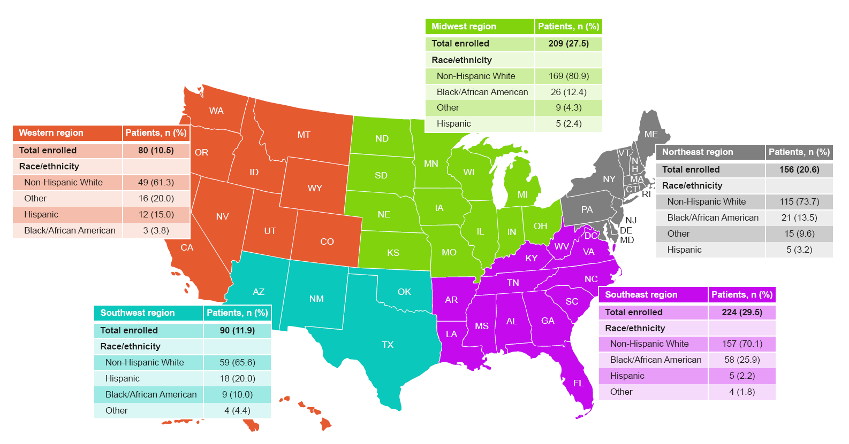
PAH = pulmonary arterial hypertension; SPHERE = SelexiPag: tHe usErs dRug rEgistry

