Supplementary Table 1. Baseline Characteristics by Insurance Type

Characteristic | BCBS  N = 10,814¹ | Medicaid  N = 47,298¹ | Medicare  N = 357¹ | Other  N = 5,446¹ | Other Government  N = 4,134¹ | Private  N = 45,395¹ | Self Pay  N = 11,261¹ | Workers Comp  N = 107¹ | p-value²
Age (years) | 12.0 (8.0, 15.0) | 9.0 (4.0, 14.0) | 12.0 (5.0, 15.0) | 12.0 (7.0, 15.0) | 9.0 (4.0, 14.0) | 12.0 (7.0, 15.0) | 11.0 (5.0, 15.0) | 15.0 (11.0, 16.0) | <0.001
Injury Severity Score | 16.0 (12.0, 21.0) | 16.0 (11.0, 22.0) | 16.0 (11.0, 22.0) | 16.0 (12.0, 22.0) | 16.0 (11.0, 22.0) | 16.0 (10.0, 20.0) | 16.0 (11.0, 25.0) | 16.0 (13.0, 22.0) | <0.001
Glasgow Coma Scale | 15.0 (14.0, 15.0) | 15.0 (12.0, 15.0) | 15.0 (13.0, 15.0) | 15.0 (12.0, 15.0) | 15.0 (13.0, 15.0) | 15.0 (14.0, 15.0) | 15.0 (8.0, 15.0) | 15.0 (10.0, 15.0) | <0.001
Sex |  |  |  |  |  |  |  |  | <0.001
Female | 3,519 (33%) | 16,141 (34%) | 124 (35%) | 1,934 (36%) | 1,397 (34%) | 14,808 (33%) | 3,646 (32%) | 26 (24%)
Male | 7,295 (67%) | 31,157 (66%) | 233 (65%) | 3,512 (64%) | 2,737 (66%) | 30,587 (67%) | 7,615 (68%) | 81 (76%)
Mechanism of Injury
Assault | 38 (0.4%) | 657 (1.4%) | 5 (1.4%) | 41 (0.8%) | 39 (0.9%) | 242 (0.5%) | 141 (1.3%) | 4 (3.7%)
Fall | 3,024 (28%) | 11,195 (24%) | 96 (27%) | 919 (17%) | 1,132 (27%) | 13,034 (29%) | 2,168 (19%) | 25 (23%)
Firearm | 157 (1.5%) | 2,041 (4.3%) | 15 (4.2%) | 176 (3.2%) | 182 (4.4%) | 843 (1.9%) | 590 (5.2%) | 3 (2.8%)
MVC | 3,528 (33%) | 17,961 (38%) | 117 (33%) | 2,902 (53%) | 1,645 (40%) | 15,466 (34%) | 4,619 (41%) | 44 (41%)
Other | 3,987 (37%) | 14,690 (31%) | 117 (33%) | 1,352 (25%) | 1,071 (26%) | 15,376 (34%) | 3,532 (31%) | 31 (29%)
Stab/Cut | 80 (0.7%) | 754 (1.6%) | 7 (2.0%) | 56 (1.0%) | 65 (1.6%) | 434 (1.0%) | 211 (1.9%) | 0 (0%)
In-Hospital Mortality | 294 (2.7%) | 1,653 (3.5%) | 20 (5.6%) | 259 (4.8%) | 135 (3.3%) | 1,053 (2.3%) | 699 (6.2%) | 5 (4.7%)
¹Median (Q1, Q3); n (%)
²Kruskal-Wallis rank sum test; Pearson's Chi-squared test; NA

Supplementary Table 2. Regression analysis and interaction analysis

Characteristic | OR | 95% CI | p-value
Race/Ethnicity
Non-Hispanic White | — | —
Non-Hispanic Black or African American | 1.12 | 0.99, 1.26 | 0.072
Non-Hispanic Asian | 0.76 | 0.42, 1.28 | 0.3
Non-Hispanic American Indian or Alaska Native | 0.94 | 0.65, 1.33 | 0.7
Non-Hispanic Native Hawaiian or Pacific Islander | 0.98 | 0.32, 2.45 | >0.9
Hispanic or Latino | 0.92 | 0.80, 1.05 | 0.2
Other/Unknown | 1.02 | 0.82, 1.25 | 0.9
Insurance Status
Medicaid | — | —
Other | 1.02 | 0.92, 1.14 | 0.7
Private | 0.91 | 0.83, 1.01 | 0.083
Self-pay | 1.20 | 1.04, 1.39 | 0.014
Age (years) | 0.98 | 0.97, 0.98 | <0.001
Injury Severity Score | 1.04 | 1.04, 1.04 | <0.001
Glasgow Coma Scale | 0.67 | 0.67, 0.68 | <0.001
Sex
Female | — | —
Male | 0.95 | 0.90, 1.01 | 0.14
Mechanism of Injury
Fall | — | —
MVC | 1.27 | 1.13, 1.42 | <0.001
Firearm | 4.19 | 3.60, 4.87 | <0.001
Stab/Cut | 2.16 | 1.56, 2.97 | <0.001
Assault | 2.79 | 2.10, 3.68 | <0.001
Other | 2.05 | 1.84, 2.30 | <0.001
Race/Ethnicity * Insurance Status
Non-Hispanic Black or African American * Other | 1.06 | 0.87, 1.29 | 0.5
Non-Hispanic Asian * Other | 1.60 | 0.78, 3.33 | 0.2
Non-Hispanic American Indian or Alaska Native * Other | 0.64 | 0.30, 1.27 | 0.2
Non-Hispanic Native Hawaiian or Pacific Islander * Other | 0.19 | 0.01, 1.47 | 0.2
Hispanic or Latino * Other | 1.02 | 0.82, 1.27 | 0.8
Other/Unknown * Other | 1.19 | 0.89, 1.58 | 0.2
Non-Hispanic Black or African American * Private | 1.13 | 0.92, 1.39 | 0.2
Non-Hispanic Asian * Private | 1.25 | 0.63, 2.57 | 0.5
Non-Hispanic American Indian or Alaska Native * Private | 0.88 | 0.35, 1.97 | 0.8
Non-Hispanic Native Hawaiian or Pacific Islander * Private | 0.95 | 0.17, 4.69 | >0.9
Hispanic or Latino * Private | 1.07 | 0.84, 1.35 | 0.6
Other/Unknown * Private | 0.93 | 0.68, 1.27 | 0.6
Non-Hispanic Black or African American * Self-pay | 0.91 | 0.71, 1.17 | 0.5
Non-Hispanic Asian * Self-pay | 1.83 | 0.78, 4.26 | 0.2
Non-Hispanic American Indian or Alaska Native * Self-pay | 2.32 | 0.99, 5.33 | 0.050
Non-Hispanic Native Hawaiian or Pacific Islander * Self-pay | 4.60 | 0.48, 55.2 | 0.2
Hispanic or Latino * Self-pay | 1.04 | 0.80, 1.36 | 0.8
Other/Unknown * Self-pay | 1.22 | 0.82, 1.79 | 0.3
Abbreviations: CI = Confidence Interval, OR = Odds Ratio

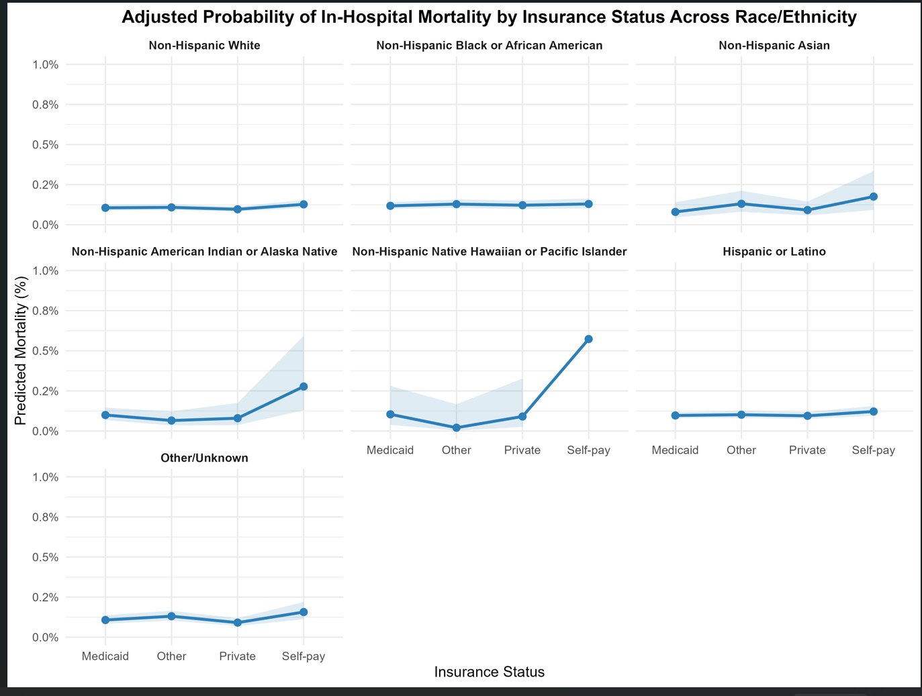
Supplementary Figure 1. Adjusted probability of in-hospital mortality by insurance status across race/ethnicity

