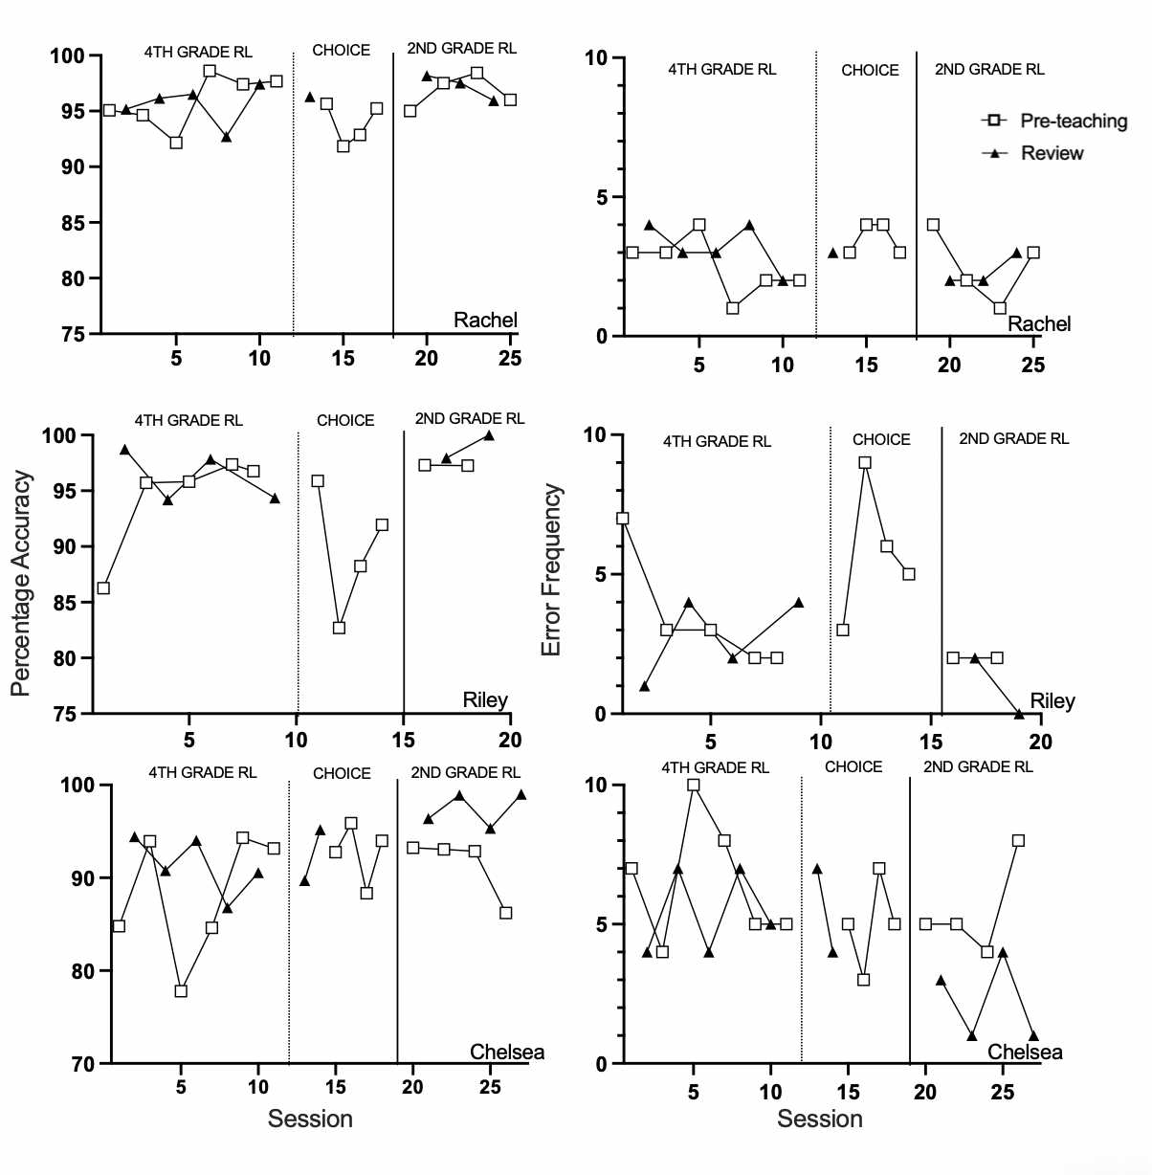
Supplemental Figure 1
Accuracy and error frequency during the first WRCM probe in morning intervention sessions.
Note. RL = reading level.

Supplemental Figure 2

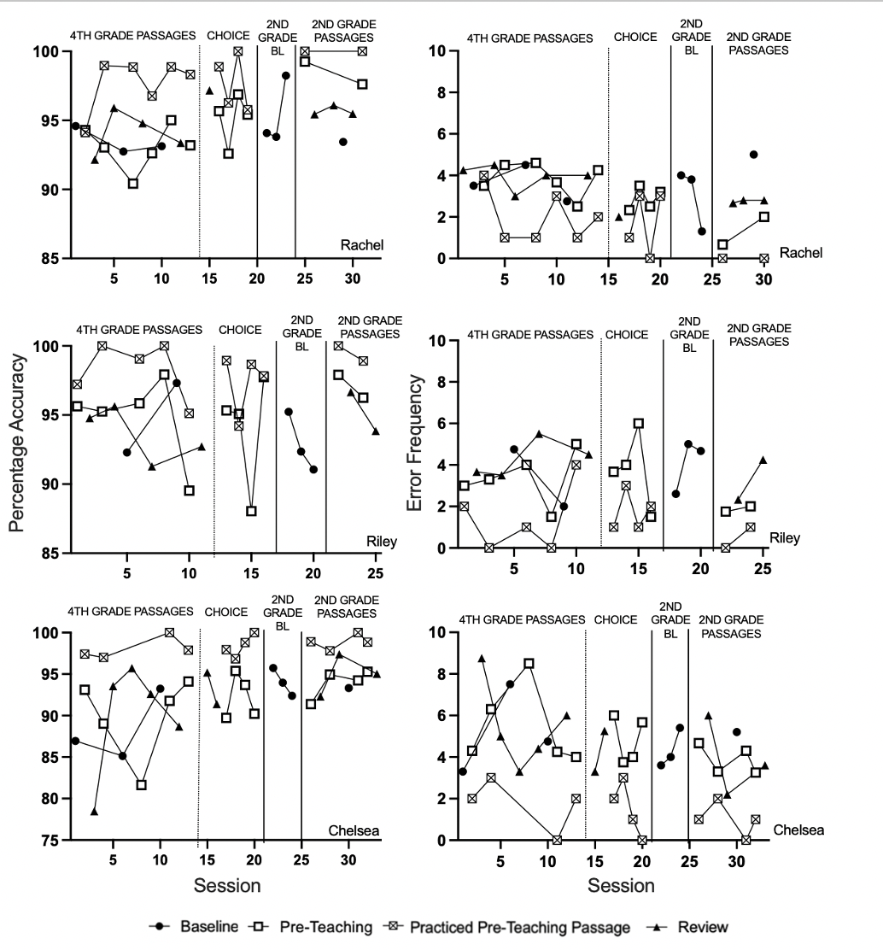
Accuracy and Error Frequency During Small Group Readings.

Note. BL = baseline.

Supplemental Figure 3
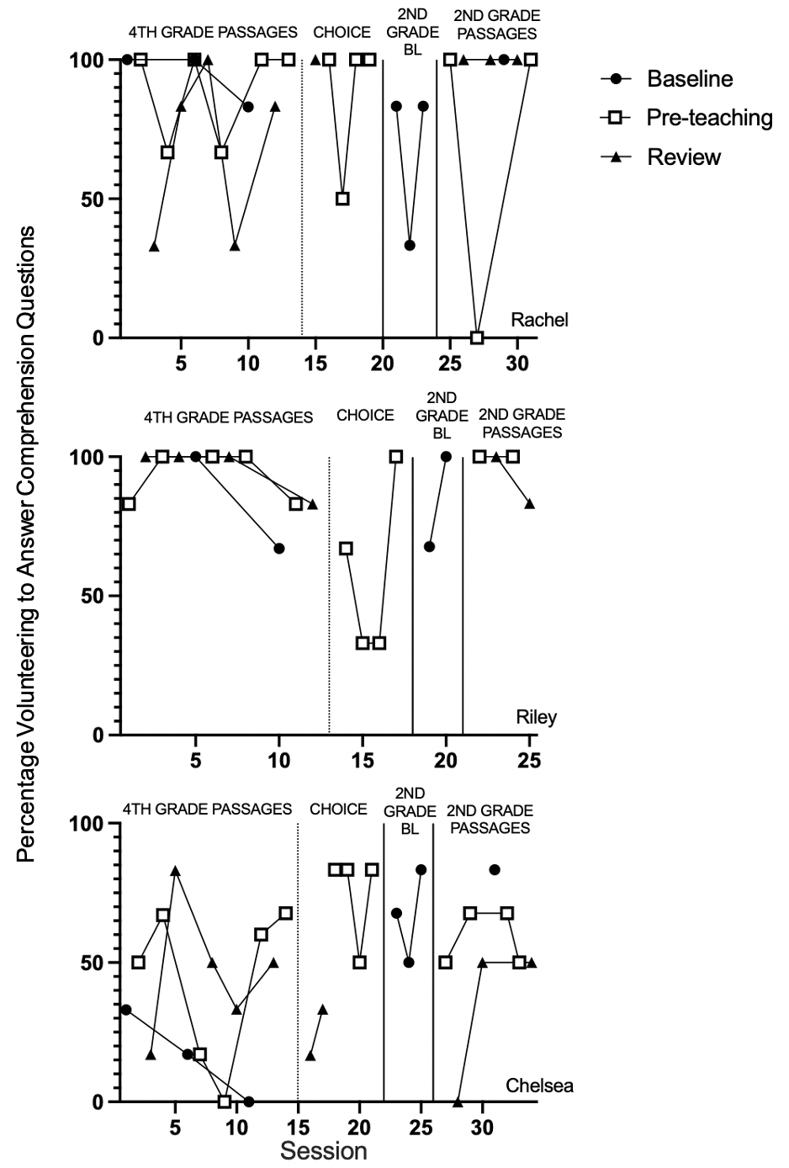
Percentage of volunteering to answer comprehension questions.

Note. BL = baseline

Procedural Fidelity Checklists
Afternoon Small Group – Procedural Fidelity Checklist
Correct materials present (reading passages [one for experimenter, one for participant], timer, rewards)
___ Correct instructions provided
___ Experimenter reads the first word if the participant does not begin reading within 3s of saying “Begin”
___ Experimenter records words read incorrectly by marking the error on their copy
___ Stops timer at one minute and instructs participant to stop reading
___ Records the last word read by marking their copy
___ Allows participant to select reward

______ out of 7
______________________________________________________________________________

Morning Individual Intervention – Procedural Fidelity Checklist
Correct materials present (WRCM reading passage [one for experimenter, one for participant], pre-teaching OR review reading passage [one for experimenter, one for participant], timer, colored condition card, rewards)
___ Correct condition colored card on display
___ Correct (pre-teaching or review) instructions provided
___ Experimenter reads the first word if the participant does not begin reading within 3s of saying “Begin” for initial WRCM probe
___ Experimenter records words read incorrectly by marking the error on their copy
___ Experimenter stops timer at one minute and instructs participant to stop reading
___ Records the last word read by marking their copy
___ Experimenter reads (pre-teaching or review) reading passage
___ Participant reads (pre-teaching or review) passage 3x or until they reach mastery criterion
___ Experimenter stops timer at one minute and instructs participant to stop reading
___ Experimenter records the number of times the student read the passage until mastery or reaching the maximum allotted
___ Experimenter helps participant with any words they need assistance with
___ Allows participant to select reward

______ out of 13
______________________________________________________________________________

