Supplementary Information

Supplementary Figure 1

Seating Arrangements and Participant Locations Used in The Classroom
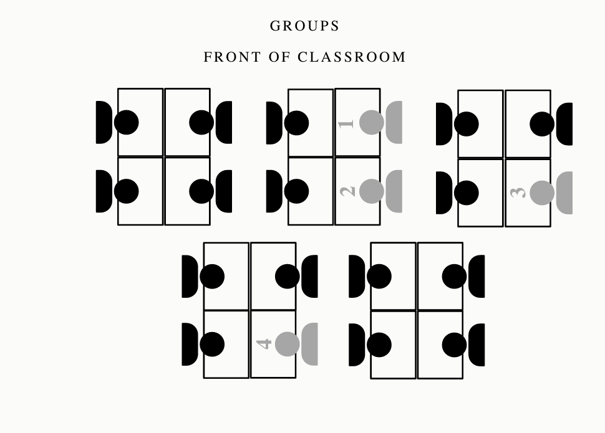
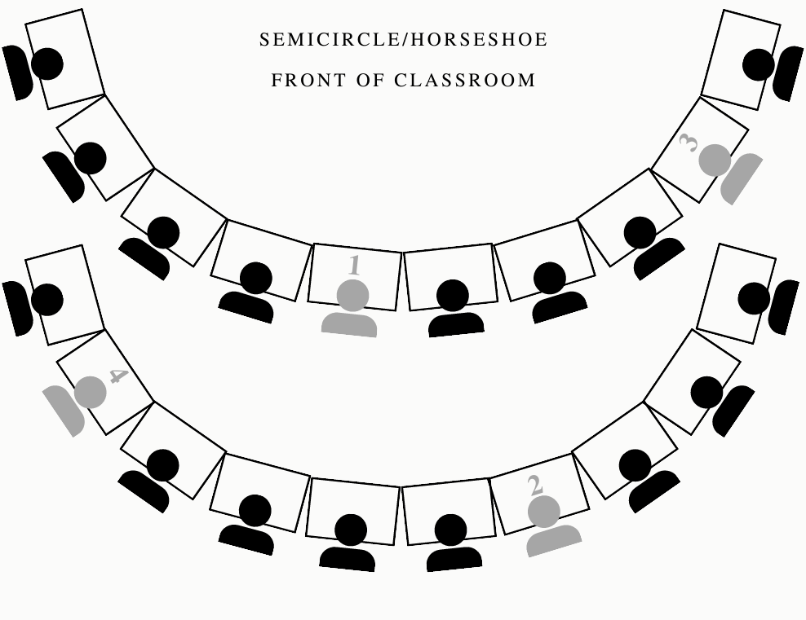
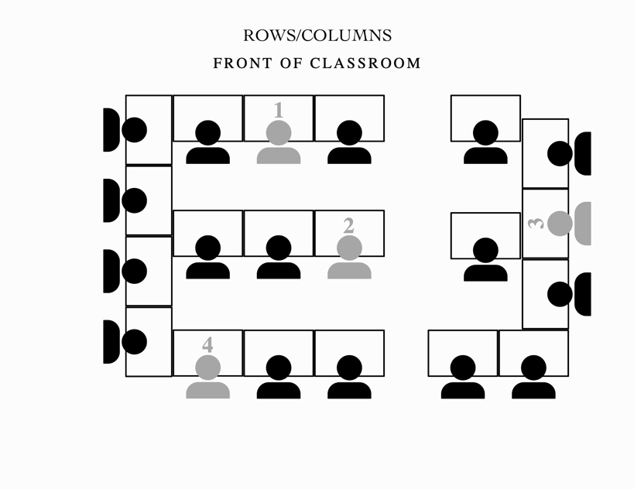

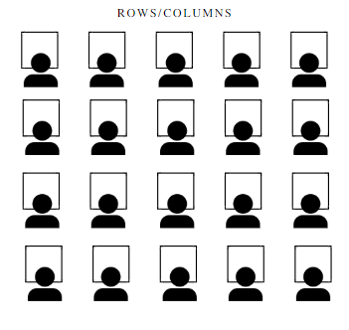

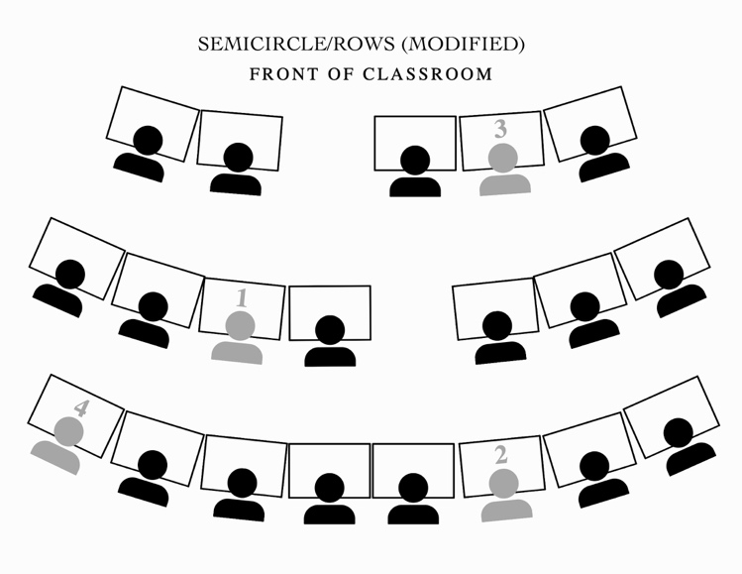
ROWS/COLUMNS (MODIFIED)

Note. Student participants represented by grey shading. Student One: Oliver, Student Two: Toby, Student Three: Thelma, and Student Four: Francis
Supplementary Table 1

Treatment Integrity Checklist Across Phases

Item | Yes or No
1. The correct seating arrangement is set up (rows, semicircle, groups)
2. Students are seated in the correct seat according to the seating chart
3. The predetermined classroom management system is implemented
4. If applicable, a different seating arrangement from the previous day is
used
5. If applicable, the majority vote for the seating arrangement is used

Supplementary Table 2
Interobserver Agreement and Treatment Integrity Across Phases
 | Baseline | Rows (modified) | Groups | Semicircle | Choice (Semicircle) | Modified Semicircle/Rows
% of Sessions IOA | 60.0% | 33.0% | 66.0% | 33.0% | 33.0% | 33.0%
Disruption IOA | 91.7% | 96.0% | 91.5% | 94.0% | 91.0% | 91.0%
On-Task IOA | 90.0% | 95.0% | 84.5% | 78.0% | 90.0% | 82.0%
Total IOA | 90.9% | 96.0% | 88.0% | 86.0% | 91.0% | 87.0%
% of Sessions TI | 100.0% | 100.0% | 100.0% | 100.0% | 100.0% | 100.0%
Treatment Integrity | 92.0% | 100.0% | 100.0% | 100.0% | 100.0% | 100.0%

Supplementary Table 3
Teacher and Student Pre- and Post-Seating Arrangement Questionnaire Responses

 | Question | Pre | Post
Student 1 | Q1: What is important to you during math? | listening | (did not answer)
Student 1 | Q2: Do you prefer sitting in rows, groups, or semicircles? | groups | Semicircle
Student 1 | Q3: What do you want to get better at during math? | learning my times tables | times tables
Student 2 | Q1: What is important to you during math? | To get most questions right | I don't know
Student 2 | Q2: Do you prefer sitting in rows, groups, or semicircles? | Groups | (did not answer)
Student 2 | Q3: What do you want to get better at during math? | Divison | nothing
Student 3 | Q1: What is important to you during math? | I don't know | everything
Student 3 | Q2: Do you prefer sitting in rows, groups, or semicircles? | rows | modified semicircle
Student 3 | Q3: What do you want to get better at during math? | everything | division
Student 4 | Q1: What is important to you during math? | focus | focus
Student 4 | Q2: Do you prefer sitting in rows, groups, or semicircles? | groups - "I don't like this one (rows) because I am near a student I don't like" | Rows
Student 4 | Q3: What do you want to get better at during math? | silence | I don't know
Teacher | Q1: What are your goals for yourself when teaching a math lesson? | teaching to mastery - making the math lesson engaging | positive environment, engaging lessons, clear instructions and explicit teaching of concepts
Teacher | Q2: What are your goals for your students when teaching a math lesson? | students being able to do problems independently | understanding math concepts, increased understanding and ability to perform tasks independently
Teacher | Q3: Do you prefer students sitting in rows, groups, or semicircles? (Figures included) | rows | rows
Teacher | Q4: What outcomes would you like to see for yourself based on your seating arrangement? | ability to move around the room | reach students easily, check their work frequently, positive interactions with students
Teacher | Q5: What outcomes would you like to see for your students based on your seating arrangement? | better focus, listening, understanding of material | better focus and attention following directions / clear understanding
Teacher | Q6: Why do you like your preferred seating arrangement? | students can all easily see the board | kids are facing forward, can easily see the board
Teacher | Q7: Explains reasons limiting your use of your preferred seating arrangement. | space | space in room, TV not centered (walk space between desks)
Teacher | Q8: What seating arrangement are you least likely to use? | groups | groups
Teacher | Q9: Why are you least likely to use this seating arrangement? | students get distracted | students have difficulty listening and following directions/distractions with other students
Teacher | Q10: Do you change seating arrangements throughout the day? | not often/ only when there is a problem | only for certain students
Teacher | Q11: What seating arrangement makes students more on-task? | facing forward - rows | facing forward semi circles or row/columns
Teacher | Q12: What seating arrangement makes students less disruptive? | facing forward - rows | semi-circle

Supplementary Table 4
Teacher and Student Social Validity Questionnaire Responses

 | GROUPS | SEMICIRCLE | ROWS  (modified) | SEMICIRCLE/ROWS  (modified)
 | Question 1: Did you like how the seats were set up today?
Student 1 | 5.0 | 5.0 | 5.0 | 5.0
Student 2 | 5.0 | 5.0 | 2.0 | 4.0
Student 3 | 3.0 | 5.0 | 5.0 | 5.0
Student 4 | 3.0 | 1.0 | 3.0 | 5.0
Class Average | 3.8 | 4.0 | 3.2 | 4.7
Teacher | 5.0 | 6.5 | 6.0 | 6.0
 | Question 2: Were you able to focus on the lesson today?
Student 1 | 5.0 | 5.0 | 5.0 | 5.0
Student 2 | 5.0 | 5.0 | 3.0 | 4.0
Student 3 | 5.0 | 5.0 | 5.0 | 5.0
Student 4 | 3.0 | 5.0 | 5.0 | 5.0
Class Average | 4.4 | 4.75 | 4.6 | 4.8
Teacher | 6.0 | 6.5 | 5.0 | 6.0
 | Question 3: Were you on-task?
Student 1 | 5.0 | 5.0 | 5.0 | 5.0
Student 2 | 5.0 | 5.0 | 5.0 | 5.0
Student 3 | 5.0 | 5.0 | 5.0 | 5.0
Student 4 | 5.0 | 5.0 | 5.0 | 5.0
Class Average | 4.6 | 5.0 | 4.9 | 5.0
Teacher | 6.0 | 6.5 | 4.0 | 6.0
 | Question 4: Were you working and listening quietly?
Student 1 | 5.0 | 5.0 | 5.0 | 5.0
Student 2 | 5.0 | 4.5 | 5.0 | 4.0
Student 3 | 5.0 | 5.0 | 5.0 | 5.0
Student 4 | 5.0 | 5.0 | 5.0 | 5.0
Class Average | 4.7 | 4.75 | 5.0 | 4.8
Teacher | 6.0 | 6.0 | 4.0 | 6.0
 | Question 5: Did you finish your work?
Student 1 | 5.0 | 5.0 | 5.0 | 5.0
Student 2 | 5.0 | 3.0 | 5.0 | 5.0
Student 3 | 5.0 | 5.0 | 5.0 | 5.0
Student 4 | 5.0 | 5.0 | 5.0 | 5.0
Class Average | 4.8 | 4.7 | 5.0 | 5.0
Teacher | 7.0 | 6.5 | 6.0 | 6.0
 | Question 6: Did you do well on your work?
Student 1 | 5.0 | 5.0 | 5.0 | 5.0
Student 2 | 4.0 | 5.0 | 5.0 | 5.0
Student 3 | 5.0 | 5.0 | 5.0 | 5.0
Student 4 | 5.0 | 5.0 | 5.0 | 5.0
Class Average | 4.5 | 4.8 | 4.8 | 4.8
Teacher | 6.0 | 6.0 | 6.0 | 6.0

