Supplementary Material

Supplementary Table 1. Risk of bias assessment with regard to SMR analyses, according to Newcastle-Ottawa scale. Abbreviations: SMR, standardized mortality ratio.
First author,  year | Selection |  |  |  | Comparability | Outcome |  |  | Total score
First author,  year | Representativeness of Exposed Cohort | Selection of Nonexposed Cohort | Ascertainment of Exposure | Outcome Not Present at Baseline | Comparability of cohorts | Assessment of Outcome | Sufficient Follow-Up Duration | Adequate Follow-up | Total score
Dekkers,  2007 (18) | 1 | 1 | 1 | 1 | 2 | 1 | 1 | 1 | 9
Hammarstrand,  2017 (35) | 1 | 1 | 1 | 1 | 2 | 1 | 1 | 1 | 9
Lindholm,  2006 (33) | 1 | 1 | 1 | 1 | 2 | 1 | 1 | 1 | 9
Nielsen,  2007 (17) | 1 | 1 | 1 | 1 | 2 | 1 | 1 | 1 | 9
Ntali,  2016 (14) | 1 | 1 | 1 | 1 | 2 | 1 | 1 | 1 | 9
Oh,  2021 (15) | 1 | 1 | 0 | 1 | 2 | 1 | 1 | 1 | 8
Olsson,  2015 (16) | 1 | 1 | 0 | 1 | 2 | 1 | 1 | 1 | 8
Olsson,  2017 (36) | 1 | 1 | 1 | 1 | 2 | 1 | 1 | 1 | 9

Supplementary Table 2. Risk of bias assessment with regard to internal analyses of predictors of mortality, according to Newcastle-Ottawa scale.
First author,  year | Selection |  |  |  | Comparability | Outcome |  |  | Total score
First author,  year | Representativeness of Exposed Cohort | Selection of Nonexposed Cohort | Ascertainment of Exposure | Outcome Not Present at Baseline | Comparability of cohorts | Assessment of Outcome | Sufficient Follow-Up Duration | Adequate Follow-up | Total score
Chang,  2008 (19) | 1 | 1 | 1 | 1 | 1 | 1 | 1 | 1 | 8
Hammarstrand,  2017 (35) | 1 | 1 | 1 | 1 | 1 | 1 | 1 | 1 | 8
Hsiao,  2019 (27) | 1 | 1 | 0 | 1 | 1 | 1 | 1 | 1 | 7
Ntali,  2016 (14) | 1 | 1 | 1 | 1 | 1 | 1 | 1 | 1 | 8
Olsson,  2015 (16) | 1 | 1 | 0 | 1 | 2 | 1 | 1 | 1 | 8
Olsson,  2017 (36) | 1 | 1 | 1 | 1 | 2 | 1 | 1 | 1 | 9
O’Reilly,  2016 (34) | 1 | 1 | 1 | 1 | 2 | 1 | 1 | 1 | 9

Supplementary Figure 1. Evaluation of small-study effects by visual assessment of funnel plot asymmetry. Effect sizes and standard errors are reported on a square root scale, according to the method by Vandenbroucke (31). Abbreviations: CI, confidence interval; sqrt(SMR), square root of the standardized mortality ratio.
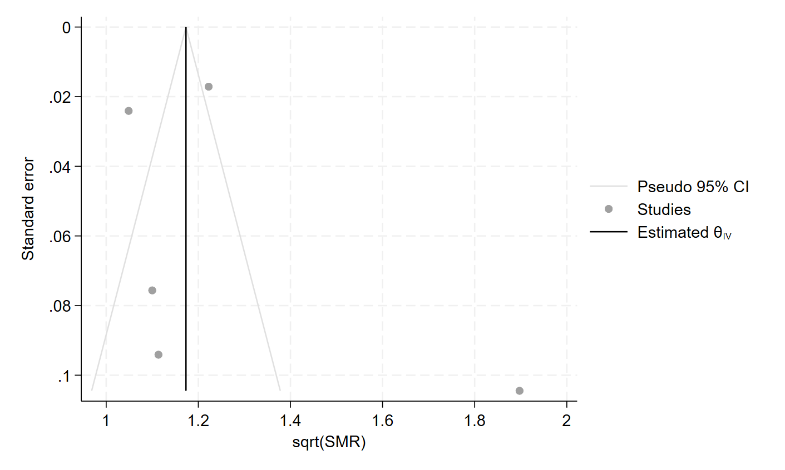
Appendix 1. Electronic search strategy

PUBMED
Advanced search, All fields
(
(“non-functioning pituitary adenoma” OR “non-functioning pituitary adenomas” OR “nonfunctioning pituitary adenoma” OR “nonfunctioning pituitary adenomas” OR “non-functional pituitary adenoma” OR “non-functional pituitary adenomas” OR “nonfunctional pituitary adenoma” OR “nonfunctional pituitary adenomas”)
OR
(“non-functioning pituitary microadenoma” OR “non-functioning pituitary microadenomas” OR “nonfunctioning pituitary microadenoma” OR “nonfunctioning pituitary microadenomas” OR “non-functional pituitary microadenoma” OR “non-functional pituitary microadenomas” OR “nonfunctional pituitary microadenoma” OR “nonfunctional pituitary microadenomas”)
OR
(“non-functioning pituitary macroadenoma” OR “non-functioning pituitary macroadenomas” OR “nonfunctioning pituitary macroadenoma” OR “nonfunctioning pituitary macroadenomas” OR “non-functional pituitary macroadenoma” OR “non-functional pituitary macroadenomas” OR “nonfunctional pituitary macroadenoma” OR “nonfunctional pituitary macroadenomas”)
OR
(“non-functioning pituitary tumor” OR “non-functioning pituitary tumors” OR “nonfunctioning pituitary tumor” OR “nonfunctioning pituitary tumors” OR “non-functional pituitary tumor” OR “non-functional pituitary tumors” OR “nonfunctional pituitary tumor” OR “nonfunctional pituitary tumors”)
OR
(“pituitary” AND (“non-functioning adenoma” OR “non-functioning adenomas” OR “nonfunctioning adenoma” OR “nonfunctioning adenomas” OR “non-functional adenoma” OR “non-functional adenomas” OR “nonfunctional adenoma” OR “nonfunctional adenomas”))
OR
(“pituitary” AND (“non-functioning microadenoma” OR “non-functioning microadenomas” OR “nonfunctioning microadenoma” OR “nonfunctioning microadenomas” OR “non-functional microadenoma” OR “non-functional microadenomas” OR “nonfunctional microadenoma” OR “nonfunctional microadenomas”))
OR
(“pituitary” AND (“non-functioning macroadenoma” OR “non-functioning macroadenomas” OR “nonfunctioning macroadenoma” OR “nonfunctioning macroadenomas” OR “non-functional macroadenoma” OR “non-functional macroadenomas” OR “nonfunctional macroadenoma” OR “nonfunctional macroadenomas”))
OR
(“pituitary” AND (“non-functioning tumor” OR “non-functioning tumors” OR “nonfunctioning tumor” OR “nonfunctioning tumors” OR “non-functional tumor” OR “non-functional tumors” OR “nonfunctional tumor” OR “nonfunctional tumors”))
)
AND
(“mortality” OR “death” OR “survival”)

EMBASE
Quick search, All fields
(
(“non-functioning pituitary adenoma” OR “non-functioning pituitary adenomas” OR “nonfunctioning pituitary adenoma” OR “nonfunctioning pituitary adenomas” OR “non-functional pituitary adenoma” OR “non-functional pituitary adenomas” OR “nonfunctional pituitary adenoma” OR “nonfunctional pituitary adenomas”)
OR
(“non-functioning pituitary microadenoma” OR “non-functioning pituitary microadenomas” OR “nonfunctioning pituitary microadenoma” OR “nonfunctioning pituitary microadenomas” OR “non-functional pituitary microadenoma” OR “non-functional pituitary microadenomas” OR “nonfunctional pituitary microadenoma” OR “nonfunctional pituitary microadenomas”)
OR
(“non-functioning pituitary macroadenoma” OR “non-functioning pituitary macroadenomas” OR “nonfunctioning pituitary macroadenoma” OR “nonfunctioning pituitary macroadenomas” OR “non-functional pituitary macroadenoma” OR “non-functional pituitary macroadenomas” OR “nonfunctional pituitary macroadenoma” OR “nonfunctional pituitary macroadenomas”)
OR
(“non-functioning pituitary tumor” OR “non-functioning pituitary tumors” OR “nonfunctioning pituitary tumor” OR “nonfunctioning pituitary tumors” OR “non-functional pituitary tumor” OR “non-functional pituitary tumors” OR “nonfunctional pituitary tumor” OR “nonfunctional pituitary tumors”)
OR
(“pituitary” AND (“non-functioning adenoma” OR “non-functioning adenomas” OR “nonfunctioning adenoma” OR “nonfunctioning adenomas” OR “non-functional adenoma” OR “non-functional adenomas” OR “nonfunctional adenoma” OR “nonfunctional adenomas”))
OR
(“pituitary” AND (“non-functioning microadenoma” OR “non-functioning microadenomas” OR “nonfunctioning microadenoma” OR “nonfunctioning microadenomas” OR “non-functional microadenoma” OR “non-functional microadenomas” OR “nonfunctional microadenoma” OR “nonfunctional microadenomas”))
OR
(“pituitary” AND (“non-functioning macroadenoma” OR “non-functioning macroadenomas” OR “nonfunctioning macroadenoma” OR “nonfunctioning macroadenomas” OR “non-functional macroadenoma” OR “non-functional macroadenomas” OR “nonfunctional macroadenoma” OR “nonfunctional macroadenomas”))
OR
(“pituitary” AND (“non-functioning tumor” OR “non-functioning tumors” OR “nonfunctioning tumor” OR “nonfunctioning tumors” OR “non-functional tumor” OR “non-functional tumors” OR “nonfunctional tumor” OR “nonfunctional tumors”))
)
AND
(“mortality” OR “death” OR “survival”)
NOT
(conference review OR conference abstract).pt

COCHRANE LIBRARY
Advanced search, All text
(
(“non-functioning pituitary adenoma” OR “non-functioning pituitary adenomas” OR “nonfunctioning pituitary adenoma” OR “nonfunctioning pituitary adenomas” OR “non-functional pituitary adenoma” OR “non-functional pituitary adenomas” OR “nonfunctional pituitary adenoma” OR “nonfunctional pituitary adenomas”)
OR
(“non-functioning pituitary microadenoma” OR “non-functioning pituitary microadenomas” OR “nonfunctioning pituitary microadenoma” OR “nonfunctioning pituitary microadenomas” OR “non-functional pituitary microadenoma” OR “non-functional pituitary microadenomas” OR “nonfunctional pituitary microadenoma” OR “nonfunctional pituitary microadenomas”)
OR
(“non-functioning pituitary macroadenoma” OR “non-functioning pituitary macroadenomas” OR “nonfunctioning pituitary macroadenoma” OR “nonfunctioning pituitary macroadenomas” OR “non-functional pituitary macroadenoma” OR “non-functional pituitary macroadenomas” OR “nonfunctional pituitary macroadenoma” OR “nonfunctional pituitary macroadenomas”)
OR
(“non-functioning pituitary tumor” OR “non-functioning pituitary tumors” OR “nonfunctioning pituitary tumor” OR “nonfunctioning pituitary tumors” OR “non-functional pituitary tumor” OR “non-functional pituitary tumors” OR “nonfunctional pituitary tumor” OR “nonfunctional pituitary tumors”)
OR
(“pituitary” AND (“non-functioning adenoma” OR “non-functioning adenomas” OR “nonfunctioning adenoma” OR “nonfunctioning adenomas” OR “non-functional adenoma” OR “non-functional adenomas” OR “nonfunctional adenoma” OR “nonfunctional adenomas”))
OR
(“pituitary” AND (“non-functioning microadenoma” OR “non-functioning microadenomas” OR “nonfunctioning microadenoma” OR “nonfunctioning microadenomas” OR “non-functional microadenoma” OR “non-functional microadenomas” OR “nonfunctional microadenoma” OR “nonfunctional microadenomas”))
OR
(“pituitary” AND (“non-functioning macroadenoma” OR “non-functioning macroadenomas” OR “nonfunctioning macroadenoma” OR “nonfunctioning macroadenomas” OR “non-functional macroadenoma” OR “non-functional macroadenomas” OR “nonfunctional macroadenoma” OR “nonfunctional macroadenomas”))
OR
(“pituitary” AND (“non-functioning tumor” OR “non-functioning tumors” OR “nonfunctioning tumor” OR “nonfunctioning tumors” OR “non-functional tumor” OR “non-functional tumors” OR “nonfunctional tumor” OR “nonfunctional tumors”))
)
AND
(“mortality” OR “death” OR “survival”)

