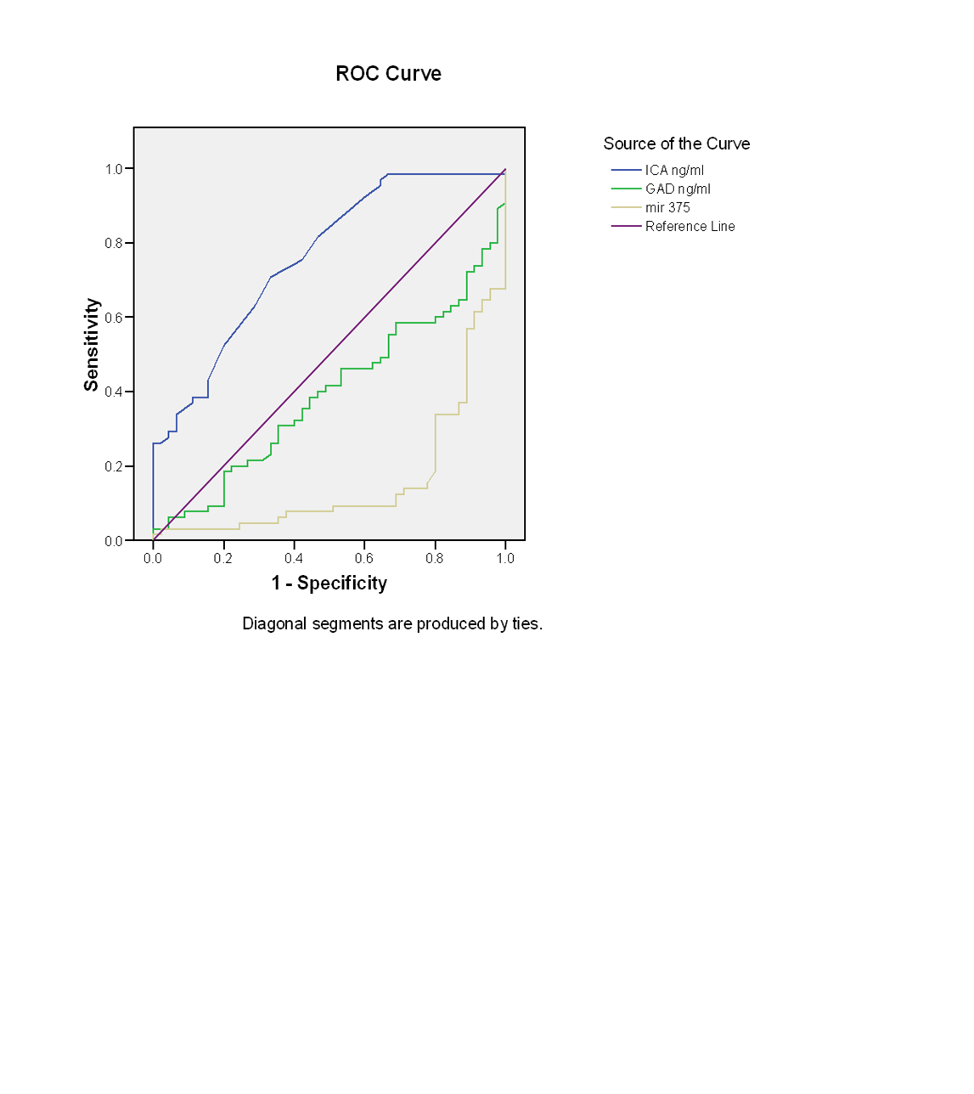Fig 1: ROC curves for ICA islet cell, GADA glutamic acid decarboxylase autoantibodies and mir 375. The diagonal line represents a test with no diagnostic value.

