Table S1 Electromyography indicators, VAS and TCSS scores of DPN and T2DM.
Normally distributed and continuous data were presented as mean ± standard deviation and independent sample t-test was used for continuous variables.

Variable | T2DM  (n=25) | DPN  (n=25) | P value
UNML | 2.52±0.33 | 2.95±0.53 | 0.001
MNML | 3.54±0.42 | 4.43±0.87 | ＜0.001
CPNML | 2.87±0.36 | 3.99±0.97 | ＜0.001
UNMA | 7.60±1.71 | 6.04±1.84 | 0.003
MNMA | 6.52±1.19 | 5.29±1.40 | 0.002
CPNMA | 5.07±1.54 | 1.99±1.13 | ＜0.001
UNMCV | 58.28±5.67 | 48.96±5.93 | ＜0.001
MNMCV | 55.71±4.99 | 50.25±4.99 | 0.001
CPNMCV | 52.59±8.41 | 37.14±3.51 | ＜0.001
UNFL | 26.20±2.49 | 28.79±3.35 | 0.003
MNFL | 26.31±2.29 | 29.90±2.56 | ＜0.001
CPNFL | 46.91±4.16 | 54.94±6.23 | ＜0.001
UNSL | 1.90±0.27 | 2.47±0.59 | ＜0.001
MNSL | 2.36±0.24 | 3.02±0.45 | ＜0.001
SPNSL | 1.76±0.27 | 2.43±0.42 | ＜0.001
UNSA | 7.54±1.95 | 3.36±1.78 | ＜0.001
MNSA | 10.14±3.57 | 4.47±2.66 | ＜0.001
SPNSA | 10.62±4.91 | 3.46±1.71 | ＜0.001
UNSCV | 59.33±7.08 | 51.31±8.85 | 0.001
MNSCV | 56.94±6.70 | 48.48±5.00 | ＜0.001
SPNSCV | 62.46±8.65 | 49.10±5.56 | ＜0.001
VAS | 0.00±0.00 | 3.52±2.20 | ＜0.001
TCSS | 2.40±0.96 | 11.16±2.46 | ＜0.001

Metabolites (μmol/g) | T2DM  (n=25) | DPN  (n=25) | VIP  Score | P Value
Formate | 0.1330±0.0193 | 0.0853±0.0144 | 2.7043 | ＜0.001
Hypoxanthine | 0.0652±0.0150 | 0.0691±0.0097 | 0.5313 | 0.273
Histidine | 0.0661±0.0111 | 0.0691±0.0114 | 0.4522 | 0.347
Phenylalanine | 0.0723±0.0137 | 0.0774±0.0130 | 0.5651 | 0.185
Tyrosine | 0.0571±0.0124 | 0.0626±0.0100 | 0.6027 | 0.091
Glucose | 6.7876±0.6969 | 6.5487±0.2654 | 0.6594 | 0.119
Lactate | 3.5298±1.0793 | 5.3042±0.6653 | 2.3680 | ＜0.001
Creatine | 0.0850±0.0178 | 0.0715±0.0081 | 1.6235 | 0.002
Citrate | 0.1088±0.0110 | 0.1065±0.0145 | 0.0313 | 0.535
Glutamine | 0.6075±0.1670 | 0.6742±0.1206 | 0.6630 | 0.103
Acetate | 0.0917±0.0154 | 0.0924±0.0162 | 0.0564 | 0.868
Alanine | 0.5381±0.0748 | 0.5121±0.1452 | 0.6915 | 0.431
Valine | 0.3369±0.0738 | 0.3229±0.0410 | 0.6538 | 0.411
Isoleucine | 0.1555±0.0317 | 0.1418±0.0423 | 0.4921 | 0.200
Leucine | 0.1432±0.0106 | 0.1343±0.0352 | 0.5164 | 0.235
3-Hydroxybutytrate | 0.2407±0.0647 | 0.2433±0.0506 | 0.0298 | 0.875
Tryptophan | 0.0521±0.0072 | 0.0525±0.0101 | 0.1354 | 0.862
Inosine | 0.0264±0.0048 | 0.0244±0.0043 | 0.8201 | 0.137
Ca²⁺ | 1.1383±0.0860 | 1.1385±0.0613 | 0.1156 | 0.991
Mg²⁺ | 0.3516±0.0804 | 0.3722±0.0673 | 0.5252 | 0.333

Table S2 Twenty serum metabolites concentration and VIP scores between T2DM and DPN.

Independent sample t-test was used for continuous variables presented as mean ± standard deviation. VIP represents variable importance in projection and VIP scores were obtained from the OPLS-DA model.

Table S3 Twenty serum amino acids of T2DM and DPN

Amino acids  (μmol/L) | T2DM  (n=25) | DPN  (n=25) | P Value
Glycine | 229.83±38.05 | 211.82±38.32 | 0.102
Serine | 121.59±22.42 | 115.14±18.70 | 0.275
Asparagine | 48.78±12.01 | 43.61±6.45 | 0.066
Arginine | 45.98±7.22 | 24.69±4.06 | ＜0.001
Alanine | 442.03±141.48 | 494.77±135.24 | 0.184
Homoproline | 25.67±9.86 | 25.44±10.03 | 0.937
Proline | 217.84±72.03 | 213.85±78.36 | 0.852
Valine | 268.47±89.88 | 288.67±108.51 | 0.477
Methionine | 26.25±7.53 | 23.01±4.03 | 0.065
Tyrosine | 72.81±17.63 | 72.35±18.14 | 0.928
Phenylalanine | 70.31±13.52 | 72.10±10.17 | 0.599
Isoleucine | 87.28±26.75 | 74.40±36.38 | 0.160
Leucine | 158.14±31.62 | 158.48±75.59 | 0.983
Hydroxyproline | 15.33±6.51 | 12.95±5.81 | 0.180
Threonine | 125.67±32.40 | 116.31±25.00 | 0.258
Tryptophane | 76.35±33.77 | 65.91±22.89 | 0.207
Glutamic acid | 178.06±38.69 | 190.87±40.41 | 0.258
Aspartic acid | 10.64±3.78 | 10.54±2.64 | 0.913
Histidine | 91.49±14.98 | 84.94±13.42 | 0.110
Lysine | 191.28±58.70 | 186.06±44.63 | 0.725
Independent sample t-test was used for normally distributed and continuous data, presented as mean ± standard deviation.

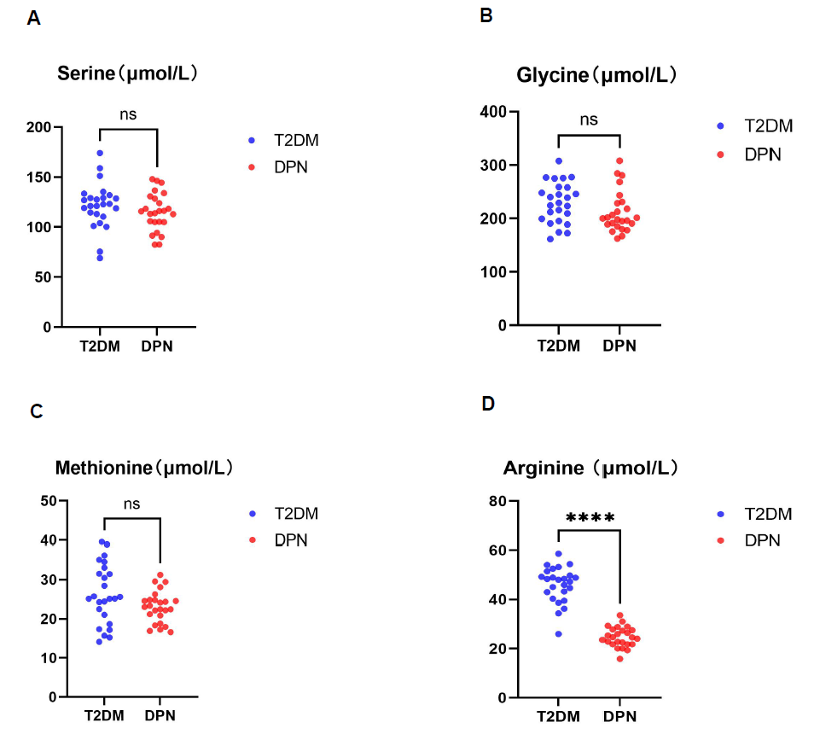

Fig S1 The comparison of Serine (A), Glycine (B), Methionine (C) and Arginine(D) between T2DM group and DPN group. ^{ns} p＞0.05, **** p＜0.0001.

