Optimization of Dosing Regimens for the Long-Acting Growth Hormone Pegpesen: A Population PK/PD Modeling Approach

Youni Zhao^{1#}, Fenfang Zou^{1#}, Jianbo Gu¹, Ruoyi He¹, Yalin Yin^{1*}
¹ Xiamen Amoytop Biotech Co., Ltd, Xiamen, Fujian, P.R.China

#These authors have contributed equally to this work and share first authorship.

*Corresponding author:
Yalin Yin
Xiamen Amoytop Biotech Co., Ltd.,
Xiamen City, Fujian Province,
China
Email: yinyalin@amoytop.com

SUPPLEMENTARY MATERIALS
Figures
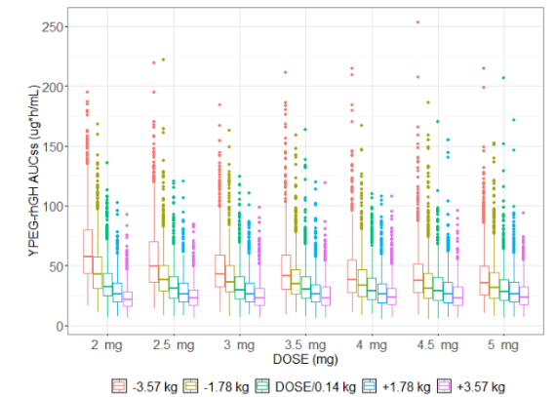
Fig. S1 Steady-state pharmacokinetic area under the curve of Pegpesen by weight group

Tables
Table S1 Baseline of the phase I study of Pegpesen in healthy adult subjects (NCT 01339182)
 | 0.01 mg/kg/week (N=4) | 0.03 mg/kg/week (N=8) | 0.06 mg/kg/week (N=8) | 0.12 mg/kg/week (N=8) | 0.2 mg/kg/week (N=8)
Male, % | 4 (100%) | 8 (100%) | 8 (100%) | 8 (100%) | 8 (100%)
Age, years | 35.3 (7.80) | 27.6 (2.56) | 26.6 (6.37) | 32.1 (8.56) | 34.5 (3.46)
Height, cm | 170.00 (8.49) | 166.88 (5.91) | 166.50 (7.60) | 170.63 (4.14) | 167.00 (6.19)
Weight, kg | 62.9 (5.46) | 62.7 (7.83) | 66.3 (6.73) | 65.0 (5.95) | 67.5 (4.15)
BMI, kg/m² | 21.8 (2.38) | 22.6 (2.77) | 23.9 (1.12) | 22.3 (2.07) | 24.2 (1.64)
Data are mean (SD) unless otherwise stated. Abbreviations: BMI, body mass index.

Table S2 Dose Correspondence between Pegpesen and Daily rhGH Based on Equivalent Steady-State IGF-1 Exposure over a One-Week Interval.
Daily rhGH Dose (IU/kg/day) | Steady-State IGF-1 Exposure (AUC) with Daily rhGH (AUEC ng*h/mL) | Pegpesen Dose (mg/kg/week) | Steady-State IGF-1 Exposure (AUC) with Pegpesen (AUEC ng*h/mL) | IGF-1 AUC Ratio (Pegpesen / daily rhGH)
0.1 | 34571.62 | 0.14 | 33757.77 | 0.98
0.11 | 35218.05 | 0.15 | 35240.43 | 1.00
0.12 | 35810.6 | 0.17 | 37543.16 | 1.05
0.13 | 36373.69 | 0.18 | 38612.36 | 1.06
0.14 | 36877 | 0.2 | 40385.85 | 1.10
0.15 | 37342.96 | 0.21 | 41054.47 | 1.10
0.16 | 37780.55 | 0.22 | 41571.97 | 1.10
0.17 | 38185.43 | 0.24 | 42140.06 | 1.10
0.18 | 38533.57 | 0.25 | 42359.16 | 1.10
0.19 | 38851.74 | 0.27 | 42843.27 | 1.10
0.2 | 39155.86 | 0.28 | 43086.42 | 1.10
Abbreviations: rhGH, recombinant human growth hormone; IGF-1, insulin-like growth factor 1; AUC, area under the curve; AUEC, area under effect curve.

