Table 1 Salivary cortisol (F), cortisone (E) and cortisol/cortisone ratio (F/E) median values in healthy subjects and in PAI patients
 | Healthy subjects (n=43) | PAI patients (n=19)
 |  | T0 | T1
F0 (ng/ml) | 8.20 [5.30-11.60] | 0.47 [0.47-2.25] | 0.47 [0.47-1.50]
F1(ng/ml) | 8.20 [4.50-15.00] | 29.44 [12.60-102.4] | 24.95 [19.24-74.21]
F2 (ng/ml) | 4.30 [2.30-7.30] | 7.67 [1.39-16.63] | 4.50 [1.97-8.90]
F3 (ng/ml) | 2.80 [1.70-4.40] | 3.10 [0.64-4.88] | 5.91 [1.43-22.04]
F4 (ng/ml) | 1.70 [1.00-3.00] | 1.13 [0.47-2.26] | 2.26 [0.47-6.95]
F5 (ng/ml) | 0.90 [0.60-1.20] | 0.47 [0.47-1.02] | 1.10 [0.47-2.48]
E0 (ng/ml) | 25.00 [19.20-29.00] | 2.00 [2.00-3.70] | 2.00 [2.00-3.23]
E1 (ng/ml) | 29.30 [19.40-36.00] | 42.70 [33.77-60.22] | 43.99 [36.88-49.54]
E2 (ng/ml) | 18.30 [14.70-26.30] | 20.23 [9.91-30.60] | 21.96 [10.93-31.65]
E3 (ng/ml) | 13.00 [11.10-17.80] | 10.50 [4.48-20.18] | 10.75 [7.04-18.72]
E4 (ng/ml) | 11.00 [6.80-16.20] | 6.59 [2.64-12.99] | 11.46 [3.04-21.18]
E5 (ng/ml) | 5.40 [4.10-8.70] | 2.29 [2.00-7.50] | 4.31 [2.00-9.14]
F/E0 | 0.34 [0.27-0.41] | 0.24 [0.24-0.71] | 0.24 [0.24-0.29]
F/E1 | 0.29 [0.21-0.41] | 0.51 [0.34-1.77] | 0.57 [0.41-1.50]
F/E2 | 0.23 [0.17-0.33] | 0.28 [0.13-0.64] | 0.22 [0.18-0.42]
F/E3 | 0.19 [0.15-0.26] | 0.21 [0.16-0.30] | 0.27 [0.16-1.65]
F/E4 | 0.18 [0.13-0.21] | 0.22 [0.17-0.24] | 0.22 [0.15-0.30]
F/E5 | 0.17 [0.13-0.21] | 0.24 [0.18-0.24] | 0.24 [0.21-0.25]

Data are reported as median [25th-75th percentile]
Abbreviations: PAI, primary adrenal insufficiency; F, cortisol; E, cortisone

Fig 1 Cortisol (F) and Cortisone (E) profile in PAI patients at T0
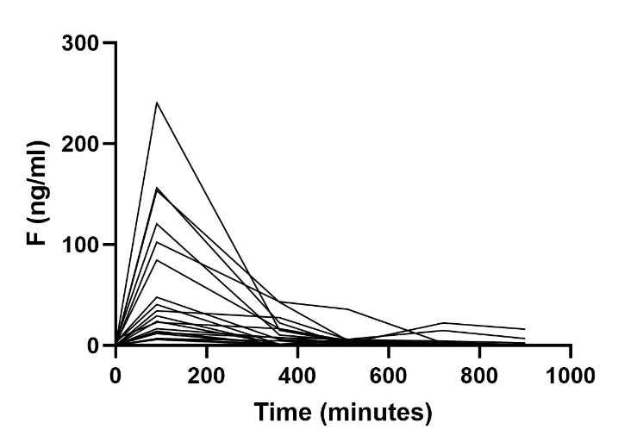
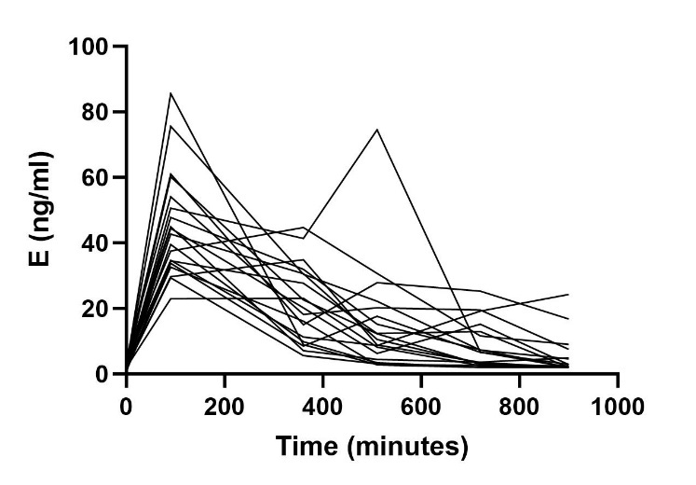

Fig 2 Cortisol (F) and Cortisone (E) profile in PAI patients at T1

