SUPPLEMENTARY MATERIALS

Analysis of the efficacy and safety of liraglutide, semaglutide, and tirzepatide for the treatment of overweight and obesity: a systematic review and network meta-analysis

Wiktoria Pałka¹, Paweł Moćko^{2*}, Katarzyna Śladowska³, Przemysław Holko³, Paweł Kawalec³
¹Faculty of Health Sciences, Institute of Public Health, Jagiellonian University Medical College, ul. Skawińska 8, 31-066 Krakow, Poland
² Department of Health Policy and Management, Faculty of Health Sciences, Institute of Public Health, Jagiellonian University Medical College, ul. Skawińska 8, 31-066 Krakow, Poland
³ Department of Nutrition and Drug Research, Faculty of Health Sciences, Institute of Public Health, Jagiellonian University Medical College, ul. Skawińska 8, 31-066 Krakow, Poland

*Corresponding Autor: Paweł Kawalec

Supplementary Table 1. Search strategy used in PubMed for GLP-1 and GLP-1/GIP receptor agonists (RAs) used in patients with overweight/obesity (last search: 13.12.2025)
N | Query
1 | Obesity OR Overweight
2 | Liraglutide OR NN 2211 OR NN-2211 OR NN2211 OR Victoza OR Saxenda
3 | Semaglutide OR Ozempic OR Rybelsus OR Wegovy
4 | Tirzepatide OR LY3298176 OR Zepbound OR Mounjaro
5 | Filters applied: Randomized Controlled Trial
6 | Filters applied: Humans
7 | Language: English
Supplementary Table 2. Search strategy used in EMBASE for GLP-1 and GLP-1/GIP RAs used in patients with overweight/obesity (last search: 13.12.2025)
N | Query
1 | 'adipose tissue hyperplasia' OR 'adipositas' OR 'adiposity' OR 'alimentary obesity' OR 'body weight, excess' OR 'corpulency' OR 'fat overload syndrome' OR 'nutritional obesity' OR 'obesitas' OR 'overweight' OR 'obesity'
2 | '4p 004' OR '4p004' OR 'biolide' OR 'diavic' OR 'ligobesy' OR 'liraglutide recombinant' OR 'nevolat' OR 'nn 2211' OR 'nn2211' OR 'nnc 90 1170' OR 'nnc 90-1170' OR 'nnc90 1170' OR 'nnc90-1170' OR 'rd 12014' OR 'rd12014' OR 'saxenda' OR 'victoza' OR 'zegluxen' OR 'liraglutide'
3 | 'nn 6535' OR 'nn 9535' OR 'nn 9536' OR 'nn 9924' OR 'nn 9931' OR 'nn 9932' OR 'nn6535' OR 'nn9535' OR 'nn9536' OR 'nn9924' OR 'nn9931' OR 'nn9932' OR 'nnc 0113 0217' OR 'nnc01130217' OR 'og 217 sc' OR 'og 217sc' OR 'og217sc' OR 'ozempic' OR 'rybelsus' OR 'wegovy' OR 'semaglutide'
4 | 'ly 3298176' OR 'ly3298176' OR 'mounjaro' OR 'mounjaro kwikpen' OR 'zepbound' OR 'tirzepatide'
5 | 'randomized controlled trial'/lim
6 | ‘humans'/lim
7 | ‘embase’/lim
8 | ‘english’/lim
Supplementary Table 3. Search strategy used in Cochrane Library for GLP-1 and GLP-1/GIP RAs used in patients with overweight/obesity (last search: 13.12.2025)
N | Query
1 | Obesity OR Overweight
2 | Liraglutide OR NN 2211 OR NN-2211 OR NN2211 OR Victoza OR Saxenda
3 | Semaglutide OR Ozempic OR Rybelsus OR Wegovy
4 | Tirzepatide OR LY3298176 OR Zepbound OR Mounjaro
5 | Filters applied: Trials
6 | Filters applied: Search word variations
7 | Language: English

Supplementary Table 4. Registered GLP-1 and GLP-1/GIP RAs with their dosing and administration route
Drug |  | Dosing and administration route
Liraglutide | Saxenda,  (EMA, FDA) | The recommended maintenance dose is 3.0 mg administered once daily by SC injection, starting with a dose of 0.6 mg.
   | Dose | Weeks
  Dose escalation 4 weeks | 0.6 mg | 1
  Dose escalation 4 weeks | 1.2 mg | 1
  Dose escalation 4 weeks | 1.8 mg | 1
  Dose escalation 4 weeks | 2.4 mg | 1
  Maintenance dose | 3.0 mg
Semaglutide | Wegovy,  (EMA, FDA) | The recommended maintenance dose is 2.4 mg administered once weekly by SC injection, starting with a dose of 0.25 mg.  In trials, the target dose of 7.2 mg of semaglutide was reached at week 20 of dose escalation.
  Dose escalation | Weekly dose
  Week 1–4 | 0.25 mg
  Week 5–8 | 0.5 mg
  Week 9–12 | 1 mg
  Week 13–16 | 1.7 mg
  Maintenance dose | 2.4 mg
Tirzepatide | Mounjaro (EMA) /Zepbound (FDA) | The recommended maintenance dosages are 5 mg, 10 mg, or 15 mg administered once weekly by SC injection. The starting dose of tirzepatide is 2.5 mg once weekly. After 4 weeks, the dose should be increased to 5 mg once weekly. If needed, dose increases can be made in 2.5 mg increments after a minimum of 4 weeks on the current dose.
EMA – European Medicines Agency; FDA – Food and Drug Administration; SC – subcutaneous

Supplementary Table 5. Baseline characteristics of patients from trials included in the review and/or network meta-analysis – homogeneity analysis
Acronym [trial number] | Intervention | Dosing | Female  [n (%)] | Age  [Mean±SD] or [Median (IQR)] | Body weight [kg]  [Mean±SD] or [Median (IQR)] | BMI [kg/m²]  [Mean±SD] or [Median (IQR)] | Waist circumference [cm]  [Mean±SD] or [Median (IQR)]
SCALE Obesity and Prediabetes [NCT01272219] | Liraglutide | 3.0 mg | 1957 (78.7) | 45.2±12.1 | 106.2±21.2 | 38.3±6.4 | 115.0±14.4
SCALE Obesity and Prediabetes [NCT01272219] | Placebo | - | 971 (78.1) | 45.0±12.0 | 106.2±21.7 | 38.3±6.3 | 114.5±14.3
SCALE Diabetes [NCT01272232] | Liraglutide | 3.0 mg | 203 (48.0) | 55.0±10.8 | 105.7±21.9 | 37.1±6.5 | 118.0±14.4
SCALE Diabetes [NCT01272232] | Liraglutide | 1.8 mg | 103 (48.8) | 54.9±10.7 | 105.8±21.0 | 37.0±6.9 | 117.5±14.7
SCALE Diabetes [NCT01272232] | Placebo | - | 115 (54.2) | 54.7±9.8 | 106.5±21.3 | 37.4±7.1 | 117.3±14.0
SCALE IBT [NCT02963935] | Liraglutide | 3.0 mg | 119 (83.8) | 45.4±11.6 | 108.5±22.1 | 39.3±6.8 | 116±14.4
SCALE IBT [NCT02963935] | Placebo | - | 116 (82.9) | 49.0±11.2 | 106.7±22.0 | 38.7±7.2 | 115±15.6
SCALE Insulin [NCT02963922] | Liraglutide | 3.0 mg | 108 (54.5) | 55.9±11.3 | 100.6±20.8 | 35.9±6.5 | 114.8±13.7
SCALE Insulin [NCT02963922] | Placebo | - | 99 (50.0) | 57.6±10.4 | 98.9±19.9 | 35.3±5.8 | 114.2±13.2
STEP 1 [NCT03548935] | Semaglutide | 2.4 mg | 955 (73.1) | 46±13 | 105.4±22.1 | 37.8±6.7 | 114.6±14.8
STEP 1 [NCT03548935] | Placebo | - | 498 (76.0) | 47±12 | 105.2±21.5 | 38.0±6.5 | 114.8±14.4
STEP 2 [NCT03552757] | Semaglutide | 2.4 mg | 223 (55.2) | 55±11 | 99.9±22.5 | 35.9±6.4 | 114.5±14.3
STEP 2 [NCT03552757] | Semaglutide | 1.0 mg | 203 (50.4) | 56±10 | 99.0±21.1 | 35.3±5.9 | 113.9±14.0
STEP 2 [NCT03552757] | Placebo | - | 190 (47.1) | 55±11 | 100.5±20.9 | 35.9±6.5 | 115.5±13.9
STEP 3 [NCT03611582] | Semaglutide | 2.4 mg | 315 (77.4) | 46±13 | 106.9±22.8 | 38.1±6.7 | 113.6±15.1
STEP 3 [NCT03611582] | Placebo | - | 180 (88.2) | 46±13 | 103.7±22.9 | 37.8±6.9 | 111.8±16.2
STEP 5 [NCT03693430] | Semaglutide | 2.4 mg | 123 (80.9) | 47.3±11.7 | 105.6±20.8 | 38.6±6.7 | 115.8±14.3
STEP 5 [NCT03693430] | Placebo | - | 113 (74.3) | 47.4±10.3 | 106.5±23.1 | 38.5±7.2 | 115.7±15.5
STEP 6 [NCT03811574] | Semaglutide | 2.4 mg | 85 (42.7) | 52±12 | 86.9±16.5 | 32.0±4.6 | 103.8±11.8
STEP 6 [NCT03811574] | Semaglutide | 1.7 mg | 37 (36.6) | 51±10 | 86.1±11.9 | 31.6±3.7 | 101.4±8.8
STEP 6 [NCT03811574] | Placebo | - | 26 (25.7) | 50±9 | 90.2±15.1 | 31.9±4.2 | 103.8±9.9
STEP 8 [NCT04074161] | Semaglutide | 2.4 mg | 102 (81.0) | 48±14 | 102.5±25.3 | 37.0±7.4 | 111.8±16.3
STEP 8 [NCT04074161] | Liraglutide | 3.0 mg | 97 (76.4) | 49±13 | 103.7±22.5 | 37.2±6.4 | 113.5±15.0
STEP 8 [NCT04074161] | Placebo | - | 66 (77.6) | 51±12 | 108.8±23.1 | 38.8±6.5 | 115.4±15.1
STEP 9 [NCT05064735] | Semaglutide | 2.4 mg | 228 (84.1) | 56±10 | 108.7±24.1 | 40.5±7.3 | 118.3±15.8
STEP 9 [NCT05064735] | Placebo | - | 104 (76.5) | 56±10 | 108.5±24.5 | 40.0±7.1 | 119.7±15.9
STEP 10 [NCT05040971] | Semaglutide | 2.4 mg | 100 (72.5) | 53±11 | 111.9±21.5 | 39.9±6.6 | 120.1±14.8
STEP 10 [NCT05040971] | Placebo | - | 47 (68.1) | 53±11 | 111.0±23.5 | 40.4±7.6 | 119.9±14.7
STEP-HFpEF [NCT04788511] | Semaglutide | 2.4 mg | 149 (56.7) | 70 (62-75) | 104.7 (92.4-120.1) | 37.2 (33.9-41.1) | 119.0 (110.5-127.1)
STEP-HFpEF [NCT04788511] | Placebo | - | 148 (55.6) | 69 (62-75) | 105.3 (92.4-122.0) | 36.9 (33.3-41.6) | 120.0 (110.5-129.0)
STEP-HFpEF DM [NCT04916470] | Semaglutide | 2.4 mg | 128 (41.3) | 69 (62-74) | 103.8 (91.9–119.0) | 36.9 (33.6-41.5) | 122.0 (113.0–131.5)
STEP-HFpEF DM [NCT04916470] | Placebo | - | 145 (47.4) | 70 (63-75) | 101.7 (89.5–116.4) | 36.9 (33.5-41.1) | 118.5 (111.0–129.0)
SELECT [NCT03574597] | Semaglutide | 2.4 mg | 2448 (27.8) | 61.6±8.9 | 96.5±17.5 | 33.3±5.0 | 111.3±13.1
SELECT [NCT03574597] | Placebo | - | 2424 (27.5) | 61.6±8.8 | 96.8±17.8 | 33.4±5.0 | 111.4±13.1
STEP UP  [NCT05646706] | Semaglutide | 7.2 mg | 753 (74.9) | 47±12 | 112.4±23.8 | 39.8±7.0 | 118.4±15.8
STEP UP  [NCT05646706] | Semaglutide | 2.4 mg | 137 (68.2) | 46±12 | 116.5±26.2 | 40.5±7.8 | 120.3±16.9
STEP UP  [NCT05646706] | Placebo | - | 147 (73.1) | 48±12 | 112.4±22.8 | 39.7±6.6 | 118.6±14.5
STEP UP T2D  [NCT05649137] | Semaglutide | 7.2 mg | 166 (54.1) | 57±10 | 110.5±22.9 | 38.7±7.1 | 121.8±15.2
STEP UP T2D  [NCT05649137] | Semaglutide | 2.4 mg | 47 (45.6) | 58±10 | 107.0±23.0 | 37.7±6.4 | 119.1±13.2
STEP UP T2D  [NCT05649137] | Placebo | - | 52 (51.0) | 55±10 | 112.1±22.9 | 39.0±7.6 | 123.9±15.5
REDEFINE 1  [NCT05567796] | Semaglutide | 2.4 mg | 199 (65.9) | 47.4±11.5 | 105.9±20.7 | 37.4±5.9 | 114.2±15.3
REDEFINE 1  [NCT05567796] | Cagrilintide | 2.4 mg | 208 (68.9) | 46.6±11.2 | 106.5±22.9 | 38.0±6.4 | 114.1±14.9
REDEFINE 1  [NCT05567796] | Cagrilintide + Semaglutide | 2.4 mg + 2.4 mg | 1441 (68.4) | 47.1±11.9 | 107.2±23.2 | 38.0±6.8 | 115.0±15.7
REDEFINE 1  [NCT05567796] | Placebo | - | 461 (65.4) | 46.7±11.9 | 106.6±23.7 | 37.8±7.1 | 114.1±15.3
SURMOUNT-1 [NCT04184622] | Tirzepatide | 5 mg | 426 (67.6) | 45.6±12.7 | 102.9±20.71 | 37.4±6.63 | 113.2±14.25
SURMOUNT-1 [NCT04184622] | Tirzepatide | 10 mg | 427 (67.1) | 44.7±12.4 | 105.8±23.32 | 38.2±7.01 | 114.8±15.80
SURMOUNT-1 [NCT04184622] | Tirzepatide | 15 mg | 425 (67.5) | 44.9±12.3 | 105.6±22.92 | 38.1±6.69 | 114.4±15.59
SURMOUNT-1 [NCT04184622] | Placebo | - | 436 (67.8) | 44.4±12.5 | 104.8±21.37 | 38.2±6.89 | 114.0±14.92
SURMOUNT-2 [NCT04657003] | Tirzepatide | 10 mg | 158 (50.6) | 54.3±10.7 | 100.9±20.9 | 36.0±6.4 | 114.2±14.1
SURMOUNT-2 [NCT04657003] | Tirzepatide | 15 mg | 159 (51.1) | 53.6±10.6 | 99.6±20.1 | 35.7±6.1 | 114.6±13.1
SURMOUNT-2 [NCT04657003] | Placebo | - | 159 (50.5) | 54.7±10.5 | 101.7±22.3 | 36.6±7.3 | 116.0±15.7
SURMOUNT-5 [NCT05822830] | Tirzepatide | 10 mg or 15 mg (MTD) | 242 (64.7) | 45.0±12.9 | 112.7±24.8 | 39.4±7.4 | 117.7±16.1
SURMOUNT-5 [NCT05822830] | Semaglutide | 1.7 mg or 2.4 mg (MTD) | 243 (64.6) | 44.4±12.7 | 113.4±26.3 | 39.4±7.7 | 118.8±17.6
SURMOUNT-CN [NCT05024032] | Tirzepatide | 10 mg | 35 (50.0) | 34.7±7.2 | 92.2±16.2 | 32.6±4.1 | 105.0±10.4
SURMOUNT-CN [NCT05024032] | Tirzepatide | 15 mg | 35 (49.3) | 35.8±9.3 | 91.3±16.2 | 32.0±3.7 | 104.2±10.9
SURMOUNT-CN [NCT05024032] | Placebo | - | 33 (47.8) | 37.8±10.2 | 92.0±15.8 | 32.4±3.6 | 105.3±10.4
SURMOUNT-J [NCT04844918] | Tirzepatide | 10 mg | 30 (41.1) | 49.0±10.9 | 92.4±15.0 | 33.2±4.1 | 107.7±9.8
SURMOUNT-J [NCT04844918] | Tirzepatide | 15 mg | 32 (41.6) | 51.1±10.3 | 91.7±14.8 | 33.6±4.3 | 107.6±10.4
SURMOUNT-J [NCT04844918] | Placebo | - | 30 (40.0) | 52.3±10.9 | 92.0±15.3 | 33.7±4.9 | 108.7±10.9
SUMMIT [NCT04847557] | Tirzepatide | 15 mg | 200 (54.9) | 65.5±10.5 | 102.9±21.7 | 38.3±6.4 | -
SUMMIT [NCT04847557] | Placebo | - | 193 (52.6) | 65.0±10.9 | 103.1±22.7 | 38.2±7.0 | -
BMI – Body Mass Index; IQR – Interquartile Range; MTD – Maximum Tolerated Dose; SD – Standard Deviation

Supplementary Table 6. Input to NMA – efficacy outcomes
Acronym [trial number] | Intervention 1 | Intervention 2 | Change in Body Weight (%)  MD [SE] | Change in waist circumference (cm)  MD [SE] | Change in BMI (kg/m²)  MD [SE]
SCALE Obesity and Prediabetes [NCT01272219] | Liraglutide 3.0 mg | Placebo | -5.4 [0.2] | -4.2 [0.26] | -2 [0.08]
SCALE Diabetes  [NCT01272232] | Liraglutide 3.0 mg | Placebo | -4 [0.56] | -3.22 [0.5] | -1.5 [0.17]
SCALE Diabetes  [NCT01272232] | Liraglutide 1.8 mg | Placebo | -2.71 [0.66] | -2.06 [0.58] | -0.95 [0.19]
SCALE Diabetes  [NCT01272232] | Liraglutide 3.0 mg | Liraglutide 1.8 mg | -1.29 [0.54] | -1.16 [0.51] | -0.56 [0.17]
SCALE IBT  [NCT02963935] | Liraglutide 3.0 mg | Placebo | -3.4 [0.94] | -2.7 [0.99] | -
SCALE Insulin  [NCT02963922] | Liraglutide 3.0 mg | Placebo | -4.3 [0.59] | -2.7 [0.61] | -
STEP 1  [NCT03548935] | Semaglutide 2.4 mg | Placebo | -12.44 [0.47] | -9.42 [0.45] | -4.61 [0.18]
STEP 2  [NCT03552757] | Semaglutide 2.4 mg | Placebo | -6.21 [0.54] | -4.9 [0.56] | -2.3 [0.18]
STEP 2  [NCT03552757] | Semaglutide 2.4 mg | Semaglutide 1.0 mg | -2.65 [0.52] | -2.7 [0.51] | -1 [0.18]
STEP 2  [NCT03552757] | Semaglutide 1.0 mg | Placebo | -3.56 [0.49] | -2.2 [0.51] | -1.3 [0.21]
STEP 3  [NCT03611582] | Semaglutide 2.4 mg | Placebo | -10.3 [0.87] | -8.3 [0.89] | -3.8 [0.33]
STEP 5  [NCT03693430] | Semaglutide 2.4 mg | Placebo | -12.6 [1.4] | -9.2 [1.53] | -4.3 [0.71]
STEP 6  [NCT03811574] | Semaglutide 2.4 mg | Placebo | -11.06 [0.93] | -9.26 [0.87] | -
STEP 6  [NCT03811574] | Semaglutide 1.7 mg | Placebo | -7.52 [1.07] | -5.87 [1] | -
STEP 6  [NCT03811574] | Semaglutide 2.4 mg | Semaglutide 1.7 mg | -3.54 [0.85] | -3.39 [0.88] | -
STEP 8  [NCT04074161] | Semaglutide 2.4 mg | Liraglutide 3.0 mg | -9.4 [1.33] | -6.6 [1.25] | -
STEP 8  [NCT04074161] | Semaglutide 2.4 mg | Placebo | -13.9 [1.45] | - | -
STEP 8  [NCT04074161] | Liraglutide 3.0 mg | Placebo | -4.5 [1.43] | - | -
STEP 9  [NCT05064735] | Semaglutide 2.4 mg | Placebo | -10.5 [0.94] | -6.9 [1.12] | -
STEP 10  [NCT05040971] | Semaglutide 2.4 mg | Placebo | -11.2 [0.92] | -8.3 [4.23] | -
STEP-HFpEF  [NCT04788511] | Semaglutide 2.4 mg | Placebo | -10.7 [0.64] | -9.1 [0.79] | -
STEP-HFpEF DM  [NCT04916470] | Semaglutide 2.4 mg | Placebo | -6.4 [0.61] | -6.4 [0.69] | -
SELECT  [NCT03574597] | Semaglutide 2.4 mg | Placebo | -8.51 [0.12] | -6.53 [0.13] | -
STEP UP  [NCT05646706] | Semaglutide 7.2 mg | Semaglutide 2.4 mg | -3.1 [0.79] | -2.9 [0.84] | -1.3 [0.33]
STEP UP  [NCT05646706] | Semaglutide 7.2 mg | Placebo | -14.8 [0.71] | -11.7 [0.66] | -5.8 [0.28]
STEP UP  [NCT05646706] | Semaglutide 2.4 mg | Placebo | -11.7 [0.9] | -8.8 [0.98] | -4.5 [0.41]
STEP UP T2D  [NCT05649137] | Semaglutide 7.2 mg | Semaglutide 2.4 mg | -2.8 [0.97] | -1.7 [0.84] | -1.1 [0.38]
STEP UP T2D  [NCT05649137] | Semaglutide 7.2 mg | Placebo | -9.3 [0.84] | -6.5 [1.25] | -3.7 [0.33]
STEP UP T2D  [NCT05649137] | Semaglutide 2.4 mg | Placebo | -6.5 [1.07] | -4.8 [1.25] | -2.6 [0.42]
REDEFINE 1  [NCT05567796] | Cagrilintide + Semaglutide | Placebo | -17.3 [0.38] | -13.4 [0.46] | -6.6 [0.13]
REDEFINE 1  [NCT05567796] | Cagrilintide + Semaglutide | Semaglutide 2.4 mg | -5.5 [0.61] | -4.1 [1.1] | -2.2 [0.23]
REDEFINE 1  [NCT05567796] | Cagrilintide + Semaglutide | Cagrilintide | -8.9 [0.61] | -6.8 [0.61] | -3.4 [0.23]
REDEFINE 1  [NCT05567796] | Semaglutide 2.4 mg | Placebo | -11.8 [0.48] | -9.3 [1.16] | -4.4 [0.24]
REDEFINE 1  [NCT05567796] | Cagrilintide | Placebo | -8.4 [0.48] | -6.6 [0.72] | -3.2 [0.24]
REDEFINE 1  [NCT05567796] | Semaglutide 2.4 mg | Cagrilintide | -3.4 [0.68] | -2.7 [1.23] | -1.2 [0.31]
SURMOUNT-1 [NCT04184622] | Tirzepatide 5 mg | Placebo | -11.9 [0.77] | -10.1 [2.3] | -
SURMOUNT-1 [NCT04184622] | Tirzepatide 10 mg | Placebo | -16.4 [0.79] | -13.8 [0.74] | -
SURMOUNT-1 [NCT04184622] | Tirzepatide 15 mg | Placebo | -17.8 [0.77] | -14.5 [0.74] | -
SURMOUNT-1 [NCT04184622] | Tirzepatide 10 mg | Tirzepatide 5 mg | -4.5 [0.68] | -3.7 [2.31] | -
SURMOUNT-1 [NCT04184622] | Tirzepatide 15 mg | Tirzepatide 10 mg | -1.4 [0.68] | -0.7 [0.77] | -
SURMOUNT-1 [NCT04184622] | Tirzepatide 15 mg | Tirzepatide 5 mg | -5.9 [0.65] | -4.4 [2.31] | -
SURMOUNT-2 [NCT04657003] | Tirzepatide 10 mg | Placebo | -9.6 [0.77] | -7.4 [0.79] | -3.5 [0.28]
SURMOUNT-2 [NCT04657003] | Tirzepatide 15 mg | Placebo | -11.6 [0.74] | -9.8 [0.74] | -4.2 [0.26]
SURMOUNT-2 [NCT04657003] | Tirzepatide 15 mg | Tirzepatide 10 mg | -2 [0.8] | -2.4 [0.82] | -0.7 [0.25]
SURMOUNT-CN [NCT05024032] | Tirzepatide 10 mg | Placebo | -11.3 [1.53] | -8.7 [1.28] | -3.6 [0.48]
SURMOUNT-CN [NCT05024032] | Tirzepatide 15 mg | Placebo | -15.1 [1.56] | -11.8 [1.3] | -5 [0.48]
SURMOUNT-CN [NCT05024032] | Tirzepatide 15 mg | Tirzepatide 10 mg | -3.8 [1.61] | -3.1 [1.06] | -1.4 [0.69]
SURMOUNT-J [NCT04844918] | Tirzepatide 10 mg | Placebo | -14 [1.35] | - | -
SURMOUNT-J [NCT04844918] | Tirzepatide 15 mg | Placebo | -19 [1.33] | - | -
SURMOUNT-J [NCT04844918] | Tirzepatide 15 mg | Tirzepatide 10 mg | -5 [1.26] | - | -
SUMMIT [NCT04847557] | Tirzepatide 15 mg | Placebo | -11.6 [0.64] | - | -
BMI – Body Mass Index; MD – Mean Difference; MTD – Maximum Tolerated Dose; SE – Standard Error
Supplementary Table 7. Input to NMA – safety outcomes
Acronym [trial number] | Intervention | Dosing | Any AEs  [n/N] | SAEs  [n/N] | AEs leading to discontinuation of drug or placebo  [n/N] | Injection site reaction  [n/N]
SCALE Obesity and Prediabetes [NCT01272219] | Liraglutide | 3.0 mg | 1992/2481 | 154/2481 | 246/2481 | -
SCALE Obesity and Prediabetes [NCT01272219] | Placebo | - | 786/1242 | 62/1242 | 47/1242 | -
SCALE Diabetes [NCT01272232] | Liraglutide | 3.0 mg | 392/422 | 37/422 | 39/422 | 39/422
SCALE Diabetes [NCT01272232] | Liraglutide | 1.8 mg | 190/210 | 18/210 | 18/210 | 17/210
SCALE Diabetes [NCT01272232] | Placebo | - | 182/212 | 13/212 | 7/212 | 18/212
SCALE IBT [NCT02963935] | Liraglutide | 3.0 mg | 136/142 | 6/142 | 12/142 | -
SCALE IBT [NCT02963935] | Placebo | - | 124/140 | 2/140 | 6/140 | -
SCALE Insulin [NCT02963922] | Liraglutide | 3.0 mg | 180/195 | 16/195 | 15/195 | -
SCALE Insulin [NCT02963922] | Placebo | - | 175/197 | 19/197 | 6/197 | -
STEP 1 [NCT03548935] | Semaglutide | 2.4 mg | 1171/1306 | 128/1306 | 92/1306 | 65/1306
STEP 1 [NCT03548935] | Placebo | - | 566/655 | 42/655 | 20/655 | 44/655
STEP 2 [NCT03552757] | Semaglutide | 2.4 mg | 353/403 | 40/403 | 25/403 | 12/403
STEP 2 [NCT03552757] | Semaglutide | 1.0 mg | 329/402 | 31/402 | 20/402 | 6/402
STEP 2 [NCT03552757] | Placebo | - | 309/402 | 37/402 | 14/402 | 10/402
STEP 3 [NCT03611582] | Semaglutide | 2.4 mg | 390/407 | 37/407 | 24/407 | 22/407
STEP 3 [NCT03611582] | Placebo | - | 196/204 | 6/204 | 6/204 | 12/204
STEP 5 [NCT03693430] | Semaglutide | 2.4 mg | 146/152 | 12/152 | 9/152 | 10/152
STEP 5 [NCT03693430] | Placebo | - | 136/152 | 18/152 | 7/152 | 15/152
STEP 6 [NCT03811574] | Semaglutide | 2.4 mg | 171/199 | 10/199 | 5/199 | 4/199
STEP 6 [NCT03811574] | Semaglutide | 1.7 mg | 82/100 | 7/100 | 3/100 | 0/100
STEP 6 [NCT03811574] | Placebo | - | 80/101 | 7/101 | 1/101 | 0/101
STEP 8 [NCT04074161] | Semaglutide | 2.4 mg | 120/126 | 10/126 | 4/126 | 0/126
STEP 8 [NCT04074161] | Liraglutide | 3.0 mg | 122/127 | 14/127 | 16/127 | 14/127
STEP 8 [NCT04074161] | Placebo | - | 81/85 | 6/85 | 3/85 | 5/85
STEP 9 [NCT05064735] | Semaglutide | 2.4 mg | - | 27/269 | 18/269 | -
STEP 9 [NCT05064735] | Placebo | - | - | 11/135 | 4/135 | -
STEP 10 [NCT05040971] | Semaglutide | 2.4 mg | - | 12/138 | 8/138 | -
STEP 10 [NCT05040971] | Placebo | - | - | 6/69 | 1/69 | -
STEP-HFpEF [NCT04788511] | Semaglutide | 2.4 mg | - | 35/263 | 35/263 | -
STEP-HFpEF [NCT04788511] | Placebo | - | - | 71/266 | 14/266 | -
STEP-HFpEF DM [NCT04916470] | Semaglutide | 2.4 mg | - | 55/310 | 33/310 | -
STEP-HFpEF DM [NCT04916470] | Placebo | - | - | 88/306 | 25/306 | -
SELECT [NCT03574597] | Semaglutide | 2.4 mg | - | 2941/8803 | 1461/8803 | -
SELECT [NCT03574597] | Placebo | - | - | 3204/8801 | 718/8801 | -
STEP UP  [NCT05646706] | Semaglutide | 7.2 mg | 878/1004 | 68/1004 | 54/1004 | 25/1004
STEP UP  [NCT05646706] | Semaglutide | 2.4 mg | 169/201 | 22/201 | 8/201 | 2/201
STEP UP  [NCT05646706] | Placebo | - | 156/201 | 11/201 | 2/201 | 3/201
STEP UP T2D  [NCT05649137] | Semaglutide | 7.2 mg | 246/307 | 28/307 | 17/307 | 8/307
STEP UP T2D  [NCT05649137] | Semaglutide | 2.4 mg | 77/103 | 9/103 | 6/103 | 2/103
STEP UP T2D  [NCT05649137] | Placebo | - | 74/102 | 9/102 | 3/102 | 2/102
REDEFINE 1  [NCT05567796] | Semaglutide | 2.4 mg | 271/302 | 15/302 | 11/302 | 8/302
REDEFINE 1  [NCT05567796] | Cagrilintide | 2.4 mg | 254/302 | 27/302 | 8/302 | 51/302
REDEFINE 1  [NCT05567796] | Cagrilintide + Semaglutide | 2.4 mg + 2.4 mg | 1943/2106 | 206/2106 | 125/2106 | 256/2106
REDEFINE 1  [NCT05567796] | Placebo | - | 580/705 | 43/705 | 25/705 | 21/705
SURMOUNT-1 [NCT04184622] | Tirzepatide | 5 mg | 510/630 | 40/630 | 27/630 | 18/630
SURMOUNT-1 [NCT04184622] | Tirzepatide | 10 mg | 520/636 | 44/636 | 45/636 | 36/636
SURMOUNT-1 [NCT04184622] | Tirzepatide | 15 mg | 497/630 | 32/630 | 39/630 | 29/630
SURMOUNT-1 [NCT04184622] | Placebo | - | 463/643 | 44/643 | 17/643 | 2/643
SURMOUNT-2 [NCT04657003] | Tirzepatide | 10 mg | 242/312 | 18/312 | 12/312 | -
SURMOUNT-2 [NCT04657003] | Tirzepatide | 15 mg | 222/311 | 27/311 | 23/311 | -
SURMOUNT-2 [NCT04657003] | Placebo | - | 239/315 | 23/315 | 12/315 | -
SURMOUNT-CN [NCT05024032] | Tirzepatide | 10 mg | 67/70 | 3/70 | 2/70 | -
SURMOUNT-CN [NCT05024032] | Tirzepatide | 15 mg | 64/71 | 8/71 | 5/71 | -
SURMOUNT-CN [NCT05024032] | Placebo | - | 57/69 | 6/69 | 1/69 | -
SURMOUNT-J [NCT04844918] | Tirzepatide | 10 mg | 61/73 | 8/73 | 7/73 | 4/73
SURMOUNT-J [NCT04844918] | Tirzepatide | 15 mg | 66/77 | 5/77 | 8/77 | 4/77
SURMOUNT-J [NCT04844918] | Placebo | - | 52/75 | 5/75 | 5/75 | 0/75
SUMMIT [NCT04847557] | Tirzepatide | 15 mg | 313/364 | 96/364 | 23/364 | -
SUMMIT [NCT04847557] | Placebo | - | 279/367 | 94/367 | 5/367 | -
AE – Adverse Event; BMI – Body Mass Index; MTD – Maximum Tolerated Dose; SAE – Serious Adverse Event

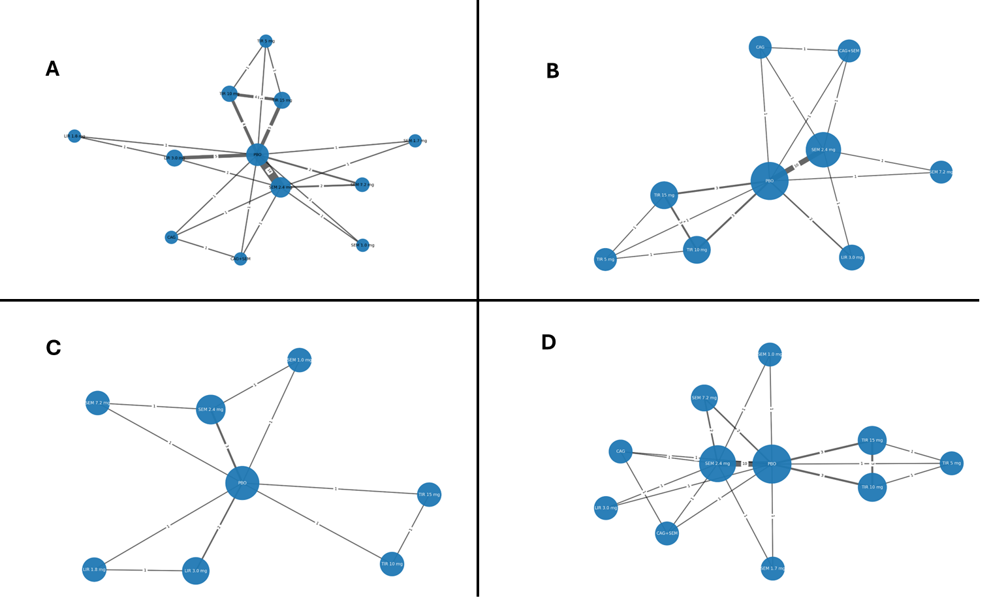
CAG – Cagrilintide; CAG+SEM – Cagrilintide + Semaglutide; LIR – Liraglutide; PBO – Placebo; SEM – Semaglutide; TIR – Tirzepatide
Supplementary Figure 1. Network diagram considering NMA networks for change in body weight (%): A) overall B) subgroup of patients with overweight or obesity without diabetes C) subgroup of patients with overweight or obesity with diabetes D) subgroup of patients with overweight or obesity and with or without diabetes
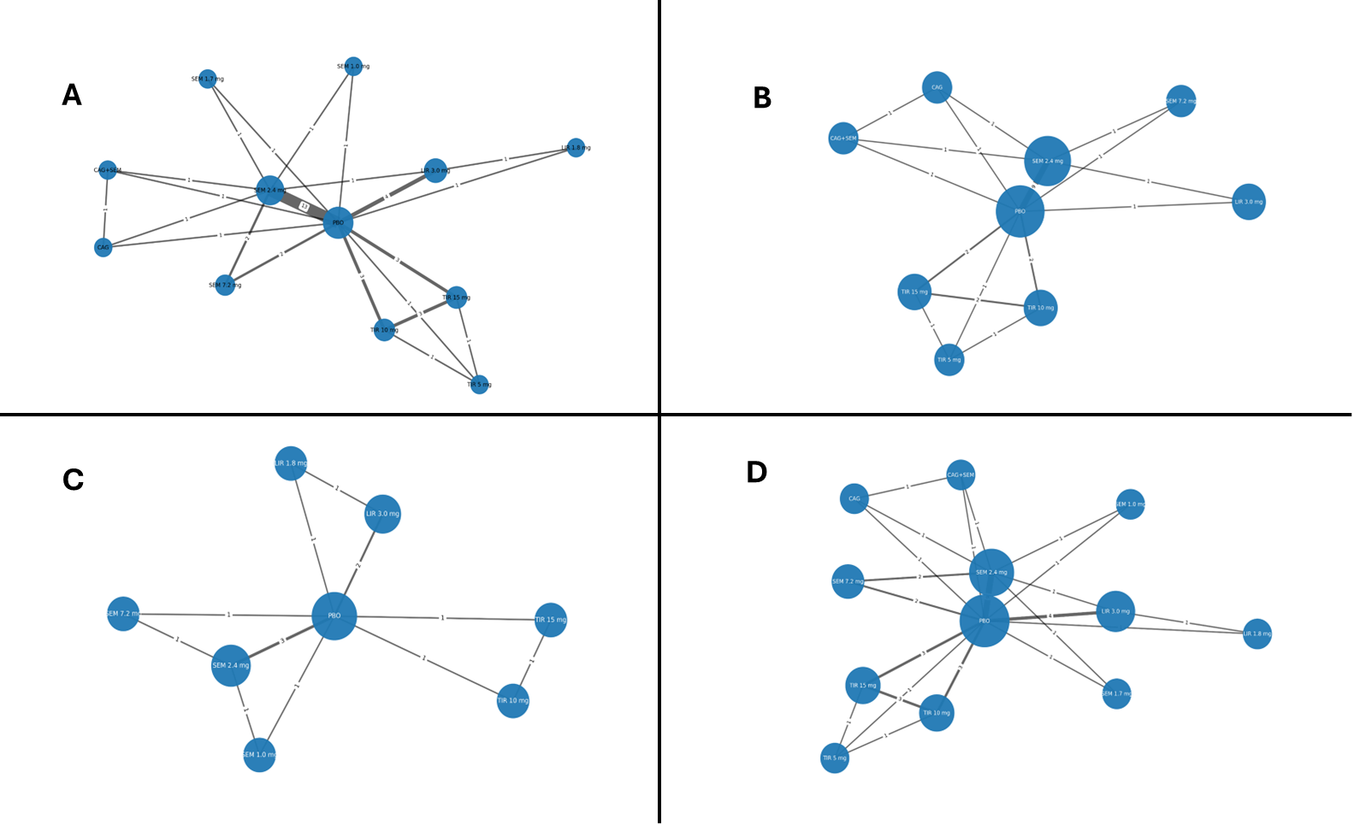
CAG – Cagrilintide; CAG+SEM – Cagrilintide + Semaglutide; LIR – Liraglutide; PBO – Placebo; SEM – Semaglutide; TIR – Tirzepatide
Supplementary Figure 2. Network diagram considering NMA networks for change in waist circumference (cm): A) overall, B) subgroup of patients with overweight or obesity without diabetes, C) subgroup of patients with overweight or obesity with diabetes, D) subgroup of patients with overweight or obesity and with or without diabetes
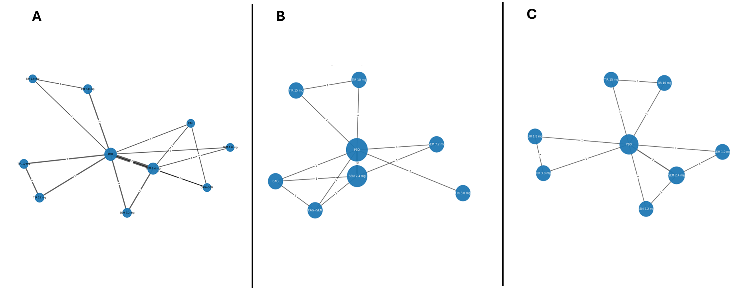
CAG – Cagrilintide; CAG+SEM – Cagrilintide + Semaglutide; LIR – Liraglutide; PBO – Placebo; SEM – Semaglutide; TIR – Tirzepatide
Supplementary Figure 3. Network diagram considering NMA networks for change in Body Mass Index (kg/m²) A) overall and subgroup of patients with overweight or obesity and with or without diabetes, B) subgroup of patients with overweight or obesity without diabetes, C) subgroup of patients with overweight or obesity with diabetes

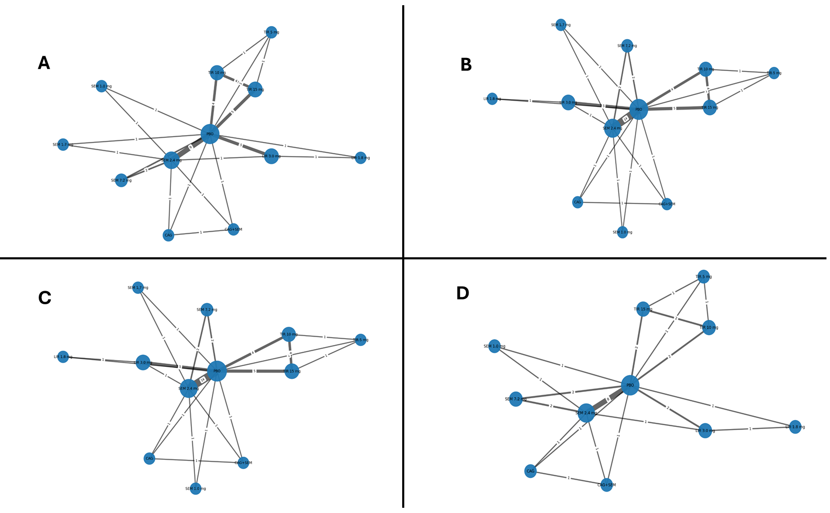

CAG – Cagrilintide; CAG+SEM – Cagrilintide + Semaglutide; LIR – Liraglutide; PBO – Placebo; SEM – Semaglutide; TIR – Tirzepatide
Supplementary Figure 4. Network diagram considering NMA networks for: for: A) any AEs, B) SAEs, C) AEs leading to discontinuation of drug or placebo, D) injection site reactions

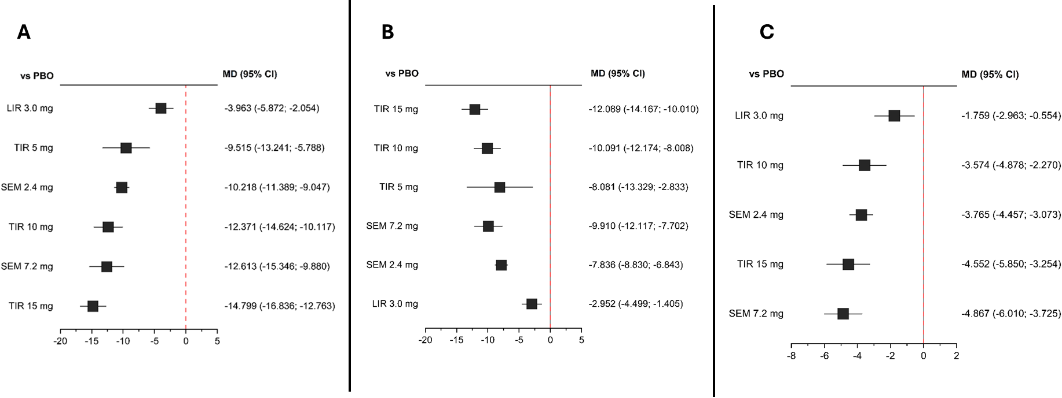
CI – Confidence Interval; LIR – liraglutide; OR – Odds Ratio; PBO – placebo; SEM – semaglutide; TIR – tirzepatide
Supplementary Figure 5. Results of the comparative analysis of GLP-1 and GLP-1/GIP RAs versus placebo for change in: A) body weight (%), B) waist circumference (cm), C) Body Mass Index (kg/m²)

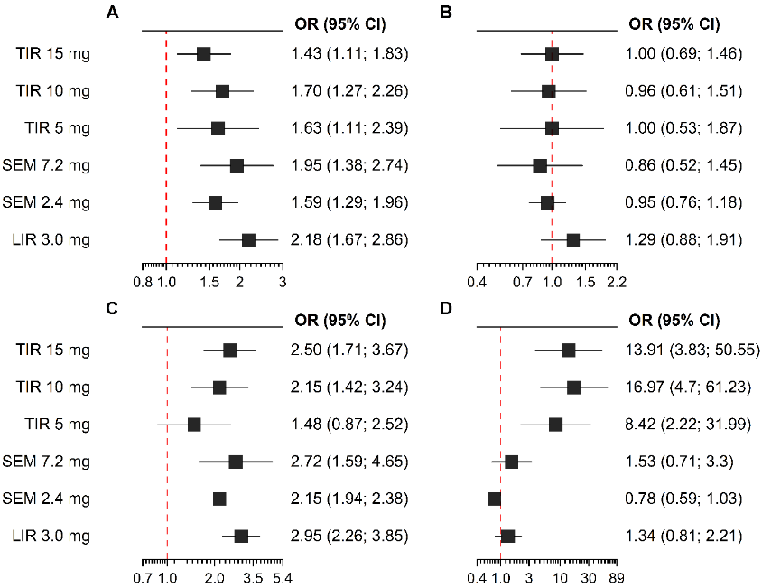
CI – Confidence Interval; LIR – liraglutide; OR – Odds Ratio; PBO – placebo; SEM – semaglutide; TIR – tirzepatide
Supplementary Figure 6. Results of the comparative analysis of GLP-1 and GLP-1/GIP RAs versus placebo for: A) any AEs, B) SAEs, C) AEs leading to discontinuation of drug or placebo, D) injection site reactions
Supplementary Table 8. Results of a comparative analysis of GLP-1 and GLP-1/GIP RAs assessed in included trials in terms of change in body weight (%) [Mean Difference (95% CI)] (for the interventions of interest)
LIR 3.0 mg | -4.35 (-6.31; -2.38) | 9.40 (4.55; 14.25) | - | - | - | -
-3.96 (-5.87; -2.05) | PBO | 10.16 (8.98; 11.34) | 12.10 (9.01; 15.20) | 12.86 (10.54; 15.18) | 14.81 (12.78; 16.85) | 11.90 (7.54; 16.26)
6.25 (4.08; 8.43) | 10.22 (9.05; 11.39) | SEM 2.4 mg | 2.95 (-0.19; 6.10) | - | - | -
8.65 (5.34; 11.96) | 12.61 (9.88; 15.35) | 2.39 (-0.35; 5.14) | SEM 7.2 mg | - | - | -
8.41 (5.45; 11.36) | 12.37 (10.12; 14.62) | 2.15 (-0.39; 4.69) | -0.24 (-3.78; 3.30) | TIR 10 mg | 2.89 (0.58; 5.20) | -4.50 (-8.81; -0.19)
10.84 (8.04; 13.63) | 14.80 (12.76; 16.84) | 4.58 (2.23; 6.93) | 2.19 (-1.22; 5.59) | 2.43 (0.18; 4.67) | TIR 15 mg | -5.90 (-10.19; -1.61)
5.55 (1.36; 9.74) | 9.51 (5.79; 13.24) | -0.70 (-4.61; 3.20) | -3.10 (-7.72; 1.52) | -2.86 (-6.61; 0.90) | -5.28 (-9.00; -1.57) | TIR 5 mg
The statistically significant results (p<0.05) are marked in red and bolded. The results of direct comparisons are presented above the labels; NMA results are shown below the labels
LIR – Liraglutide; PBO – Placebo; SEM – Semaglutide; TIR – Tirzepatide
Supplementary Table 9. Results of a comparative analysis of GLP-1 and GLP-1/GIP RAs assessed in included trials in terms of change in body weight (%) [Mean Difference (95% CI)] (for the interventions of interest) - subgroup of patients with overweight or obesity without diabetes
LIR 3.0 mg | -5.03 (-8.24; -1.83) | 9.40 (4.50; 14.30) | . | . | . | .
-4.30 (-7.31; -1.30) | PBO | 11.26 (9.84; 12.68) | 14.80 (10.42; 19.18) | 14.15 (11.38; 16.92) | 17.40 (14.64; 20.17) | 11.90 (7.48; 16.32)
7.02 (3.86; 10.18) | 11.32 (9.92; 12.73) | SEM 2.4 mg | 3.10 (-1.33; 7.53) | . | . | .
10.31 (5.48; 15.14) | 14.62 (10.77; 18.46) | 3.29 (-0.56; 7.15) | SEM 7.2 mg | . | . | .
9.84 (5.75; 13.92) | 14.14 (11.37; 16.91) | 2.82 (-0.29; 5.92) | -0.48 (-5.22; 4.27) | TIR 10 mg | 3.23 (0.48; 5.98) | -4.50 (-8.86; -0.14)
13.08 (9.00; 17.16) | 17.38 (14.62; 20.15) | 6.06 (2.96; 9.16) | 2.77 (-1.97; 7.51) | 3.24 (0.49; 5.99) | TIR 15 mg | -5.90 (-10.24; -1.56)
6.69 (1.76; 11.63) | 11.00 (7.08; 14.91) | -0.33 (-4.49; 3.83) | -3.62 (-9.11; 1.87) | -3.14 (-7.04; 0.75) | -6.39 (-10.28; -2.50) | TIR 5 mg
The statistically significant results (p<0.05) are marked in red and bolded. The results of direct comparisons are presented above the labels; NMA results are shown below the labels
LIR – Liraglutide; PBO – Placebo; SEM – Semaglutide; TIR – Tirzepatide

Supplementary Table 10. Results of a comparative analysis of GLP-1 and GLP-1/GIP RAs assessed in included trials in terms of change in body weight (%) [Mean Difference (95% CI)] (for the interventions of interest) - subgroup of patients with overweight or obesity with diabetes
LIR 3.0 mg | -4.14 (-4.94; -3.35) | . | . | . | .
-4.14 (-4.94; -3.35) | PBO | 6.32 (5.57; 7.06) | 9.30 (7.65; 10.95) | 9.60 (8.10; 11.10) | 11.60 (10.15; 13.05)
2.18 (1.09; 3.27) | 6.32 (5.57; 7.06) | SEM 2.4 mg | 2.80 (0.90; 4.70) | . | .
5.08 (3.43; 6.74) | 9.23 (7.78; 10.68) | 2.91 (1.42; 4.40) | SEM 7.2 mg | . | .
5.46 (3.76; 7.15) | 9.60 (8.10; 11.10) | 3.28 (1.61; 4.96) | 0.37 (-1.72; 2.46) | TIR 10 mg | 2.00 (0.44; 3.56)
7.46 (5.80; 9.11) | 11.60 (10.15; 13.05) | 5.28 (3.65; 6.91) | 2.37 (0.32; 4.42) | 2.00 (0.44; 3.56) | TIR 15 mg
The statistically significant results (p<0.05) are marked in red and bolded. The results of direct comparisons are presented above the labels; NMA results are shown below the labels
LIR – Liraglutide; PBO – Placebo; SEM – Semaglutide; TIR – Tirzepatide
Supplementary Table 11. Results of a comparative analysis of GLP-1 and GLP-1/GIP RAs assessed in included trials in terms of change in body weight (%) [Mean Difference (95% CI)] (for the interventions of interest) - subgroup of patients with overweight or obesity and with or without diabetes
LIR 3.0 mg | -4.34 (-6.40; -2.28) | 9.40 (4.35; 14.45) | . | . | . | .
-4.01 (-6.02; -2.01) | PBO | 10.69 (9.20; 12.17) | 12.10 (8.86; 15.34) | 12.86 (10.44; 15.29) | 15.77 (13.35; 18.19) | 11.90 (7.32; 16.48)
6.74 (4.35; 9.13) | 10.76 (9.29; 12.22) | SEM 2.4 mg | 2.95 (-0.34; 6.25) | . | . | .
8.86 (5.37; 12.35) | 12.87 (9.98; 15.77) | 2.12 (-0.79; 5.02) | SEM 7.2 mg | . | . | .
8.83 (5.68; 11.98) | 12.84 (10.42; 15.27) | 2.09 (-0.75; 4.92) | -0.03 (-3.81; 3.75) | TIR 10 mg | 2.90 (0.49; 5.32) | -4.50 (-9.03; 0.03)
11.74 (8.59; 14.88) | 15.75 (13.33; 18.17) | 4.99 (2.16; 7.82) | 2.88 (-0.90; 6.65) | 2.91 (0.49; 5.32) | TIR 15 mg | -5.90 (-10.41; -1.39)
5.99 (1.55; 10.43) | 10.00 (6.04; 13.96) | -0.75 (-4.98; 3.47) | -2.87 (-7.78; 2.03) | -2.84 (-6.79; 1.11) | -5.75 (-9.69; -1.80) | TIR 5 mg
The statistically significant results (p<0.05) are marked in red and bolded. The results of direct comparisons are presented above the labels; NMA results are shown below the labels
LIR – Liraglutide; PBO – Placebo; SEM – Semaglutide; TIR – Tirzepatide

Supplementary Table 12. Results of a comparative analysis of GLP-1 and GLP-1/GIP RAs assessed in included trials in terms of change in waist circumference (cm) [Mean Difference (95% CI)] (for the interventions of interest)
LIR 3.0 mg | -3.26 (-4.93; -1.59) | 6.60 (2.64; 10.56) | - | - | - | -
-2.95 (-4.50; -1.40) | PBO | 7.70 (6.68; 8.72) | 9.51 (6.94; 12.08) | 10.11 (8.03; 12.20) | 12.06 (9.98; 14.14) | 10.10 (4.63; 15.57)
4.88 (3.13; 6.64) | 7.84 (6.84; 8.83) | SEM 2.4 mg | 2.30 (-0.19; 4.79) | - | - | -
6.96 (4.29; 9.62) | 9.91 (7.70; 12.12) | 2.07 (-0.12; 4.27) | SEM 7.2 mg | - | - | -
7.14 (4.54; 9.73) | 10.09 (8.01; 12.17) | 2.25 (-0.05; 4.56) | 0.18 (-2.85; 3.22) | TIR 10 mg | 2.01 (-0.05; 4.07) | -3.70 (-9.19; 1.79)
9.14 (6.55; 11.73) | 12.09 (10.01; 14.17) | 4.25 (1.95; 6.56) | 2.18 (-0.85; 5.21) | 2.00 (-0.06; 4.06) | TIR 15 mg | -4.40 (-9.89; 1.09)
5.13 (-0.34; 10.60) | 8.08 (2.83; 13.33) | 0.24 (-5.10; 5.59) | -1.83 (-7.52; 3.86) | -2.01 (-7.26; 3.24) | -4.01 (-9.26; 1.24) | TIR 5 mg
The statistically significant results (p<0.05) are marked in red and bolded. The results of direct comparisons are presented above the labels; NMA results are shown below the labels
LIR – Liraglutide; PBO – Placebo; SEM – Semaglutide; TIR – Tirzepatide
Supplementary Table 13. Results of a comparative analysis of GLP-1 and GLP-1/GIP RAs assessed in included trials in terms of change in waist circumference (cm) [Mean Difference (95% CI)] (for the interventions of interest) - subgroup patients with overweight or obesity without diabetes
LIR 3.0 mg | -4.20 (-7.64; -0.76) | 6.60 (2.40; 10.80) | . | . | . | .
-3.28 (-6.00; -0.57) | PBO | 8.38 (7.04; 9.73) | 11.70 (8.05; 15.35) | 11.59 (8.80; 14.37) | 13.34 (10.54; 16.13) | 10.10 (4.46; 15.74)
5.24 (2.47; 8.01) | 8.52 (7.22; 9.83) | SEM 2.4 mg | 2.90 (-0.88; 6.68) | . | . | .
8.29 (4.16; 12.42) | 11.57 (8.36; 14.79) | 3.05 (-0.18; 6.28) | SEM 7.2 mg | . | . | .
8.30 (4.41; 12.19) | 11.58 (8.80; 14.37) | 3.06 (-0.01; 6.13) | 0.01 (-4.24; 4.26) | TIR 10 mg | 1.82 (-0.91; 4.54) | -3.70 (-9.36; 1.96)
10.13 (6.24; 14.02) | 13.41 (10.62; 16.20) | 4.89 (1.81; 7.97) | 1.84 (-2.42; 6.10) | 1.83 (-0.90; 4.55) | TIR 15 mg | -4.40 (-10.06; 1.26)
5.72 (-0.38; 11.83) | 9.01 (3.53; 14.48) | 0.48 (-5.14; 6.11) | -2.56 (-8.91; 3.78) | -2.58 (-8.05; 2.89) | -4.40 (-9.87; 1.07) | TIR 5 mg
The statistically significant results (p<0.05) are marked in red and bolded. The results of direct comparisons are presented above the labels; NMA results are shown below the labels
LIR – Liraglutide; PBO – Placebo; SEM – Semaglutide; TIR – Tirzepatide
Supplementary Table 14. Results of a comparative analysis of GLP-1 and GLP-1/GIP RAs assessed in included trials in terms of change in waist circumference (cm) [Mean Difference (95% CI)] (for the interventions of interest) - subgroup of patients with overweight or obesity with diabetes
LIR 3.0 mg | -3.00 (-3.86 to -2.13) | . | . | . | .
-3.00 (-3.86 to -2.13) | PBO | 5.43 (4.55; 6.32) | 6.50 (3.98; 9.02) | 7.40 (5.75; 9.05) | 9.80 (8.24 to 11.36)
2.44 (1.20; 3.67) | 5.43 (4.55; 6.32) | SEM 2.4 mg | 1.70 (-0.05; 3.45) | . | .
3.98 (2.01; 5.96) | 6.98 (5.21; 8.76) | 1.55 (-0.11; 3.20) | SEM 7.2 mg | . | .
4.40 (2.54; 6.26) | 7.40 (5.75; 9.05) | 1.97 (0.09; 3.84) | 0.42 (-2.01; 2.84) | TIR 10 mg | 2.40 (0.69; 4.11)
6.80 (5.02; 8.58) | 9.80 (8.24 to 11.36) | 4.37 (2.57; 6.16) | 2.82 (0.46; 5.18) | 2.40 (0.69; 4.11) | TIR 15 mg
The statistically significant results (p<0.05) are marked in red and bolded. The results of direct comparisons are presented above the labels; NMA results are shown below the labels
LIR – Liraglutide; PBO – Placebo; SEM – Semaglutide; TIR – Tirzepatide
Supplementary Table 15. Results of a comparative analysis of GLP-1 and GLP-1/GIP RAs assessed in included trials in terms of change in waist circumference (cm) [Mean Difference (95% CI)] (for the interventions of interest) - subgroup of patients with overweight or obesity and with or without diabetes
LIR 3.0 mg | -3.25 (-5.09 to -1.41) | 6.60 (2.35 to 10.85) | . | . | . | .
-2.98 (-4.68 to -1.28) | PBO | 7.98 (6.60; 9.36) | 9.45 (6.66 to 12.25) | 10.09 (7.82 to 12.36) | 12.05 (9.79 to 14.32) | 10.10 (4.42 to 15.78)
5.18 (3.16; 7.21) | 8.16 (6.84; 9.49) | SEM 2.4 mg | 2.30 (-0.42; 5.02) | . | . | .
7.06 (4.13; 9.99) | 10.04 (7.60 to 12.49) | 1.88 (-0.55; 4.31) | SEM 7.2 mg | . | . | .
7.09 (4.26; 9.93) | 10.07 (7.81 to 12.34) | 1.91 (-0.72; 4.54) | 0.03 (-3.30; 3.37) | TIR 10 mg | 2.02 (-0.22; 4.26) | -3.70 (-9.40; 2.00)
9.10 (6.27 to 11.93) | 12.08 (9.82 to 14.35) | 3.92 (1.30; 6.54) | 2.04 (-1.29; 5.37) | 2.01 (-0.23; 4.25) | TIR 15 mg | -4.40 (-10.10; 1.30)
5.09 (-0.59 to 10.77) | 8.07 (2.65 to 13.49) | -0.09 (-5.67; 5.49) | -1.97 (-7.92; 3.97) | -2.00 (-7.43; 3.42) | -4.01 (-9.43; 1.41) | TIR 5 mg
The statistically significant results (p<0.05) are marked in red and bolded. The results of direct comparisons are presented above the labels; NMA results are shown below the labels
LIR – Liraglutide; PBO – Placebo; SEM – Semaglutide; TIR – Tirzepatide
Supplementary Table 16. Results of a comparative analysis of GLP-1 and GLP-1/GIP RAs assessed in included trials in terms of change in Body Mass Index (kg/m²) [Mean Difference (95% CI)] (for the interventions of interest) – overall and subgroup of patients with overweight or obesity and with or without diabetes
LIR 3.0 mg | -1.76 (-2.96; -0.55) | - | - | - | -
-1.76 (-2.96; -0.55) | PBO | 3.77 (3.07; 4.46) | 4.77 (3.50; 6.03) | 3.55 (2.24; 4.85) | 4.56 (3.26; 5.86)
2.01 (0.62; 3.40) | 3.76 (3.07; 4.46) | SEM 2.4 mg | 1.20 (-0.09; 2.49) | - | -
3.11 (1.45; 4.77) | 4.87 (3.72; 6.01) | 1.10 (-0.05; 2.25) | SEM 7.2 mg | - | -
1.82 (0.04; 3.59) | 3.57 (2.27; 4.88) | -0.19 (-1.67; 1.29) | -1.29 (-3.03; 0.44) | TIR 10 mg | 0.98 (-0.38; 2.34)
2.79 (1.02; 4.56) | 4.55 (3.25; 5.85) | 0.79 (-0.68; 2.26) | -0.32 (-2.04; 1.41) | 0.98 (-0.38; 2.34) | TIR 15 mg
The statistically significant results (p<0.05) are marked in red and bolded. The results of direct comparisons are presented above the labels; NMA results are shown below the labels
LIR – Liraglutide; PBO – Placebo; SEM – Semaglutide; TIR – Tirzepatide
Supplementary Table 17. Results of a comparative analysis of GLP-1 and GLP-1/GIP RAs assessed in included trials in terms of change in Body Mass Index (kg/m²) [Mean Difference (95% CI)] (for the interventions of interest) - subgroup of patients with overweight or obesity without diabetes
LIR 3.0 mg | -2.00 (-2.29 to -1.71) | . | . | . | .
-2.00 (-2.29 to -1.71) | PBO | 4.40 (4.12; 4.68) | 5.80 (5.20; 6.40) | 3.60 (2.62; 4.58) | 5.00 (4.02; 5.98)
2.40 (2.00; 2.80) | 4.40 (4.12; 4.68) | SEM 2.4 mg | 1.30 (0.60; 2.00) | . | .
3.76 (3.17; 4.34) | 5.76 (5.25; 6.26) | 1.36 (0.84; 1.88) | SEM 7.2 mg | . | .
1.60 (0.57; 2.63) | 3.60 (2.62; 4.58) | -0.80 (-1.82; 0.22) | -2.16 (-3.26; -1.05) | TIR 10 mg | 1.40 (0.03; 2.77)
3.00 (1.97; 4.03) | 5.00 (4.02; 5.98) | 0.60 (-0.42; 1.62) | -0.76 (-1.86; 0.35) | 1.40 (0.03; 2.77) | TIR 15 mg
The statistically significant results (p<0.05) are marked in red and bolded. The results of direct comparisons are presented above the labels; NMA results are shown below the labels
LIR – Liraglutide; PBO – Placebo; SEM – Semaglutide; TIR – Tirzepatide
Supplementary Table 18. Results of a comparative analysis of GLP-1 and GLP-1/GIP RAs assessed in included trials in terms of change in Body Mass Index (kg/m²) [Mean Difference (95% CI)] (for the interventions of interest) - subgroup of patients with overweight or obesity with diabetes
LIR 3.0 mg | -1.51 (-1.83 to -1.19) | . | . | . | .
-1.51 (-1.83 to -1.19) | PBO | 2.35 (2.02; 2.67) | 3.70 (3.05; 4.35) | 3.50 (2.95; 4.05) | 4.20 (3.70; 4.70)
0.84 (0.38; 1.29) | 2.35 (2.02; 2.67) | SEM 2.4 mg | 1.10 (0.35; 1.85) | . | .
2.09 (1.43; 2.75) | 3.60 (3.02; 4.18) | 1.25 (0.66; 1.85) | SEM 7.2 mg | . | .
1.99 (1.35; 2.63) | 3.50 (2.95; 4.05) | 1.15 (0.52; 1.79) | -0.10 (-0.90; 0.70) | TIR 10 mg | 0.70 (0.20; 1.20)
2.69 (2.09; 3.29) | 4.20 (3.70; 4.70) | 1.85 (1.26; 2.45) | 0.60 (-0.16; 1.36) | 0.70 (0.20; 1.20) | TIR 15 mg
The statistically significant results (p<0.05) are marked in red and bolded. The results of direct comparisons are presented above the labels; NMA results are shown below the labels
LIR – Liraglutide; PBO – Placebo; SEM – Semaglutide; TIR – Tirzepatide
Supplementary Table 19. Results of a comparative analysis of GLP-1 and GLP-1/GIP RAs assessed in included trials in terms of any AEs [OR (95% CI)] (for the interventions of interest)
LIR 3.0 mg | 2.17 (1.64; 2.85) | 1.22 (0.35; 4.29) | - | - | - | -
2.18 (1.66; 2.86) | PBO | 0.63 (0.51; 0.78) | 0.56 (0.38; 0.82) | 0.62 (0.46; 0.84) | 0.70 (0.55; 0.91) | 0.61 (0.40; 0.93)
1.37 (0.97; 1.93) | 0.63 (0.51; 0.78) | SEM 2.4 mg | 0.75 (0.50; 1.12) | - | - | -
1.12 (0.72; 1.73) | 0.51 (0.37; 0.72) | 0.82 (0.58; 1.15) | SEM 7.2 mg | - | - | -
1.28 (0.86; 1.90) | 0.59 (0.44; 0.78) | 0.93 (0.65; 1.33) | 1.15 (0.73; 1.79) | TIR 10 mg | 1.26 (0.93; 1.70) | 1.05 (0.68; 1.63)
1.53 (1.05; 2.21) | 0.70 (0.55; 0.90) | 1.11 (0.80; 1.55) | 1.37 (0.89; 2.08) | 1.19 (0.89; 1.59) | TIR 15 mg | 0.88 (0.57; 1.36)
1.34 (0.83; 2.14) | 0.61 (0.42; 0.90) | 0.97 (0.63; 1.51) | 1.20 (0.72; 2.00) | 1.04 (0.70; 1.55) | 0.88 (0.59; 1.29) | TIR 5 mg
The statistically significant results (p<0.05) are marked in red and bolded. The results of direct comparisons are presented above the labels; NMA results are shown below the labels
LIR – Liraglutide; PBO – Placebo; SEM – Semaglutide; TIR – Tirzepatide
Supplementary Table 20. Results of a comparative analysis of GLP-1 and GLP-1/GIP RAs assessed in included trials in terms of SAEs [OR (95% CI)] (for the interventions of interest)
LIR 3.0 mg | 1.30 (0.87; 1.94) | 1.44 (0.52; 3.97) | - | - | - | -
1.29 (0.88; 1.91) | PBO | 1.05 (0.84; 1.31) | 0.87 (0.46; 1.65) | 1.08 (0.67; 1.73) | 1.01 (0.69; 1.47) | 1.08 (0.53; 2.20)
1.37 (0.89; 2.11) | 1.06 (0.85; 1.32) | SEM 2.4 mg | 1.36 (0.75; 2.46) | - | - | -
1.50 (0.79; 2.84) | 1.16 (0.69; 1.94) | 1.10 (0.66; 1.82) | SEM 7.2 mg | - | - | -
1.35 (0.74; 2.44) | 1.04 (0.66; 1.64) | 0.98 (0.60; 1.63) | 0.90 (0.45; 1.78) | TIR 10 mg | 0.97 (0.60; 1.56) | 1.10 (0.54; 2.23)
1.29 (0.75; 2.22) | 1.00 (0.68; 1.46) | 0.94 (0.61; 1.46) | 0.86 (0.46; 1.63) | 0.96 (0.61; 1.51) | TIR 15 mg | 0.79 (0.38; 1.64)
1.30 (0.62; 2.71) | 1.00 (0.53; 1.88) | 0.95 (0.49; 1.84) | 0.86 (0.38; 1.95) | 0.96 (0.51; 1.83) | 1.00 (0.53; 1.89) | TIR 5 mg
The statistically significant results (p<0.05) are marked in red and bolded. The results of direct comparisons are presented above the labels; NMA results are shown below the labels
LIR – Liraglutide; PBO – Placebo; SEM – Semaglutide; TIR – Tirzepatide
Supplementary Table 21. Results of a comparative analysis of GLP-1 and GLP-1/GIP RAs assessed in included trials in terms of AEs leading to discontinuation of drug or placebo [OR (95% CI)] (for the interventions of interest)
LIR 3.0 mg | 2.79 (2.12; 3.66) | 4.40 (1.42; 13.57) | - | - | - | -
2.95 (2.26; 3.85) | PBO | 0.46 (0.42; 0.51) | 0.32 (0.13; 0.83) | 0.52 (0.34; 0.80) | 0.40 (0.27; 0.58) | 0.61 (0.33; 1.13)
1.37 (1.03; 1.82) | 0.47 (0.42; 0.52) | SEM 2.4 mg | 0.84 (0.46; 1.53) | - | - | -
1.08 (0.60; 1.97) | 0.37 (0.21; 0.63) | 0.79 (0.46; 1.34) | SEM 7.2 mg | - | - | -
1.37 (0.84; 2.24) | 0.47 (0.31; 0.70) | 1.00 (0.65; 1.53) | 1.27 (0.64; 2.50) | TIR 10 mg | 0.88 (0.62; 1.25) | 1.70 (1.04; 2.79)
1.18 (0.74; 1.88) | 0.40 (0.27; 0.59) | 0.86 (0.58; 1.27) | 1.09 (0.56; 2.10) | 0.86 (0.61; 1.21) | TIR 15 mg | 1.47 (0.89; 2.45)
1.99 (1.10; 3.59) | 0.67 (0.40; 1.14) | 1.45 (0.84; 2.48) | 1.84 (0.86; 3.90) | 1.45 (0.90; 2.32) | 1.69 (1.05; 2.72) | TIR 5 mg
The statistically significant results (p<0.05) are marked in red and bolded. The results of direct comparisons are presented above the labels; NMA results are shown below the labels
LIR – Liraglutide; PBO – Placebo; SEM – Semaglutide; TIR – Tirzepatide
Supplementary Table 22. Results of a comparative analysis of GLP-1 and GLP-1/GIP RAs assessed in included trials in terms of injection site reactions [OR (95% CI)] (for the interventions of interest)
LIR 3.0 mg | 1.25 (0.75; 2.08) | 32.32 (1.91; 548.01) | - | - | - | -
1.34 (0.81; 2.21) | PBO | 1.28 (0.97; 1.68) | 0.65 (0.25; 1.68) | 0.06 (0.02; 0.21) | 0.07 (0.02; 0.26) | 0.11 (0.02; 0.46)
1.71 (0.97; 3.02) | 1.28 (0.97; 1.68) | SEM 2.4 mg | 0.53 (0.18; 1.52) | - | - | -
0.87 (0.35; 2.18) | 0.65 (0.30; 1.40) | 0.51 (0.24; 1.10) | SEM 7.2 mg | - | - | -
0.08 (0.02; 0.31) | 0.06 (0.02; 0.21) | 0.05 (0.01; 0.17) | 0.09 (0.02; 0.40) | TIR 10 mg | 1.22 (0.76; 1.95) | 2.04 (1.15; 3.63)
0.10 (0.02; 0.38) | 0.07 (0.02; 0.26) | 0.06 (0.02; 0.21) | 0.11 (0.02; 0.49) | 1.22 (0.76; 1.95) | TIR 15 mg | 1.64 (0.90; 2.99)
0.16 (0.04; 0.66) | 0.12 (0.03; 0.45) | 0.09 (0.02; 0.36) | 0.18 (0.04; 0.85) | 2.02 (1.14; 3.57) | 1.65 (0.92; 2.98) | TIR 5 mg
The statistically significant results (p<0.05) are marked in red and bolded. The results of direct comparisons are presented above the labels; NMA results are shown below the labels
LIR – Liraglutide; PBO – Placebo; SEM – Semaglutide; TIR – Tirzepatide
Supplementary Table 23. P score (overall rank based on P score among drugs used in the treatment of overweight/obesity and placebo) for assessed efficacy outcomes (for the interventions of interest)
Change in Body Weight (%) | P-Score | Rank | Change in waist circumference (cm) | P-Score | Rank | Change in BMI (kg/m²) | P-Score | Rank
TIR 15 mg | 0.9167 | 1 | TIR 15 mg | 0.9238 | 1 | SEM 7.2 mg | 0.8422 | 1
SEM 7.2 mg | 0.7760 | 2 | TIR 10 mg | 0.7603 | 2 | TIR 15 mg | 0.7903 | 2
TIR 10 mg | 0.7588 | 3 | SEM 7.2 mg | 0.7511 | 3 | SEM 2.4 mg | 0.6244 | 3
SEM 2.4 mg | 0.5977 | 4 | TIR 5 mg | 0.5994 | 4 | TIR 10 mg | 0.5775 | 4
TIR 5 mg | 0.5471 | 5 | SEM 2.4 mg | 0.5764 | 5 | LIR 3.0 mg | 0.2599 | 5
LIR 3.0 mg | 0.1908 | 6 | LIR 3.0 mg | 0.2067 | 6 | Placebo | 0.0114 | 6
Placebo | 0.0078 | 7 | Placebo | 0.0101 | 7 | - | - | -
BMI – Body Mass Index; LIR – Liraglutide; SEM – Semaglutide; TIR – Tirzepatide
Supplementary Table 24. P score (overall rank based on P score among drugs used in the treatment of overweight/obesity and placebo) for assessed efficacy outcomes (for the interventions of interest) - subgroup of patients with overweight or obesity without diabetes
Change in Body Weight (%) | P-Score | Rank | Change in waist circumference (cm) | P-Score | Rank | Change in BMI (kg/m²) | P-Score | Rank
TIR 15 mg | 0.9268 | 1 | TIR 15 mg | 0.9007 | 1 | SEM 7.2 mg | 0.8448 | 1
SEM 7.2 mg | 0.7165 | 2 | SEM 7.2 mg | 0.7110 | 2 | TIR 15 mg | 0.7061 | 2
TIR 10 mg | 0.6800 | 3 | TIR 10 mg | 0.7033 | 3 | SEM 2.4 mg | 0.5804 | 3
SEM 2.4 mg | 0.4493 | 4 | TIR 5 mg | 0.4852 | 4 | TIR 10 mg | 0.4061 | 4
TIR 5 mg | 0.4311 | 5 | SEM 2.4 mg | 0.4241 | 5 | LIR 3.0 mg | 0.1430 | 5
LIR 3.0 mg | 0.1323 | 6 | LIR 3.0 mg | 0.1384 | 6 | Placebo | 4.93E-14 | 6
Placebo | 0.0003 | 7 | Placebo | 0.0012 | 7 | - | - | -
BMI – Body Mass Index; LIR – Liraglutide; SEM – Semaglutide; TIR – Tirzepatide
Supplementary Table 25. P score (overall rank based on P score among drugs used in the treatment of overweight/obesity and placebo) for assessed efficacy outcomes (for the interventions of interest) - subgroup of patients with overweight or obesity with diabetes
Change in Body Weight (%) | P-Score | Rank | Change in waist circumference (cm) | P-Score | Rank | Change in BMI (kg/m²) | P-Score | Rank
TIR 15 mg | 0.9975 | 1 | TIR 15 mg | 0.9982 | 1 | TIR 15 mg | 9.91E-01 | 1
TIR 10 mg | 0.8061 | 2 | TIR 10 mg | 0.8021 | 2 | SEM 7.2 mg | 0.8083 | 2
SEM 7.2 mg | 0.7679 | 3 | SEM 7.2 mg | 0.7635 | 3 | TIR 10 mg | 7.72E-01 | 3
SEM 2.4 mg | 0.5714 | 4 | SEM 2.4 mg | 0.5790 | 4 | SEM 2.4 mg | 0.5714 | 4
LIR 3.0 mg | 0.4003 | 5 | LIR 3.0 mg | 0.3927 | 5 | LIR 3.0 mg | 0.3930 | 5
Placebo | 0.0000 | 6 | Placebo | 0.0001 | 6 | Placebo | 0.0000 | 6
BMI – Body Mass Index; LIR – Liraglutide; SEM – Semaglutide; TIR – Tirzepatide
Supplementary Table 26. P score (overall rank based on P score among drugs used in the treatment of overweight/obesity and placebo) for assessed efficacy outcomes (for the interventions of interest) - subgroup of patients with overweight or obesity and with or without diabetes
Change in Body Weight (%) | P-Score | Rank | Change in waist circumference (cm) | P-Score | Rank | Change in BMI (kg/m²) | P-Score | Rank
TIR 15 mg | 0.9315 | 1 | TIR 15 mg | 0.9181 | 1 | SEM 7.2 mg | 0.8422 | 1
SEM 7.2 mg | 0.7625 | 2 | SEM 7.2 mg | 0.7559 | 2 | TIR 15 mg | 0.7903 | 2
TIR 10 mg | 0.7602 | 3 | TIR 10 mg | 0.7517 | 3 | SEM 2.4 mg | 0.6244 | 3
SEM 2.4 mg | 0.6045 | 4 | TIR 5 mg | 0.5887 | 4 | TIR 10 mg | 0.5775 | 4
TIR 5 mg | 0.5530 | 5 | SEM 2.4 mg | 0.5884 | 5 | LIR 3.0 mg | 0.2599 | 5
LIR 3.0 mg | 0.1880 | 6 | LIR 3.0 mg | 0.2060 | 6 | Placebo | 0.0114 | 6
Placebo | 0.0086 | 7 | Placebo | 0.0124 | 7 | - | - | -
BMI – Body Mass Index; LIR – Liraglutide; SEM – Semaglutide; TIR – Tirzepatide
Supplementary Table 27. P score (overall rank based on P score among drugs used in the treatment of overweight/obesity and placebo) for assessed safety outcomes (for the interventions of interest)
Any AEs | P-Score | Rank | SAEs | P-Score | Rank | AEs leading to discontinuation of drug or placebo | P-Score | Rank | Injection site reactions | P-Score | Rank
Placebo | 0.9110 | 1 | SEM 7.2 mg | 0.7253 | 1 | Placebo | 0.9287 | 1 | SEM 2.4 mg | 0.8839 | 1
TIR 15 mg | 0.5997 | 2 | SEM 2.4 mg | 0.6639 | 2 | TIR 5 mg | 0.7411 | 2 | Placebo | 0.7423 | 2
SEM 2.4 mg | 0.4660 | 3 | TIR 10 mg | 0.6279 | 3 | SEM 2.4 mg | 0.4749 | 3 | LIR 3.0 mg | 0.6040 | 3
TIR 5 mg | 0.4338 | 4 | Placebo | 0.5840 | 4 | TIR 10 mg | 0.4648 | 4 | SEM 7.2 mg | 0.5817 | 4
TIR 10 mg | 0.3789 | 5 | TIR 15 mg | 0.5821 | 5 | TIR 15 mg | 0.3008 | 5 | TIR 5 mg | 0.2498 | 5
SEM 7.2 mg | 0.2409 | 6 | TIR 5 mg | 0.5780 | 6 | SEM 7.2 mg | 0.2570 | 6 | TIR 15 mg | 0.1027 | 6
LIR 3.0 mg | 0.1342 | 7 | LIR 3.0 mg | 0.3120 | 7 | LIR 3.0 mg | 0.1571 | 7 | TIR 10 mg | 0.0318 | 7
AE – Adverse Event; LIR – Liraglutide; SAE – Serious Adverse Event; SEM – Semaglutide; TIR – Tirzepatide

Supplementary Table 28. Heterogeneity assessment – efficacy outcomes
Outcome | Tau | I² | Q value - total | p value (Q test) - total | Q value - within designs | p value (Q test) - within designs | Q value - between designs | p value (Q test) - between designs
Overall population
Change in Body Weight (%) | 2.0892 | 92% | 311.59 | <0.0001 | 167.28 | <0.0001 | 144.30 | <0.0001
Change in waist circumference (cm) | 1.5890 | 86% | 150.00 | <0.0001 | 73.83 | <0.0001 | 76.17 | <0.0001
Change in BMI (kg/m²) | 0.8599 | 92.4% | 308.93 | <0.0001 | 164.17 | <0.0001 | 144.75 | <0.0001
Subgroup of patients with overweight or obesity without diabetes
Change in Body Weight (%) | 2.1193 | 91.7% | 167.87 | <0.0001 | 96.22 | <0.0001 | 71.65 | <0.0001
Change in waist circumference (cm) | 1.7377 | 86.4% | 80.75 | <0.0001 | 51.41 | <0.0001 | 29.34 | <0.0001
Change in BMI (kg/m²) | 0.1280 | 15.5% | 4.73 | 0.3160 | 4.69 | 0.0960 | 0.04 | 0.9781
Subgroup of patients with overweight or obesity with diabetes
Change in Body Weight (%) | 0.00 | 0% | 0.22 | 0.9738 | 0.00 | - | 0.22 | 0.9738
Change in waist circumference (cm) | 0.2918 | 15.8% | 3.56 | 0.3129 | 0.00 | - | 3.56 | 0.3129
Change in BMI (kg/m²) | 0.00 | 0% | 0.43 | 0.5110 | 0.00 | - | 0.43 | 0.5110
Subgroup of patients with overweight or obesity and with or without diabetes
Change in Body Weight (%) | 2.2076 | 89.9% | 198.92 | <0.0001 | 63.88 | <0.0001 | 135.04 | <0.0001
Change in waist circumference (cm) | 1.7723 | 84.8% | 111.92 | <0.0001 | 23.27 | 0.0056 | 88.65 | <0.0001
Change in BMI (kg/m²) | 0.8599 | 92.4% | 308.93 | <0.0001 | 164.17 | <0.0001 | 144.75 | <0.0001
BMI – Body Mass Index
Supplementary Table 29. Heterogeneity assessment – safety outcomes
Outcome | Tau | I² | Q value - total | p value (Q test) - total | Q value - within designs | p value (Q test) - within designs | Q value - between designs | p value (Q test) - between designs
Any AEs | 0.1701 | 31.6% | 29.22 | 0.0835 | 17.23 | 0.0694 | 11.99 | 0.2857
SAEs | 0.2824 | 54.8% | 55.25 | 0.0005 | 45.51 | <0.0001 | 9.74 | 0.4640
AEs leading to discontinuation of drug or placebo | 0.0331 | 0.9% | 25.22 | 0.4501 | 8.75 | 0.8904 | 16.47 | 0.0869
Injection site reactions | 0.00 | 0% | 6.91 | 0.8066 | 0.80 | 0.9389 | 6.11 | 0.5270
AE – Adverse Event; SAE – Serious Adverse Event

EMA: https://www.ema.europa.eu-EPAR/saxenda. Accessed 19 Oct 2025.
FDA: https://www.accessdata.fda.gov/saxenda. Accessed 19 Oct 2025.
EMA: https://www.ema.europa.eu-EPAR/wegovy. Accessed 19 Oct 2025.
FDA https://www.accessdata.fda.gov/wegovy. Accessed 12 Jan 2026.
EMA: https://www.ema.europa.eu-EPAR/mounjaro. Accessed 19 Oct 2025.
FDA: https://www.accessdata.fda.gov/zepbound. Accessed 19 Oct 2025.

