1.For phase 1,the formula was used in the study: N=〖2×[(μ_α+μ_β )σ/δ]〗^2α = 0.05 (1 tail), β = 0.1μ_α=1.64 (1 tail), μ_β=1.28 (1 tail), σ=0.6[1], δ=0.5,N = 26, total n=52.
For phase 2, We used PASS11 software to calculate sample size, and the three sets of means were respectively LC=616,CC=755,OAC=525, the standard deviation is 180, α = 0.05(2 tail), β=0.15.The sample size of each group was 15, total n=45.
2. We use the method of stratified randomization and sequentially numbered, opaque, sealed envelopes.
The specific method is shown in the figure and table.
The first phase as the table:
 | oAC group | Placebo group
Male, age18～40, CKD3 | 2 | 2
Male, age40～60, CKD3 | 5 | 5
Male, age＞60, CKD3 | 5 | 5
Male, age18～40, CKD4 | 3 | 3
Male, age40～60, CKD4 | 6 | 6
Male, age＞60, CKD4 | 4 | 4
Female, age18～40, CKD3 | 2 | 2
Female, age40～60, CKD3 | 5 | 5
Female, age＞60, CKD3 | 4 | 4
Female, age18～40, CKD4 | 3 | 3
Female, age40～60, CKD4 | 6 | 5
Female, age＞60, CKD4 | 4 | 4
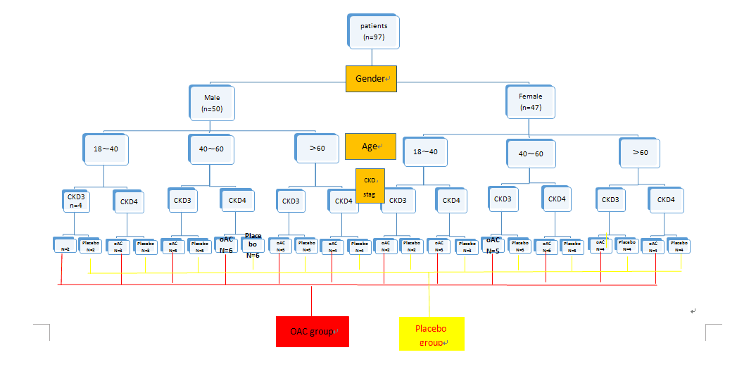

The second phase as the table:
 | oAC | CC | LC
Male, age18～40, CKD3 | 1 | 1 | 1
Male, age40～60, CKD3 | 2 | 2 | 2
Male, age＞60, CKD3 | 1 | 1 | 1
Male, age18～40, CKD4 | 2 | 2 | 2
Male, age40～60, CKD4 | 3 | 2 | 2
Male, age＞60, CKD4 | 1 | 1 | 1
Female, age18～40, CKD3 | 0 | 0 | 0
Female, age40～60, CKD3 | 2 | 2 | 2
Female, age＞60, CKD3 | 1 | 1 | 1
Female, age18～40, CKD4 | 1 | 1 | 1
Female, age40～60, CKD4 | 2 | 3 | 2
Female, age＞60, CKD4 | 1 | 1 | 1

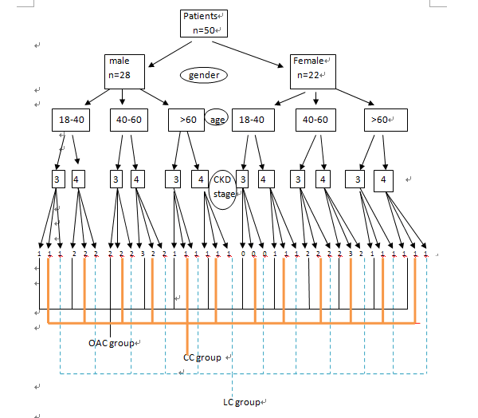
3.
Table 3: The change of CACS value in the second stage of the study
Follow-up time（month） |  | CACS |  |  |  | P value
Follow-up time（month） |  | oAC | CC | LC |  | P value
0 |  | 210.4±80.9  205.0（167.0-287.0） | 189.9±103.7  176.0（107.5-280.5） | 186.9±80.0  185.0（131.3-247.0） |  | 0.709
6 |  | 246.4±68.3ª  228.0（202.5-317.0） | 362.5±105.6  371.0（276.0-450.5） | 197.7±72.0  203.5（164.3-261.0） |  | 0.000
12 |  | 443.0（386.0-501.0）^{b} | 543.0（471.5-580.0） | 357.0（246.5-457.0） |  | 0.000
18 |  | 488.5（445.0-538.3）^{c} | 550.0（522.0-650.0） | 387.0（238.0-491.0） |  | 0.000
24 |  | 525.5±104.2^{d}  538.0（437.0-549.0） | 688.1±183.7  730.0（616.0-806.8） | 431.4±122.5  458.0（360.0-530.0） |  | 0.000
Results are reported as mean ± standard deviation for normally distributed variables or median (interquartile range) for variables with skewed distributions.
Note: OAC group compared with LC group, ªP> 0.05, ^{b}P <0.05, ^{c}P <0.01, ^{d}P > 0.05.

