The effect of exercise training in people with pre-dialysis chronic kidney disease. A systematic review with meta-analysis.
Annette Traise*, Gudrun Dieberg, Melissa J Pearson, Neil A Smart
Clinical Exercise Physiology, School of Science and Technology, University of New England, NSW 2351, Australia
* Corresponding author
Online Resource 3
Supplemental material: Figures 1 – 9: Egger Funnel Plot of Comparison (pseudo 95% confidence interval) of outcomes
Supplemental Figure 1 Aerobic capacity funnel plot of comparison
Supplemental Figure 2 Functional ability funnel plot of comparison
Supplemental Figure 3 Quality of Life
Supplemental Figure 4 Renal parameters funnel plot of comparison
Supplemental Figure 5 Cardiovascular Risk Factors: Blood Pressure
Supplemental Figure 6 Cardiovascular Risk Factors: Endothelial factors
Supplemental Figure 7 Cardiovascular Risk Factors: Lipids and blood parameters
Supplemental Figure 8 Cardiovascular Risk Factors: Body composition parameters
Supplemental Figure 9 Inflammatory markers

Supplemental Figure 1 Aerobic capacity funnel plot of comparison
SF1a: Peak VO2 (mL/kg/min) (by intervention modality); SF1b: Peak VO2 (mL/kg/min) (by CKD stage); SF1c: Peak respiratory ratio (by intervention modality); SF1d: Peak respiratory ratio (by CKD stage)
SF1a: Peak VO₂ (mL/kg/min) p<0.00001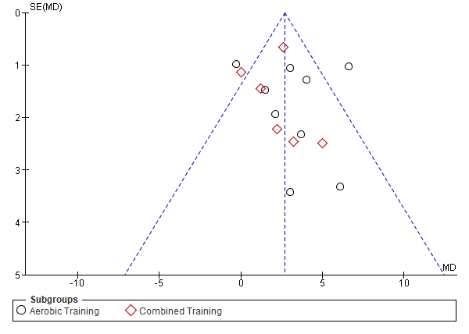 | SF1b: Peak VO₂ (mL/kg/min) p<0.00001  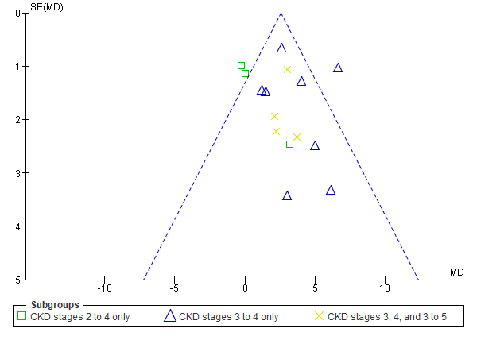
SF1c: Peak respiratory ratio p=0.44  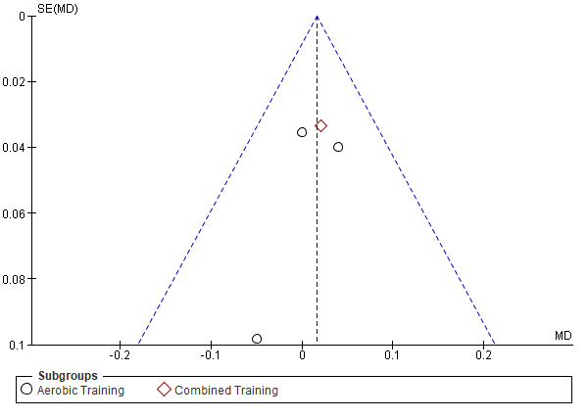 | SF1d: Peak respiratory ratio p=0.44  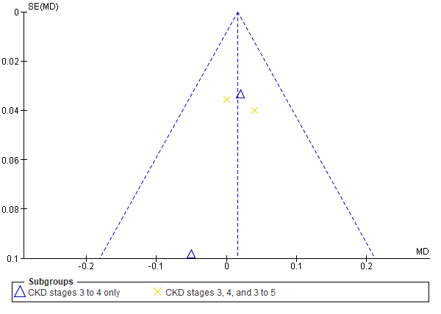
Supplemental Figure 2 Functional ability funnel plot of comparison
SF2a: Six-minute walk distance test (m) (by intervention modality); SF2b: Six-minute walk distance test (m) (by CKD stage); SF2c: Timed up and go test (by intervention modality); SF2d: Timed up and go test (by CKD stage); SF2e: Two-minute step test (by intervention modality); SF2f: Two-minute step test (by CKD stage); SF2g: Sit to stand test (by intervention modality); SF2h: Sit to stand test (by CKD stage); SF2i: Handgrip strength (kg) (by intervention modality); SF2j: Handgrip strength (kg) (by CKD stage)
SF2a: 6MWT (m) p<0.00001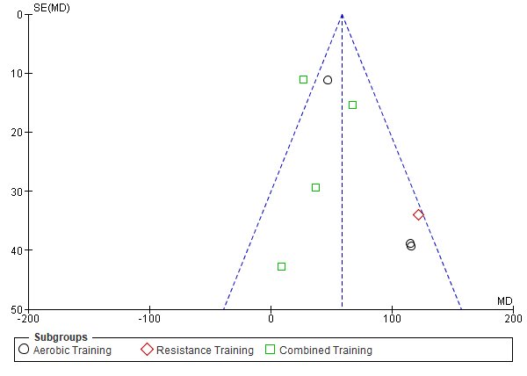 | SF2b: 6MWT (m) p<0.00001  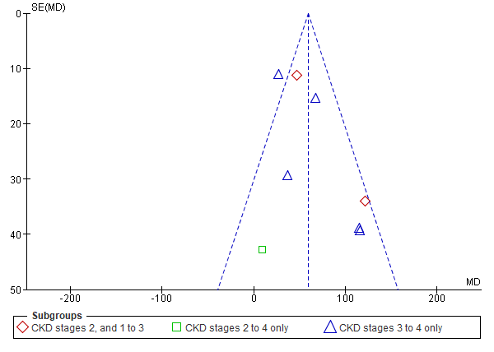
SF2c: Timed up and go test (3m and return) p=0.0006  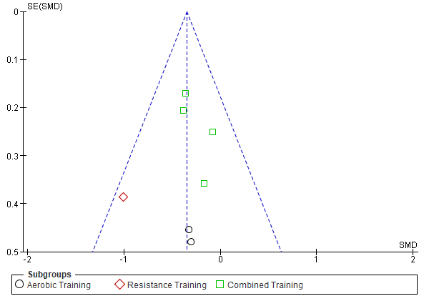 | SF2d: Timed up and go test (3m and return) p=0.0006  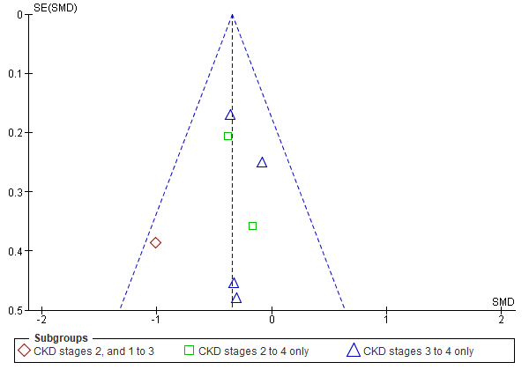
SF2e: Two-minute step test (no of steps) p=0.0001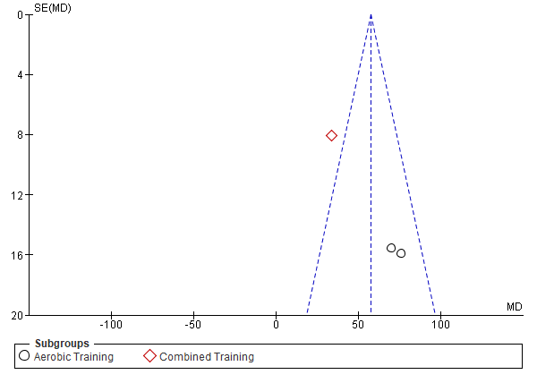 | SF2f: Two-minute step test (no of steps) p=0.0001  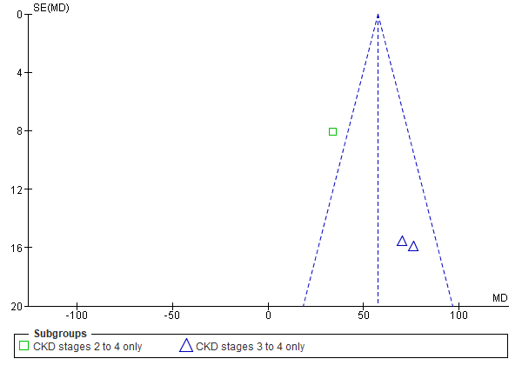
SF2g: Sit to stand test (reps in 30sec) p=0.004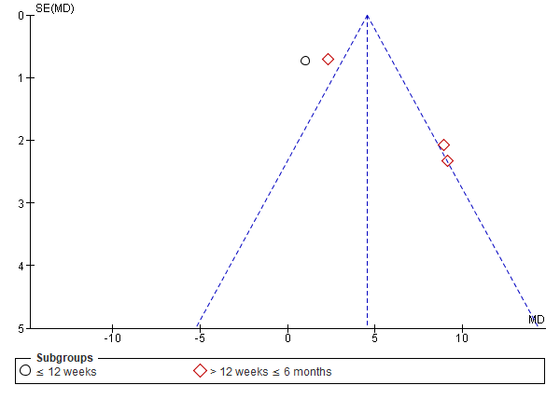 | SF2h: Sit to stand test (reps in 30sec) p=0.004  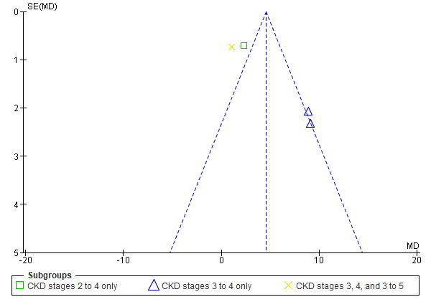
SF2i: Handgrip strength (kg) p=0.13  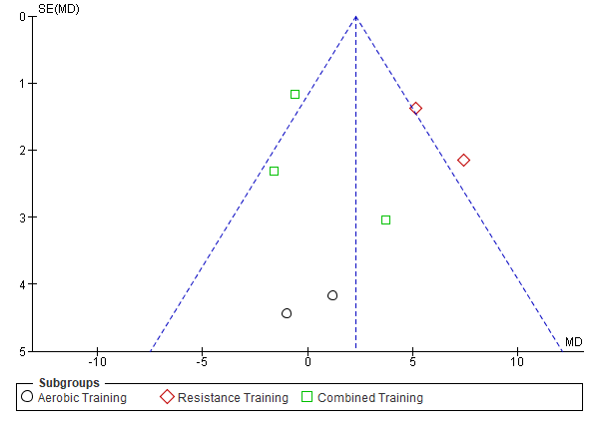 | SF2j: Handgrip strength (kg) p=0.13  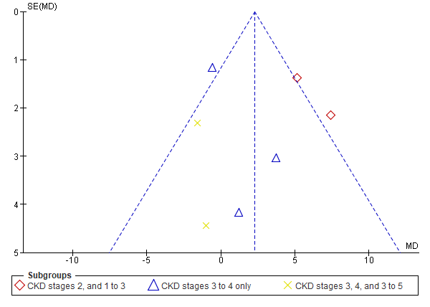

Supplemental Figure 3 Quality of Life
SF3a: General Health (by intervention modality); SF3b: General Health (by CKD stage); SF3c: Mental Component Summary (by intervention modality); SF3d: Mental Component Summary (by CKD stage); SF3e: Physical Component Summary (by intervention modality); SF3f: Physical Component Summary (by CKD stage).
SF3a: General Health p=0.05  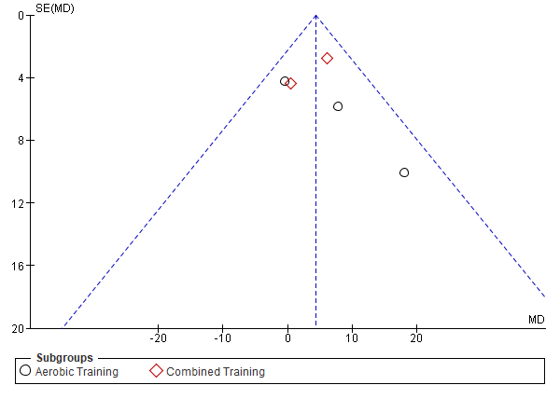 | SF3b: General Health p=0.05  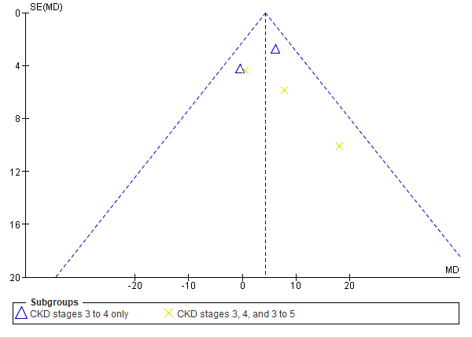
SF3c: Mental Component Summary p=0.03  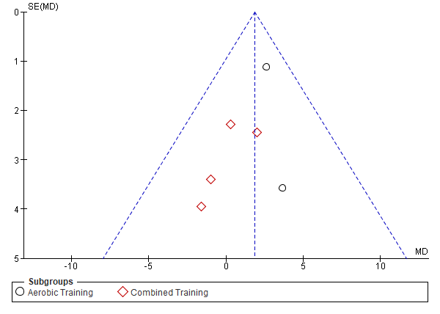 | SF3d: Mental Component Summary  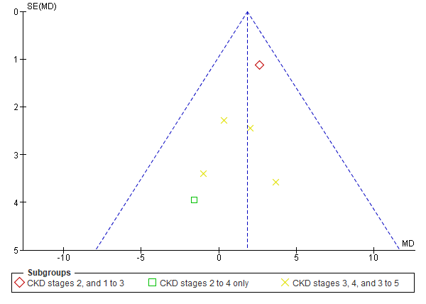
SF3e: Physical Component Summary p=0.22  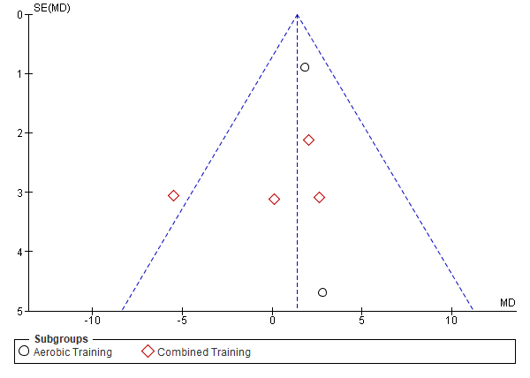 | SF3f: Physical Component Summary p=0.22  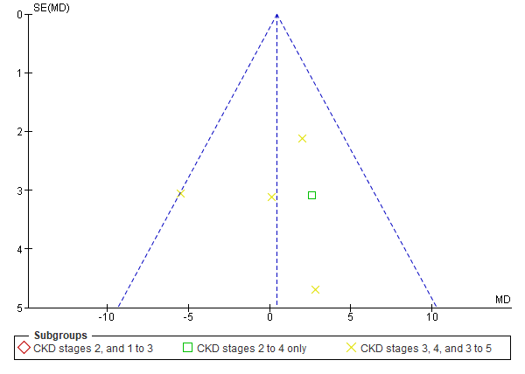

Supplemental Figure 4 Renal parameters funnel plot of comparison
SF4a: Estimated glomerular filtration rate (mL/min/1.73m2) (by intervention modality); SF4b: Estimated glomerular filtration rate (mL/min/1.73m2) (by CKD stage); SF4c: Estimated glomerular filtration rate cystatin-C (mL/min/1.73m2) (by intervention modality); SF4d: Estimated glomerular filtration rate cystatin-C (mL/min/1.73m2) (by CKD stage); SF4e: Serum creatinine (mg/dL) (by intervention modality); SF4f: Serum creatinine (mg/dL) (by CKD stage); SF4g: Serum albumin (g/dL) (by intervention modality); SF4h: Serum albumin (g/dL) (by CKD stage); SF4i: Serum cystatin-C (mg/L) (by intervention modality); SF4j: Serum cystatin-C (mg/L) (by CKD stage); SF4k: Urine albumin-creatinine ratio (g/gCr) (by intervention modality); SF4l: Urine albumin-creatinine ratio (g/gCr) (by CKD stage); SF4m: Urine protein-creatinine ratio (g/gCr) (by intervention modality); SF4n: Urine protein-creatinine ratio (g/gCr) (by CKD stage); SF4o: 24 hour Urine Protein (g/24hr) (by intervention modality); SF4p: 24 hour Urine Protein (g/24hr) (by CKD stage); SF4q: Blood urea nitrogen (mg/dL) (by intervention modality); SF4r: Blood urea nitrogen (mg/dL) (by CKD stage)

SF4a: Estimated glomerular filtration rate (mL/min/1.73m²) p=0.001  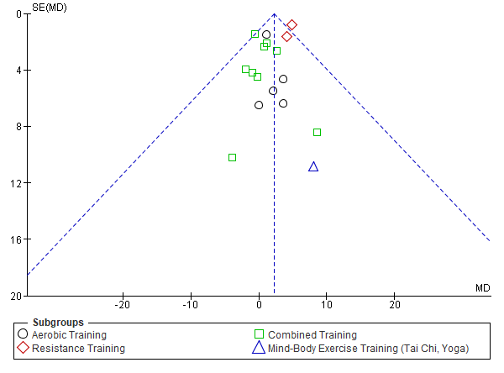 | SF4b: Estimated glomerular filtration rate (mL/min/1.73m²) p=0.001  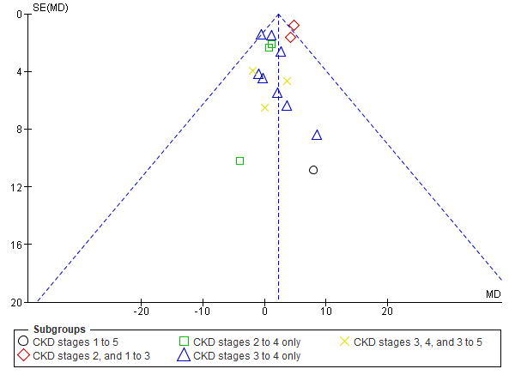
SF4c: Estimated glomerular filtration rate cystatin-C (mL/min/1.73m²) p=0.15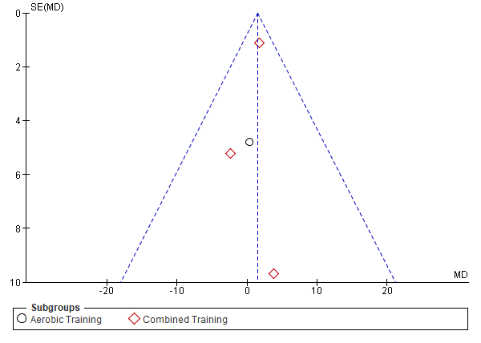 | SF4d: Estimated glomerular filtration rate cystatin-C (mL/min/1.73m²) p=0.15  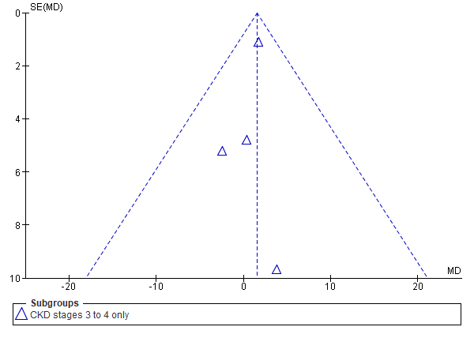
SF4e: Serum creatinine (mg/dL) p=0.39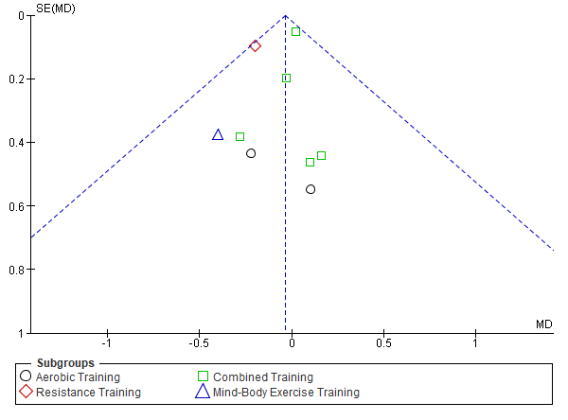 | SF4f: Serum creatinine (mg/dL) p=0.39  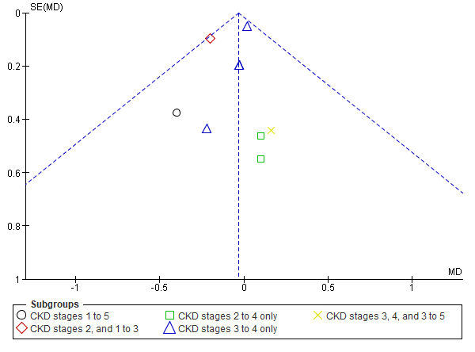
SF4g: Serum Albumin (g/dL) p=0.16  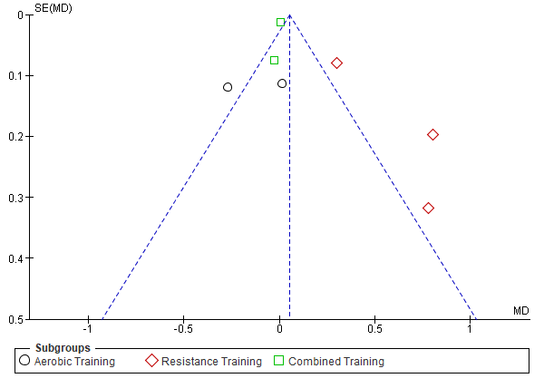 | SF4h: Serum Albumin (g/dL) p=0.16  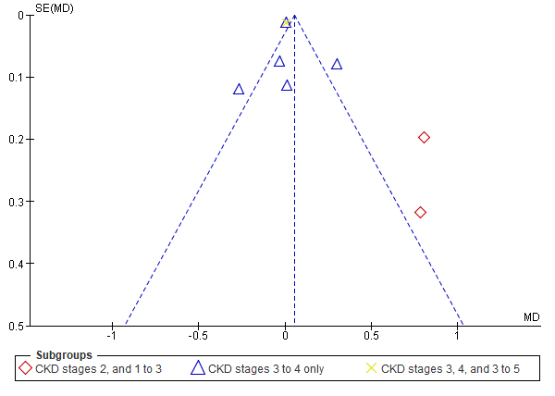
SF4i: Serum cystatin-C (mg/L) p=0.004  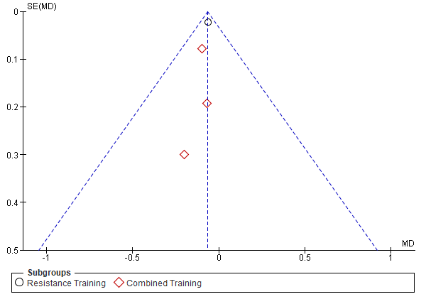 | SF4j: Serum cystatin-C (mg/L) p=0.004  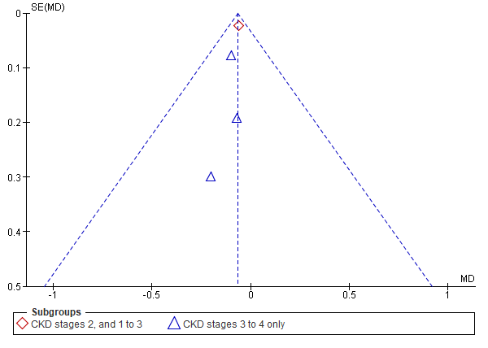
SF4k: Urine albumin-creatinine ratio (g/gCr) p=0.90  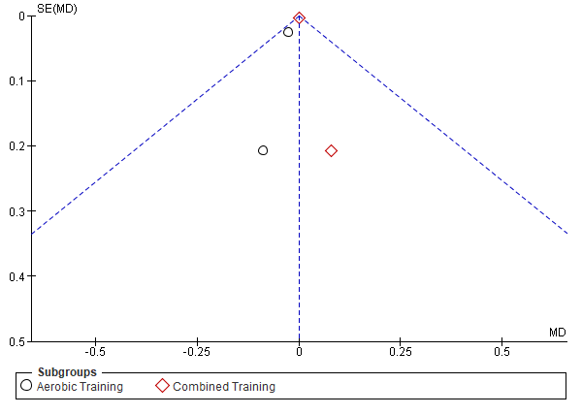 | SF4l: Urine albumin-creatinine ratio (g/gCr) p=0.90  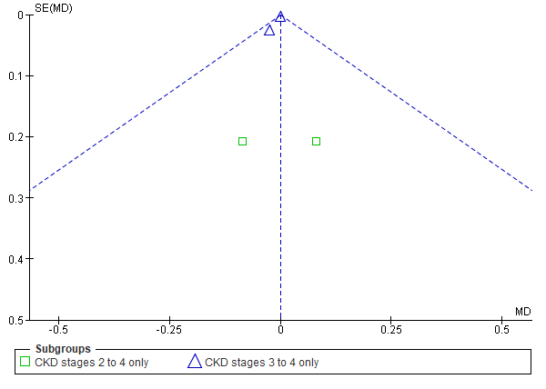
SF4m: Urine protein-creatinine ratio (g/gCr) p=0.92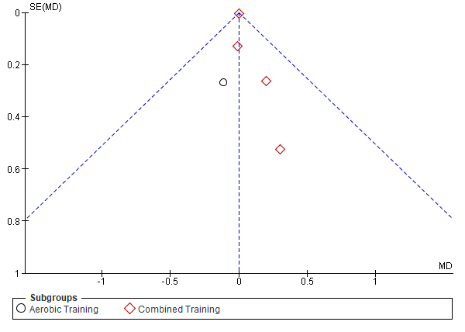 | SF4n: Urine protein-creatinine ratio (g/gCr) p=0.92  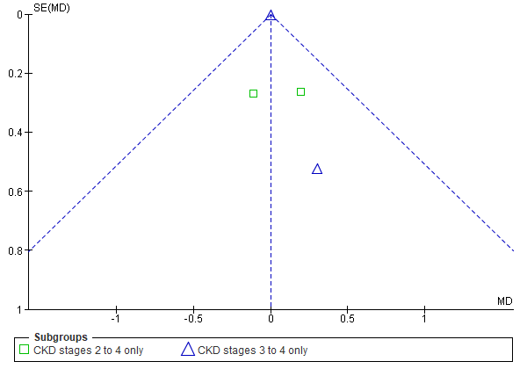
SF4o: 24 hour Urine Protein (g/24hr) p=0.79  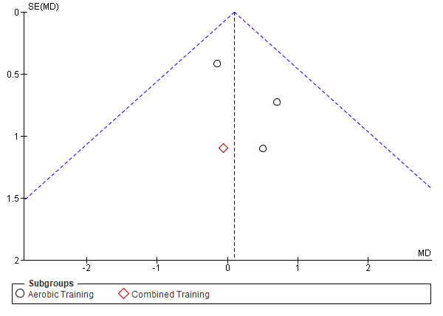 | SF4p: 24 hour Urine Protein (g/24hr) p=0.79  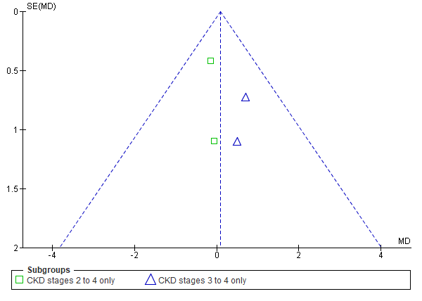
SF4q: Blood urea nitrogen (mg/dL) p=0.82  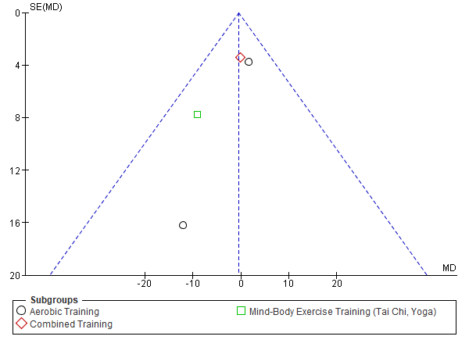 | SF4r: Blood urea nitrogen (mg/dL) p=0.82  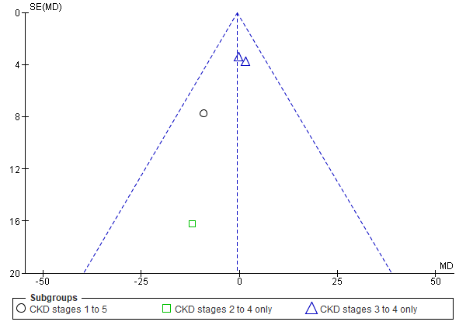

Supplemental Figure 5 Cardiovascular Risk Factors: Blood Pressure
SF5a: Resting Heart Rate (by intervention modality); SF5b: Resting Heart Rate (by CKD stage); SF5c: Systolic Blood Pressure (by intervention modality); SF5d: Systolic Blood Pressure (by CKD stage); SF5e: Diastolic Blood Pressure (by intervention modality); SF5f: Diastolic Blood Pressure (by CKD stage); SF5g: Ambulatory 24 hour systolic blood pressure (mmHg) (by intervention modality); SF5h: Ambulatory 24 hour systolic blood pressure (mmHg) (by CKD stage); SF5i: Ambulatory 24 hour diastolic blood pressure (mmHg) (by intervention modality); SF5j: Ambulatory 24 hour diastolic blood pressure (mmHg) (by CKD stage)
SF5a: Resting Heart Rate (bpm) p=0.04  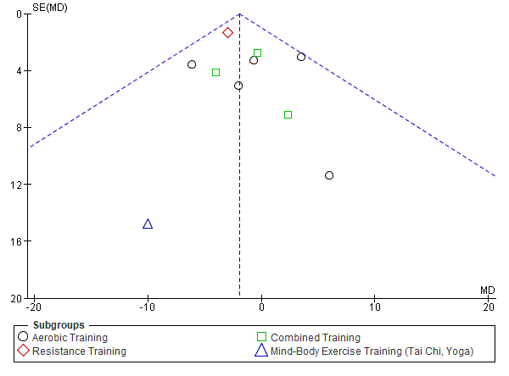 | SF5b: Resting Heart Rate (by CKD stage) (bpm) p=0.04  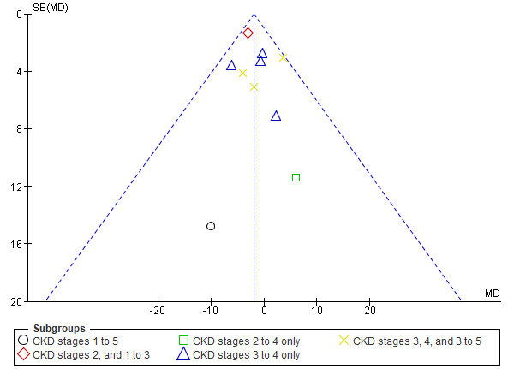
SF5d: Systolic Blood Pressure (mmHg) p=0.35  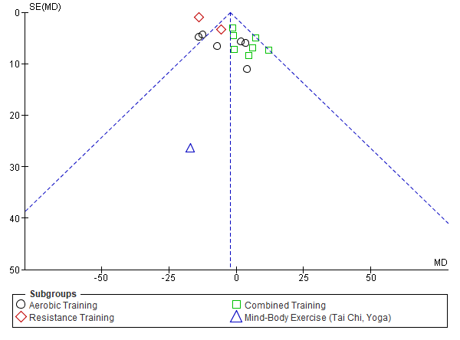 | SF5d: Systolic Blood Pressure (mmHg) p=0.35  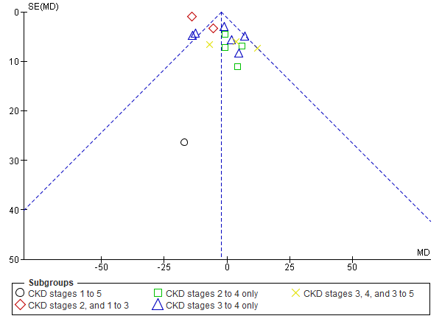
SF5e: Diastolic Blood Pressure (mmHg) p=0.32  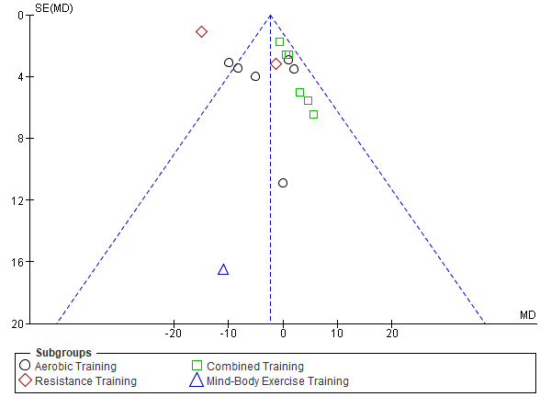 | SF5f: Diastolic Blood Pressure (mmHg) p=0.32  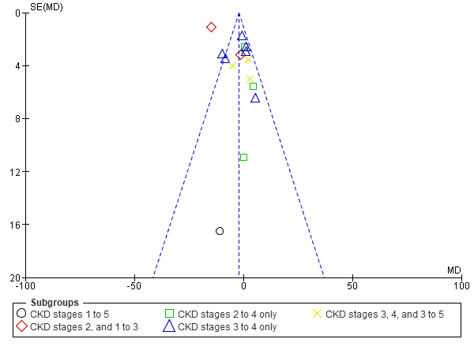
SF5g: Ambulatory 24 hour systolic blood pressure (mmHg) p=0.97  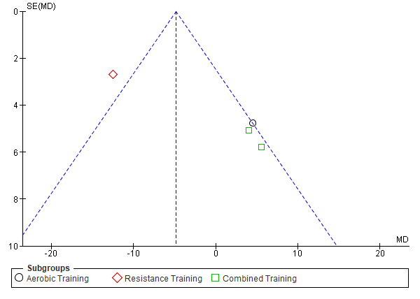 | SF5h: Ambulatory 24 hour systolic blood pressure  (mmHg) p=0.97  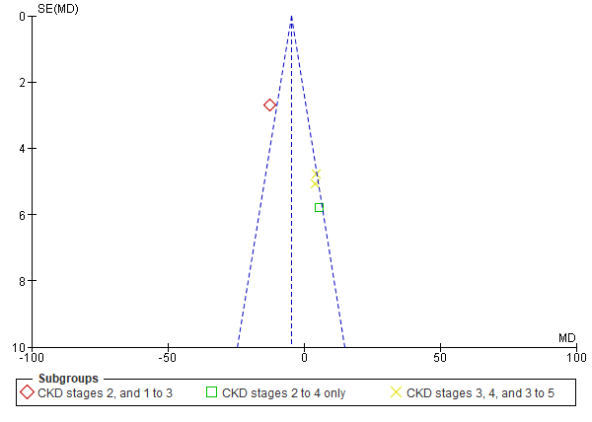
SF5i: Ambulatory 24 hour diastolic blood pressure (mmHg) p=0.83  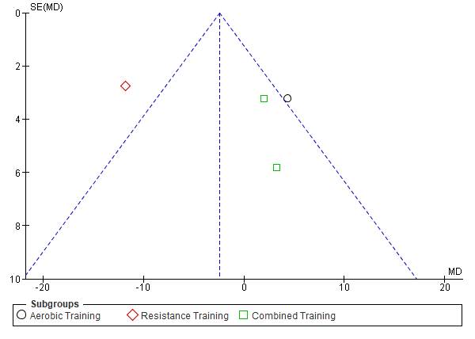 | SF5j: Ambulatory 24 hour diastolic blood pressure  (mmHg) p=0.83  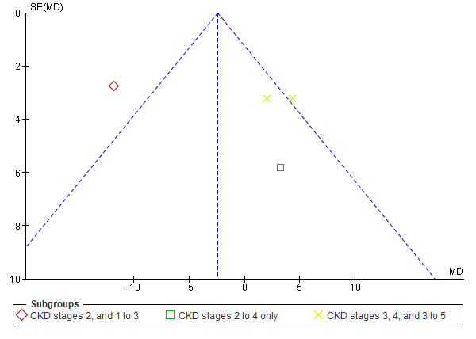

Supplemental Figure 6 Cardiovascular Risk Factors: Endothelial factors
SF6a: Pulse Wave Velocity (m/s) (by intervention modality); SF6b: Pulse Wave Velocity (m/s) (by CKD stage); SF6c: Augmentation Index central arterial (%) (by intervention modality); SF6d: Augmentation Index central arterial (%) (by CKD stage); SF6e: Asymmetric dimethylarginine (umol/L) (by intervention modality); SF6f: Asymmetric dimethylarginine (umol/L) (by CKD stage)
SF6a: Pulse Wave Velocity (m/s) p=0.80  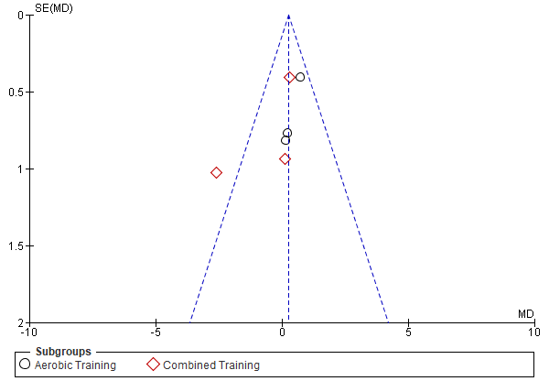 | SF6b: Pulse Wave Velocity (m/s) p=0.80  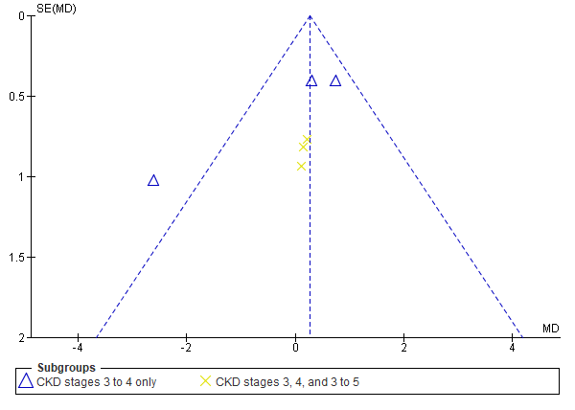
SF6c: Augmentation Index central arterial (%) p=0.25  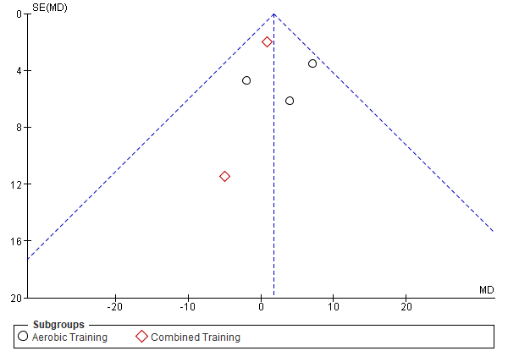 | SF6d: Augmentation Index central arterial (%) p=0.25  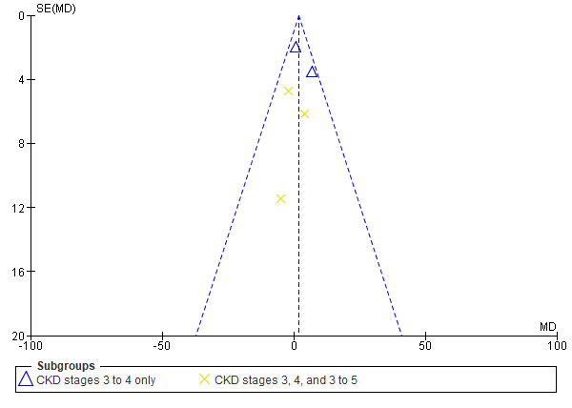
SF6e: Asymmetric dimethylarginine (umol/L) p=0.07  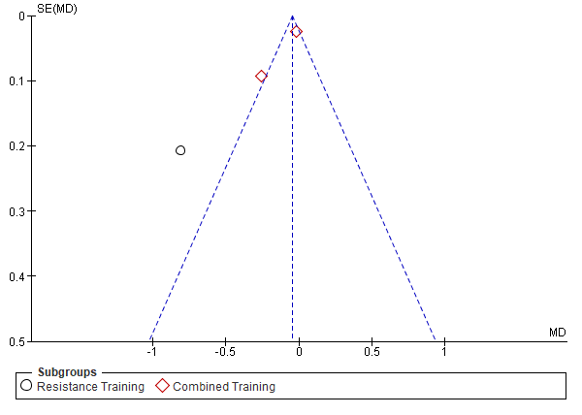 | SF6f: Asymmetric dimethylarginine (umol/L) p=0.07  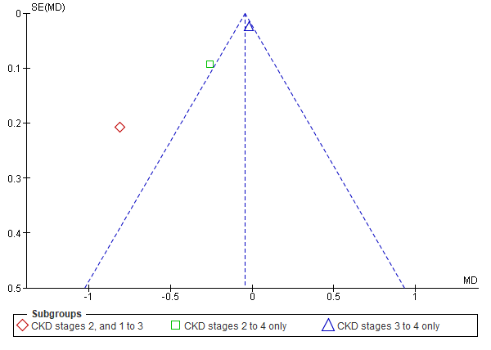

Supplemental Figure 7 Cardiovascular Risk Factors: Lipids and blood parameters
SF7a: Triglyceride (by intervention modality); SF7b: Triglyceride (by CKD stage); SF7c: Total Cholesterol (by intervention modality); SF7d: Total Cholesterol (by CKD stage); SF7e: Low Density Lipoprotein (by intervention modality); SF7f: Low Density Lipoprotein (by CKD stage); SF7g: High Density Lipoprotein (by intervention modality); SF7h: High Density Lipoprotein (by CKD stage); SF7i: Glycosylated Haemoglobin (by intervention modality); SF7j: Glycosylated Haemoglobin (by CKD stage); SF7k: Blood Glucose (mg/dL) (by intervention modality); SF7l: Blood Glucose (mg/dL) (by CKD stage); SF7m: Haemoglobin (g/dL) (by intervention modality); SF7n: Haemoglobin (g/dL) (by CKD stage)
SF7a: Triglyceride (mg/dL) p<0.00001  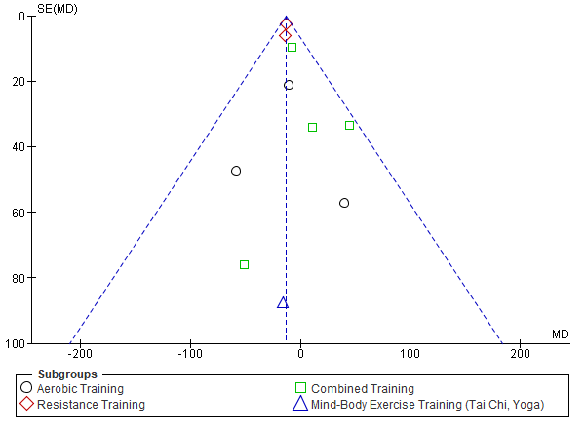 | SF7b: Triglyceride (mg/dL) p<0.00001  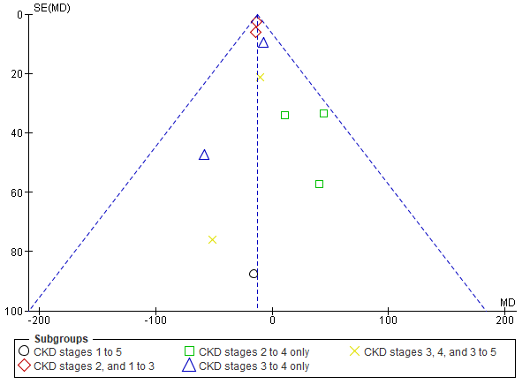
SF7c: Total Cholesterol (mg/dL) p=0.20  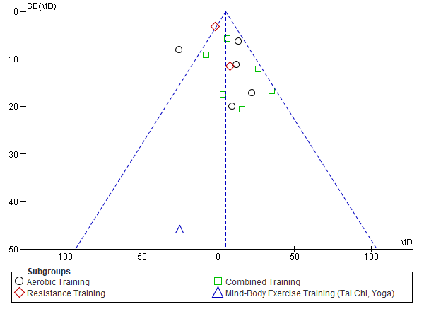 | SR6d: Total Cholesterol (mg/dL) p=0.20  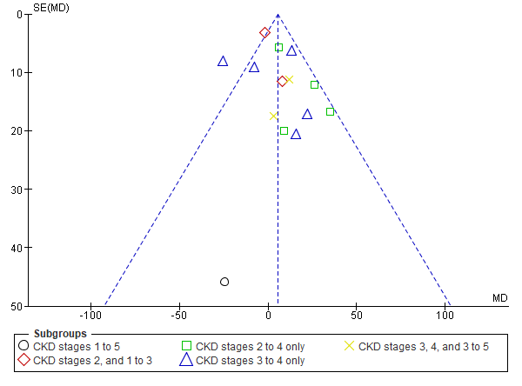
SF7e: Low Density Lipoprotein(mg/dL) p=0.06  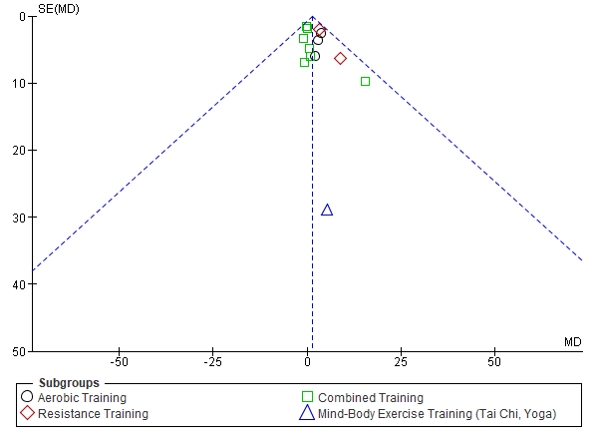 | SF7f: Low Density Lipoprotein (mg/dL) p=0.06  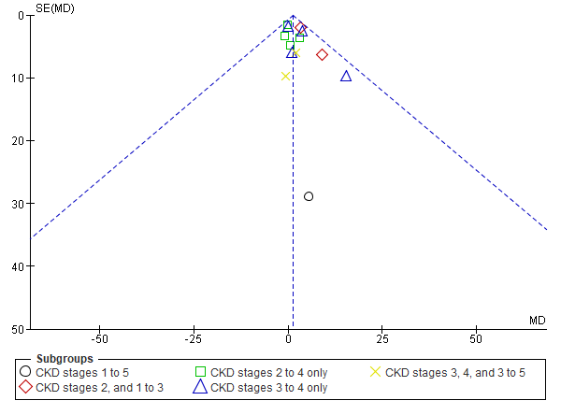
SF7g: High Density Lipoprotein (mg/dL) p=0.11 | SF7h: High Density Lipoprotein (mg/dL) p=0.11
SF7i: Glycosylated Haemoglobin (%) p=0.04  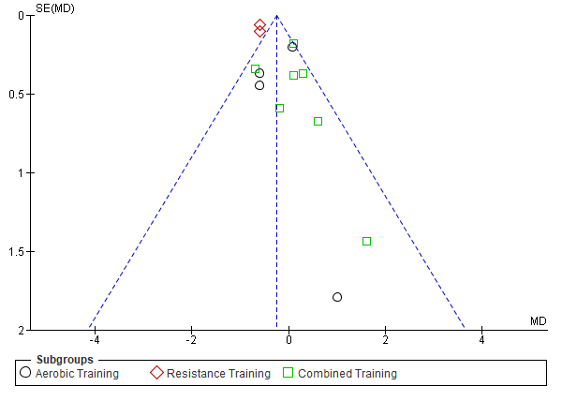 | SF7j: Glycosylated Haemoglobin (%) p=0.04  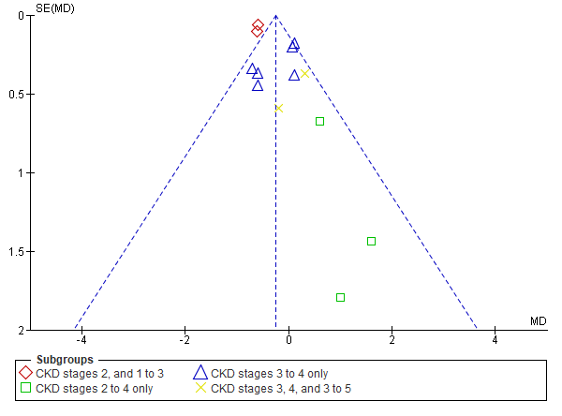
SF7k: Blood Glucose (mg/dL) p=0.29  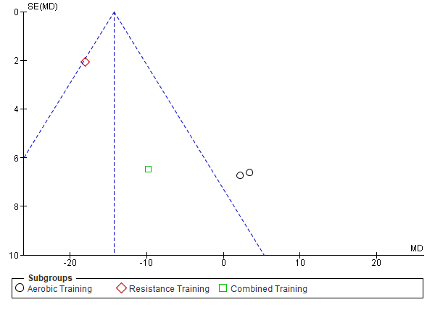 | SF7l: Blood Glucose (mg/dL) p=0.29  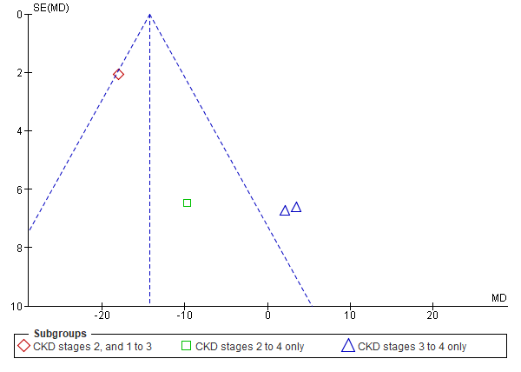
SF7m: Haemoglobin (g/dL) p=0.08  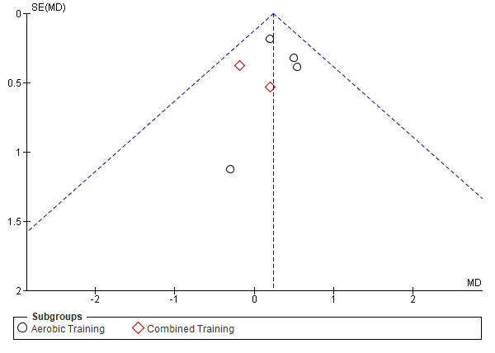 | SF7n: Haemoglobin (g/dL) p=0.08  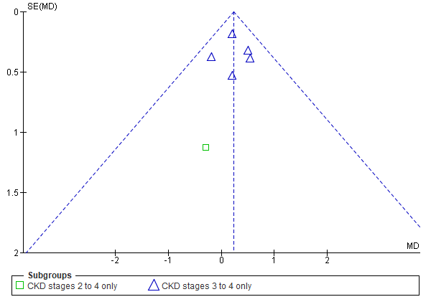

Supplemental Figure 8 Cardiovascular Risk Factors: Body composition parameters
SF8a: Waist circumference (cm) (by intervention modality); SF8b: Waist circumference (cm) (by CKD stage); SF8c: Body Weight (by intervention modality); SF8d: Body Weight (by CKD stage); SF8e: Body Mass Index (by intervention modality); SF8f: Body Mass Index (by CKD stage); SF8g: Body Fat (%) (by intervention modality); SF8h: Body Fat (%)(by CKD stage);SF8i: Lean body mass (kg) (by intervention modality); SF8l: Lean body mass (kg) (by CKD stage)

SF8a: Waist circumference (cm) p<0.00001  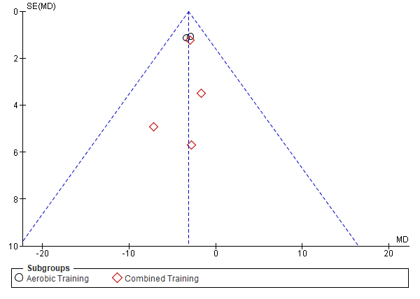 | SF8b: Waist circumference (cm) p<0.00001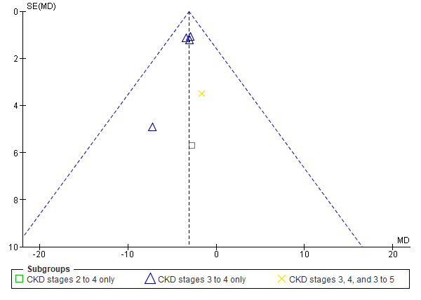
SF8c: Body Weight (kg) p=0.62  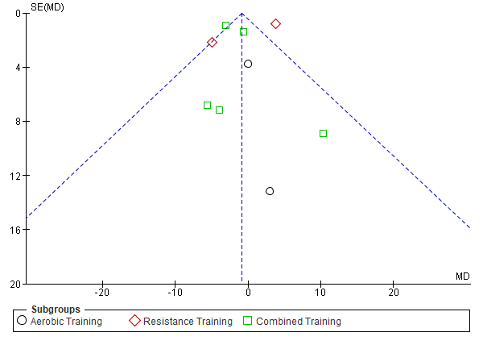 | SF8d: Body Weight (kg) p=0.62  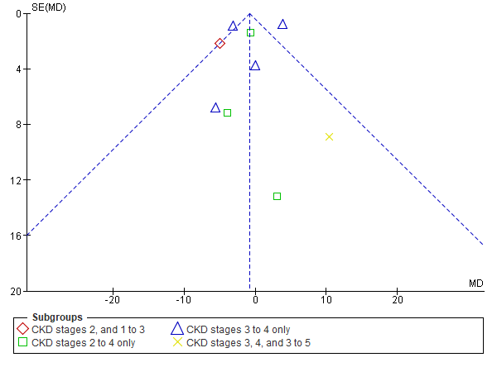
SF8d: Body Mass Index (kg/m²) p=0.18  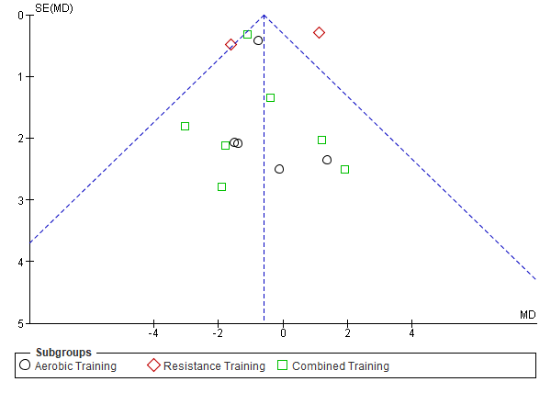 | SF8f: Body Mass Index (kg/m²) p=0.18  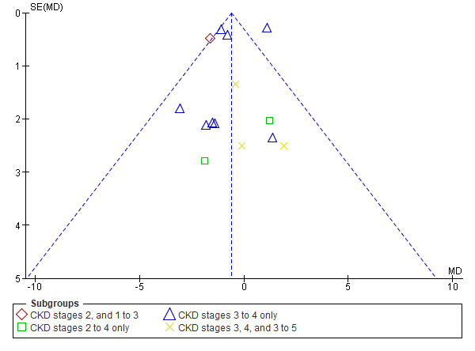
SF8g: Body Fat (%) p=0.09  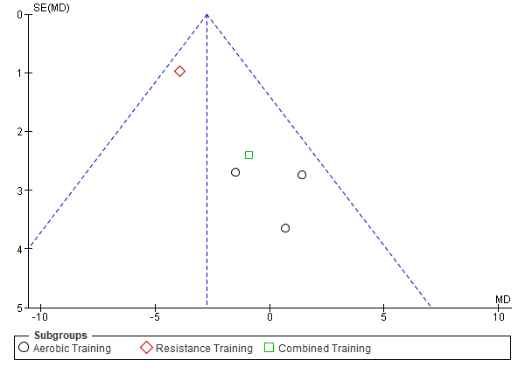 | SF8h: Body Fat (%) p=0.09  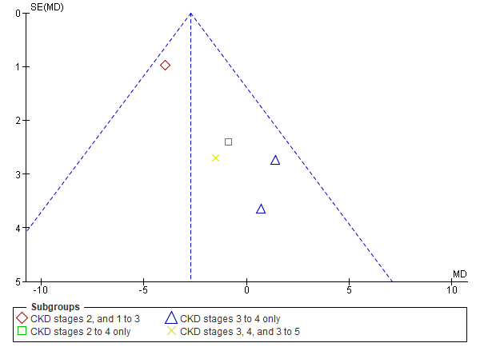
SF8i: Lean body mass (kg) p=0.06  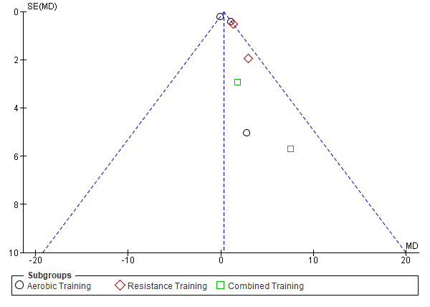 | SF8j: Lean body mass (kg) p=0.06  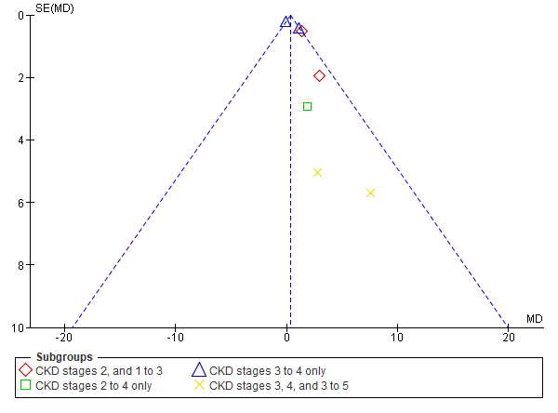

Supplemental Figure 9 Inflammatory markers
SF9a: Interleukin-6 (by intervention modality); SF9b: Interleukin-6 (by CKD stage); SF9c: C-reactive protein (by intervention modality); SF9d: C-reactive protein (by CKD stage).
SF9a: Interleukin-6 (pg/mL) p=0.007  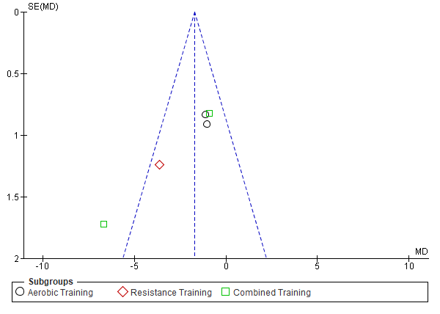 | SF9b: Interleukin-6 (pg/mL) p=0.007  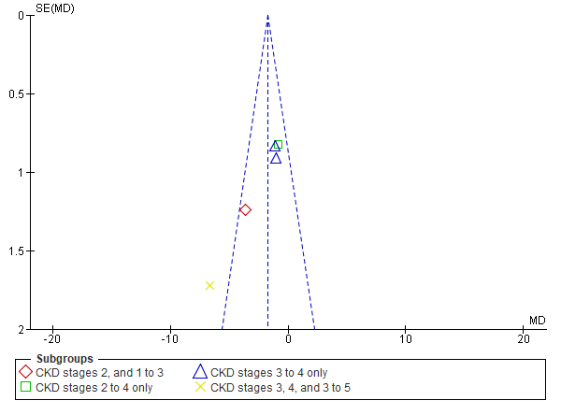
SF9c: C-reactive protein (mg/L) p=0.92  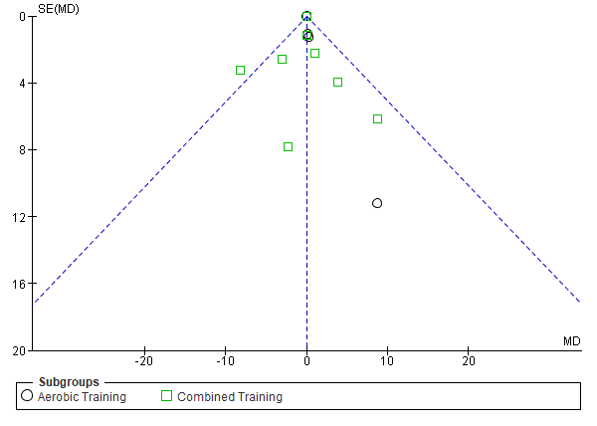 | SF9c: C-reactive protein (mg/L) p=0.92  