Supplemental Data - Tables

Table S1. Primer sequences for genes analyzed in leaves and stems of E. globulus and E. grandis.

Gene name | Sequence 5´to 3´
EgKIN10B_F | AGAGAGTTGCGCCAGAAATC
EgKIN10B_R | TCGTAAAGTTTGGCGTGGTC
EgKIN10C_F | TTCCGACCTTCCAATGGCTAC
EgKIN10C_R | TTCCACGATTGAAGGTGCAC
IDH_F | AGTTTGAGGCTGCTGGAATC
IDH_R | CTTGCATGCCCACACATAAC

Table S2. Abbreviations of the major compounds identified in samples of leaves and stems of E. globulus and E. grandis.

Abbreviation | Compound
1,6-b-Glc | 1,6-anhydro-β-D-glucose
3,6-Gal | 3,6-anhydro-galactose
3-CQA | 3-cafeoylquinic acid
3-P-ShikA | Shikimate-3-phosphate
Ala | Alanine
Ara | Arabinose
Asp | Aspartate
BenA | Benzoate
Cat | Catechin
CitA | Citrate
DHA | Dehydroascorbic acid
EryOH | Erythritol
Fru | Fructose
Gal | Galactose
GalnOH | Galactinol
Glc | Glucose
Glc-6-P | Glucose-6-phosphate
Gln | Glutamine
Glu | Glutamate
Gly | Glycerol
GlyA | Glycerate
GlycA | Glycolate
hCys | Homocysteine
Ile | Isoleucine
Leu | Leucine
MalA | Malate
Malt | Maltose
Man | Mannose
mIno | myo-Inositol
o-Coum | o-Coumarate
P | Phosphate
Phe | Phenylalanine
Put | Putrescine
QuinA | Quinate
Raf | Raffinose
Rib | Ribulose
Ser | Serine

Table S2 (cont.). Abbreviations of the major compounds identified in samples of leaves and stems of E. globulus and E. grandis.

Abbreviation | Compound
ShikA | Shikimate
Suc | Sucrose
SucA | Succinate
ThrA | Threonate
Trp | Tryptophan
Tyr | Tyrosine
Val | Valine
Xyl | Xylose
Table S3. Main vectors of the first three principal components (PCs) of the analysis presented in Figure S8.
.
 | First PC | Second PC | Thrid PC
Positive portion | Leucine at 0h | Sucrose at 0h | Phenylalanine at 6h
Positive portion | Aspartate at 0h | Phenylalanine at 24h | Succinate at 24h
Positive portion | Valine at 0h | Glucose at 6h | Citrate at 0h
Positive portion | Isoleucine at 0h | Tryptophan at 24h | Alanine at 18h
Positive portion | Isoleucine at 6h | Galactose at 0h | Citrate at 24h
Negative portion | Succinate at 18h | Citrate at 12h | Fructose at 0h
Negative portion | Glucose at 0h | Malate at 24h | Serine at 24h
Negative portion | Fructose at 0h | Malate at 0h | Valine at 24h
Negative portion | Glutamine at 0h | Malate at 6h | Glucose at 24h
Negative portion | Citrate at 6h | Raffinose at 0h | Aspartate at 24h

Table S4. Main vectors of the first three principal components (PC) of the analysis presented in Figure S9.

 | First PC | Second PC | Thrid PC
Positive portion | Valine at 0h | Leucine at 0h | Phenylalanine at 6h
Positive portion | Isoleucine at 0h | Isoleucine at 0h | Succinate at 12h
Positive portion | Leucine at 0h | Valine at 0h | Leucine at 6h
Positive portion | Tryptophan at 0h | Glucose at 24h | Isoleucine at 18h
Positive portion | Alanine at 0h | Leucine at 6h | Leucine at 18h
Negative portion | Glucose at 6h | Fructose at 0h | Malate at 6h
Negative portion | Glucose at 12h | Citrate at 18h | Sucrose at 6h
Negative portion | Fructose at 6h | Malate at 6h | Succinate at 18h
Negative portion | Fructose at 24h | Succinate at 0h | Malate at 24h
Negative portion | Succinate at 6h | Succinate at 12h | Citrate at 24h

Supplemental Data – Gene sequences
>EgKIN10B
atggaagaaccctctcggcgaacaaggtctagtgaggacccatccctgaagaattatagg
ctaataagaaatattggccacggtgcatttggcaaagtgaaagttgcaaagcatagacta
actggtatcaaagtggccattaagattcttaaccgtaaaaaaatgagggaaaagtgcatg
gaggagaaagtgagtcgggagattaagattggcaaactactgaagcatccgcatattatc
aggctatatgagaccatagagagcatgactaatgtgtatgttgtcatggagtacgcagaa
catggggacttgtttgattatattgtccagaatagaaggatcagagaggatgaagcacgg
aaattttttcagcagatcatttcaggtttagagcactgccacaaatatagggtggttcat
cgagaccttaagcctgagaatctgttgttggattctaatggcaatgtgaaaattattgat
tttggcttgagtaatattatgcacgatggctattttctaaaaacaagttgtggaagtaca
aattatgctgccccagaggttatttctggtaaactttatgcagggccagaggttgacatc
tggagttgcggtgtcgtcttatatgtagttctttgtggcgctctgccttttgatgatgaa
agcatacctaacctccatgataaaataaagagtggagtttatactcttccaagtcattta
acaactgaagcaagggatttgattgcaaggatgattgttgttgaccctttaaagcggata
accattcctgaaattcgtcaacatccttggttcttggaaaatcttcctaattatctggct
gctgctttgccaaatattaaacatcaaacggagaaggttgatgaagaaatacttgagcat
atggttgcattgggatttaacagggaacatttggtttggtctcttcaaaaaaggatacat
gatgatgctacagtgtcgtattacttgctgttagacaacaatgtatctggtactagcatt
tacagggcagagctcaataatagtgcgggacctagttcatctgctgttcccagtggtggg
ttttcagtatctgttgccaagccgcttatagaacatcagactactcagtcacggagtgtg
ggaagatggggtcttggatttcagtttggactgcagcctcatcatattatggtagaagtt
ctgaatgcactatgtcagctaaatgtctgctggaaaaagaccggacactacaacatcaag
tgcatgtggtctcgaggaggtcaagttcaagaccttactaaaaattgtcagcataatggc
ctccatttaggaaatgaacctgcaacaatccagacaaatcaagtgtctcagaacactgtc
aagtttgaactgcagctgtataaaacttgtgaagagaattatctgctggacctcctgaga
ctcacaggtccccaaatactcttttttgatctctgtgccagtttccttgcccgactgccg
ttattctagagtggcaataattactagaagagagaatcttgtctactcataataagagag
ttgcgccagaaatctagagatgtgctgacaattggagagtaccgagcgggagacggacca
cgccaaactttacgattctgccttttccagcttttgtgtaccgtgtaaaatattctgata
ctgtctatcgtaagatgaacttattgctgatgaaagggagaacattagacataaaataat
tgctttagaact

>EgKIN10C
atggatggaacgactcgagggggcagcaatgcggacatgtatctaccgaattataagctc
gggaagactctgggcatcggttcgtttggtaaggtgaaaatagcggaacacgtgttgact
gggcacaaggtcgccataaagatcctcaaccggcgcaagataaagaacatggagatggaa
gagaaagtgaggagagaaataaaaatcctcagactctttatgcatccgcacatcatccga
ctttatgaagtcattgagacgcctacggacatttatgttgtgatggagtatgtgaagtct
ggggagctgttcgattacattgtcgagaagggcaggttgcaggagaatgaagctcgcaac
ttttttcagcagattatttccggtgtggaatactgccataggaatatggtcgttcataga
gatctaaagcctgaaaacttgctgttggattctaaatggaatgtgaagatcgcagatttc
ggtctgagcaatataatgcgtgacggtcatttcttaaagacaagttgtgggagccccaac
tatgccgctccggaggttatctctggtaaactttatgcggggcctgaagtagatgtatgg
agctgtggagttatattatacgctcttctttgtggcacactccctttcgatgatgaaaac
atacctaaccttttcaagaaaatcaagggtgggatgtacactcttccaagtcacttatcg
gcaggttcaaaggacttgatcccaaggatgcttatagttaatccaatgaaacgaatcacc
attccagagatccgtcagcatccttggtttcaagctcatcttccacgttatttggccgtg
cctccacctgatacgatgcagcaagcgaaaaagattgacgaggaaatactccaggaagtg
gtcaacatgggttttgagcgcaatcaacttgtcgaatcacttcgcaaccggattcaaaat
gaggctactgttgcatactacttgttattggataaccgtttccgaccttccaatggctac
ctcggagatgagtttcaagaaacgatggagtgcaccttcaatcgtggaaatccaggggag
cttaccattccaactgttgggcctcgctacccactacctggatatatggattaccaggga
gtgaattcaaaaccaggttattatggtgctgagaagaaatgggctcttggtctccagtct
cgagcccatccacgggaaataatgactgaagttcttaaggcgctgcgagaactaaatgtg
tgctggaagaagattgggcactataacatgaagtgcatgtggaatccttgtgttcccagt
catgagagcatggttagcaatcctgtccagagtaattattttggtgatgaatctacaata
atcgagaatgatggcgcaaccaagtccagaaatgtggtcaagtttgaggtgcagctttac
aaaacgacggaggagaaatatttactcgatttgcagagggtgcagggaccccagtttctg
tttttggacctctgtgctgcttttcttgcccaactccgggtcctttag
SupplementalData-Figures
FigureS1.IdentificationofconservedandcharacteristicproteindomainsofKIN10kinasein(A)Arabidopsisthalianaandeucalyptussequences(B)KIN10Band(C)KIN10C.AnalysisconductedthroughtheonlineConservedDomainsDatabasetool(http://www.ncbi.nlm.nih.gov/cdd/).

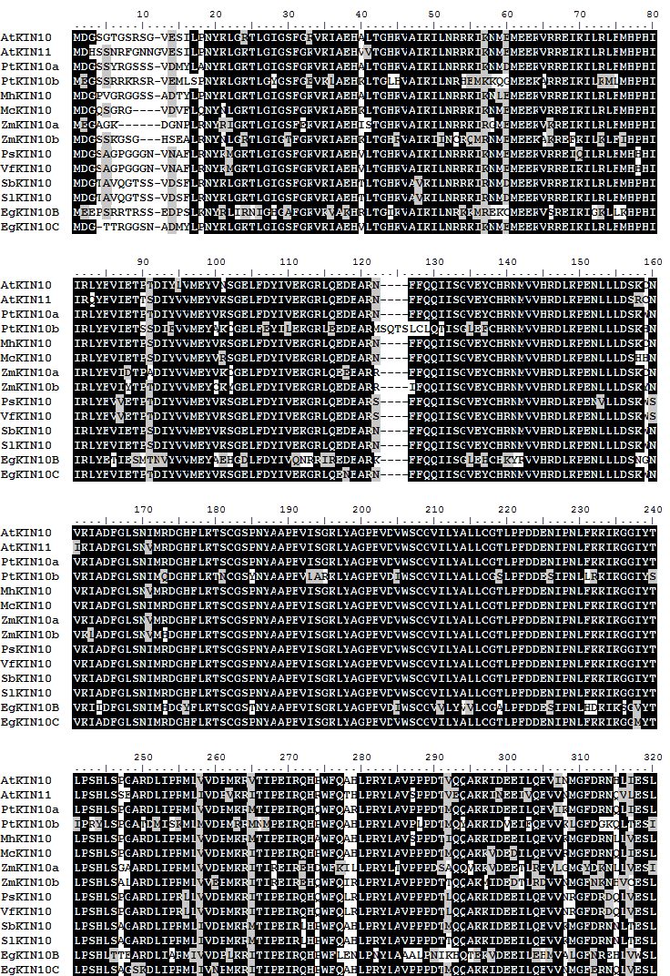
FigureS2.AligmentofpepetidesequencesofKIN10andKIN11genescodingsequencesofdifferentspecies.(At)Arabidopsisthaliana;(Eg)eucalyptussequencesobtainedinthiswork;(Mc)Mesembryanthemumcrystallinum;(Mh)Malushupehensis;(Nb)Nicotianabenthamiana;(Ps)Pisumsativum;(Pt)Populustrichocarpa;(Sb)Solanumberthaultii;(Sl)Solanumlycopersicum;(Vf)Viciafaba;(Zm)Zeamays.

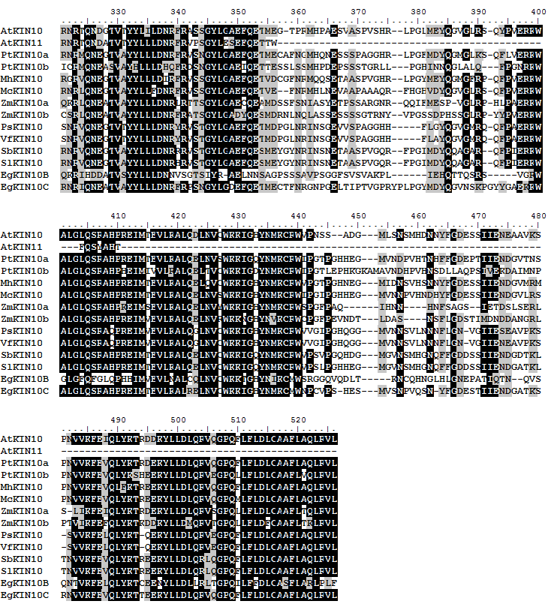
FigureS2(continuation).AligmentofpepetidesequencesofKIN10andKIN11genescodingsequencesofdifferentspecies.(At)Arabidopsisthaliana;(Eg)eucalyptussequencesobtainedinthiswork;(Mc)Mesembryanthemumcrystallinum;(Mh)Malushupehensis;(Nb)Nicotianabenthamiana;(Ps)Pisumsativum;(Pt)Populustrichocarpa;(Sb)Solanumberthaultii;(Sl)Solanumlycopersicum;(Vf)Viciafaba;(Zm)Zeamays.

FigureS3.PhylogenetictreeobtainedfromthealignmentofKIN10andKIN11genescodingsequencesofdifferentspecies.(At)Arabidopsisthaliana;(Eg)eucalyptussequencesobtainedinthiswork;(Mc)Mesembryanthemumcrystallinum;(Mh)Malushupehensis;(Nb)Nicotianabenthamiana;(Ps)Pisumsativum;(Pt)Populustrichocarpa;(Sb)Solanumberthaultii;(Sl)Solanumlycopersicum;(Vf)Viciafaba;(Zm)Zeamays.

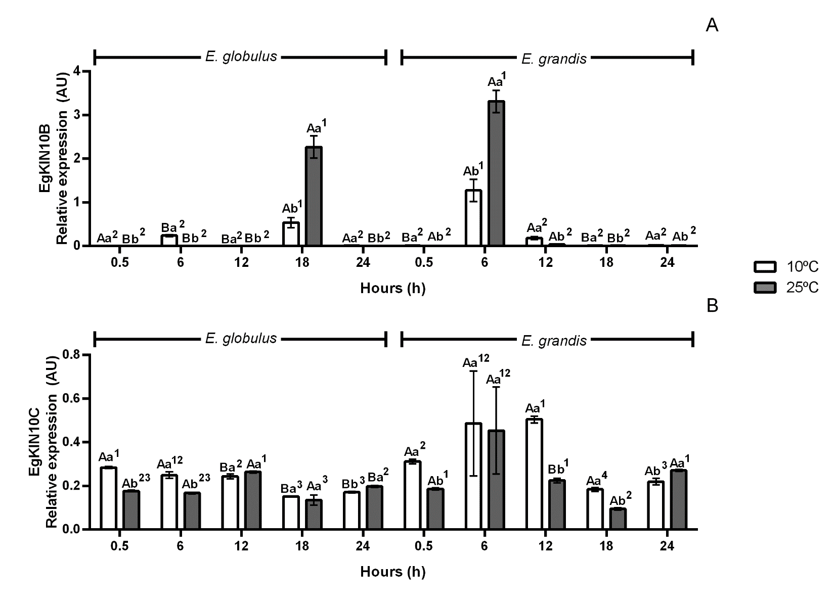
FigureS4.Relativeexpressionof(A)EgKIN10Band(B)EgKIN10CgenesinleavesofE.globulusandE.grandisexposedto10°Cand25°Cover24hours.Capitallettersindicatestatisticaldifferencesbetweenspecieswithinthesameharvestingtimepointandtreatment;lowercaselettersindicatedifferencesbetweentreatmentsforthesameharvestingtimepointandspecies;numeralsindicatedifferencesbetweenharvestingtimepointswithinthesamespeciesandtreatment.Experimentperformedwithfivebiologicalsamples.DifferencesamongexperimentalgroupsevaluatedbyOne-wayANOVAwithTukeytestat5%probabilityErrorbars:standarderror.
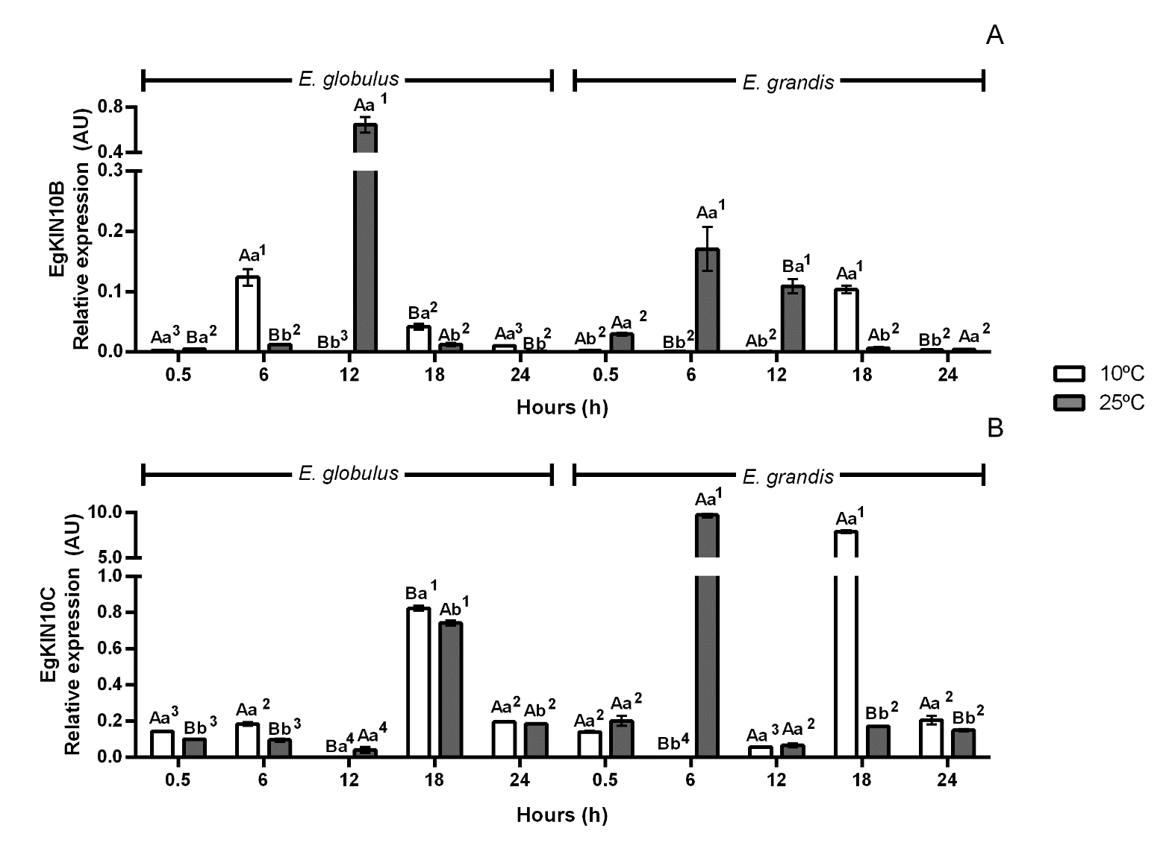
FigureS5.Relativeexpressionof(A)EgKIN10Band(B)EgKIN10CgenesinleavesofE.globulusandE.grandisexposedto10°Cand25°Cover24hours.Capitallettersindicatestatisticaldifferencesbetweenspecieswithinthesameharvestingtimepointandtreatment;lowercaselettersindicatedifferencesbetweentreatmentsforthesameharvestingtimepointandspecies;numeralsindicatedifferencesbetweenharvestingtimepointswithinthesamespeciesandtreatment.Experimentperformedwithfivebiologicalsamples.DifferencesamongexperimentalgroupsevaluatedbyOne-wayANOVAwithTukeytestat5%probabilityErrorbars:standarderror.

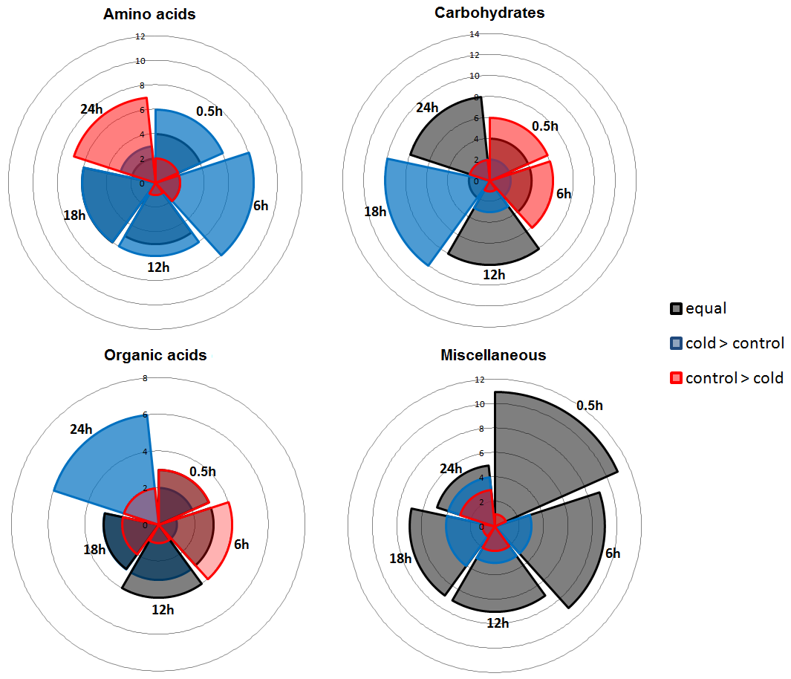
FigureS6.Numberofcompoundswhosecontentwashigher(blueshade),lower(redshade)orequal(blackshade)inleafsamplesofE.globulusexposedto10ºCcomparedtoplantsexposedto25ºCover24h.CompoundsaredescribedinFigure6andTableS2.

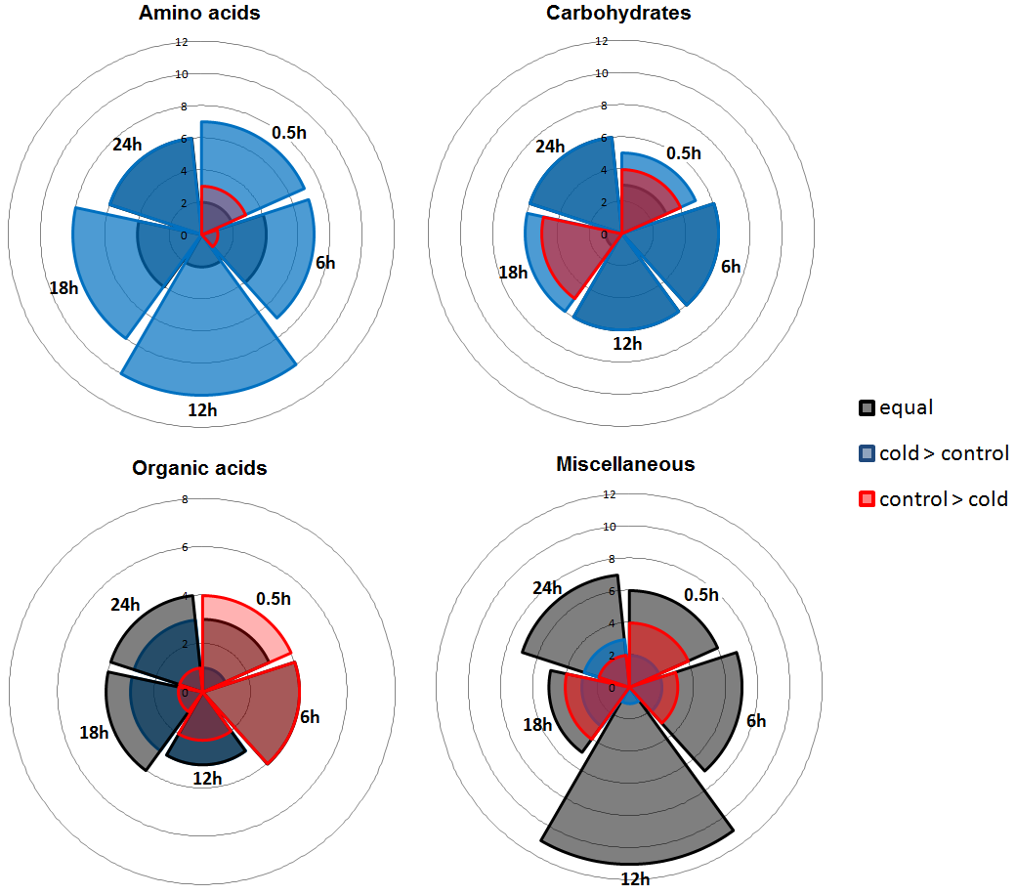
FigureS7.Numberofcompoundswhosecontentwashigher(blueshade),lower(redshade)orequal(blackshade)inleafsamplesofE.grandisexposedto10ºCcomparedtoplantsexposedto25ºCover24h.CompoundsaredescribedinFigure7andTableS2.

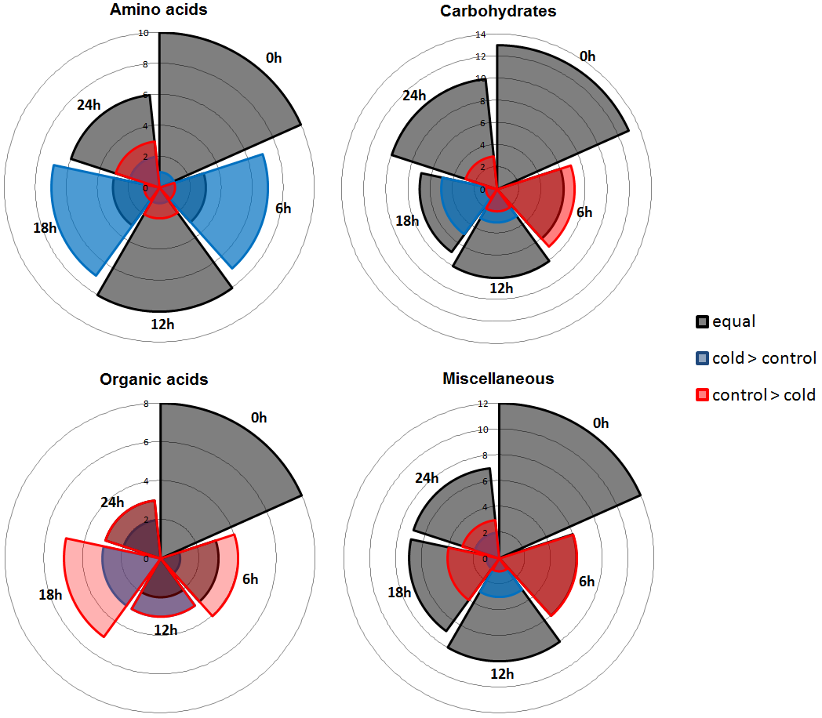
FigureS8.Numberofcompoundswhosecontentwashigher(blueshade),lower(redshade)orequal(blackshade)instemsamplesofE.globulusexposedto10ºCcomparedtoplantsexposedto25ºCover24h.CompoundsaredescribedinFigure6andTableS2.

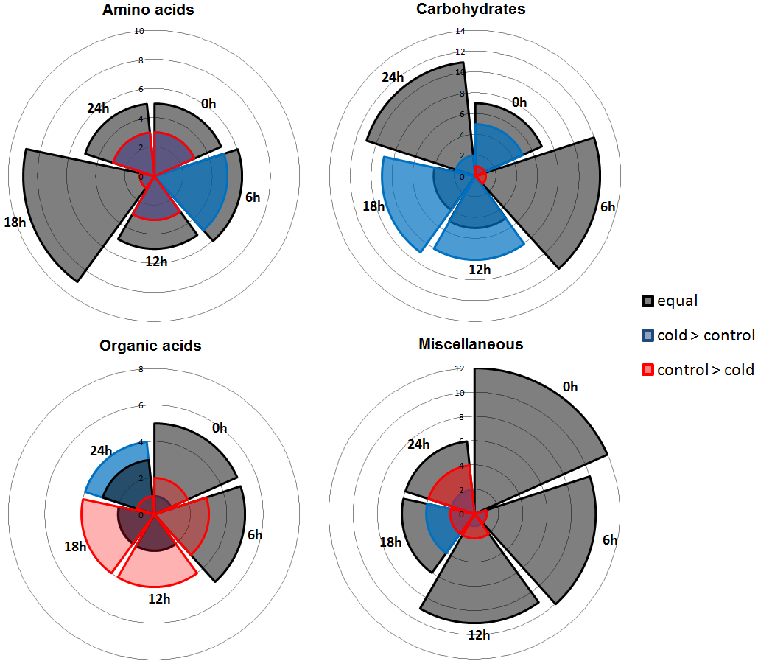
FigureS9.Numberofcompoundswhosecontentwashigher(blueshade),lower(redshade)orequal(blackshade)instemsamplesofE.grandisexposedto10ºCcomparedtoplantsexposedto25ºCover24h.CompoundsaredescribedinFigure6andTableS2.

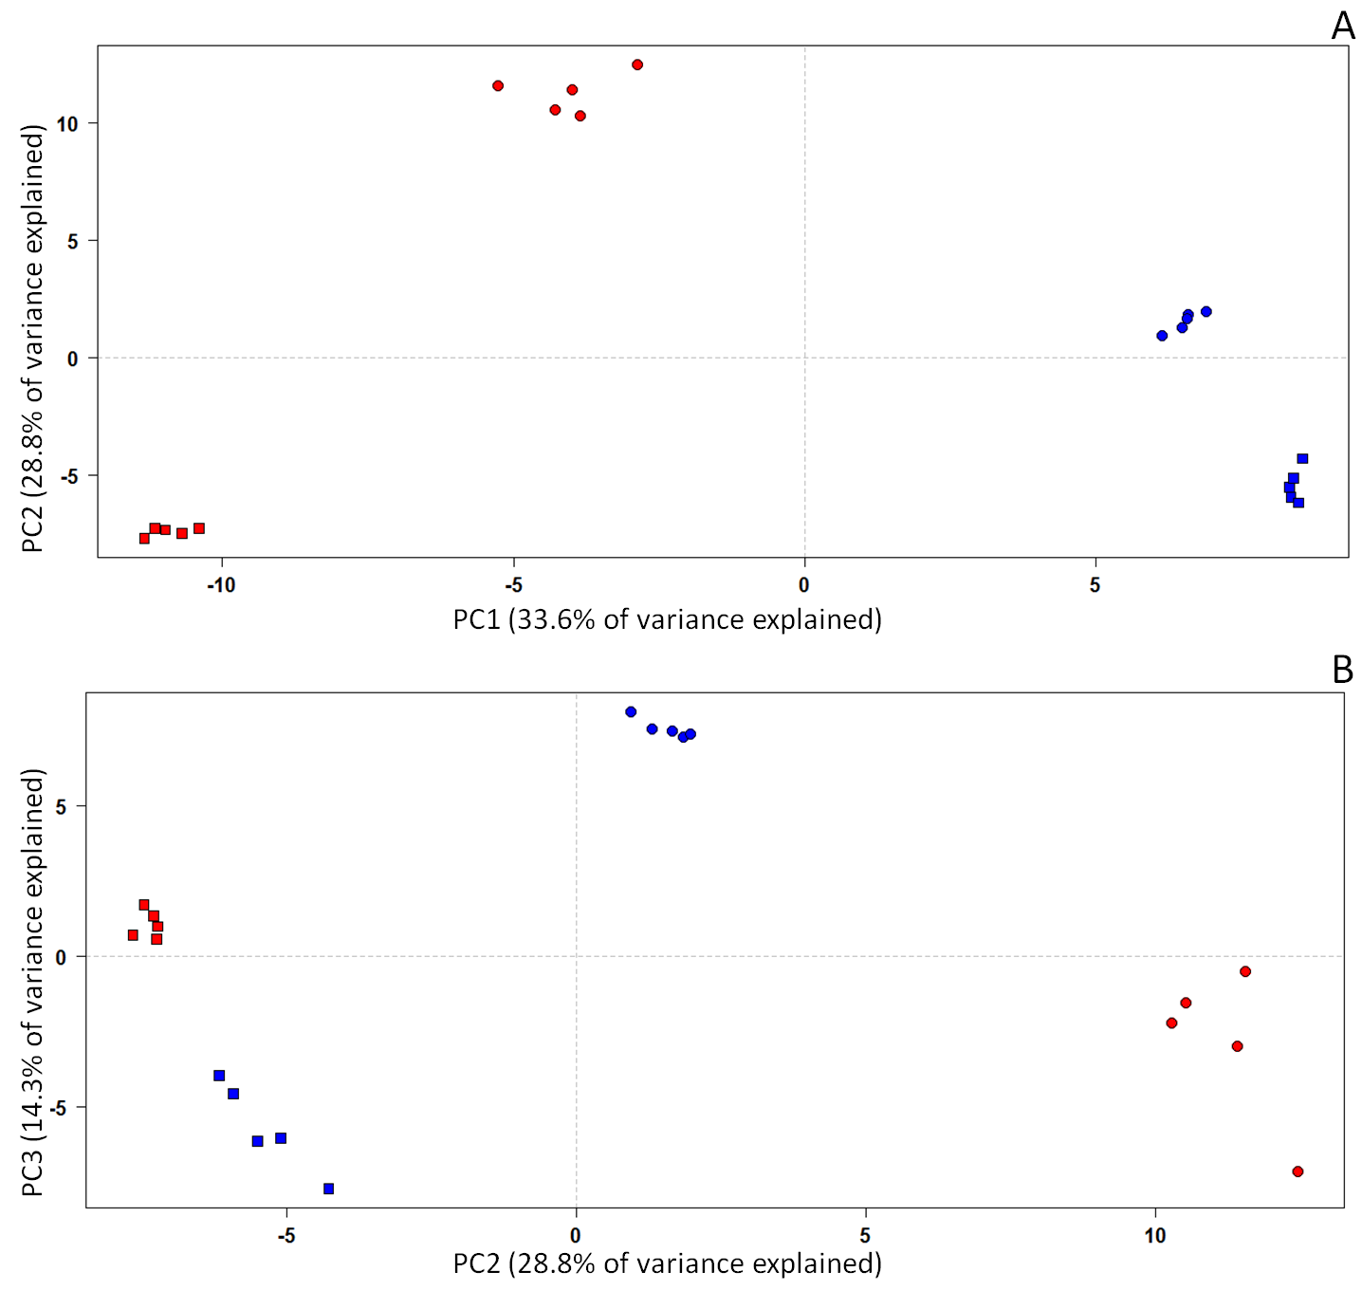
FigureS10.PrincipalcomponentsanalysisusingdifferentmetabolitesidentifiedinE.globulus()andE.grandis()leavesexposedto10ºC(blue)andcontrolcondition,25ºC(red).(A)interactionbetweencomponents1and2;(B)interactionbetweencomponents2and3.

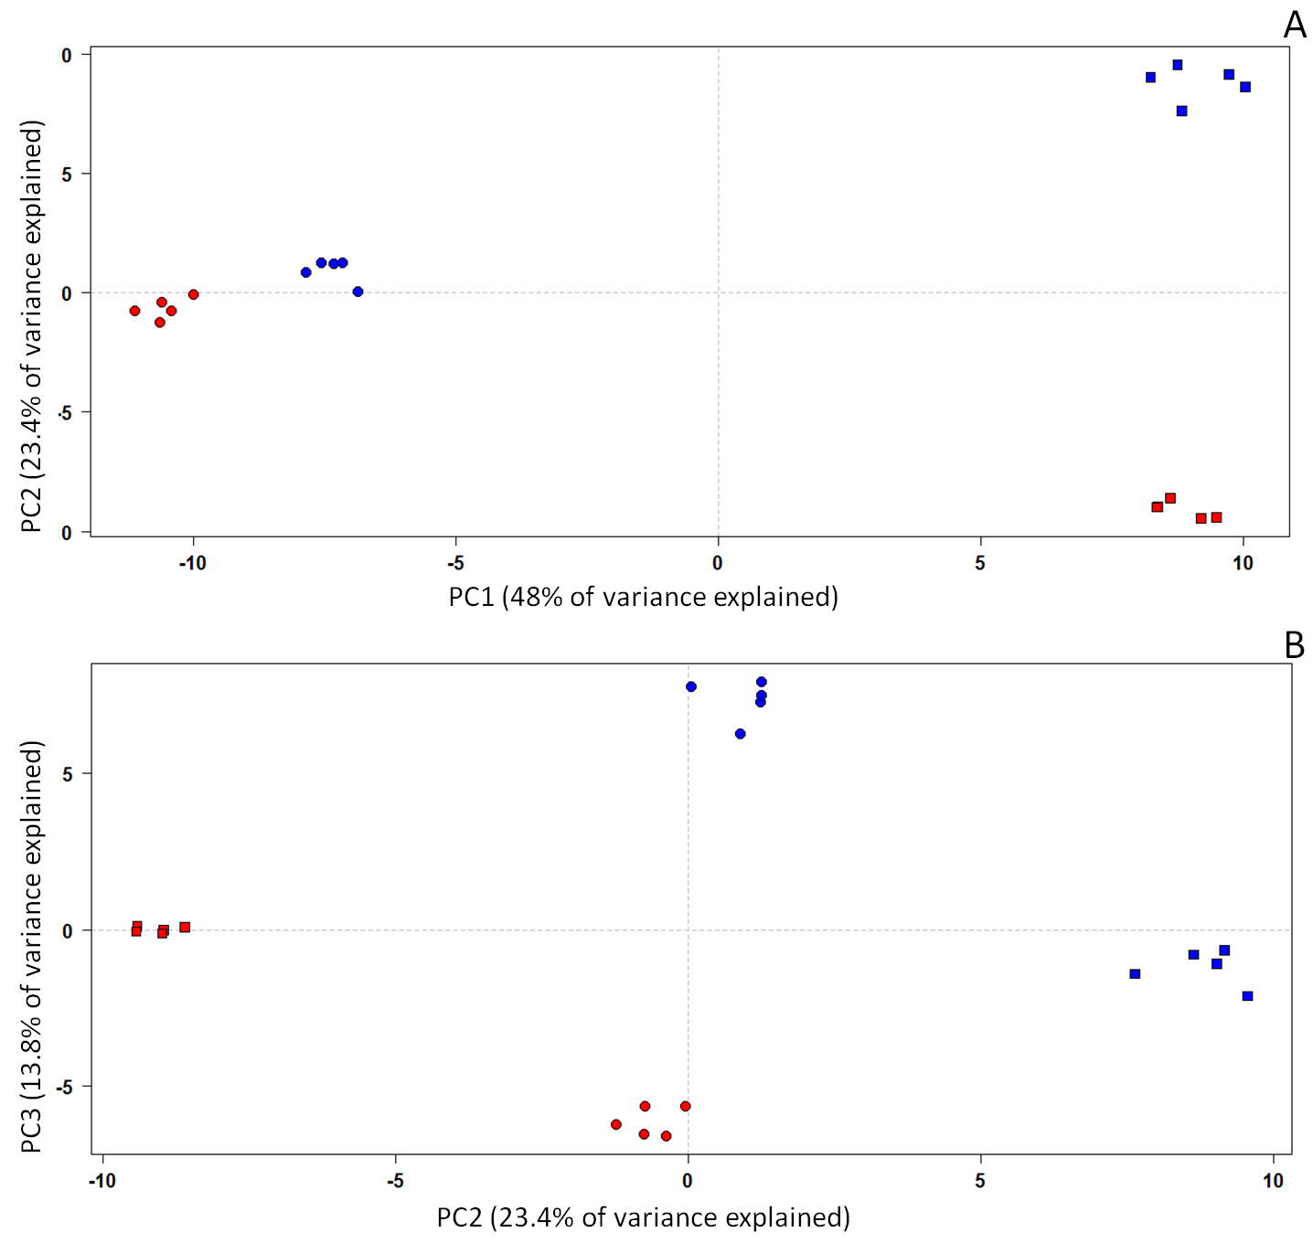
FigureS11.PrincipalcomponentsanalysisusingdifferentmetabolitesidentifiedinE.globulus()andE.grandis()stemsexposedto10ºC(blue)andcontrolcondition,25ºC(red).(A)interactionbetweencomponents1and2;(B)interactionbetweencomponents2and3.

