Supplementary Information

How does the leaf heat sensitivity relate to the species' geographical distribution range in the Brazilian savanna?

Tony César de Sousa Oliveira^{1,2*}, Vinicius Dorea Oliveira³, Luiza Beraldi Gallo², Bart Kruijt⁴, Elmar Veenendaal¹, Tomas Ferreira Domingues^{2*}

¹ Plant Ecology and Nature Conservation Group, Wageningen University (WU), Wageningen, The Netherlands
² Department of Biology, Faculty of Philosophy, Sciences and Letters at Ribeirão Preto, University of São Paulo, Ribeirão Preto, SP, Brazil
³ Department of Plant Biology, Institute of Biology, University of Campinas, Campinas, SP, Brazil
⁴ Water Systems and Global Change Group, Wageningen University (WU), Wageningen, The Netherlands

*Corresponding authors: tonycsoliveira@hotmail.com.br; tomas@ffclrp.usp.br

Fig. S1 Representation of the temperature response of F_{v′}/F_{m}′ for each study species per area using the logistic non-linear least squares model (Equation 2). Here, we utilized the intercept and slope coefficients of the logit (F_{v′}/F_{m}′) ~ leaf temperature derived from Equation 1 for a hypothetical leaf temperature range of 25-60°C.
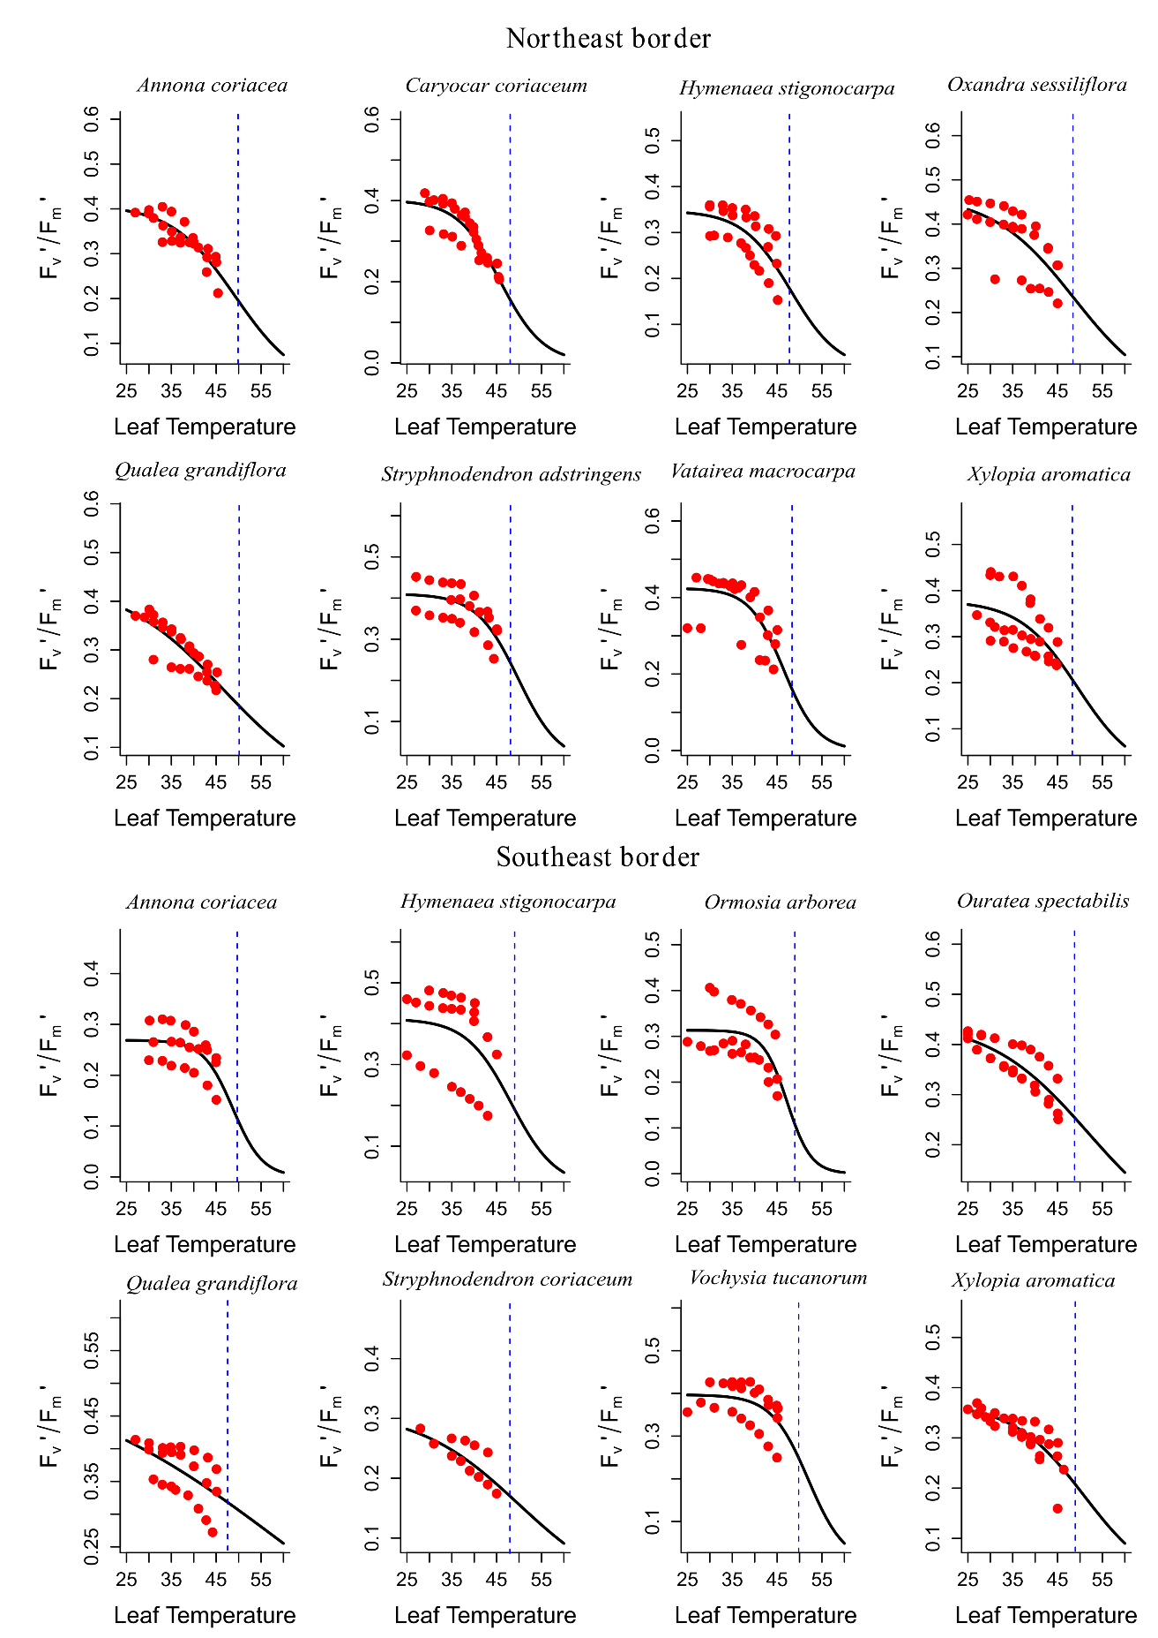
Fig. S2 Relationship between the temperature causing a 50% decline in F_{v}'/F_{m}' (T₅₀) and thermal safety margin (TSM) with leaf area (LA) and leaf mass per area (LMA). The groups of boxplots represent species with wide distribution (a, b, c, d) and restricted species (e, f, g, h).
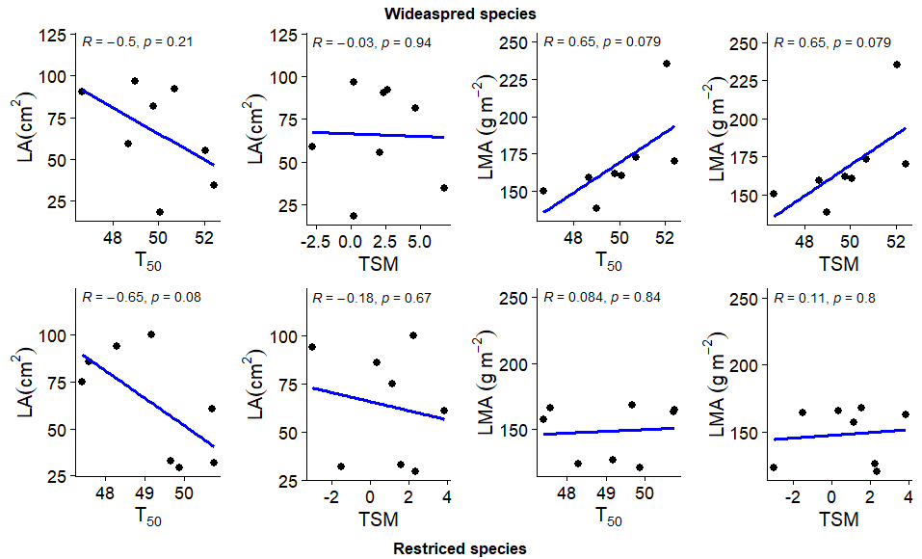

Table S1. The frequency of the studied restricted species across the seven biogeographic districts proposed by Françoso (2019)—Central (CE), Central-West (CW), Northeast (NE), Northwest (NW), South (S), Southeast (SE), and Southwest (SW)—is presented here. Each district corresponds to Castro's biodiversity supercenters: the Northeast Supercenter (NS), Central Supercenter (CS), and Southeast Supercenter (SS) (Castro, 1994). Values highlighted in bold indicate the core center where each species exhibits its highest frequency.

Species | NS |  | CS |  |  | SS
Species | NE | NW | SW | CW | C | S | SE
Northeast restricted species
C. coriaceum | 0.22 | 0.42 | 0 | 0.02 | 0 | 0 | 0
O. sessiliflora | 0.03 | 0.12 | 0 | 0 | 0 | 0 | 0
S. coriaceum | 0.32 | 0.12 | 0 | 0.07 | 0 | 0 | 0
V. macrocarpa | 0.75 | 0.92 | 0.44 | 0.83 | 0.52 | 0.28 | 0.21
Southeast Restricted species
O. arborea | 0.14 | 0.21 | 0.19 | 0.21 | 0.88 | 0.55 | 0.71
O. spectabilis | 0.6 | 0.82 | 0.31 | 0.71 | 0.85 | 0.01 | 0.39
S.adstringens | 0 | 0 | 0 | 0 | 0 | 0 | 0
V. tucanorum | 0.08 | 0.02 | 0.04 | 0.04 | 0.21 | 0.66 | 0.12

Table S2: Mean and standard errors (SE) per species for the asymptote (θa) of the leaf temperature–response of F_{v}′/F_{m}′, the intercept (θb) and slope coefficients (θc) of the logit-transformed F_{v}′/F_{m}′ from Equation 1, the species-specific fitting parameters (b and c), and the maximum leaf temperature (T_{max}) from Equation 3.
Species | θ_{a} |  | θ_{b} |  | θ_{c} |  | b |  | c |  | T_{max}
Species | Mean | SE | Mean | SE | Mean | SE | Mean | SE | Mean | SE | Mean | SE
A. coriacea | 0.3 | 0 | 13.3 | 2.7 | -0.3 | 0.1 | 0.4 | 0.3 | 0.2 | 0.1 | 46.9 | 1.5
H. stigonocarpa | 0.4 | 0 | 8.5 | 2 | -0.2 | 0 | 0.6 | 0.3 | 0.1 | 0 | 46.2 | 2
Q. gradiflora | 0.4 | 0 | 9.3 | 2 | -0.2 | 0 | 0.3 | 0.1 | 0.1 | 0 | 50.7 | 0.5
X. aromatica | 0.4 | 0 | 8.7 | 2.2 | -0.2 | 0 | 0.5 | 0.3 | 0.1 | 0.1 | 47.8 | 1.5
C. coriaceum | 0.3 | 0 | 12.3 | 0.6 | -0.3 | 0 | 0.2 | 0.1 | 0.1 | 0.1 | 47.2 | 0.5
O. sessiliflora | 0.4 | 0.1 | 11 | 0.8 | -0.2 | 0 | 0.3 | 0 | 0 | 0 | 47.5 | 1.7
S. coriaceum | 0.7 | 0.4 | 4.9 | 3.4 | -0.1 | 0.1 | 0.1 | 0 | 0.1 | 0.1 | 51.3 | 3.3
V. macrocarpa | 0.4 | 0 | 11.1 | 2.5 | -0.2 | 0.1 | 0.4 | 0.3 | 0.1 | 0.1 | 46.3 | 1.5
O. arborea | 0.5 | 0 | 5.1 | 2 | -0.1 | 0 | 1.1 | 0.8 | 0 | 0 | 46.9 | 0.6
O. spectabilis | 0.3 | 0 | 11 | 3.2 | -0.2 | 0.1 | 0.3 | 0.1 | 0.1 | 0 | 48.1 | 0.4
S. adstringens | 0.4 | 0 | 12 | 0.5 | -0.2 | 0 | 0.2 | 0 | 0.1 | 0 | 46.9 | 1.3
V. tucanorum | 0.4 | 0 | 12.2 | 2.4 | -0.2 | 0.1 | 0.4 | 0.2 | 0.1 | 0 | 52.3 | 2.8

Table S3: Results of Mixed Effects Models. Sum Sq: Sum of squares associated with the predictor variable. df: Degrees of freedom for the effect. F value: Calculated F statistic. p value: p value associated with the predictor variable.
Model | Variable | Sum Sq | df | F value | p value
T50 | Deciduousness | 1.0569 | 2 | 0.5285 | 0.5895
TSM | Deciduousness | 0.7477 | 2 | 0.3739 | 0.6881

