Supporting Information

for the manuscript

Application of Artificial Intelligence towards the Prediction of Natural Rubber Concentration in Rubber Dandelion (Taraxacum kok-saghyz)

Peter Polyak¹*, Jonathan Fresnedo-Ramirez², Meirambek Mutalkhanov^{1,3}, Nathaniel P. King-Smith¹, Katrina Cornish^{1,2,4}, Judit E. Puskas¹

¹Department of Food, Agricultural and Biological Engineering, College of Food, Agricultural and Environmental Sciences, The Ohio State University, 1680 Madison Avenue, Wooster, OH 44691
²Department of Horticulture and Crop Science, College of Food, Agricultural and Environmental Sciences, The Ohio State University, 1680 Madison Avenue, Wooster, OH 44691
³Al-Farabi Kazakh National University, Department of Biotechnology, 71 al-Farabi Ave. Almaty, Kazakhstan
⁴U.S. Arid Land Agricultural Research Center, Maricopa, AZ 85138

*Corresponding author: Peter Polyak, polyak.10@osu.edu

SI Table 1. Pearson Correlation Coefficients of HOTEL plants
 |  | Dependent variables
 |  | Solid rubber/roots (g∙roots⁻¹) | Total rubber/roots (g∙roots⁻¹)
Independent variables |  | #1 | #2
Whole plant mass (g) | #1 | 0.8588 | 0.9019
Fresh rosette mass (g) | #2 | 0.7675 | 0.8133
Fresh roots mass (g) | #3 | 0.9374 | 0.9698
Dry rosette mass (g) | #4 | 0.6912 | 0.7131
Dry roots mass (g) | #5 | 0.9333 | 0.9704
Water/roots (mL∙roots⁻¹) | #6 | 0.9326 | 0.9628
Water conc (mL∙g⁻¹ roots DM) | #7 | -0.1797 | -0.1960
Fresh tap roots length (cm) | #8 | 0.5808 | 0.6016
Fresh rosette diameter (cm) | #9 | 0.6857 | 0.7396
Shoot/roots ratio Fresh (-) | #10 | 0.1066 | 0.1254
Shoot/roots ratio Dry (-) | #11 | -0.2853 | -0.3005

SI Table 2. Pearson Correlation Coefficients of OH1004 plants
 |  | Dependent variables
 |  | Solid rubber/roots (g∙roots⁻¹) | Total rubber/roots (g∙roots⁻¹)
Independent variables |  | #1 | #2
Whole plant mass (g) | #1 | 0.8704 | 0.8621
Fresh rosette mass (g) | #2 | 0.5431 | 0.5487
Fresh roots mass (g) | #3 | 0.9036 | 0.8907
Dry rosette mass (g) | #4 | 0.5185 | 0.5264
Dry roots mass (g) | #5 | 0.9690 | 0.9707
Water/roots (mL∙roots⁻¹) | #6 | 0.8688 | 0.8531
Water conc (mL∙g⁻¹ roots DM) | #7 | -0.2088 | -0.2139
Fresh tap roots length (cm) | #8 | 0.4720 | 0.4843
Fresh rosette diameter (cm) | #9 | 0.4028 | 0.4130
Shoot/roots ratio Fresh (-) | #10 | -0.3382 | -0.3278
Shoot/roots ratio Dry (-) | #11 | -0.4518 | -0.4424

SI Table 3. p values of independent-dependent variable correlations of HOTEL plants.
 |  | Dependent variables
 |  | Solid rubber/roots (g∙roots⁻¹) | Total rubber/roots (g∙roots⁻¹)
Independent variables |  | #1 | #2
Whole plant mass (g) | #1 | 1.980E-15 | 1.365E-12
Fresh rosette mass (g) | #2 | 1.801E-10 | 7.585E-09
Fresh roots mass (g) | #3 | 6.690E-25 | 5.315E-19
Dry rosette mass (g) | #4 | 2.424E-07 | 7.912E-07
Dry roots mass (g) | #5 | 4.607E-25 | 1.737E-18
Water/roots (mL∙roots⁻¹) | #6 | 3.423E-23 | 2.067E-18
Water conc (mL∙g⁻¹ roots DM) | #7 | 2.255E-01 | 2.672E-01
Fresh tap roots length (cm) | #8 | 4.026E-05 | 8.525E-05
Fresh rosette diameter (cm) | #9 | 4.974E-08 | 1.048E-06
Shoot/roots ratio Fresh (-) | #10 | 4.407E-01 | 5.129E-01
Shoot/roots ratio Dry (-) | #11 | 5.958E-02 | 7.437E-02
Note: cells highlighted in red contain values larger than p=0.05.

SI Table 4. p values of independent-dependent variable correlations of OH1004 plants.
 |  | Dependent variables
 |  | Solid rubber/roots (g∙roots⁻¹) | Total rubber/roots (g∙roots⁻¹)
Independent variables |  | #1 | #2
Whole plant mass (g) | #1 | 5.236E-17 | 2.257E-16
Fresh rosette mass (g) | #2 | 3.187E-05 | 2.531E-05
Fresh roots mass (g) | #3 | 4.886E-20 | 9.562E-19
Dry rosette mass (g) | #4 | 8.237E-05 | 6.120E-05
Dry roots mass (g) | #5 | 4.959E-32 | 1.248E-32
Water/roots (mL∙roots⁻¹) | #6 | 7.068E-17 | 9.725E-16
Water conc (mL∙g⁻¹ roots DM) | #7 | 1.374E-01 | 1.279E-01
Fresh tap roots length (cm) | #8 | 4.110E-04 | 2.751E-04
Fresh rosette diameter (cm) | #9 | 3.068E-03 | 2.344E-03
Shoot/roots ratio Fresh (-) | #10 | 1.419E-02 | 1.768E-02
Shoot/roots ratio Dry (-) | #11 | 7.737E-04 | 1.024E-03
Note: cells highlighted in red contain values larger than p=0.05.

SI Table 5. Weight matrix of the network trained on HOTEL data. This table is the numerical representation of the 8x5 matrix (W_{l}) shown in Eq. 4 of the manuscript.
Neuron index | Whole plant mass | Fresh rosette mass | Fresh roots mass | Dry rosette mass | Dry roots mass | Water content | Fresh tap roots length | Fresh rosette diameter
1 | 0.0481 | -0.0013 | 0.1192 | 0.0269 | 0.1627 | 0.1008 | 0.0286 | -0.0663
2 | 0.0432 | 0.0035 | 0.1002 | 0.0233 | 0.1373 | 0.0845 | 0.0202 | -0.0473
3 | 0.0733 | -0.0236 | 0.2139 | 0.0622 | 0.2799 | 0.1859 | 0.0652 | -0.1720
4 | 0.0595 | -0.0103 | 0.1605 | 0.0395 | 0.2456 | 0.1372 | 0.0470 | -0.1085
5 | -0.0700 | 0.0327 | -0.2190 | -0.0628 | -0.2851 | -0.1911 | -0.0681 | 0.1919
Note: the colors of the cells graphically represent the numeric value stored in the cell. The greener the color, the larger the value; the more reddish the color, the smaller the value.

SI Table 6. Absolute values of the weight matrix shown in SI Table 5. Data originates from the HOTEL accession.
Neuron index | Whole plant mass | Fresh rosette mass | Fresh roots mass | Dry rosette mass | Dry roots mass | Water content | Fresh tap roots length | Fresh rosette diameter
1 | 0.0481 | 0.0013 | 0.1192 | 0.0269 | 0.1627 | 0.1008 | 0.0286 | 0.0663
2 | 0.0432 | 0.0035 | 0.1002 | 0.0233 | 0.1373 | 0.0845 | 0.0202 | 0.0473
3 | 0.0733 | 0.0236 | 0.2139 | 0.0622 | 0.2799 | 0.1859 | 0.0652 | 0.1720
4 | 0.0595 | 0.0103 | 0.1605 | 0.0395 | 0.2456 | 0.1372 | 0.0470 | 0.1085
5 | 0.0700 | 0.0327 | 0.2190 | 0.0628 | 0.2851 | 0.1911 | 0.0681 | 0.1919
Note: the darker the color the larger the absolute value.

SI Table 7. Weight matrix of the network trained on OH1004 data.
Neuron index | Whole plant mass | Fresh rosette mass | Fresh roots mass | Dry rosette mass | Dry roots mass | Water content | Fresh tap roots length | Fresh rosette diameter
1 | -0.0709 | -0.2818 | 0.0315 | -0.1159 | 0.3265 | -0.0376 | 0.2534 | -0.8939
2 | -0.2376 | -0.4544 | -0.1256 | -0.5756 | -0.1218 | -0.1205 | -0.0194 | 0.4419
3 | 0.0963 | -0.2243 | 1.1387 | 0.6296 | 1.5157 | -0.1787 | 0.5059 | 0.0610
4 | 0.2020 | 0.0369 | 0.2300 | -0.0180 | 0.8964 | -0.0493 | 0.2475 | 0.1091
5 | -0.0817 | 0.0010 | -0.7025 | 0.3187 | -0.3891 | -0.1842 | -0.6159 | -0.0609
Note: the colors of the cells graphically represent the numeric value stored in the cell. The greener the color, the larger the value; the more reddish the color, the smaller the value.

SI Table 8. Absolute values of the weight matrix shown in SI Table 7. Data originates from the OH1004 accession.
Neuron index | Whole plant mass | Fresh rosette mass | Fresh roots mass | Dry rosette mass | Dry roots mass | Water content | Fresh tap roots length | Fresh rosette diameter
1 | 0.0709 | 0.2818 | 0.0315 | 0.1159 | 0.3265 | 0.0376 | 0.2534 | 0.8939
2 | 0.2376 | 0.4544 | 0.1256 | 0.5756 | 0.1218 | 0.1205 | 0.0194 | 0.4419
3 | 0.0963 | 0.2243 | 1.1387 | 0.6296 | 1.5157 | 0.1787 | 0.5059 | 0.0610
4 | 0.2020 | 0.0369 | 0.2300 | 0.0180 | 0.8964 | 0.0493 | 0.2475 | 0.1091
5 | 0.0817 | 0.0010 | 0.7025 | 0.3187 | 0.3891 | 0.1842 | 0.6159 | 0.0609
Note: the darker the color the larger the absolute value.

SI Table 9. Weight matrix of the combined model. Training data originates from the HOTEL and OH1004 accessions.
Neuron index | Whole plant mass | Fresh rosette mass | Fresh roots mass | Dry rosette mass | Dry roots mass | Water content | Fresh tap roots  length | Fresh rosette diameter | TYPE
1 | 0.0274 | -0.0309 | 0.1130 | 0.0220 | 0.2104 | 0.0298 | -0.0349 | -0.0073 | -0.1045
2 | -0.0276 | 0.0306 | -0.1128 | -0.0221 | -0.1096 | -0.0299 | 0.0345 | 0.0074 | 0.1039
3 | 0.0878 | 0.0222 | 0.1910 | 0.0826 | 0.3388 | 0.1693 | 0.2148 | -0.1683 | -0.1731
4 | 0.0272 | -0.0312 | 0.1128 | 0.0217 | 0.2101 | 0.0296 | -0.0348 | -0.0073 | -0.1047
5 | -0.0276 | 0.0302 | -0.1124 | -0.0221 | -0.3080 | -0.0299 | 0.0337 | 0.0076 | 0.1033
Note: the colors of the cells graphically represent the numeric value stored in the cell. The greener the color, the larger the value; the more reddish the color, the smaller the value

SI Table 10. Absolute values of the weight matrix of the combined model (see SI Table 9). Training data originates from the HOTEL and OH1004 accessions.
Neuron index | Whole plant mass | Fresh rosette mass | Fresh roots mass | Dry rosette mass | Dry roots mass | Water content | Fresh tap roots length | Fresh rosette diameter | TYPE
1 | 0.027 | 0.031 | 0.113 | 0.022 | 0.210 | 0.030 | 0.035 | 0.007 | 0.104
2 | 0.028 | 0.031 | 0.113 | 0.022 | 0.110 | 0.030 | 0.035 | 0.007 | 0.104
3 | 0.088 | 0.022 | 0.191 | 0.083 | 0.339 | 0.169 | 0.215 | 0.168 | 0.173
4 | 0.027 | 0.031 | 0.113 | 0.022 | 0.210 | 0.030 | 0.035 | 0.007 | 0.105
5 | 0.028 | 0.030 | 0.112 | 0.022 | 0.308 | 0.030 | 0.034 | 0.008 | 0.103
Note: the darker the color the larger the absolute value.

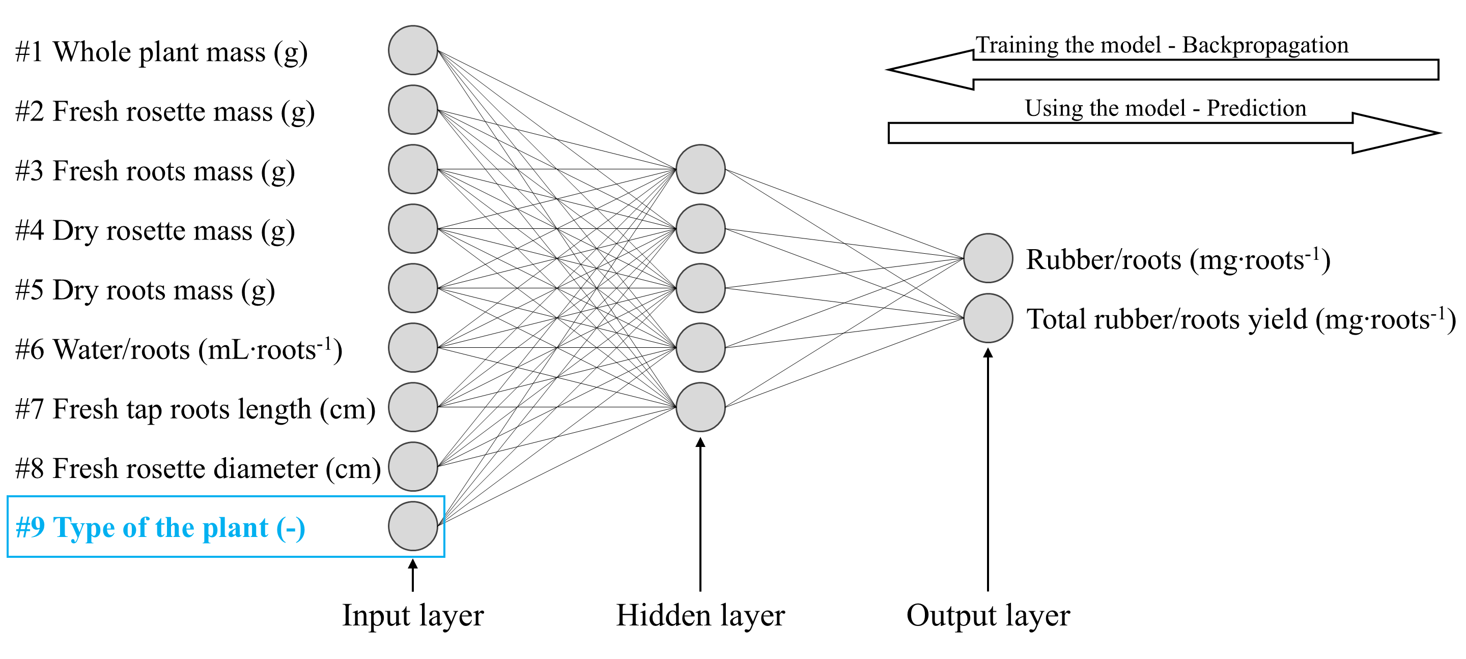
SI Fig. 1. Generalized model for the prediction of NR yield. The construction of the generalized model is based on the conversion of a qualitative parameter (plant type) to a quantitative descriptor.

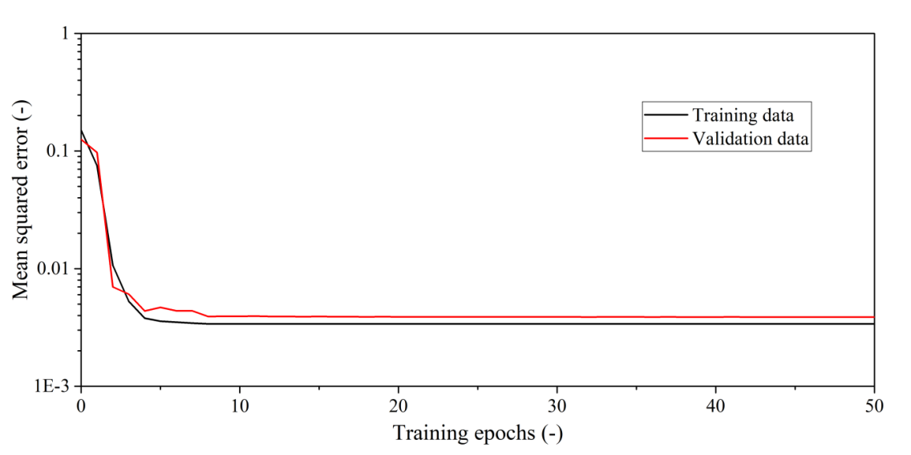
SI Fig. 2. Learning curves of combined model trained using the Levenberg-Marquardt algorithm. Training data originates from the HOTEL and OH1004 accessions.

