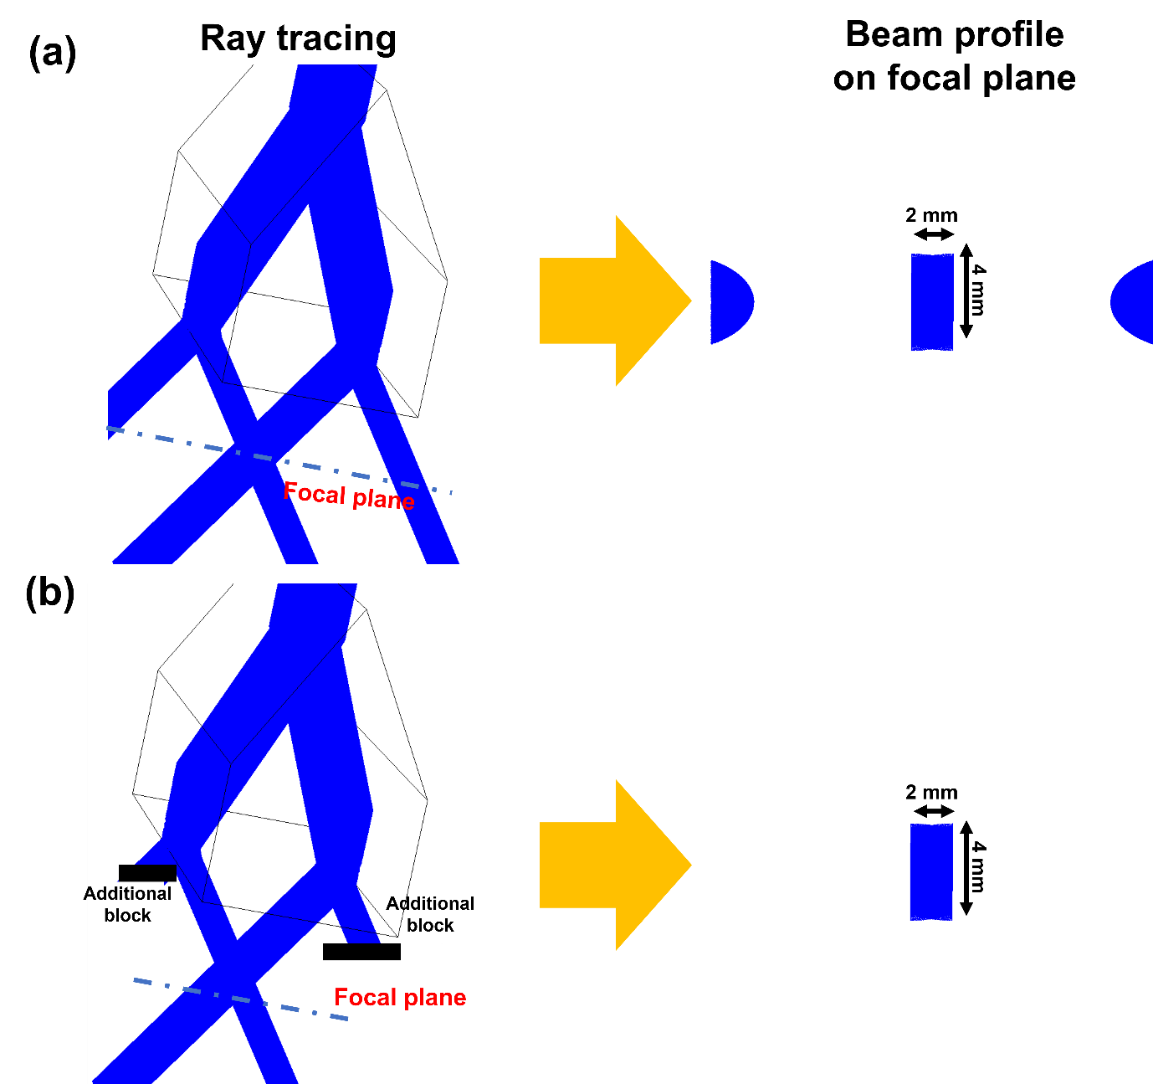
Figure S1. Schematic diagram of ray optics simulation. blue color signifes the laser beam. Ray
tracing (a) without additional block and beam profile at focal plane, and (b) with additional block and beam profile at focal plane. Although input beam is gaussian, resultant beam profile become rectangular-like due to the prism. Firstly, the prism divides input laser beam into 4 beams because this prism allows reflection for only 2 mm. Then rectangular-like and half-circular beams are observed. However, because half-circular beams are not necessary, we added additional blocks near the prism to eliminate unnecessary beams due to which, a rectangular-like beam was obtained.

