
- Yuko Tsuruma received her B.S. degree from Shibaura Institute of Technology, Tokyo, Japan, in 2008. She joined LINTEC Corporation in 2008 and has been involved in research and development for healthcare applications since 2019, focusing on minimally invasive sensing devices. Her technical background and research interests include microneedle fabrication and biomedical sensing technologies.

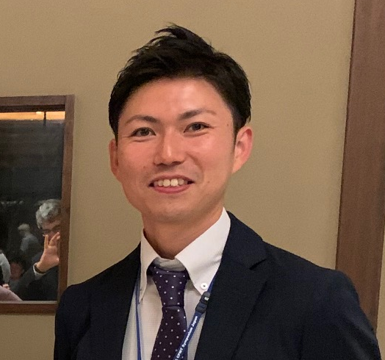
- Yosuke Koma received his M.S. degree in Life Sciences from the Graduate School of Natural Sciences, Gakushuin University, Tokyo, Japan, in 2012. In the same year, he joined LINTEC Corporation and started his career at the Electronic Materials Laboratory, where he engaged in the development of semiconductor processing tapes. In 2015, he moved to the Materials Design Laboratory and worked on self-peeling tapes for new semiconductor processes. In 2017, he returned to the Electronic Materials Laboratory to develop heat-resistant UV tapes for advanced semiconductor processes. Since 2019, he has been with the Advanced Technology Innovation Office, focusing on product development for healthcare applications.

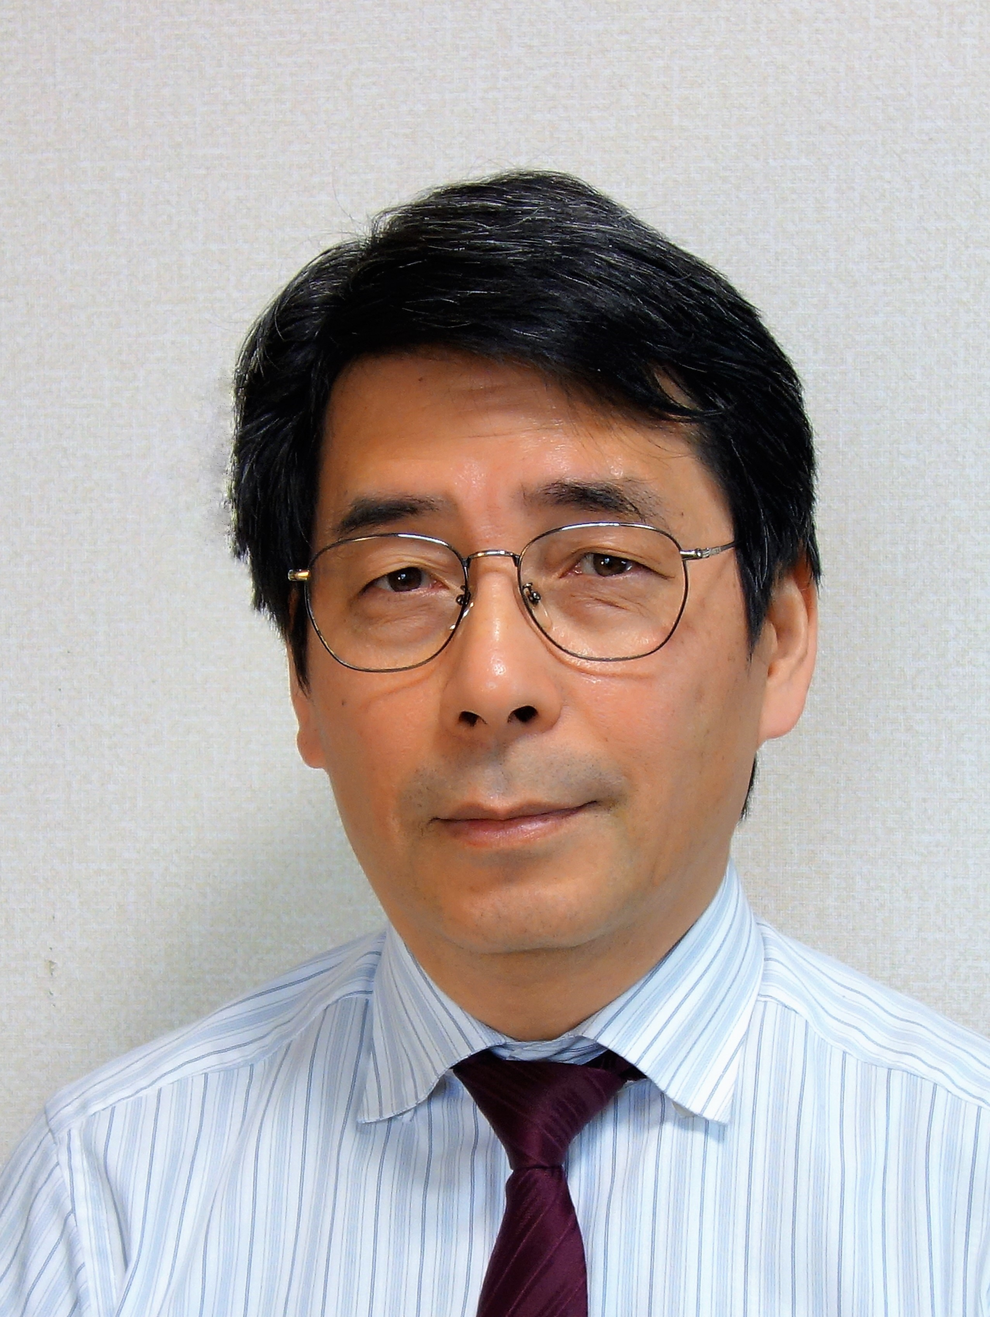
- Shigenori Aoki received his B.S. degree from Kyoto University, Kyoto, Japan, in 1985 in applied physics. In 1985, he joined Fujitsu Laboratories Ltd., Atsugi, Japan. He has successively worked on high-density packaging technologies and materials for advanced ICT products, such as millimeter-wave packaging for automotive radars, parallel-optical transceivers for data centers, and liquid cooling materials for Supercomputer K. He moved to LINTEC Corporation in 2019 and is developing new products for healthcare applications by utilizing his expertise in advanced packaging technology.

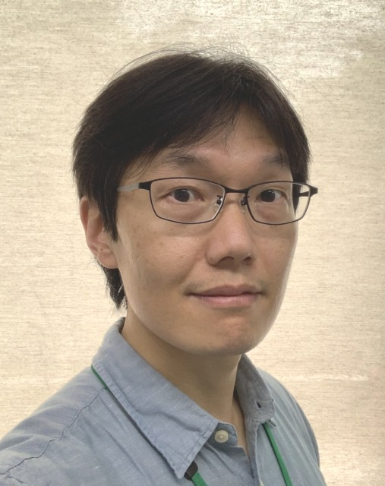
- Jongho Park is an assistant professor at Institute of Industrial Science, the University of Tokyo, Japan. After obtaining his Ph.D. in Precision Engineering, he has worked on micro/nano fabrication and its applications in the engineering as well as biomedical fields. His research interests focus on the development of biomedical microdevices using micro/nano fabrication technology. Currently, he is researching the microneedle array patch (MAP) as a novel healthcare device and further applications.

- Beomjoon Kim is a professor at the Institute of Industrial Science, the University of Tokyo, Japan. He earned his bachelor's degree from Seoul National University in 1993 and a Ph.D. in Precision Engineering from the University of Tokyo in 1998. After working at CNRS in France, since 2000, he has been an associate professor till 2014, and currently a Professor at the University of Tokyo. His research focuses on microneedle technology for medical and healthcare applications, including bio-MEMS and wearable devices.

