Big Data Analytics in Sustainability Reports: An Analysis based on the Perceived Credibility of Corporate Published Information

Appendix
Table A 1: Mathematical models for timeliness of data
Author(s) | Mathematical models | Variables
(Ballou et al. 1998) | 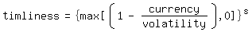 | Currency (age of data):  - Delivery date  - Extraction date  - Age at measurement  Volatility (validity period):  - Determined by data quality manager with user(s)
(Hinrichs 2002) | 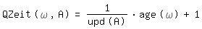 | Timeliness of attribute:  - Change in value (update)  - Date of determination  - Date of transaction  - Current time
(Even and Shankaranarayan 2007) | 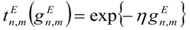 | Novelty of data item in t:  - Current time  - Time of last update  - ‘Ageing rate’ (η), defined by expert(s)
(Heinrich and Klier 2011) |  | Currency (age of data):  - Data age at measurement  - ‘Ageing rate’, to be determined statistically

Table A 2: Mathematical models for completeness of data
Author(s) | Mathematical models | Variables
(Hinrichs 2002) | 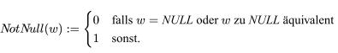  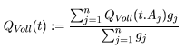 | Evaluation of completeness:  - Non-availability value, ‘unknown’ (NULL) value or deviating values  - Relative importance for application context
(Shankaranarayan et al. 2003) |  | Assignment of completeness:  - Availability of the data elements  - Relative importance for application context
(Heinrich and Klier 2015) | 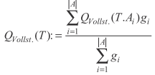 | Completeness in info-system:  - Attribute values available vs. not available  - Relative importance for application context
(Aljumaili et al. 2016) | 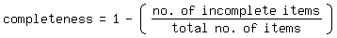 | Completeness checking:  - Missing or unknown values of the real-world entity

Table A 3: Mathematical models for accuracy of data
Author(s) | Mathematical models | Variables
(Hinrichs 2002) | 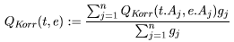  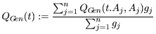 | Correctness of data values:  - Distance measure to modeled real-world entity  - Relative importance for real-world entity  Precision of data values:  - Precision due to the number of decimal places  - Digits in classification hierarchy (importance)
(Shankaranarayan et al. 2003) |  | Accuracy of data element(s):  - Number of incorrect data values  - Total number of data values
(Heinrich and Klier 2015) | 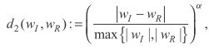 | Accuracy in info-system:  - Degree of conformity with real-world entity  - Weighting factor for effect of deviation
(Aljumaili et al. 2016) | 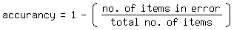 | Accuracy metrics:  - Number of items in error  - Total number of items

Figure A 1: Excerpt of sustainability report Henkel AG (Henkel Nachhaltigkeitsbericht 2015, 54)
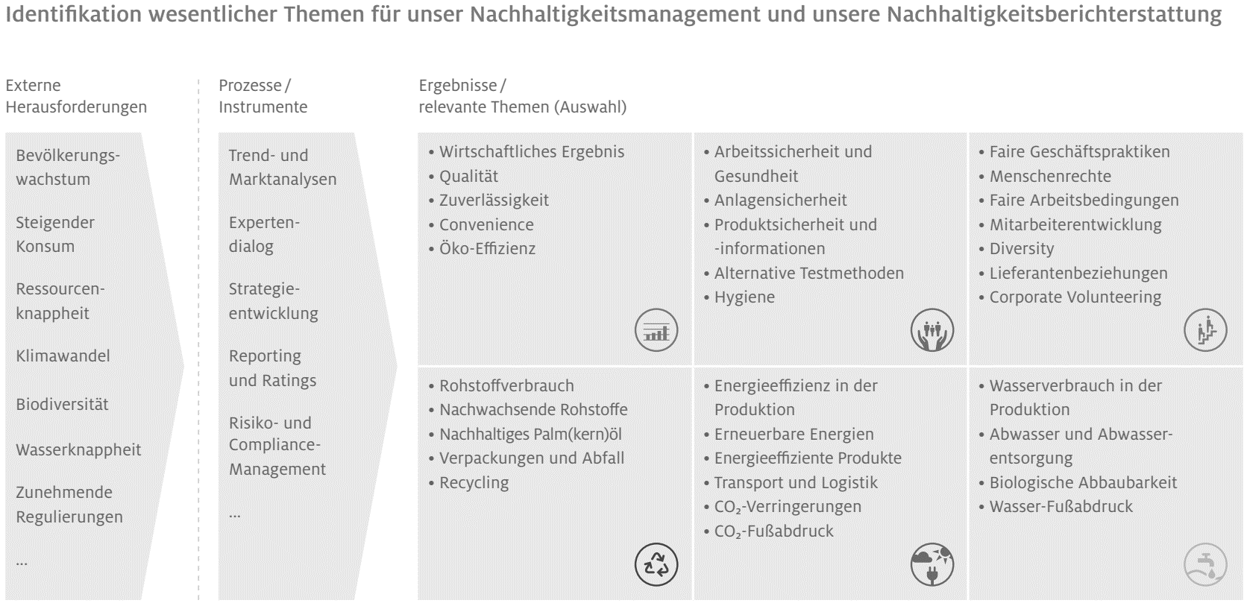

Figure A 2: Excerpt of sustainability report Volkswagen AG (VW Nachhaltigkeitsbericht 2014, 127)
