SUPPLEMENTARY MATERIAL

A Participatory GIS-based Multicriteria Decision Analysis Approach to Map the Geospatial Feasibility of Managed Aquifer Recharge in a Tunisian Coastal Watershed

Anis Chekirbane¹, Khaoula Khemiri¹, Tiago N. Martins², Catalin Stefan^{3,} Constantinos F. Panagiotou^{4*}

¹ Department of Rural Engineering, Water and Forests, INAT, University of Carthage, Tunis, Tunisia
² National Laboratory for Civil Engineering LNEC, Portugal
³ Research Group INOWAS, Department of Hydrosciences, Institute of Groundwater Management, Technische Universität Dresden, Dresden, Germany
⁴ Department of Resilient Society, ERATOSTHENES Centre of Excellence, Cyprus

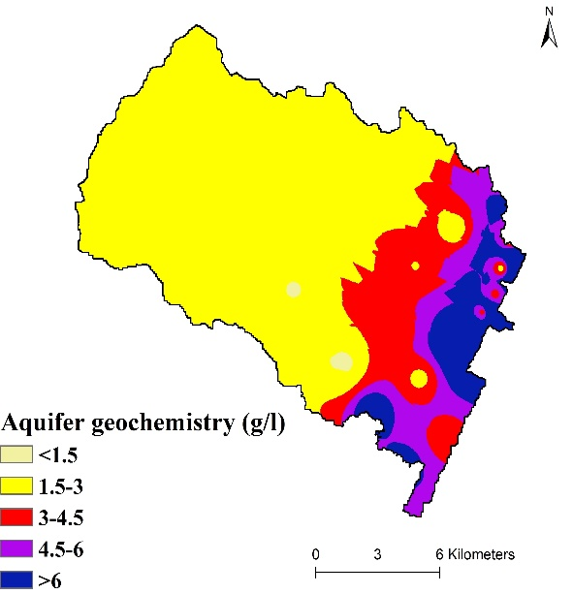 | 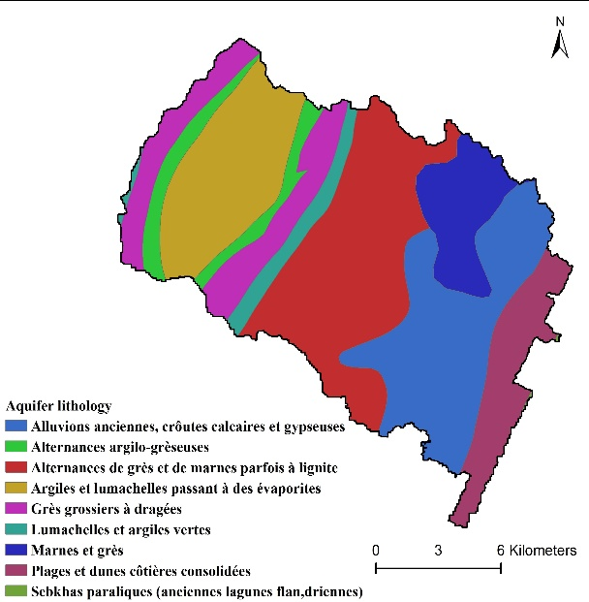
(a) | (b)
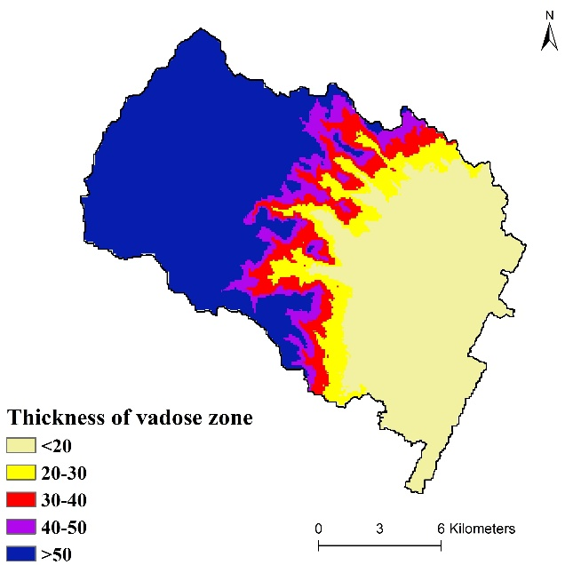 | 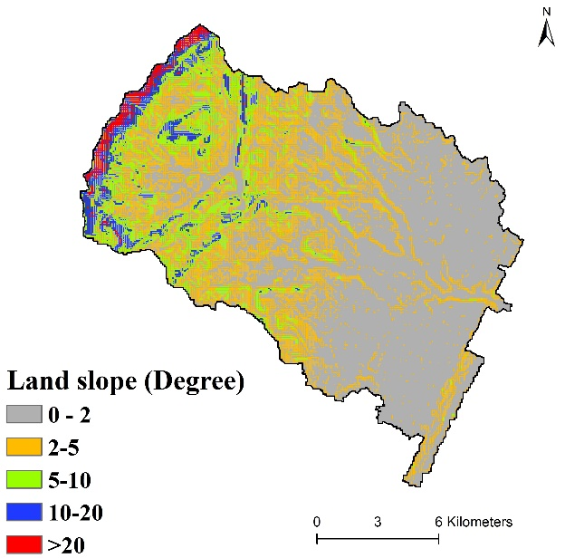
(c) | (d)
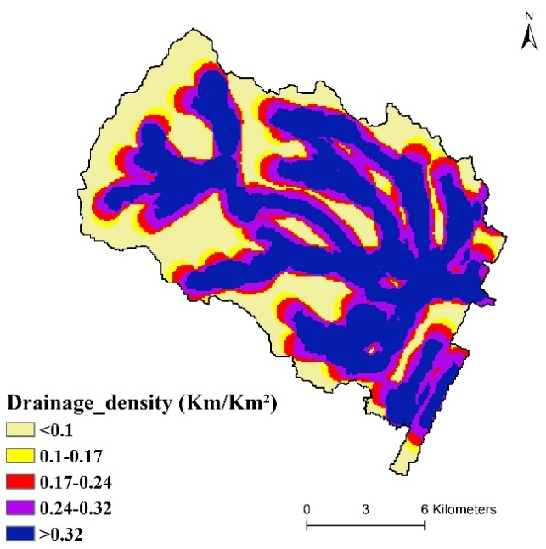 |  | 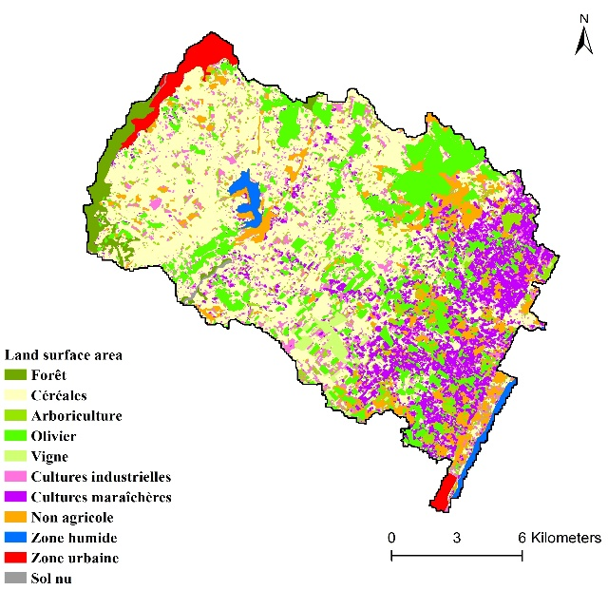
(e) |  | (f)
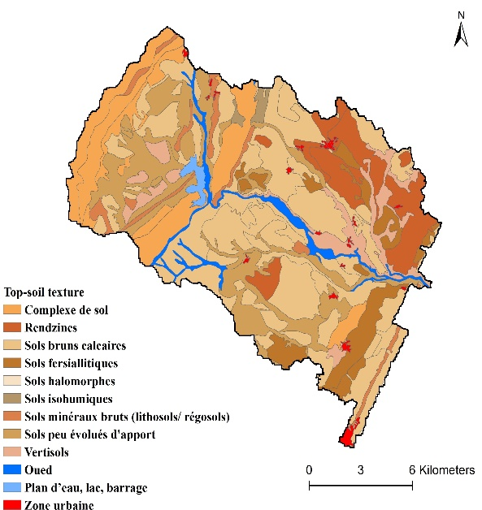 |  | 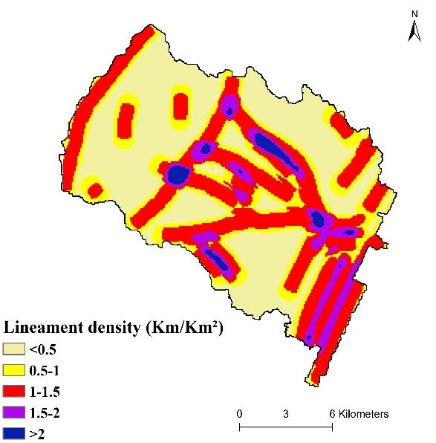
(g) |  | (h)
Fig. SM1 Intrinsic site suitability criteria for: (a) Aquifer geochemistry; (b) Aquifer lithology; (c) Thickness of vadose zone; (d) Land slope; (e) Drainage density; (f) Land surface area; (g) Top-soil texture; and (h) Lineament density

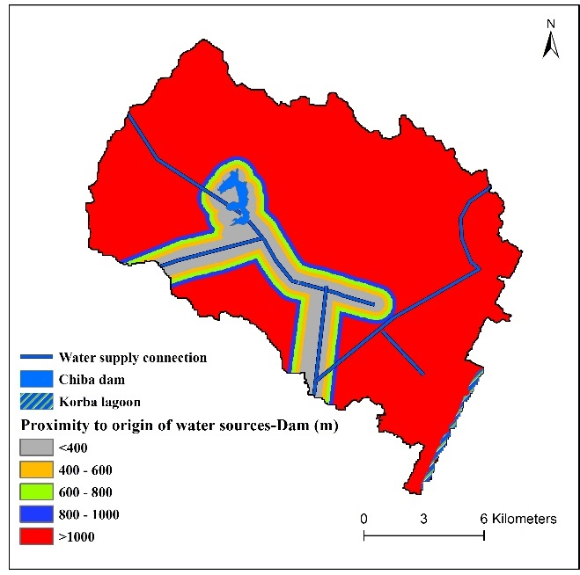 | 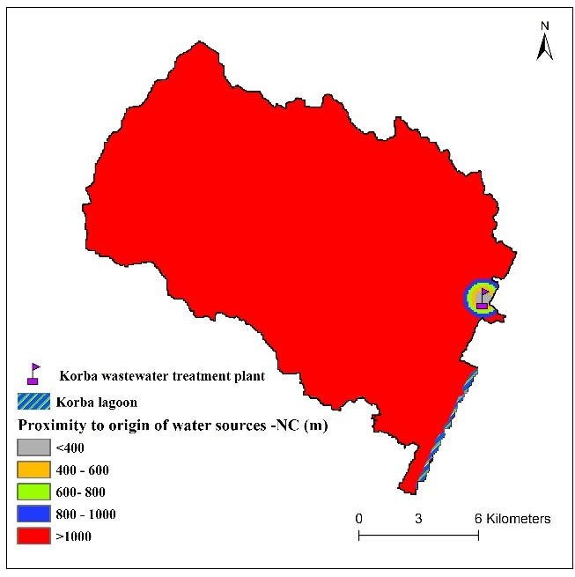
(a) | (b)

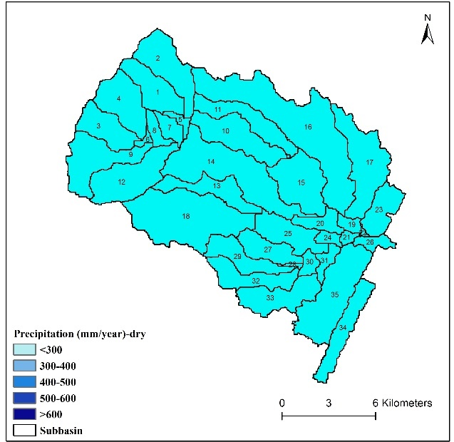 |  | 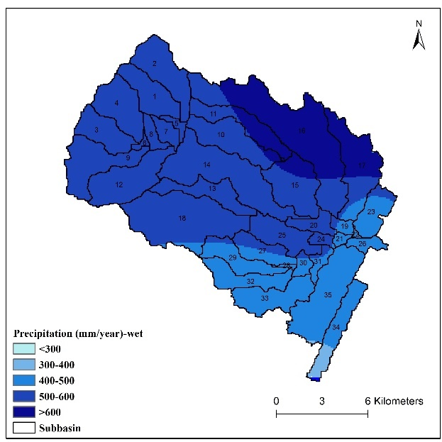
(c) |  | (d)
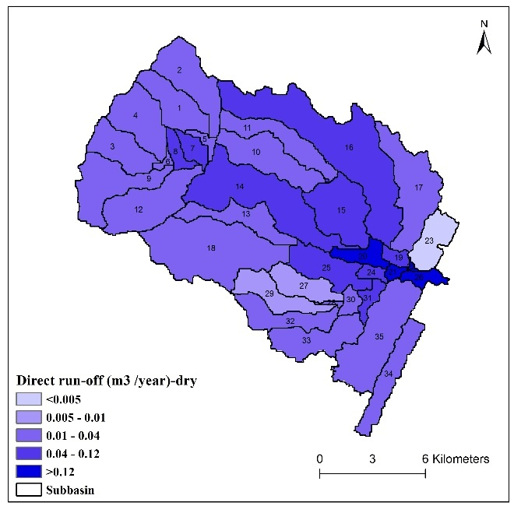 |  |  | 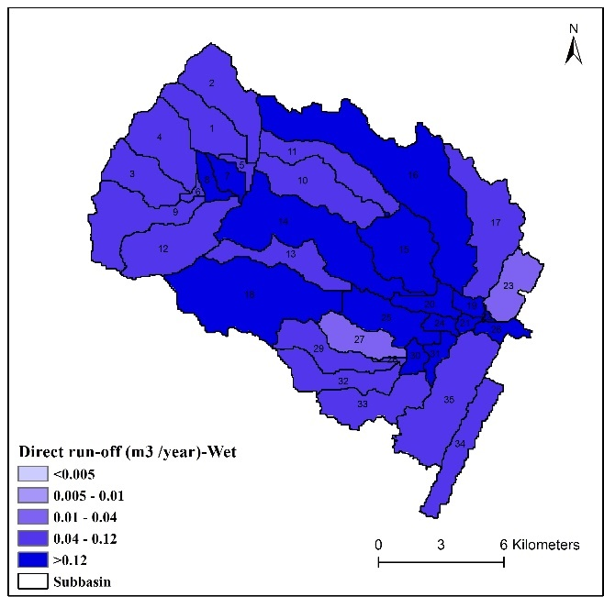
(e) |  |  | (f)
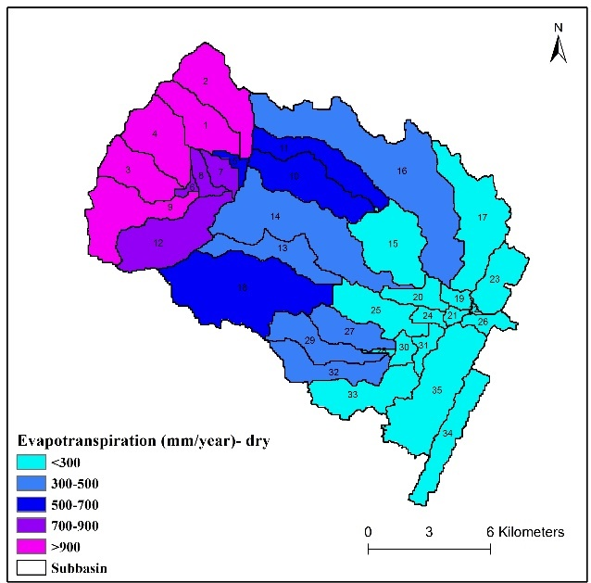 | 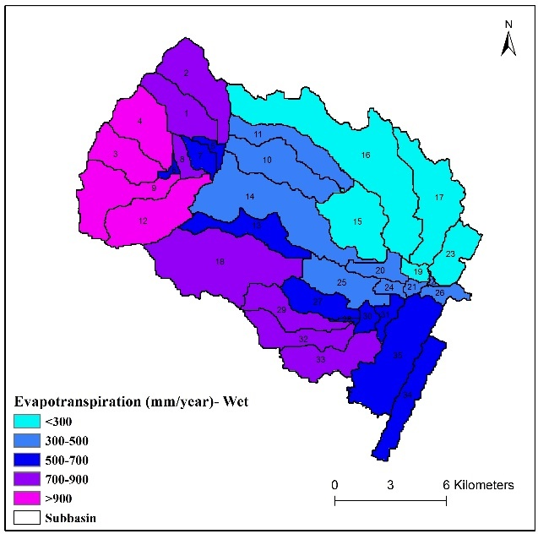
(g) | (h)
Fig. SM2 Water availability criteria for proximity to recharge water sources including (a) conventional water sources; and (b): non-conventional water sources. Water availability criteria for hydrometeorology category including: maps of the annual precipitations for dry season (c) and wet season (d); monthly runoff for dry season (e) and wet season (f); evapotranspiration for dry season (g) and wet season (h)

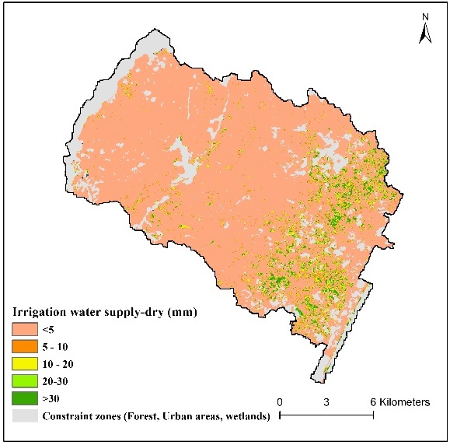 | 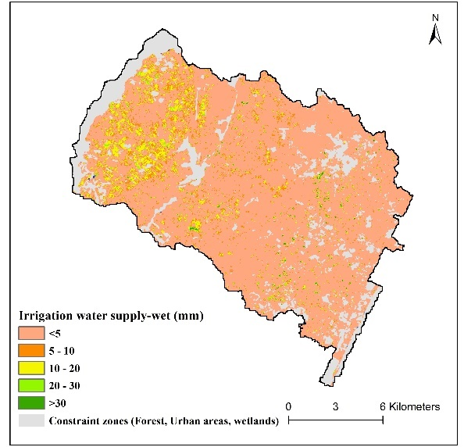
(a) | (b)
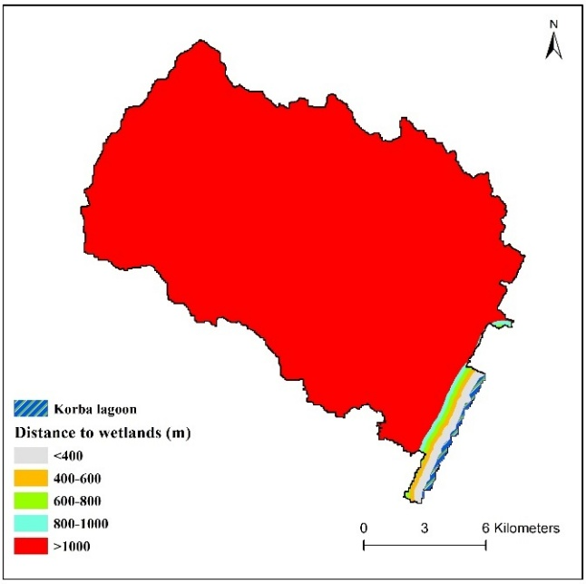
(c)
Fig. SM3 Water demand criteria including the category of irrigation water demand maps for dry season (a) and wet season (b); ecological demand including the distance to wetlands (c)

