Supplementary material – Figure 1

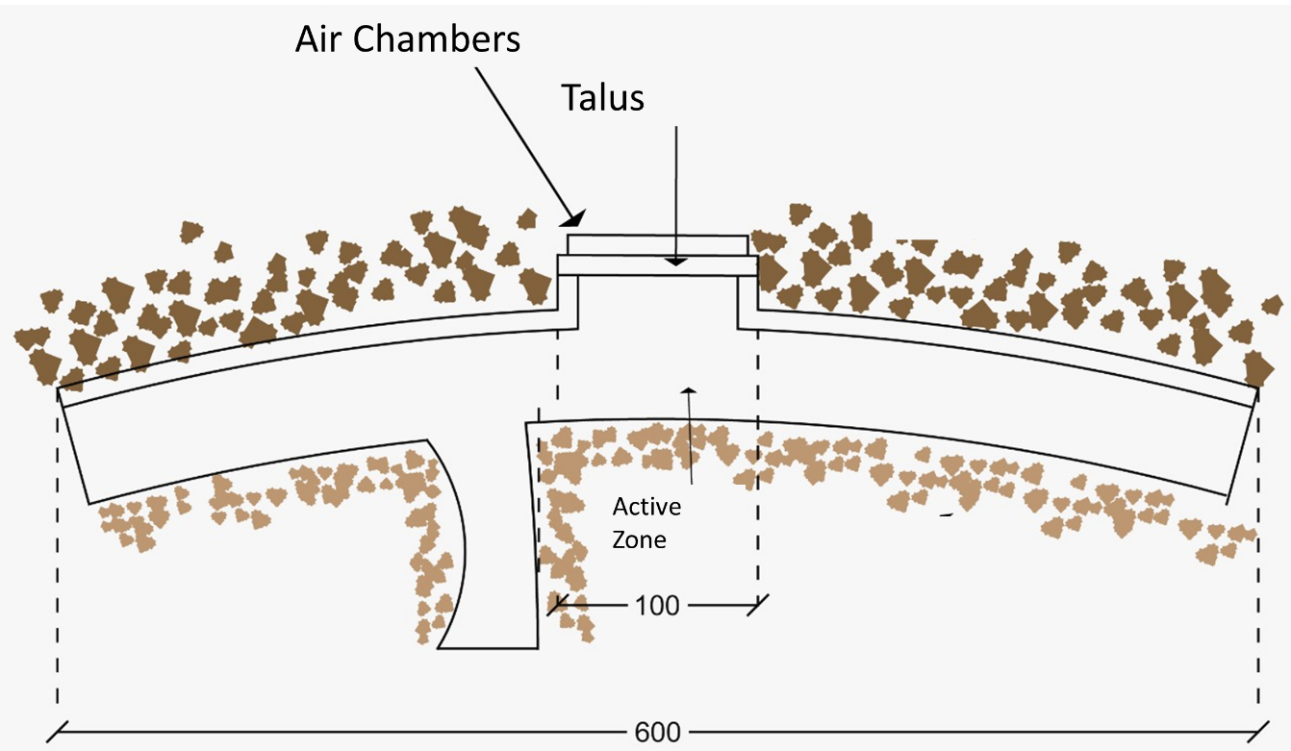
Figure 1: Design of the breakwater structure and wave power generation in Mutriku Power Plant.

Supplementary material – Figure 2
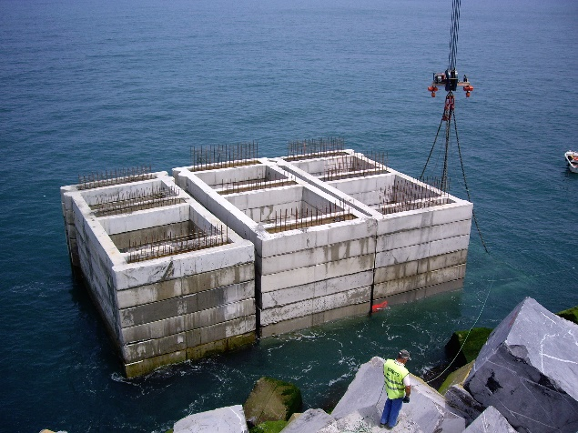
Figure 2. View of prefabricated concrete blocks during the construction phase of the Mutriku Wave Power Plant [courtesy of EVE]

Supplementary material – Table 1

Table 1: LCIA of Mutriku
Impact Categories | Acronym | Total | Construction | Generation | End of Life
Climate Change  [kg CO2 eq./kWh] | CC | 2.26E-01 | 1.95E-01 | 1.24E-02 | 1.79E-02
Fossil Depletion  [kg oil eq./kWh] | FD | 5.50E-02 | 2.81E-02 | 5.31E-03 | 2.16E-02
Human Toxicity  [kg 1.4-DB eq./kWh] | HT | 3.95E-02 | 3.32E-02 | 1.72E-03 | 4.67E-03
Marine Ecotoxicity  [kg 1.4-DB eq./kWh] | MET | 1.38E-03 | 1.07E-03 | 1.76E-04 | 1.43E-04
Marine Eutrophication  [kg N eq./kWh] | ME | 4.67E-05 | 3.83E-05 | 2.15E-06 | 6.26E-06
Metal Depletion  [kg Fe eq./kWh] | MD | 3.21E-03 | 7.94E-03 | 2.05E-04 | -4.93E-03
Ozone Depletion  [kg CFC-11 eq./kWh] | OD | 2.11E-08 | 9.48E-09 | 3.88E-10 | 1.12E-08
Particulate Matter Formation  [kg PM10 eq./kWh] | PMF | 6.44E-04 | 5.66E-04 | 1.59E-05 | 6.25E-05
Terrestrial Acidification  [kg SO2 eq./kWh] | TA | 8.52E-04 | 6.74E-04 | 2.97E-05 | 1.48E-04

Supplementary material – Table 2

Table 2: Environmental Impacts Assessment for each proposed EoL scenario and disposal site.
Impact Categories | CC  [kg CO2 eq.] | FD  [kg oil eq.] | HT  [kg 1.4-DB eq.] | MET  [kg 1.4-DB eq.] | ME  [kg N eq.] | MD  [kg Fe eq.] | OD  [kg CFC-11 eq.] | PMF  [kg PM10 eq.] | TA  [kg SO2 eq.]
E1
Steel Recycling | -5.66E-03 | -1.31E-03 | -3.71E-05 | -6.65E-07 | -2.84E-07 | -6.04E-03 | 3.17E-11 | -3.36E-06 | -1.02E-05
Aluminum Recycling | 7.40E-12 | -5.14E-12 | 1.34E-11 | 5.28E-13 | -2.01E-15 | 8.50E-14 | -2.43E-19 | 3.64E-14 | -2.88E-13
Steel Landfill | 3.65E-05 | 1.30E-05 | 3.98E-06 | 1.23E-08 | 3.83E-09 | 8.63E-07 | 1.23E-19 | 3.38E-08 | 9.48E-08
Aluminum Landfill | 2.98E-06 | 1.06E-06 | 3.25E-06 | 1.00E-09 | 3.12E-10 | 7.03E-08 | 1.00E-19 | 2.75E-09 | 7.73E-09
Limestone Landfill | 1.54E-02 | 1.58E-02 | 3.24E-03 | 9.96E-05 | 4.32E-06 | 7.65E-04 | 7.72E-09 | 4.54E-05 | 1.09E-04
Thermoplastic Landfill | 1.18E-03 | 3.56E-05 | 1.12E-05 | 4.37E-08 | 2.91E-07 | 2.38E-06 | 3.38E-19 | 1.51E-07 | 4.03E-07
Concrete Landfill | 6.88E-03 | 7.03E-03 | 1.45E-03 | 4.44E-05 | 1.93E-06 | 3.41E-04 | 3.45E-09 | 2.03E-05 | 4.87E-05
E2
Steel Recycling | -4.72E-03 | -1.09E-03 | -3.10E-05 | -5.54E-07 | -2.37E-07 | -5.04E-03 | 2.64E-11 | -2.80E-06 | -8.50E-06
Aluminum Recycling | 6.17E-12 | -4.29E-12 | 1.12E-11 | 4.41E-13 | -1.67E-15 | 7.09E-14 | -2.03E-19 | 3.04E-14 | -2.40E-13
Steel Landfill | 6.45E-05 | 2.30E-05 | 7.04E-06 | 2.17E-08 | 6.77E-09 | 1.53E-06 | 2.17E-19 | 5.98E-08 | 1.68E-07
Aluminum Landfill | 7.43E-06 | 2.64E-06 | 8.10E-07 | 2.50E-09 | 7.78E-10 | 1.76E-07 | 2.50E-20 | 6.88E-09 | 1.93E-08
Limestone Landfill | 1.54E-02 | 1.58E-02 | 3.24E-03 | 9.96E-05 | 4.32E-06 | 7.65E-04 | 7.72E-09 | 4.54E-05 | 1.09E-04
Thermoplastic Landfill | 1.18E-03 | 3.56E-05 | 1.12E-05 | 4.37E-08 | 2.91E-07 | 2.43E-06 | 3.38E-19 | 1.51E-07 | 4.03E-07
Concrete Landfill | 6.88E-03 | 7.05E-03 | 1.45E-03 | 4.44E-05 | 1.93E-06 | 3.41E-04 | 3.45E-09 | 2.03E-05 | 4.87E-05
E3
Steel Recycling | -3.14E-03 | -7.28E-04 | -2.06E-05 | -3.69E-07 | -1.58E-07 | -3.36E-03 | 1.76E-11 | -1.86E-06 | -5.66E-06
Aluminum Recycling | 4.11E-12 | -2.85E-12 | 7.42E-12 | 2.93E-13 | -1.11E-15 | 4.72E-14 | -1.35E-19 | 2.02E-14 | -1.60E-13
Steel Landfill | 1.11E-04 | 3.97E-05 | 1.22E-05 | 3.97E-08 | 1.17E-08 | 2.63E-06 | 3.79E-19 | 1.03E-07 | 2.89E-07
Aluminum Landfill | 1.49E-05 | 5.29E-06 | 1.62E-06 | 5.00E-09 | 1.56E-09 | 3.51E-07 | 4.99E-20 | 1.38E-08 | 3.86E-08
Limestone Landfill | 1.54E-02 | 1.58E-02 | 3.24E-03 | 9.96E-05 | 4.32E-06 | 7.65E-04 | 7.72E-09 | 4.54E-05 | 1.09E-04
Thermoplastic Landfill | 1.18E-03 | 3.56E-05 | 1.12E-05 | 4.37E-08 | 2.91E-07 | 2.38E-06 | 3.38E-19 | 1.51E-07 | 4.03E-07
Concrete Landfill | 6.88E-03 | 7.05E-03 | 1.45E-03 | 4.44E-05 | 1.93E-06 | 3.41E-04 | 3.45E-09 | 2.03E-05 | 4.87E-05
CC: Climate Change. FD: Fossil Depletion. HT: Human Toxicity. MET: Marine Ecotoxicity. ME: Marine Eutrophication. MD: Metal Depletion. OD: Ozone Depletion. PMF: Particulate Matter Formation. TA: Terrestrial Acidification.

