Hanninen MS Draft Appendixes

Appendix A. Brief summaries of the scopes of the 15 academic journals.

Forest Products (USA) Journal (https://forestprodjournals.org/ ) is published by the Forest Products Society to increase globally the knowledge of industrial forest products and their technical research reflecting the current state of wood science and technology. Canadian Journal of Forest Research ( http://www.nrcresearchpress.com ) is based originally on the Canadian Institute of Forestry and features articles on a broad spectrum of forest sciences including e.g., biometrics, ecology, economics, genetics, silviculture, social sciences and wood sciences. Forest Policy and Economics ( https://www.journals.elsevier.com/forest-policy-and-economics ) is global in scope and publishes research related to forests, forested landscapes, forest-related industries, and other forest-relevant land uses. These disciplines include, sociology, anthropology, human geography, history, jurisprudence, planning, development studies, and psychology research on forests. Forest Science (https://academic.ou p.com/forestscience/pages/About ) is based on the Society of American Foresters and explores “all aspects of natural and social sciences as they apply to the function and management of the forested ecosystems of the world. Scandinavian Journal of Forest Research ( https://www.tandfonline.com/action/journalInformation?show=aimsScope&journalCode=sfor20 ) is published in cooperation with Nordic Forest Research (SNS). Articles concern the entire field of forest research, e.g., silviculture, ecology, management, climate, wood science and technology. European Journal of Forest Research (https://www.springer.com/journal/10342 ) intends to contribute to a holistic understanding of the principles governing forest ecosystems, as well as their functions and services for society. The journal thus covers a broad range of subjects, from natural sciences to socio-economics. European Journal of Wood and Wood products (https://www.springer.com/journal/107/aims-and-scope ) range from roundwood to wood based products, and the journal also deals with wood as a chemical raw material, source of energy as well as with environmental and market aspects. Journal of Forestry Research ( https://www.springer.com/journal/11676 ) offers articles dealing with all aspects of forestry including basic science of forestry, forest ecology, silviculture and management, protection, wood science and technology. Silva Fennica (https://silvafennica.fi/ ) is published by the Finnish Society of Forest Science and the articles include all aspects of forest research, both basic and applied subjects. Journal of Forest Research (https://www.tandfonline.com/toc/tjfr20/current) is based on Japanese Forest Society and covers all aspects of forest research in 4 sections: socioeconomics, forest environment, silviculture and forest health. The International Forestry Review ( http://www.cfa-international.org/international_forestry_review.php ) publishes research and review papers on forest policy and science, with an emphasis on issues of transnational significance. Journal of Forest Economics ( https://www.journals.elsevier.com/journal-of-forest-economics ), published in affiliation with Department of Forest Economics at the Swedish University of Agricultural Sciences (Umeå) covers all aspects of forest economics in subject areas like forest management, industry, multiple use, policy, land use and climate change (https://www.journals.elsevier.com/journal-of-forest-economics ). The International wood products Journal (https://www.tandfonline.com/toc/ywpj20/current ), previously known as Journal of the Institute of wood Science (in 1958-2009), publishes articles on timber and wood products dealing with aspects of wood engineering and technology. Forest Science and Technology (https://www.tandfonline.com/toc/tfst20/current ) is based on Korean Forest Society. Articles deal with all aspects of forest science including forest biology, silviculture, physiology, and genetics as well as forest operations, engineering, management, forest modelling and forest products. Social, economic, information and policy sciences are also covered. The Current Forestry Reports ( https://www.springer.com/journal/40725/aims-and-scope ) publishes in-depth review articles covering broad field of forestry. The coverage spans the world of forestry, encompassing physiological processes, tree genetics, forest management, remote sensing and wood structure and function and more.

Appendix B. Searching optimal number for topics (K), using four measures: Arun2010 [47], CaoJuan2009 [35], Held-out likelihood [49] with residual analysis [50], and Semantic coherence [48]. The scale of the vertical axis is independent between panels, and it depends on the plotted indicator.

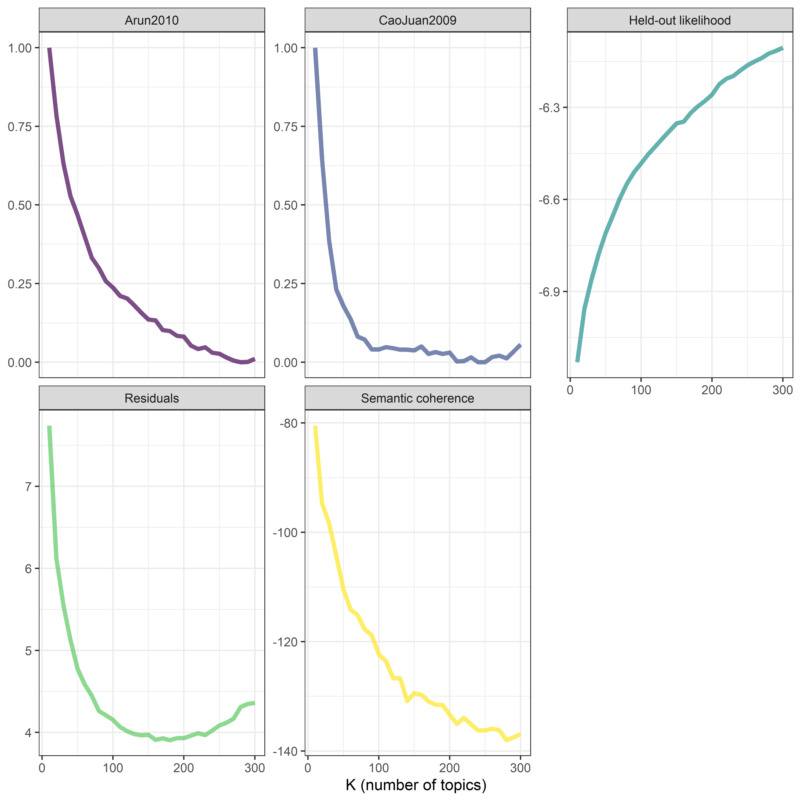

Appendix C. Searching for the optimal number for topics (K), using semantic coherency and exclusivity frontier. Colors refer to the different number of K, from 10 to 300. Lighter crossed lines depict minimum and maximum values with respect to the axis. Darker lines depict 25% and 75% percentiles, i.e. the central 50% of the probability mass. The central point depicts median semantic coherency and exclusivity.

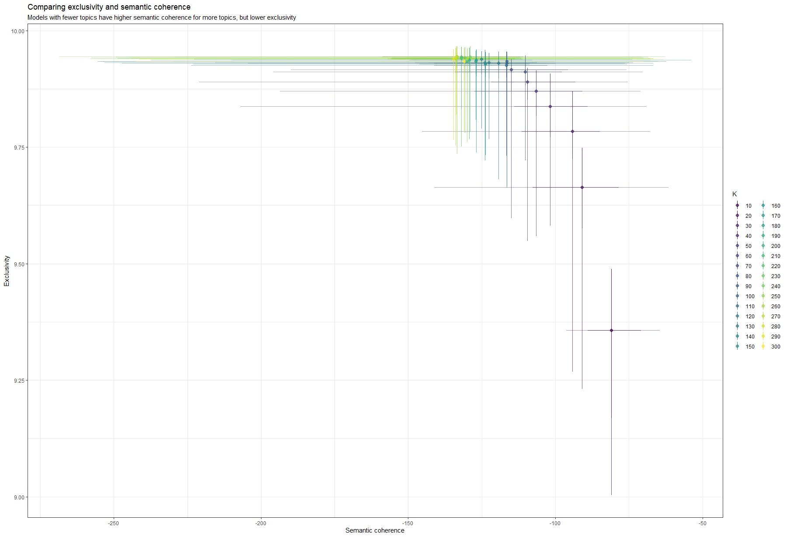

Appendix D. Topic number 1 visualized by a word cloud.

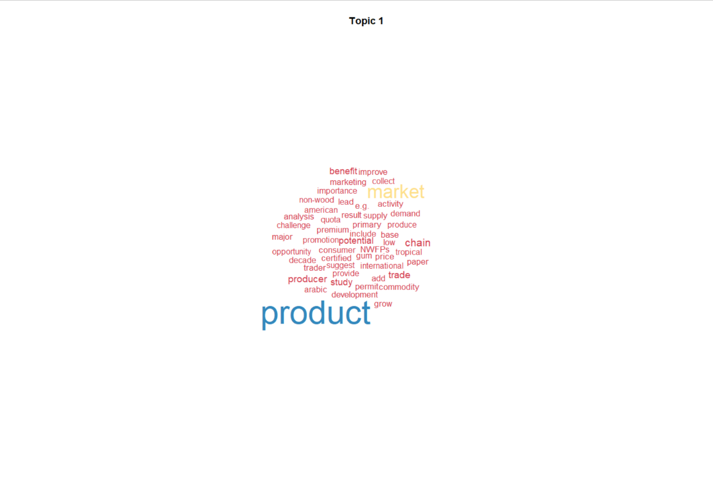

Appendix E. Classification of topics into FWC- themes and PESTE -categories covering policy (Pol), economic (Econ), social (Soc), technological (Tech), and ecological/environmental (Ecol) factors. Topics that did not seem to belong to any of the categories were classified as “Other”.

Topic | Topic words with the highest probability (β ) | FWC-themes (1-4) and PESTE categories
 |  | 1 | 2 | 3 | 4 | Other
1 | product, market, chain, producer, trade, potential, study |  |  |  | Econ
2 | height, diameter, cm, breast, index, dbh, difference | Ecol
3 | species, China, A., chinese, specific, include, c. | Ecol
4 | green, regulate, bilberry, berry, coverage, yield, maturity |  | Econ
5 | forest, management, change, increase, study, Forest, result | Ecol
6 | stream, buffer, riparian, sediment, watershed, water, watersh | Ecol
7 | degree, temperature, C, increase, rate, care, decrease |  |  | Tech
8 | growth, survival, rate, grow, effect, increase, competition | Ecol
9 | wind, effect, speed, shelter, edge, drag, time | Ecol
10 | wood, material, Wood, solid, amount, compare, due |  |  | Tech
11 | resistance, strength, screw, lateral, withdrawal, edge, staple |  |  | Tech
12 | policy, governance, actor, rights, implementation, paper, country | Pol
13 | biomass, density, estimate, aboveground, foliage, relationship, ground | Ecol
14 | composite, plastic, WPC, fiber, reinforce, strength, property |  |  | Tech
15 | tree, variation, individual, size, measure, sample, larger | Ecol
16 | return, Eucalyptus, E., timberland, investment, asset, grandi | Econ
17 | data, inventory, accuracy, forest, classification, base, estimate | Tech
18 | climate, change, climatic, condition, future, region, response | Ecol
19 | ratio, increase, reaction, bear, Si, 's, decrease |  |  |  |  | Other
20 | equation, equations, taper, estimate, function, form, data | Ecol
21 | energy, residue, fuel, bioenergy, biomass, woody, life |  |  | Tech
22 | zone, thermal, conductivity, zones, process, chitosan, flammability |  |  | Tech
23 | log, logs, wave, velocity, sawn, study, ray |  |  | Tech
24 | production, yield, produce, rotation, increase, productivity, economic | Econ
25 | heat, treatment, treat, heating, steam, mold, result |  |  | Tech
26 | crown, ring, tree, increment, competition, elevation, beech | Ecol
27 | root, fine, coarse, troo, length, Al, shoot | Ecol
28 | sample, estimate, sampling, error, estimator, plot, inventory | Tech
29 | plantation, native, type, natural, plant, exotic, establishment | Ecol
30 | P., Pinus, F, L., densiflora, nigra, sylvestris | Ecol
31 | system, teak, agroforestry, improve, crop, Acacia, eucalyptus | Ecol
32 | hybrid, poplar, plant, aspen, Populus, clone, Michx | Tech
33 | fire, burn, fuel, wildfire, severity, suppression, prescribe | Ecol
34 | litter, decomposition, rate, mass, loss, leaf, release | Ecol
35 | base, binder, material, process, resin, plywood, silica |  |  | Tech
36 | model, variable, predict, regression, data, prediction, effect |  |  |  |  | Other
37 | diversity, density, snag, structure, cavity, index, species | Ecol
38 | seed, source, dispersal, cone, bank, weight, con | Ecol
39 | lumber, hardwood, grade, softwood, mill, yield, board |  |  | Econ
40 | km, AGB, Agb, moth, cover, estimate, forest | Ecol
41 | load, frame, T, design, construction, construct, performance |  |  | Tech
42 | block, termite, test, field, attack, laboratory, resistance | Tech
43 | thinning, thin, intensity, increase, density, stand, cutting | Tech
44 | community, local, management, resource, conflict, participation, social | Soc
45 | spruce, Norway, Picea, aby, Karst, black, L. | Ecol
46 | quality, knot, improve, defect, information, quantity, produce |  |  | Tech
47 | force, cork, strain, density, measure, plank, stress |  |  | Tech
48 | Europe, trait, Central, charcoal, european, beech, Germany | Ecol
49 | female, adult, male, gender, mass, woman, size | Ecol
50 | pole, utility, hard, soft, treat, section, CCA |  |  | Tech
51 | site, regeneration, natural, type, density, establishment, study | Ecol
52 | ha, carbon, stock, C, Mg, total, class | Ecol
53 | medium, shoot, mu, culture, mg, acid, embryo | Ecol
54 | damage, risk, needle, snow, increase, storm, damaged | Ecol
55 | birch, Finland, Betula, Finnish, southern, study, pendula | Ecol
56 | surface, color, coating, exposure, weathering, degradation, change |  |  | Tech
57 | provenance, storage, frost, cold, origin, store, test | Ecol
58 | deer, browsing, browse, moose, density, weevil, effect | Ecol
59 | stage, xylem, vessel, development, formation, japonica, cell | Ecol
60 | urban, health, park, recreation, activity, study, resident |  | Soc
61 | measurement, image, data, result, detection, algorithm, method |  |  | Tech
62 | mortality, dead, live, tree, rate, size, die | Ecol
63 | moisture, dry, content, drying, Mc, kiln, wet |  |  | Tech
64 | ash, soil, effect, study, ph, increase, concentration | Ecol
65 | rainfall, canopy, throughfall, interception, event, mm, water | Ecol
66 | mm, depth, hole, diameter, thick, size, nail |  |  | Tech
67 | season, summer, period, temperature, precipitation, grow, spring | Ecol
68 | layer, core, surface, density, profile, thickness, increase |  |  | Tech
69 | stress, drink, activity, increase, tolerance, decrease, level | Ecol
70 | reserve, Elsevier, program, rights, cost, publish, economics | Soc
71 | chemical, lignin, acid, composition, analysis, cellulose, spectroscopy |  |  | Tech
72 | road, land, network, erosion, distance, cover, density |  | Econ
73 | beech, specimen, modification, modify, surface, hardness, Fagus |  |  | Tech
74 | pine, Pinus, Scots, L., sylvestris, loblolly, ponderosa | Ecol
75 | tree, selection, harvesting, harvest, cut, time, cutting |  | Econ
76 | capacity, joint, joints, moment, test, tenon, round |  |  | Tech
77 | disease, infection, incidence, M., rust, infect, dieback | Ecol
78 | level, impact, economic, result, study, visitor, indicator |  | Econ
79 | absorption, water, mechanical, property, increase, stability, weight |  |  | Tech
80 | water, pressure, increase, uptake, change, flow, transpiration | Ecol
81 | fertilization, fertilizer, application, increase, response, ha, kg | Ecol
82 | price, optimal, risk, rate, rotation, decision, financial | Econ
83 | age, class, increase, decrease, size, maximum, time | Ecol
84 | forest, owner, private, management, ownership, landowner, study | Soc
85 | company, certification, firm, innovation, business, study, performance |  |  |  | Soc
86 | resin, formaldehyde, UF, bond, PF, urea, strength |  |  | Tech
87 | population, genetic, diversity, variation, marker, genentic, analysis | Ecol
88 | carbon, sequestration, emission, stock, forest, mitigation, change | Pol
89 | wall, cell, share, test, connection, study, performance |  |  | Tech
90 | seed, germination, water, effect, dormancy, condition, irrigation | Tech
91 | density, ring, radial, width, juvenile, angle, latewood | Tech
92 | household, income, rural, livelihood, resource, forest, people | Soc
93 | test, stress, share, beam, result, load, structural |  |  | Tech
94 | fir, Douglas, Dougla, Columbia, British, menziesii, Pseudotsuga | Ecol
95 | method, canopy, gap, gaps, estimate, size, measure | Tech
96 | colour, spectra, change, NIR, sample, spectroscopy, spectral |  |  | Tech
97 | stem, volume, basal, ha, total, average, diameter | Ecol
98 | fibre, emission, formaldehyde, volatile, release, compound, MDF |  |  | Tech
99 | soil, peatland, harvest, compaction, density, trails, operation | Ecol
100 | pollen, orchard, flower, seed, male, crop, study | Ecol
101 | timber, building, construction, structural, structure, design, auction |  |  | Tech
102 | cover, understory, canopy, vegetation, regeneration, shrub, increase | Ecol
103 | N, nutrient, concentration, nitrogen, foliar, increase, concentrations | Ecol
104 | land, agricultural, deforestation, farmer, farm, reforestation, afforestation | Pol
105 | development, plant, result, field, study, seedling, T. | Ecol
106 | extract, extraction, deadwood, compound, phenolic, amount, total |  |  | Tech
107 | respondent, perception, survey, preference, study, attribute, material |  |  |  | Soc
108 | fungi, isolate, fungal, community, study, colonization, identify | Ecol
109 | co2, emission, flux, gas, rate, dioxide, carbon | Ecol
110 | panel, particleboard, property, board, particle, mechanical, density |  |  | Tech
111 | stand, structure, aged, beech, level, development, mix | Ecol
112 | soil, organic, depth, cm, matter, microbial, respiration | Ecol
113 | western, white, eastern, red, black, cedar, hemlock | Ecol
114 | industry, business, technology, firm, sale, survey, sector |  |  |  | Econ
115 | adhesive, bond, strength, share, tannin, formaldehyde, test |  |  | Tech
116 | strength, modulus, Moe, bending, elasticity, Mor, bend |  |  | Tech
117 | LAI, index, forest, vegetation, ecosystem, canopy, estimate | Tech
118 | oil, palm, stain, fungi, activity, essential, bio |  |  | Tech
119 | decision, process, information, approach, planning, stakeholder, management | Soc
120 | plant, community, effect, edge, vegetation, species, forest | Ecol
121 | harvest, cost, scenario, harvesting, increase, level, supply |  | Econ
122 | forestry, research, role, development, paper, economic, review |  |  |  |  | Other
123 | spatial, pattern, index, scale, distance, analysis, cluster |  |  |  |  | Other
124 | forests, natural, ecosystem, biodiversity, management, conservation, ecological | Ecol
125 | seedling, plant, nursery, grow, shoot, bud, planting | Tech
126 | veneer, plywood, check, laminate, press, process, time |  |  | Tech
127 | disturbance, defoliation, dynamics, outbreak, boreal, history, forest | Ecol
128 | model, data, base, simulation, uncertainty, analysis, develop |  |  |  |  | Other
129 | price, country, trade, export, demand, market, China |  |  |  | Econ
130 | furniture, design, character, piece, mark, manufacturing, study |  |  | Tech
131 | slope, map, elevation, factor, aspect, topographic, position | Tech
132 | cost, chip, supply, material, raw, chain, mill |  | Econ
133 | beetle, insect, attack, bark, outbreak, host, pest | Ecol
134 | oak, Quercus, Q., L., sprout, robur, acorn | Ecol
135 | forest, leave, deciduous, rate, floor, forests, type | Ecol
136 | treat, copper, preservative, CCA, retention, leaching, leach |  |  | Tech
137 | bark, branch, heartwood, sapwood, trunk, bole, pruning |  |  | Tech
138 | stump, productivity, cost, cut, time, machine, harvesting |  | Econ
139 | distribution, parameter, function, curve, coefficient, shape, fit | Tech
140 | fire, burn, boreal, increase, material, result, forests | Ecol
141 | gene, sequence, expression, S., analysis, study, protein | Ecol
142 | trait, genetic, family, selection, correlation, breeding, clone | Tech
143 | percent, na, loss, weight, rate, concentration, borate |  |  | Tech
144 | treatment, control, effect, reduce, removal, treat, significantly | Ecol
145 | surface, cutting, tool, roughness, cut, speed, feed |  |  | Tech
146 | forest, soil, deposition, base, site, study, forests | Ecol
147 | property, bamboo, physical, mechanical, culm, characteristic, result |  |  | Tech
148 | public, Forest, agency, media, concern, federal, issue | Pol
149 | decay, rot, fungi, loss, test, resistance, fungal | Tech
150 | strand, oriented, Osb, OSB, thickness, panel, strandboard |  |  | Tech
151 | sustainability, standard, sustainable, environmental, certification, regulation, management | Pol
152 | leaf, light, plant, trait, response, photosynthetic, leave | Ecol
153 | species, community, plant, composition, richness, abundance, diversity | Soc
154 | microwave, blue, treatment, stain, mould, wood, modification |  |  | Tech
155 | fiber, pulp, day, length, lignin, increase, material |  |  | Tech
156 | landscape, habitat, patch, forest, edge, retention, cut | Ecol
157 | plot, plots, vegetation, plant, scarification, cover, cut | Ecol
158 | planning, solution, optimization, objective, constraint, plan, management |  | Tech
159 | birch, Betula, alder, B., silver, Alnus, grow | Ecol
160 | study, result, potential, provide, due, analysis, include |  |  |  |  | Other

