Supplementary Material

Figure S1. Outline of the template for the narratives.

Table S1. The 6 sections or chapters (first row, in bold letters) and the indicators within each section included in the template for the narratives.
Historical evolution | General overview – how much, when and where | Conditions prior to the interventions | Technical aspects of the interventions | Socioeconomic and political aspects of the interventions | Results, successes and challenges
First forest restoration projects/activities | Forest area restored | Land use and management regime | Restoration goal(s) | Landowner and land manager | Level of success
Main periods | Temporal trend | Main driver(s) of degradation | Reference ecosystem | Sources and amount of funding | Land use and management regime post-intervention
Key milestones | Number of initiatives | Abiotic conditions | Approach | Funding beneficiaries | Ecological condition post-intervention
Others… | Spatial scale | Potential vegetation and forest characteristics | Type of intervention | Budget | Ecological recovery
 | Geographical distribution | Ecological condition | Intervention activities | Cost of interventions | Area successfully restored
 | Others… | Sociopolitical conditions | Species used | Policies and instruments supporting restoration | Socioeconomic improvement
 |  | Others… | Others… | Protection designation | Other success indicators
 |  |  |  | Stakeholder groups | Main obstacles
 |  |  |  | Stakeholder involvement | Monitoring
 |  |  |  | Others… | Level of stakeholder satisfaction

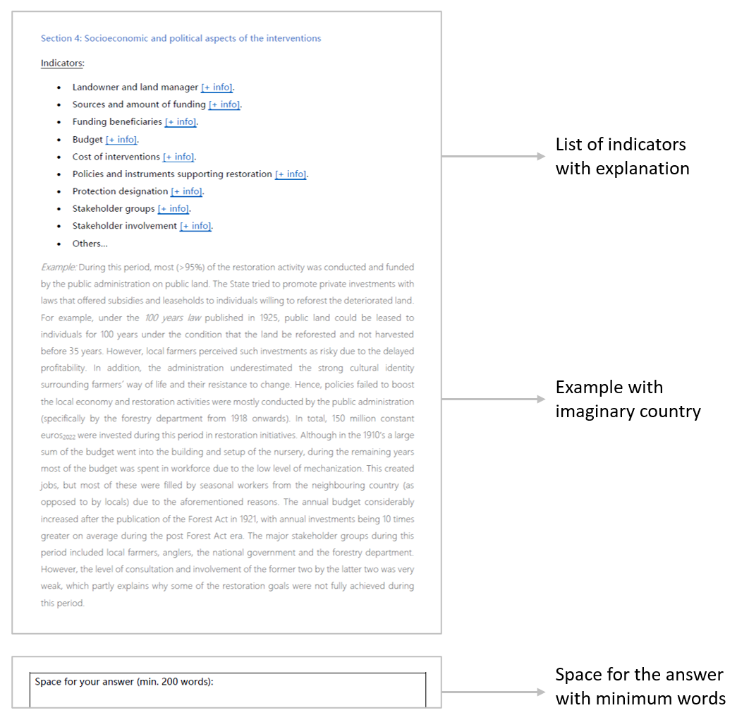
Figure S2. An example of the structure of each section within the template for the narratives.

 |  | 1700 | 1800 | 1850 |  | 1900 | 1910 |  | 1920 |  | 1930 |  | 1940 |  | 1950 | 1960 | 1970 | 1980 | 1990 |  | 2000 | 2010 | 2020 | 2023
 | Austria |  |  |  |  |  |  |  |  | 1918
 | Belgium |  |  |  |  |  |  |  |  |  |  |  | 1945
 | Croatia |  |  |  |  |  |  |  |  |  |  |  | 1945
 | Denmark
 | Finland
 | France |  |  |  |  |  |  |  |  |  |  |  | 1945
 | Germany |  |  |  |  |  |  |  |  |  |  |  | 1940
 | Greece
 | Hungary |  |  |  |  |  |  |  |  |  |  |  | 1945
 | Italy
 | Netherlands
 | Poland |  |  |  |  |  |  |  |  |  |  |  | 1945
 | Romania |  |  |  |  |  |  |  |  |  |  |  | 1948
 | Slovenia |  |  |  |  |  |  |  |  |  |  |  | 1945
 | Spain |  |  |  |  |  |  |  |  |  |  |  | 1940
 | Sweden
 | Switzerland |  |  |  |  |  |  |  |  |  |  |  | 1939
 | UK
 | Period 1 (protection) |  |  |  |  | Period 2 (production) |  |  |  |  |  |  |  | Period 3 (multifunctionality) |  |  |  |  |  | Period 4 (urban/periurban)

Figure S3. The main forest restoration periods defined by each national narrative. The numbers in the second period reflect the year chosen by those countries to mark the beginning of the second period.

Figure S4. Minimum forest cover (%) reported by countries between the 19th and 20th centuries (solid filling) and the current forest cover (striped filling).

Table S2: Pine species used for restoration in the first period (before 1940).
Species | Country
Black pine  (Pinus nigra J.F. Arnold) | The main species used in Karst afforestation in Croatia (81%) and Slovenia (90%), as well as in France and in the Italian Apennines, and to a lesser extent but also considerably in Spain and the UK.
Scots pine  (Pinus sylvestris L.) | The species of choice in heathland afforestation in the Netherlands, Belgium, the UK and Germany.
Mugo pine  (P. mugo Turra) | The first experiences with Scots pine in Denmark failed, so it was replaced by mugo pine.
Aleppo pine  (P. halepensis Mill.) | Widely used for afforestation in Mediterranean countries (e.g., Spain, Greece).
Maritime pine  (P. pinaster Aiton) | Widely used in coastal plantations in Spain and Italy. Between 1850 and 1880, it was often applied in Belgium for heathland afforestation, but due to widespread frost damage and lower stem quality, it was replaced by Scots pine.
Mountain pine  (P. uncinata Turra) | Used in drier inner alpine areas in Switzerland as well as in mountain areas in Spain (namely in the Pyrenees).
Turkish pine  (P. brutia Ten.) | Commonly used in Greece for reforestation alongside Aleppo pine.

Figure S5. Investment in afforestation by four countries (UK, Croatia, Switzerland, Slovenia) during the first period and the breakdown of the costs.

Table S3: Country-level examples of the main obstacles to successful forest restoration reported in the narratives for the first period (before 1940).
Obstacles | Country-level examples
Conflicting goals and local opposition | - Romania: Incoherent policies across sectors (forest vs. agricultural policies) alongside poverty and weak enforcement meant that many of the afforested lands were harvested, grazed or burned within a decade. Although the Romanian forest codes of 1881 and 1910 stated that reforestation after harvesting was mandatory, the fines for not complying were lower than the cost of afforestation [1].  - Austria: Local population reverted to traditional management practices (e.g., cattle grazing in forests) that were prevalent before the afforestation.  - Spain and France: When private owners did not accept the voluntary sale of their lands for afforestation, forced expropriation was applied, which entailed a very slow administrative process and many conflicts.  - Croatia: Many seedlings were plucked out by local population to ensure additional work and money in financially difficult times [2].
Limited knowledge and poor reproductive material | - Romania and Hungary: The non-native species (e.g., black locust) that previously seemed to be the perfect solution on floodplains and sandy areas showed several issues, such as low timber quality and invasiveness.  - Germany: The established conifer monocultures showed low resilience towards biotic and abiotic disturbances such as wind, snow, diseases and pests, especially in areas with lower altitudes, as early as in the middle of the 19th century [3].  - Croatia: additional planting in Karst afforestation was often needed on up to 80% of the restored area due to the poor technique and reproductive material that was used [4].  - Austria: The main obstacle of this period was the provision of forest reproductive material.
Insufficient funding | - Spain: The low budget from the public sector was the major constraint limiting the ambitious afforestation plans.  - Switzerland: The enforcement of the restrictions in the field by foresters was hampered by insufficient funding.
Political instability | - Slovenia and Croatia: The unstable political environment (e.g., wars, border changes) slowed down progress.  - The Netherlands: Ideas about employing forest management modeled after natural processes (close-to-nature management) did emerge during the first half of the 20th century, but their incorporation was prevented by the geopolitical turmoil of the same period [5].
Browsing | - Poland: The idea of introducing admixtures in spruce plantations appeared in the 1920s, but these were massively eliminated by wildlife.
Lack of post-restoration management | - France: Recommendations to manage plantations were emitted, but first thinning operations were too costly and ignored until the 1980s, when an undesirable forest structure and composition was already established.
Table S4: Country-level examples of the main effects that forest restoration initiatives had as reported in the narratives for the second period (1940-1990).
Effects of restoration | Country-level examples
Increased standing stock | - Spain: Wood production in 1984 was 10 times higher than in 1940, and nowadays, 81% of the wood volume harvested per year (20 million m³) is produced in the plantations of fast-growing species created at that time.  - Germany: The growing stock saw a sharp increase between 1949 and 1990: from 60 to 190 m³/ha in East Germany and from 95 to 300 m³/ha in West Germany [6 as cited in 7, 8].  - Switzerland: The standing stock increased from 250 to 367 m³/ha between 1950 and 1990 [9].
Afforestation targets met | - UK: The goal of planting five million acres (2.02 million ha) over a 50-year period was achieved slightly ahead of schedule [10], resulting in forest cover more than doubling between 1919 and 1990.  - Romania: The 1 million ha afforestation/reforestation plan was implemented by 1963.  - Italy: around 30,000 ha were afforested annually for almost 20 years, mainly using black pine (but these forests have proven economically unsatisfactory today due to low wood quality).
Protective function improved | - Netherlands: Afforestation was so successful that drifting sands and heather fields became threatened and consequently protected ecosystems since the 1960s [11].  - Hungary: The country's forest cover increased from 12.3 to 18.2%, leading to a reduction in erosion [12].  - Slovenia: In the Karst afforestation program, the success rate of the first post-war attempts was modest (30%) but gradually improved up to 70-80% by the end of the period [13], with approximately 10,000 ha being restored over the whole period and reducing erosion related problems.
Jobs created | - Spain: It is estimated that an average number of 3 million daily wages per year were generated in the 1940s, reaching a value of 13 million in 1954 [14].  - Romania: 100-120,000 workers were employed for planting in the largest afforestation campaigns.
Increased share of conifers | - UK: The share of conifers increased from 41% in 1947 to 67% in 1965 [15].  - Austria: The percentage of forest area covered by conifers increased from 65 to 85% between 1600 and 1988 [16, 17].  - Switzerland: It is estimated that the lowlands, characterized by natural beech forests, were replaced with conifers in mixed (57,000 ha) and pure (98,000 ha) stands.
Drained wet forests | - Sweden: About 25% of the wetland area (1.25 million ha) was lost during the 20th century and about 80% was affected by draining.
Increased area of protected forests | - Sweden: 350,000 ha of forest (1.5%) had been strictly protected by 1990.  - UK: About 16% of the total area of ancient woodland in England and 10% in Wales had been designated as nature reserves or Sites of Special Scientific Interest by 1990 [18].  - Poland: 15 national parks covering 0.65% of the country were established between 1945 and 1990.
Table S5: Country-level examples of the main obstacles to successful forest restoration reported in the narratives for the third period (after 1990).
Obstacles | Country-level examples
Lack of funding | - Recent governments reduced the budget for nature conservation (e.g., Netherlands, Sweden, France).  - Resources allocated for forest restoration had to be diverted to deal with bark beetle outbreaks and their consequences (e.g., Germany, Austria).  - The government funding mechanism that was crucial for the success of the second period stopped with the government change, leading to a sharp decline in forest restoration activities [19, 20] (Slovenia).  - Subsidies were insufficient to cover potential income losses (Hungary).
Conflicting goals | - Subsidized farming and legal/fiscal consequences from reclassifying agricultural land to forest land deterred many landowners from engaging in afforestation (e.g., Denmark, Belgium, Poland).  - The Forestry Act (1993) is quite liberal, resulting in timber production being favored over biodiversity conservation, which is partly incompatible with the Environmental Code (1995), certification rules and European legislation (Sweden).  - The forestry sector seemed quite attached to the previous productive model and, in some cases, it lobbied against EU initiatives that support biodiversity and forest ecosystem services other than wood biomass (e.g., Sweden, Finland, France).
Ownership fragmentation and decentralization | - Romania: The forest restitution after the fall of the communist party led to the fragmentation of property into nearly one million forest owners with very limited knowledge and interest in forest management and resulted in widespread illegal logging [21]. The increased share of pure coniferous stands in the past years, which is not in line with the technical norms, also raised questions about the State´s ability to coordinate efforts.  - The Netherlands: The decentralization of forest policy in 2010, among other factors, resulted in several restoration targets not being met or becoming less ambitious.  - Slovenia: With the dissolution of the unitary organization of forest management and the reprivatization of the forests, Slovenia also saw a considerable decrease in the implementation of restoration initiatives [19, 20].
Browsing | - Austria: Damage due to browsing on young plants has increased, as the number of cloven-hoofed game such as deer and roe deer has been continuously increasing for many decades, which is too high for healthy forest regeneration [22].  - Slovenia: This period has seen a particular increase in the abundance of game, including red deer, which makes it virtually impossible to return oaks to black pine plantations, despite a satisfactory number of seed sources and small seedlings [23].  - Germany: High browsing pressure from ungulates in most regions can prevent successful natural regeneration [24, 25].
Bureaucracy | - Romania: Low absorption rates (e.g., 0.08% 2007-2013) of EU rural development funding was in part due to heavy bureaucracy.  - Austria: From 2007 to 2020, the implementation of the Austrian Rural Development Program and the national Forest Fund fell far short of expectations due to administrative rules and requirements that made the measures unattractive to applicants.
Climate change and disturbances | - Germany: Tree species suitability under climate change is projected to change; e.g., beech was affected by the drought to a greater extent than anticipated [26, 27, 28].  - Croatia: The escalating incidence of forest fires is a critical challenge, attributed to climate change, human activities and historical forest mismanagement.

References:
1. Giurescu, C.C., 1975. Istoria pădurii românești din cele mai vechi timpuri pînă astăzi. Editura Ceres, Bucharest, Romania.
2. Piškorić, O., Vukelić, J., 1992. A Brief History of Croatian Forests and Forestry. Forests in Croatia, 273 – 290.
3. Mantel, K., 1990. Wald und Forst in der Geschichte: ein Lehr- und Handbuch. Schaper.
4. Ivančević, V., Piškorić O., 1986. Restoration of Forest Croatian Karst from the last Century to date. Šumarski list 7-8, 333–347.
5. Oosthoek, K.J., & Hölzl, R., 2018. Managing Northern Europe's Forests. Histories from the Age of Improvement to the Age of Ecology. Berghahn, New York, U.S. and Oxford, U.K.
6. Reichenstein, E., 1950. Die Forstwissenschaftliche Lage Deutschlands vor und nach dem Zweiten Weltkrieg. Forstarch 21, 1-3.
7. Zundel, R., Schwartz, E., 1996. 50 Jahre Forstpolitik in Deutschland (1945 bis 1994). Münster-Hiltrup Landwirtschaftsverlag.
8. Bundesministerium für Ernährung, L. Und F. (BMEL), 1994. Nationaler Waldbericht: Bericht der Bundesrepublik Deutschland zur Bewirtschaftung, Erhaltung und nachhaltigen Entwicklung der Wälder in Deutschland.
9. Waldbericht, 2005. Zahlen und Fakten zum Zustand des Schweizer Waldes. BUWAL and WSL, Bern, Switzerland.
10. Forest Research, 2022. Forestry Statistics 2022. Alice Holt, Forest Research.
11. Thissen, P.H.M., 1991. De Nederlandse staat en heideontginning, 1795-1961.
12. Lett, B., 2021. Amit a számok mutatnak–Az erdőtelepítések tapasztalatai 1920–2020. (What the numbers show - The experience of afforestation 1920-2020).
13. Perko, F., 2016. Od ogolelega do gozdnatega krasa: pogozdovanje krasa. Gozdarska založba.
14. Vadell, E., de-Miguel, S., Pemán, J., 2017. La actividad repobladora desarrollada a partir de 1940. Luces y sombras, in: Pemán, J., Iriarte, I. Lario, F.J. (Eds.), La restauración forestal de España: 75 años de una ilusión. Ministerio de Agricultura y Pesca, Alimentación y Medio Ambiente, Madrid, España, 175-226.
15. Mason, W.L., 2007. Changes in the management of British forests between 1945 and 2000 and possible future trends. Ibis 149, 41–52.
16. Hafner, F., 1994. Mehrfachnutzung des Waldes. Österreichs Wald-Vom Urwald Zur Waldwirtschaft. Österreichischer Forstverein, Vienna, Austria.
17. Hillgarter, F.W., Johann, E., 1994. Österreichs Wald–Vom Urwald zur Waldwirtschaft (2nd edition). Eigenverlag Autorengemeinschaft, Vienna, Austria.
18. Spencer, J.W. Kirby, K.J., 1992. An inventory of ancient woodland for England and Wales. Biological Conservation 62, 77-93.
19. Winkler, I., Krajčič, D., 1998. Zagotavljanje gozdne reprodukcije. Gozdarski Vestnik 56, 18-24.
20. Krajčič, D., 1999. Obseg bioloških vlaganj v gozdove v Sloveniji. Zb. gozd. lesar. 59, 33-54.
21. Munteanu, C., Nita, M.D., Abrudan, I.V., Radeloff, V.C., 2016. Historical forest management in Romania is imposing strong legacies on contemporary forests and their management. For. Ecol. Manag. 361, 79–193.
22. ÖWI. 2023. Waldinventnur. Available at: https://waldinventur.at/#/ [accessed 2024.02.15].
23. Diaci, J., Adamič, T., Rozman, A., Fidej, G., Roženbergar, D. 2019. Conversion of Pinus nigra Plantations with Natural Regeneration in the Slovenian Karst: The Importance of Intermediate, Gradually Formed Canopy Gaps. Forests 10.
24. Ammer, C. 2011. Waldbauliche und finanzielle Auswirkungen von Schalenwildverbiss. FVA-Einblick, 3/2011, 8–10.
25. Kühl, N., Geyer, J., Kröschel, M., Suchant, R. 2021. Waldumbau und Wildverbiss. AFZ- Der Wald, 06/2021, 12–15.
26. Knutzen, F., Dulamsuren, C., Meier, I. C., Leuschner, C. 2017. Recent Climate Warming-Related Growth Decline Impairs European Beech in the Center of Its Distribution Range. Ecosystems, 20(8), 1494–1511.
27. Schuldt, B., Buras, A., Arend, M., Vitasse, Y., Beierkuhnlein, C., Damm, A., Gharun, M., Grams, T. E. E., Hauck, M., Hajek, P., Hartmann, H., Hiltbrunner, E., Hoch, G., Holloway-Phillips, M., Körner, C., Larysch, E., Lübbe, T., Nelson, D. B., Rammig, A., Rigling, A., Rose, L., Ruehr, N., Schumann, K., Weiser, F., Werner, C., Wohlgemuth, T., Zang, C. Kahmen, A. 2020. A first assessment of the impact of the extreme 2018 summer drought on Central European forests. Basic and Applied Ecology, 45, 86–103.
28. Lindner, M., Fitzgerald, J. B., Zimmermann, N. E., Reyer, C., Delzon, S., van der Maaten, E., Schelhaas, M.-J., Lasch, P., Eggers, J., van der Maaten-Theunissen, M., Suckow, F., Psomas, A., Poulter, B., Hanewinkel, M. 2014. Climate change and European forests: What do we know, what are the uncertainties, and what are the implications for forest management? Journal of Environmental Management, 146, 69–83.

