Forest Ecosystem Multifunctionality: A Systematic Review of Measures and Drivers
Journal: Current Forestry Reports

Jenickson R. S. Costa^{1,2,3,*}, Pedro H. S. Brancalion^{1,4,5}, François-Xavier Joly³, Laura H. P. Simões⁶, Jonathan Bonfanti³, Guerric le Maire^{2,3}, Agnès Robin^{2,3}, Joannès Guillemot^{1,2,3}

* Correspondence to Jenickson R. S. Costa, Institut Agro Montpellier - 2 place Viala, 34060 Montpellier Cedex 2 – France, jenickson1@gmail.com

SUPPLEMENTARY MATERIAL
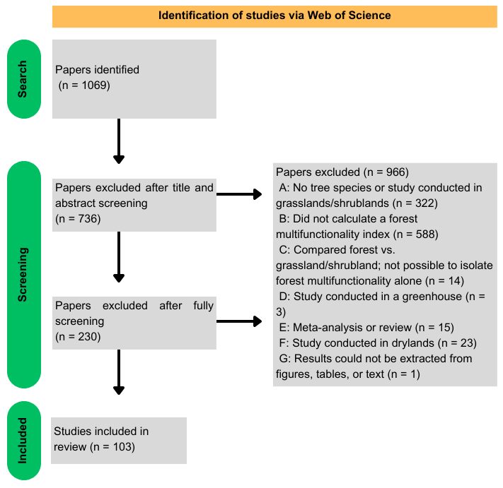
Fig. S1. Conceptual diagram of literature review process.

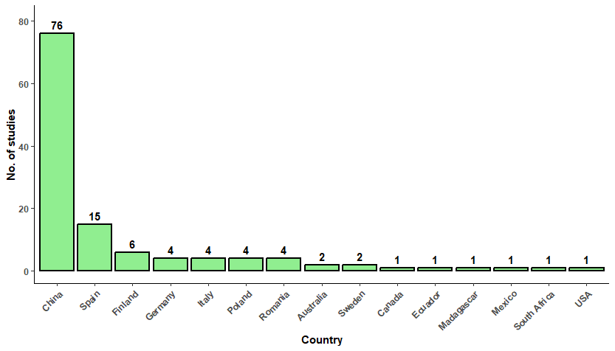
Fig. S2. Number of studies on the drivers of forest multifunctionality per country since 2015.

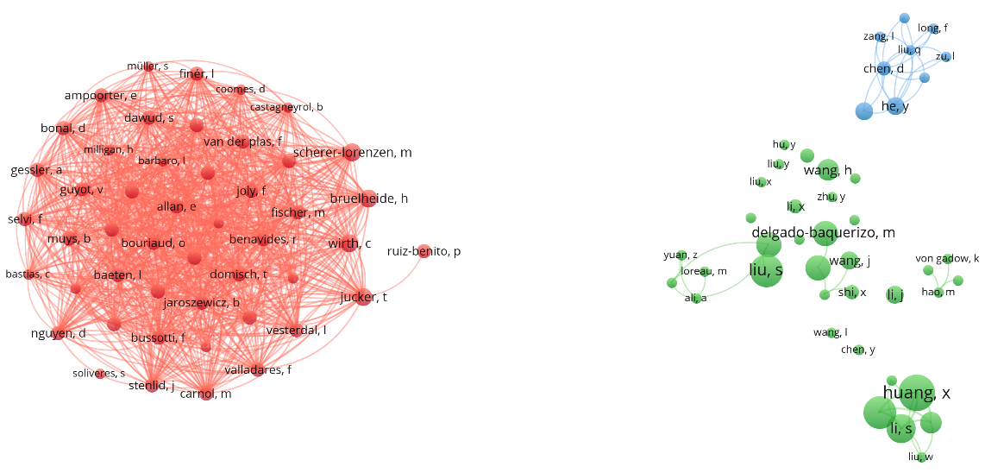
Fig. S3. Links among the 92 authors who published at least three research articles on forest multifunctionality in this review. Figure elaborated by VOSViewer.

