Supporting Information

Evaluating Indoor Low-Cost Particle Sensors: Algorithmic Insights and Calibration Approaches

Nan Ma ª, Ye Kang ^{b}, Weiduo Gan ^{c}, Jin Zhou ^{c,*}

ª Department of Civil, Environmental, and Architectural Engineering, Worcester Polytechnic Institute, Worcester, MA 01609-2280, United States
^{b} Taptana Data & AI Pty Ltd, Kellyville, New South Wales 2155, Australia
^{c} Department of Civil Engineering, Monash University, Clayton, Victoria 3800, Australia
* Corresponding author: E-mail address: Jenny.Zhou@monash.edu (Jin Zhou)

Table of Contents
Fig. S1 Time-series comparison of particle number concentration (PNC) between the PMS5003 sensor and the reference instrument across five particle size bins (a: 0.3–0.5 μm, b: 0.5–1 μm, c: 1–2.5 μm, d: 2.5–5 μm, and e: 5–10 μm) under three indoor experiments. Please note that in this figure, Sensor #1 is presented as a representative example, as the results from the other 29 units showed similar trends 4
Fig. S2 Normalised volume size distribution by SensorID #1 and reference instrument across three indoor experiments (Ex_Bushfire, Ex_Incense and Ex_Normal). Please note that in this figure, Sensor #1 is presented as a representative example, as the results from the other 29 units showed similar trends 5
Fig. S3 Scatter plots of r², RMSE, MNB, and CV for 30 sensor modules across three particle size ranges (<1, <2.5, and <10 μm) under three indoor experimental conditions (Ex_Bushfire, Ex_Incense and Ex_Normal) 6

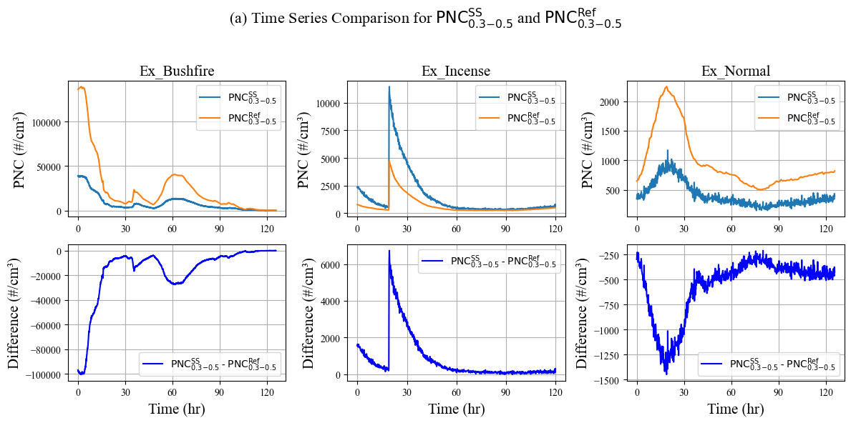
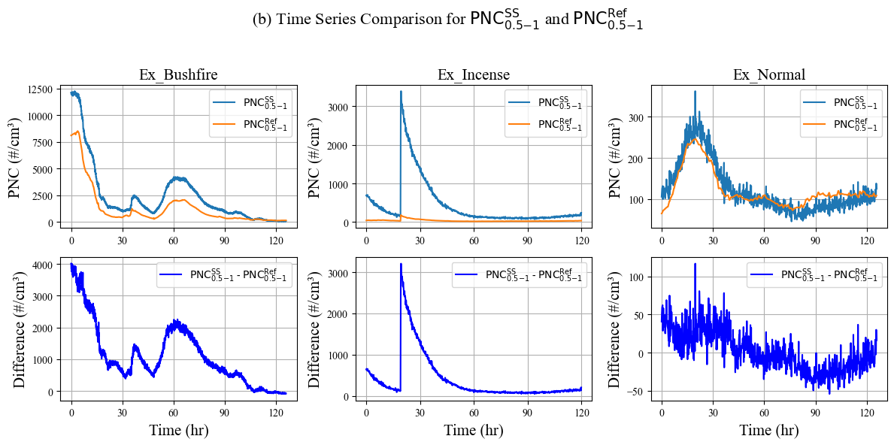
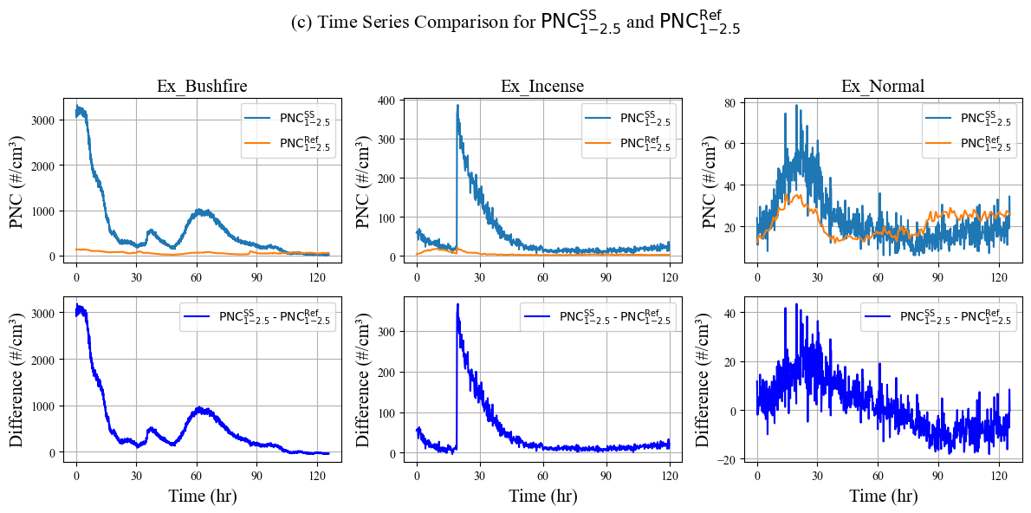
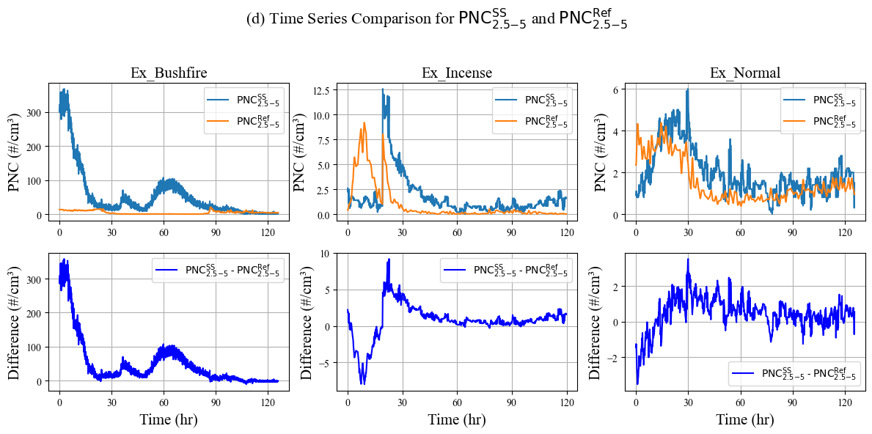
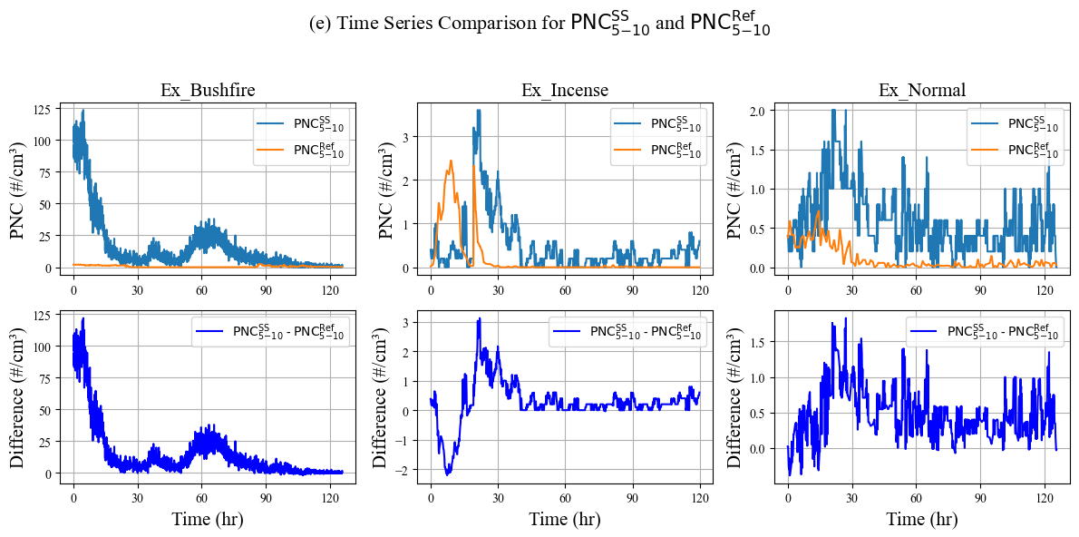

Fig. S1 Time-series comparison of particle number concentration (PNC) between the PMS5003 sensor and the reference instrument across five particle size bins (a: 0.3–0.5 μm, b: 0.5–1 μm, c: 1–2.5 μm, d: 2.5–5 μm, and e: 5–10 μm) under three indoor experiments. Please note that in this figure, Sensor #1 is presented as a representative example, as the results from the other 29 units showed similar trends

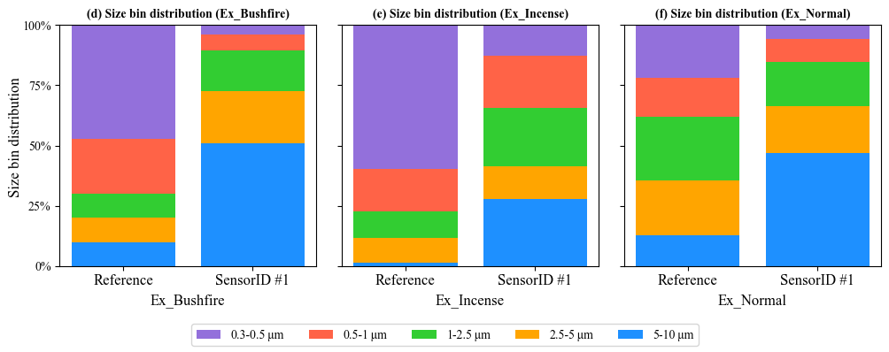

Fig. S2 Normalised volume size distribution by SensorID #1 and reference instrument across three indoor experiments (Ex_Bushfire, Ex_Incense and Ex_Normal). Please note that in this figure, Sensor #1 is presented as a representative example, as the results from the other 29 units showed similar trends

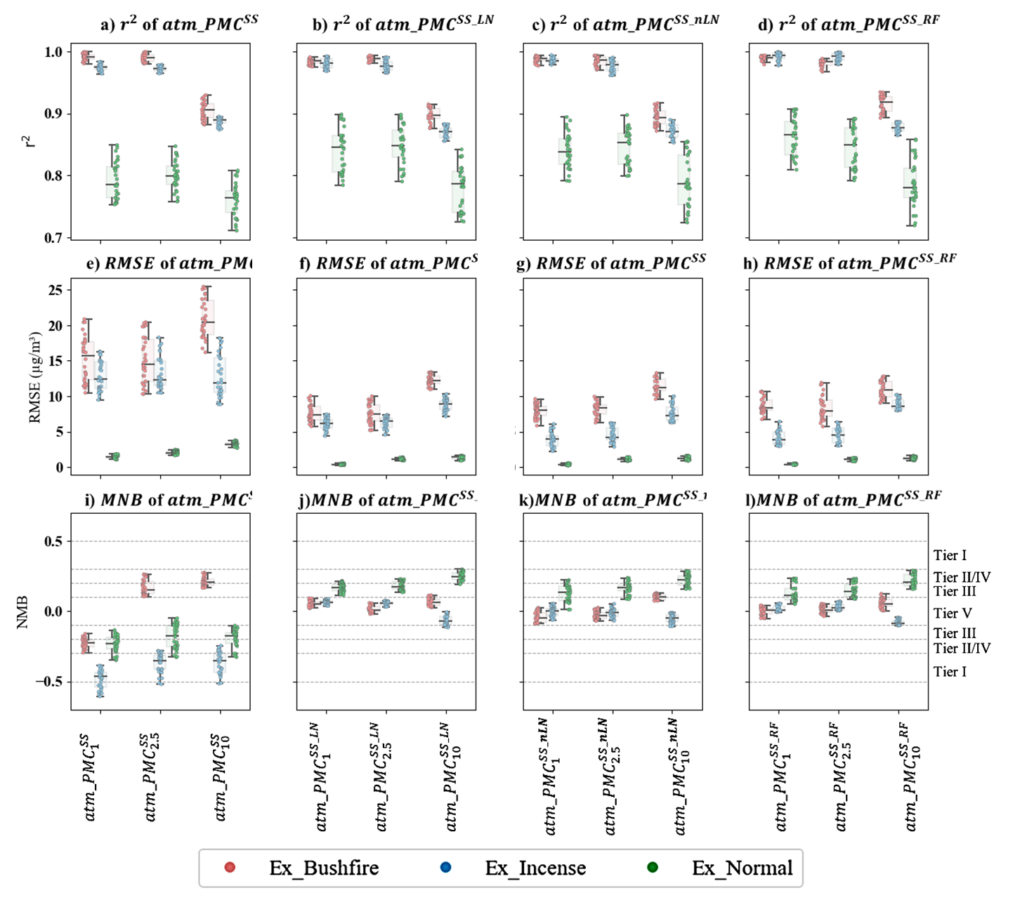

Fig. S3 Scatter plots of r², RMSE, MNB, and CV for 30 sensor modules across three particle size ranges (<1, <2.5, and <10 μm) under three indoor experimental conditions (Ex_Bushfire, Ex_Incense and Ex_Normal)

