Optimization of inhibition efficiency of Schiff bases on mild steel in acid medium: Electrochemical and RSM approach

Supplementary material
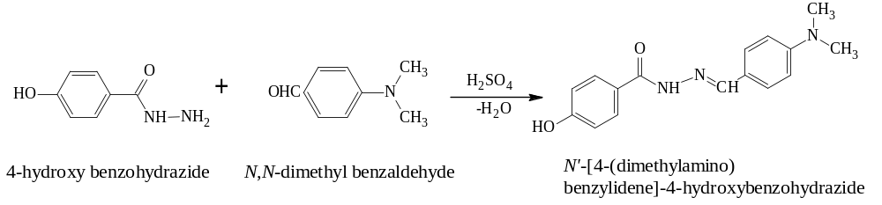

SF.1 Synthetic route of SB

SF. 2(a) FTIR spectrum, 2(b) ¹H NMR spectrum of SB

