AN UP-TO-DATE REVIEW ON INDUSTRIALLY SIGNIFICANT INHIBITORS FOR CORROSION CONTROL OF ZINC
Mikitha Pais and Padmalatha Rao*
Department of Chemistry, Manipal Institute of Technology, MAHE, Manipal, 576104, Karnataka, INDIA
Corresponding author: email: padmalatha.rao@manipal.edu

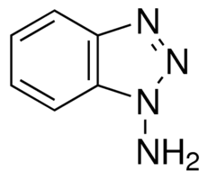

Fig. S1: Structure of amino-benzotriazole

- (b)
Fig. S2: Structure of (a) 2- [4-(methylthio) phenyl] acetohydrazide (b) 5-[4(methylthio)benzyl]-4H-1,2,4-triazole-3-thiol
(a) (b) (c)
Fig. S3: Structure of (a) triethylamine (b) triethanolamine (c) ethanolamine

- (b)
(c)
Fig. S4: Structure of (a) cetyltrimethyl ammonium bromide (b) bromohexadecyl pyridine (c) nicotinic acid

(a) (b) (c)
Fig. S5: Structure of (a) semicarbazide (b) thiosemicarbazide (c) diphenylcarbazide
(a) (b) (c) (d)
(e)
Fig. S6: Structures of various organic compounds used for the study
Fig. S7: Structure of ketosulfone

(a) (b)(c)

Fig. S8: Structure of (a) streptomycin (b) spectinomycin (c) paromomycin
Fig. S9: Structure of Seroquel
Fig. S10: Structure of ziprasidone

- (b) (c)

Fig. S11: Structure of (a) ethylenediamine N,N′-dibenzylidene, (b) ethylenediamine N,N′-di (p-methoxybenzylidene) (c) ethylenediamine N,N′-disalicylidene

Fig. S12: General structure of different m-substituted aniline-N-salicylidene
- (b) (c)
(d) (e)(f)

Fig. S13: Structure of phosphonium and ammonium compounds
(a) (b) (c)
Fig. S14: Structure of (a) o-toluidine (b) m-toluidine (c) p-toluidine
(a)

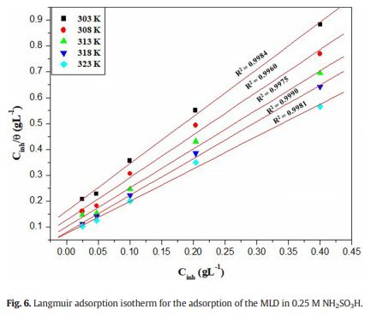
Fig. S15: Langmuir adsorption for adsorption isotherm of MLD on zinc

- (b) (c)
Fig. S16: Structure of (a) DTAB (b) TTAB(c) HTAB

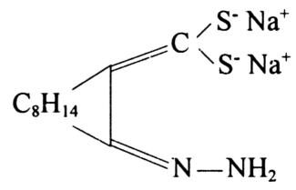
Fig. S17: Structure of 2-hydrazono-3-bornanemethylenedithiol disodium salt
Fig. S18: Structure of benzaldehyde thiosemicarbazone

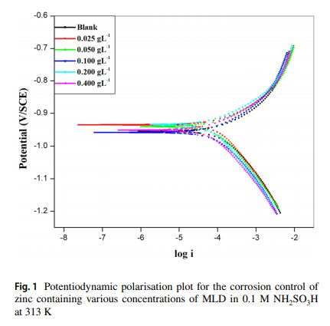
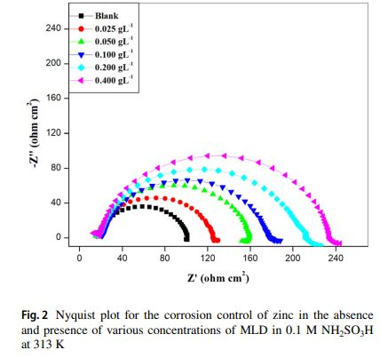

Fig. S19: (a) Potentiodynamic and (b) Nyquist plot for the corrosion and inhibition of zinc with MLD

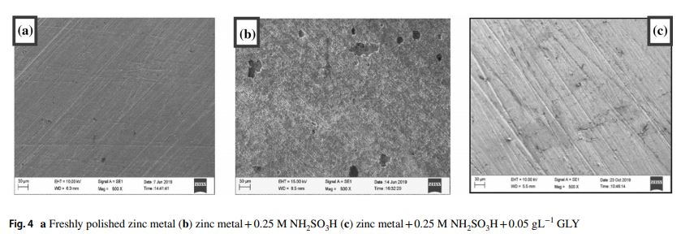
Fig. S20: Scanning Electron Microscopy images for the corrosion and inhibition of zinc

