A. Calculation of dE/dt during 60 s before each LPR
Conditions | Time  (Seconds) | dE/dt (mV/min) during 60 s before each LPR
Conditions | Time  (Seconds) | Saline | 25% as-FBS | 75% as-FBS | 25% de-FBS | 75% de-FBS
Static | 500 | 0.18 | 0.24 | 0.45 | 0.12 | 0.48
Sliding | 5980 | 1.42 | 0.31 | 0.69 | 0.38 | 0.50
Sliding | 11460 | 0.55 | 0.33 | 0.71 | 0.48 | 0.63
Sliding | 16940 | 0.64 | 0.67 | 0.69 | 0.38 | 0.62
Sliding | 22420 | 0.55 | 0.69 | 0.73 | 0.48 | 0.74
Sliding | 27900 | 1.19 | 0.88 | 0.62 | 0.55 | 0.68
Sliding | 33380 | 1.17 | 0.30 | 0.64 | 0.42 | 0.75
Static | 33960 | 0.50 | 1.12 | 0.55 | 1.17 | 0.38

B. LPR measurement data (E vs I plot)
a. Saline
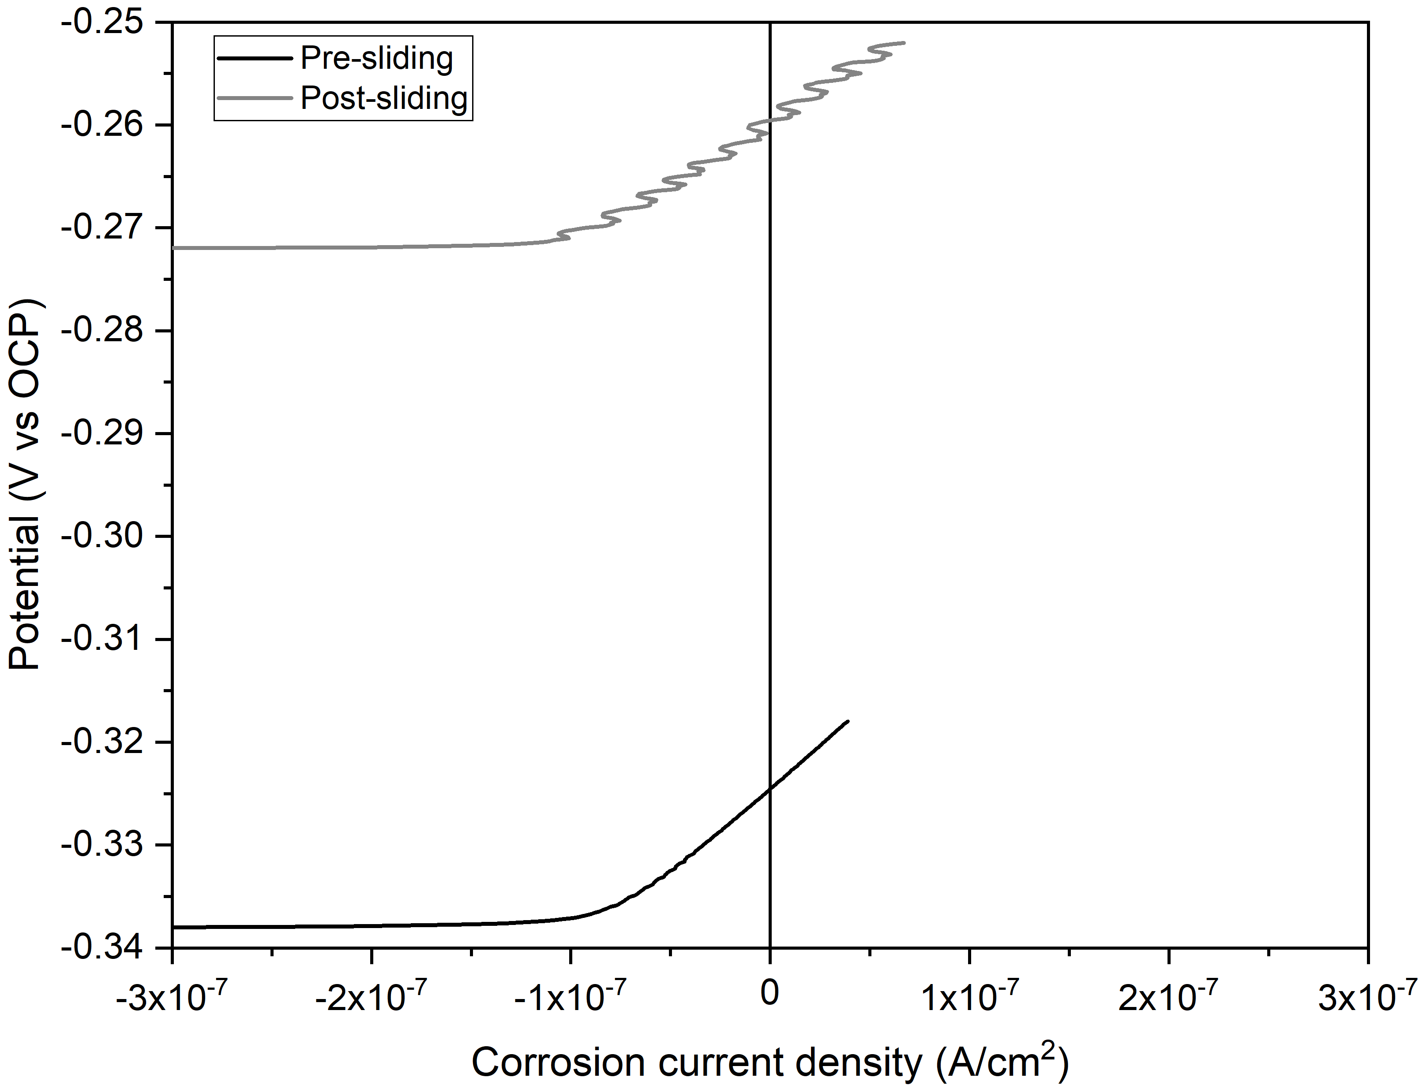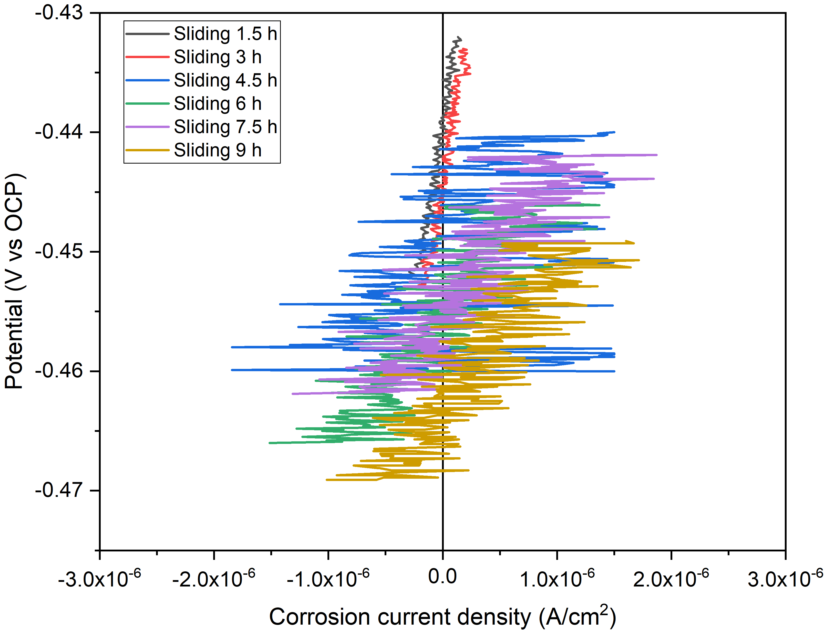

b. 25% as-FBS
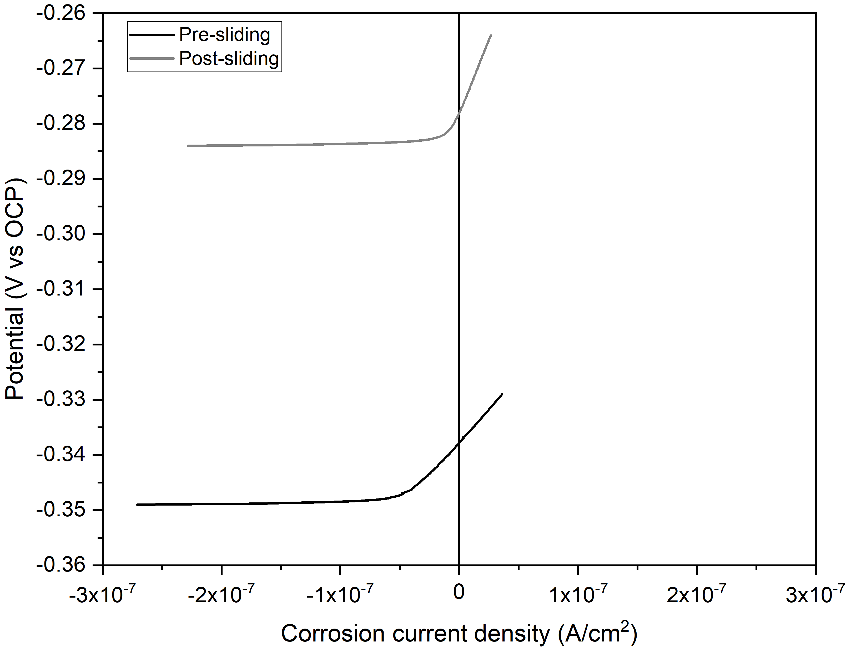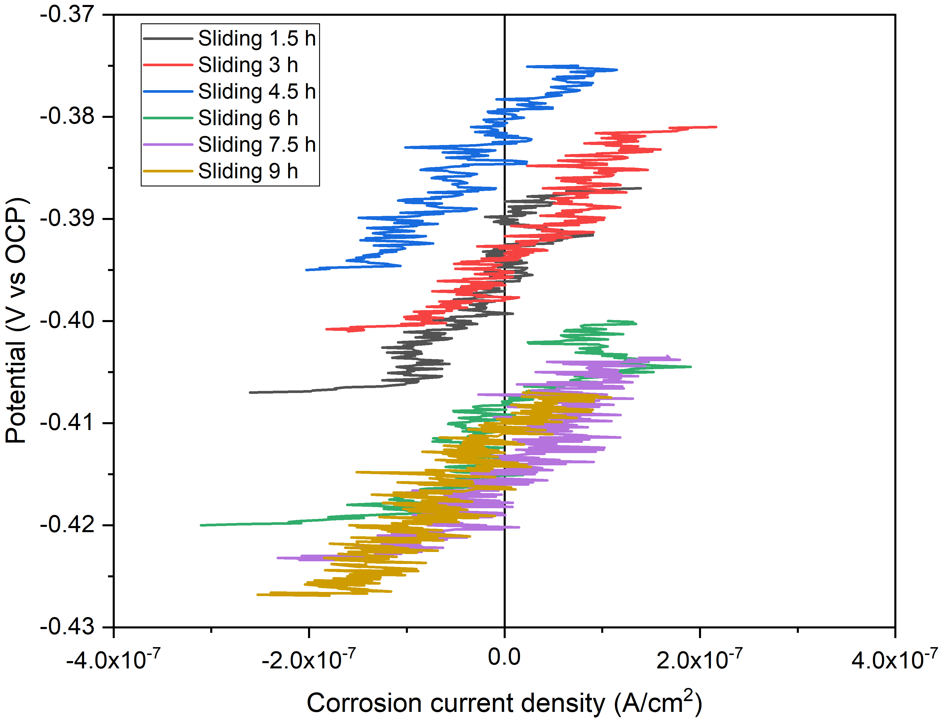

c. 75% as-FBS
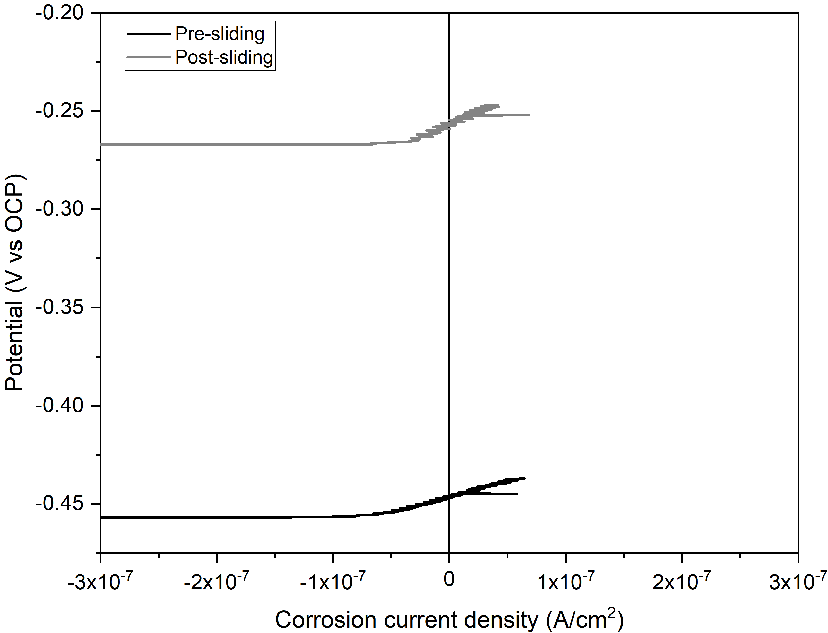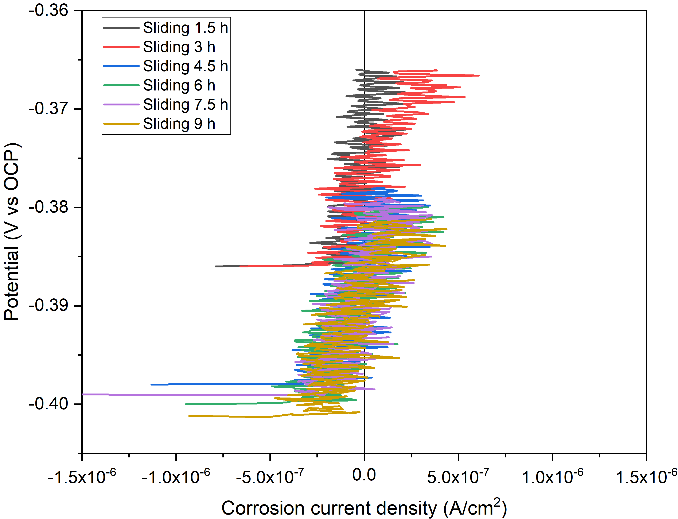

d. 25% de-FBS
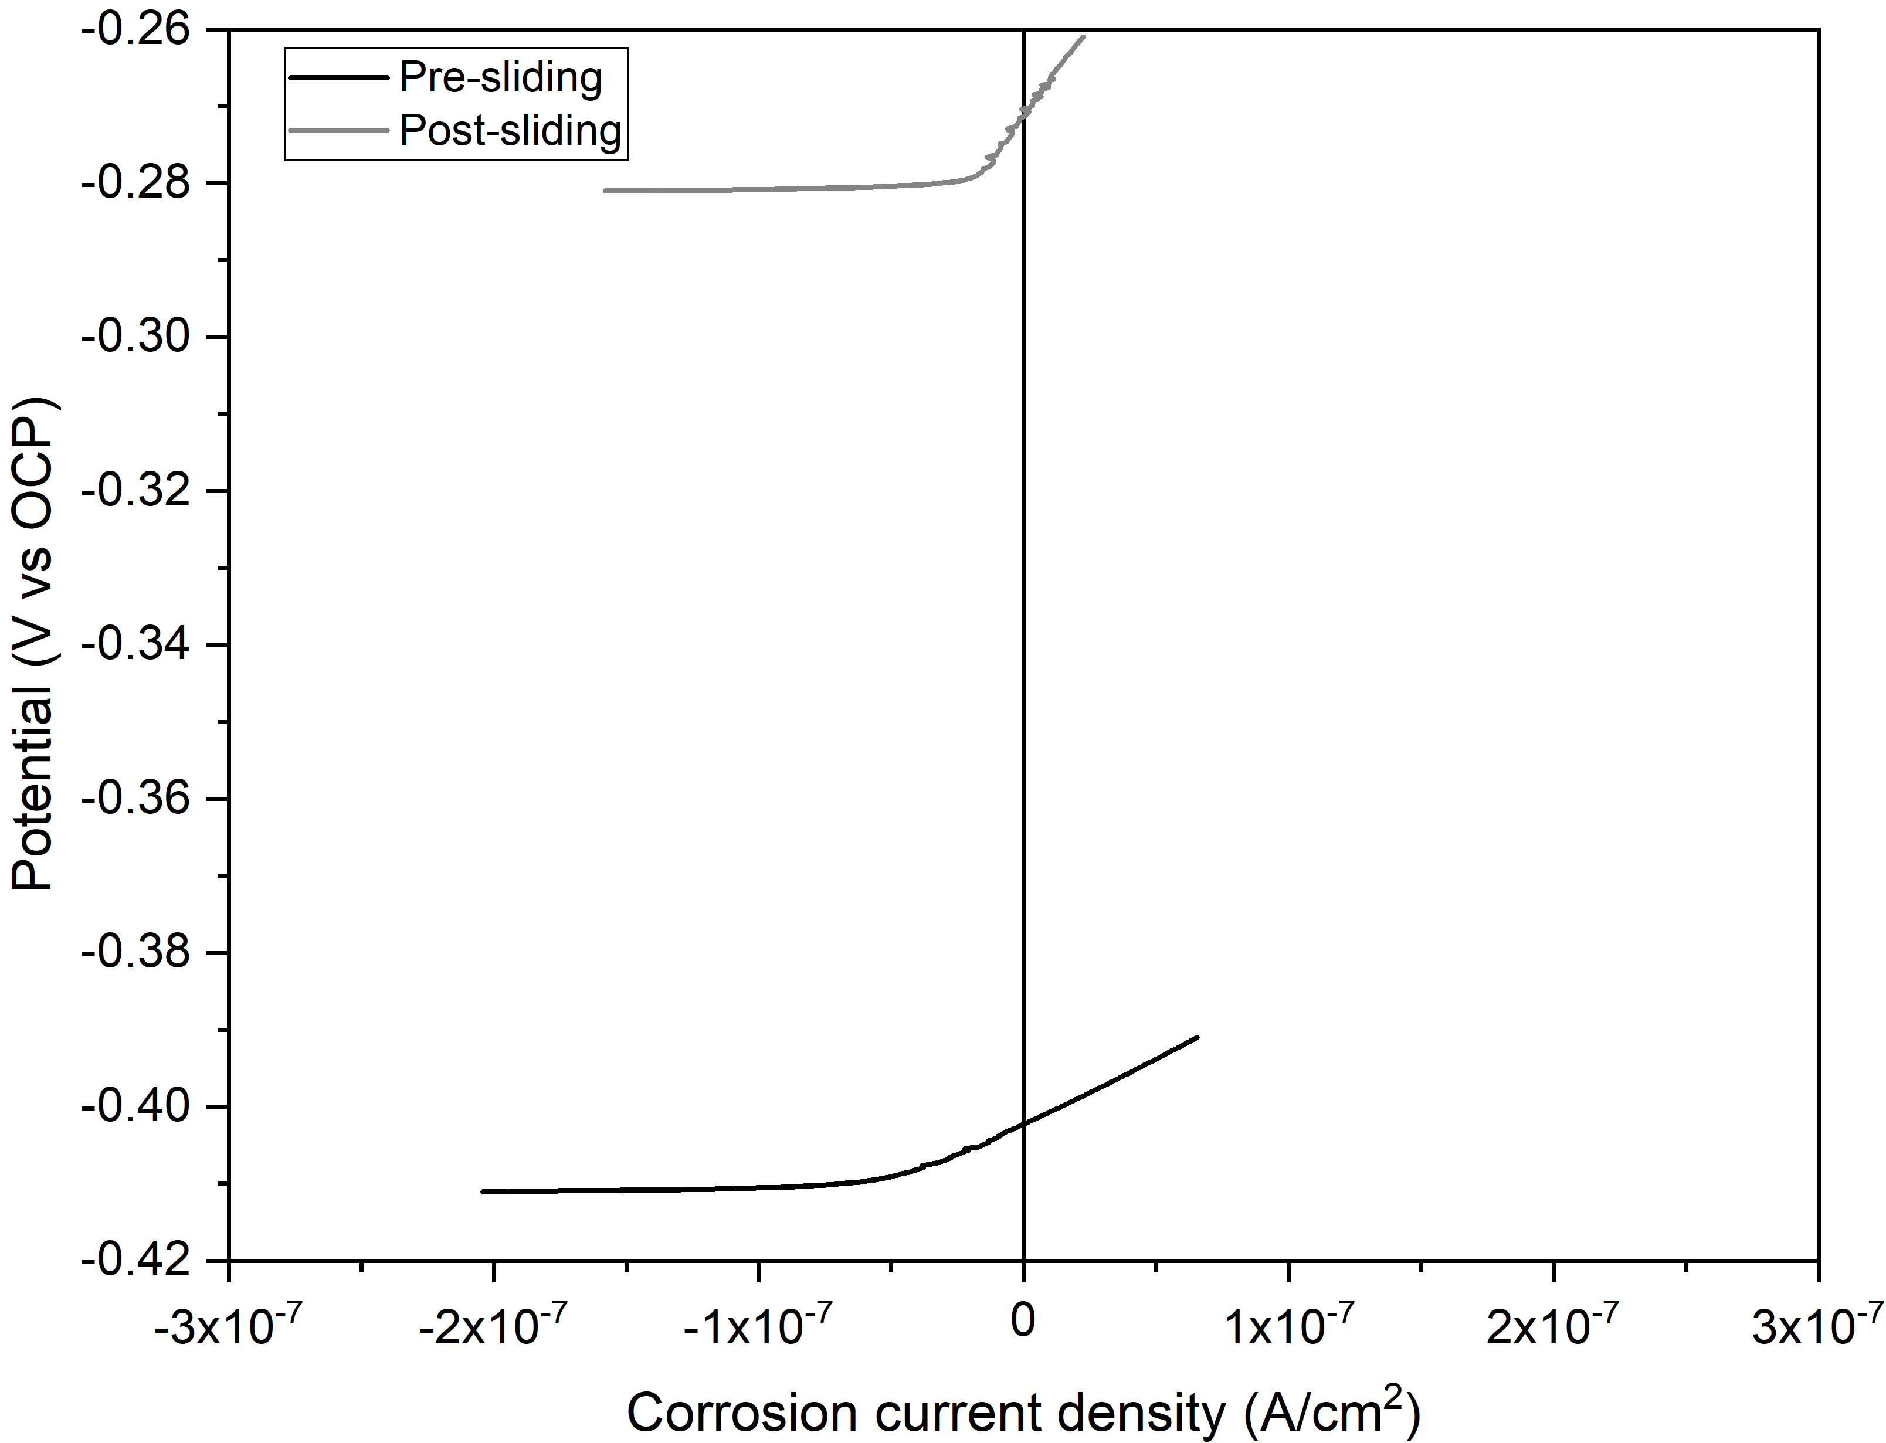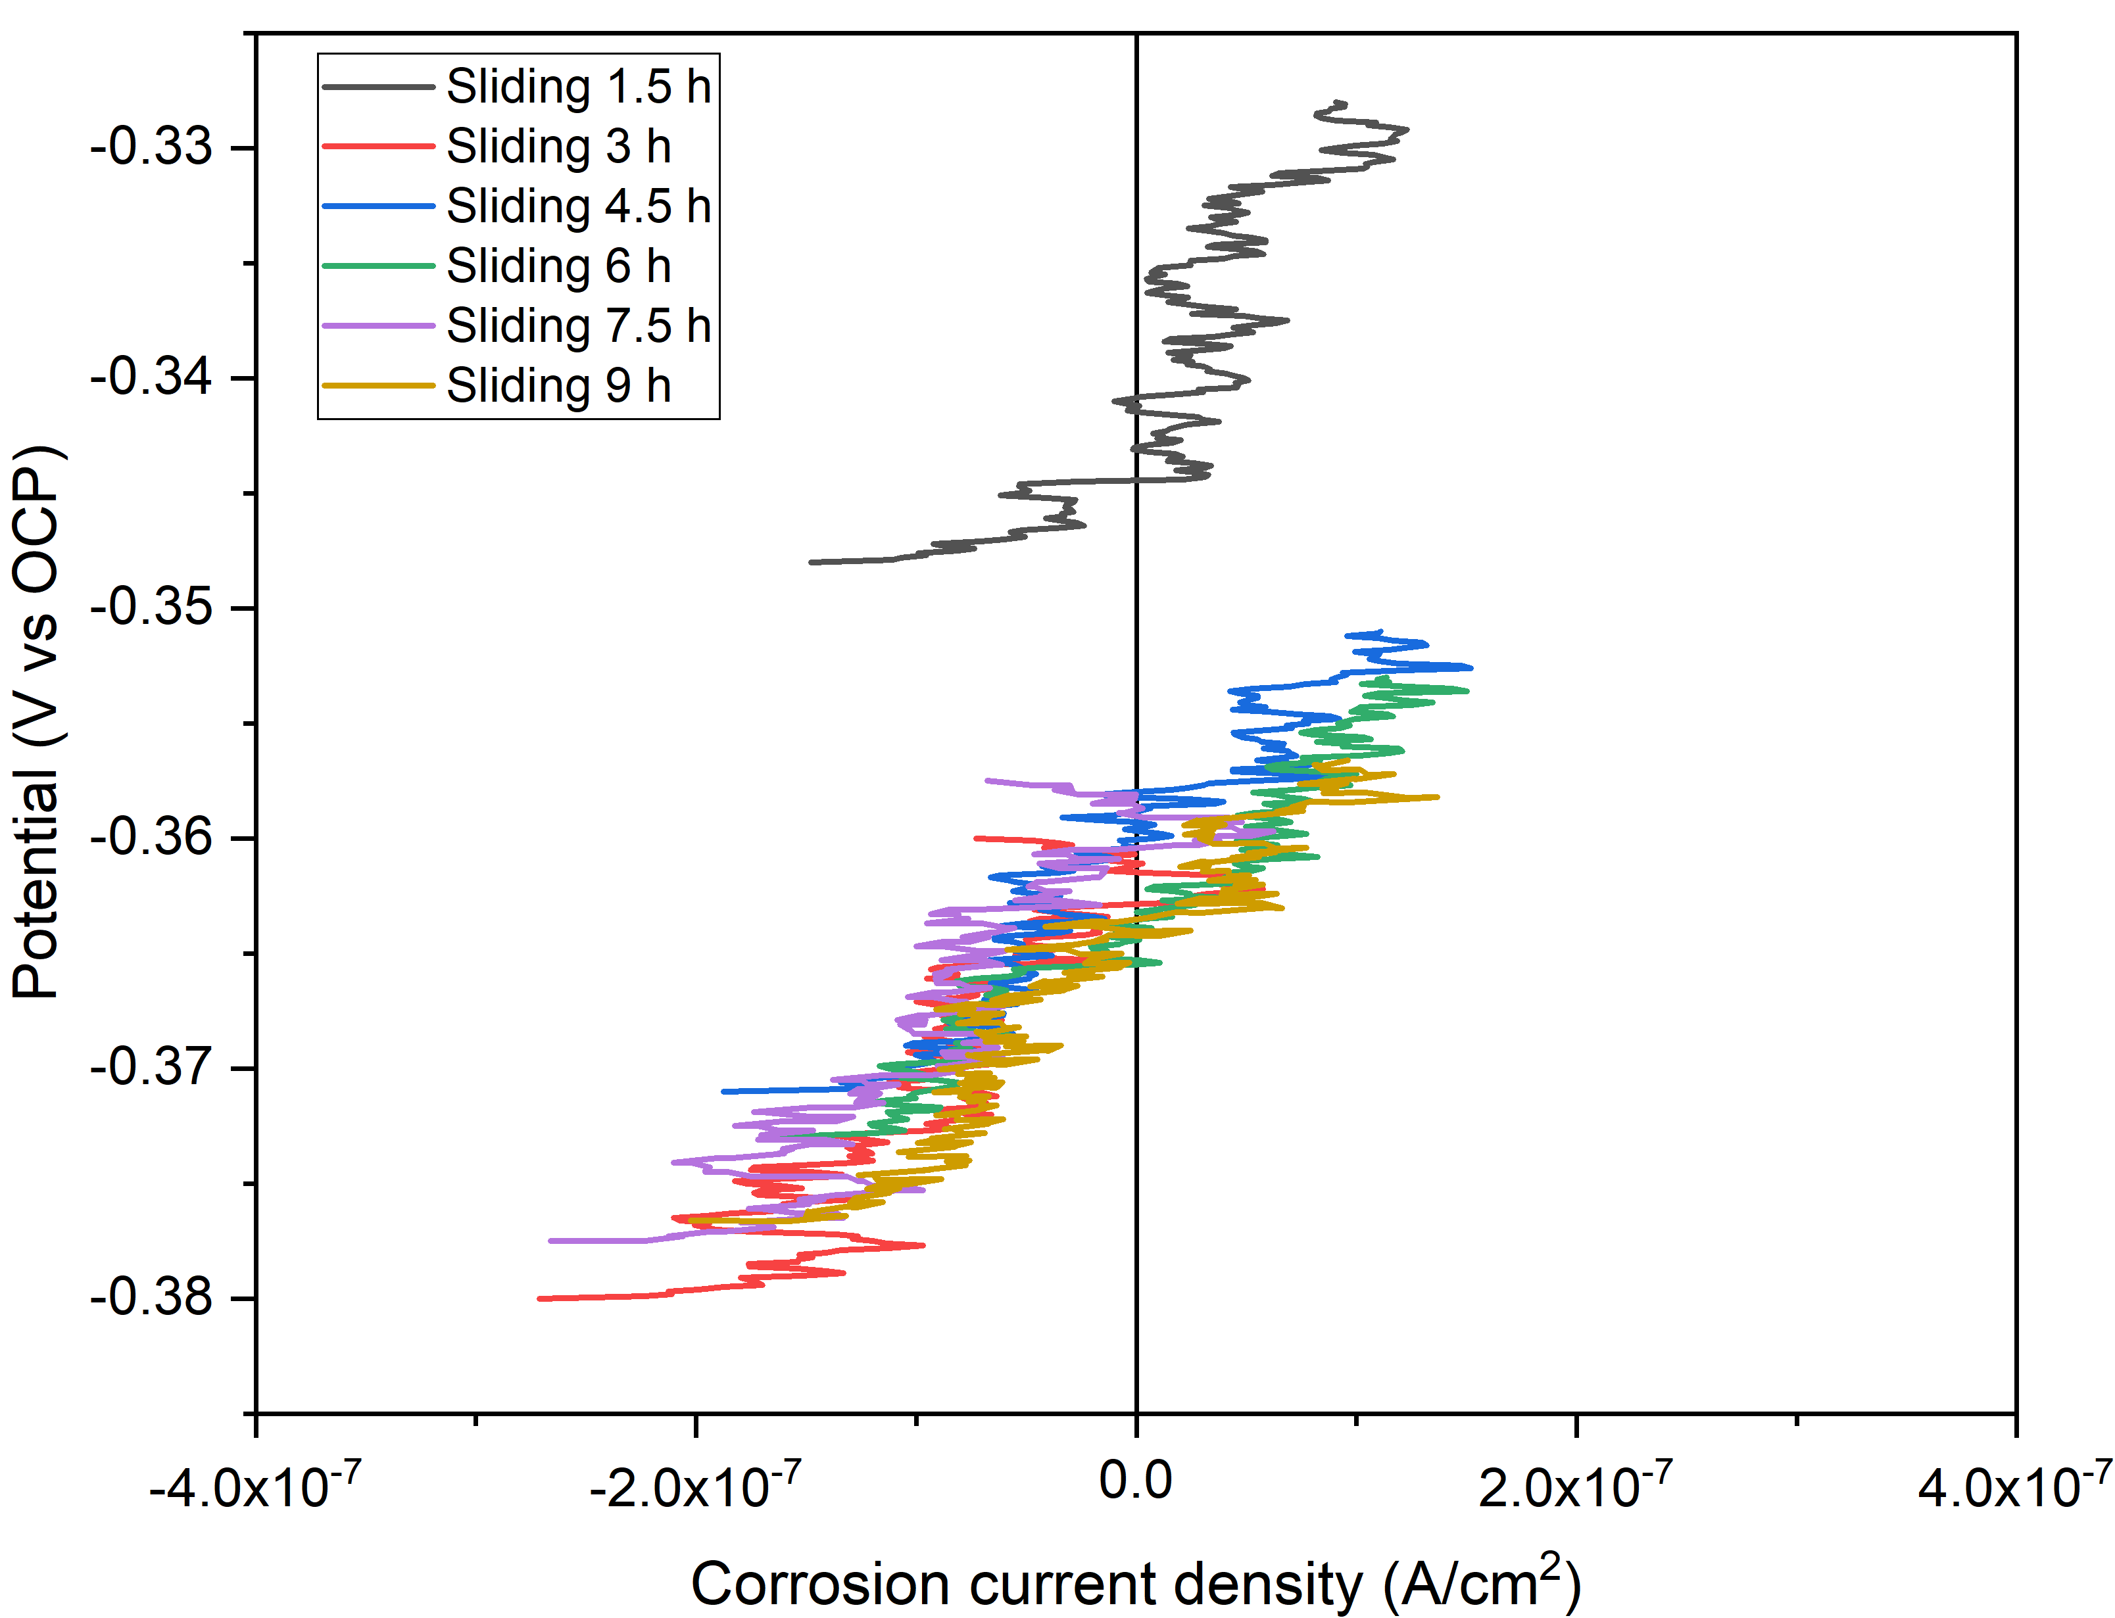

e. 75% de-FBS
