Data Supplement

Supplement 1. Study design.
Patients in the US who completed the 96-97 week global SUMMACTA and BREVACTA trials were enrolled in the LTE rollover study.
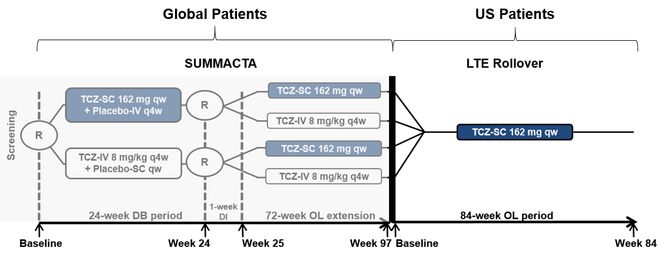
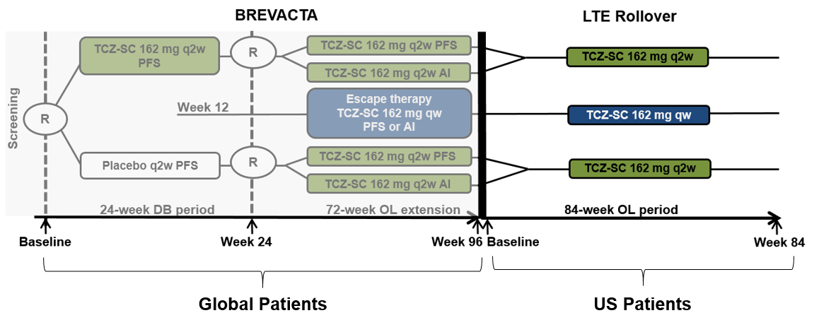
AI, autoinjector; DB, double-blind; DI, dosing interval; IV, intravenous; LTE, long-term extension; OL, open-label; PFS, prefilled syringe; qw, every week; q2w, every 2 weeks; q4w, every 4 weeks; R, randomization; SC, subcutaneous; TCZ, tocilizumab.

Supplement 2. Background therapy.
Patients could receive background therapy with ≥ 1 permitted nonbiologic disease-modifying antirheumatic drugs (DMARDs) if clinical remission (Disease Activity Score in 28 joints based on the erythrocyte sedimentation rate ≤ 2.6 or Simplified Disease Activity Index ≤ 3.3) was not achieved at 2 consecutive assessment visits. Per the schedule of assessments, the dose of the nonbiologic DMARD or methotrexate (MTX) could be reduced or the nonbiologic DMARD or MTX could have been discontinued at the physician’s discretion and as tolerated by the patient. Any other adjustments to the dose of MTX or changes in route of administration could have been made for safety reasons. The following DMARDs were permitted: MTX, chloroquine, hydroxychloroquine, parenteral gold, sulfasalazine, azathioprine, and leflunomide. These DMARDs could be used alone or in combination, except the combination of MTX and leflunomide was not allowed. All patients on MTX received ≥ 5 mg folate weekly. Oral corticosteroids, nonsteroidal antiinflammatory drugs, and analgesics were permitted up to the maximum recommended dose and could be modified on the basis of clinical response and the physician’s judgment. Use of lipid-lowering agents in patients with elevated lipids was strongly encouraged at any time during the study.

Supplement 3. Determination of anti-tocilizumab (anti-TCZ) antibodies.
Blood samples for the detection of anti-TCZ antibodies were collected at baseline, every 12 weeks during the study, and at study completion or at the early withdrawal visit, as described in the schedule of assessments in the protocol. On dosing days, samples were taken prior to dosing to obtain trough drug levels.
Serum was screened for anti-TCZ antibodies using proprietary screening and confirmation assays. Samples that were positive in the initial anti-TCZ antibody screening assay were further analyzed by a confirmation assay to confirm specificity. Patients with missing results for the confirmation assay were assumed to be negative for anti-TCZ antibodies if a screening assay result was negative. If the confirmation assay was positive at any time point (including baseline), a neutralizing assay was performed to test for the ability to inhibit the activity of TCZ.
To minimize TCZ interference with the detection of anti-TCZ antibodies in patients on TCZ treatment, TCZ-free blood samples were taken predose at the baseline visit. Study treatment at baseline should have been given ≥ 6 weeks after the last intravenous TCZ dose or ≥ 4 weeks after the last subcutaneous TCZ dose.
For patients who prematurely withdrew from the study due to serious hypersensitivity reactions, samples for anti-TCZ antibodies were obtained at the time of the event and again ≥ 6 weeks after the last dose of subcutaneous TCZ.
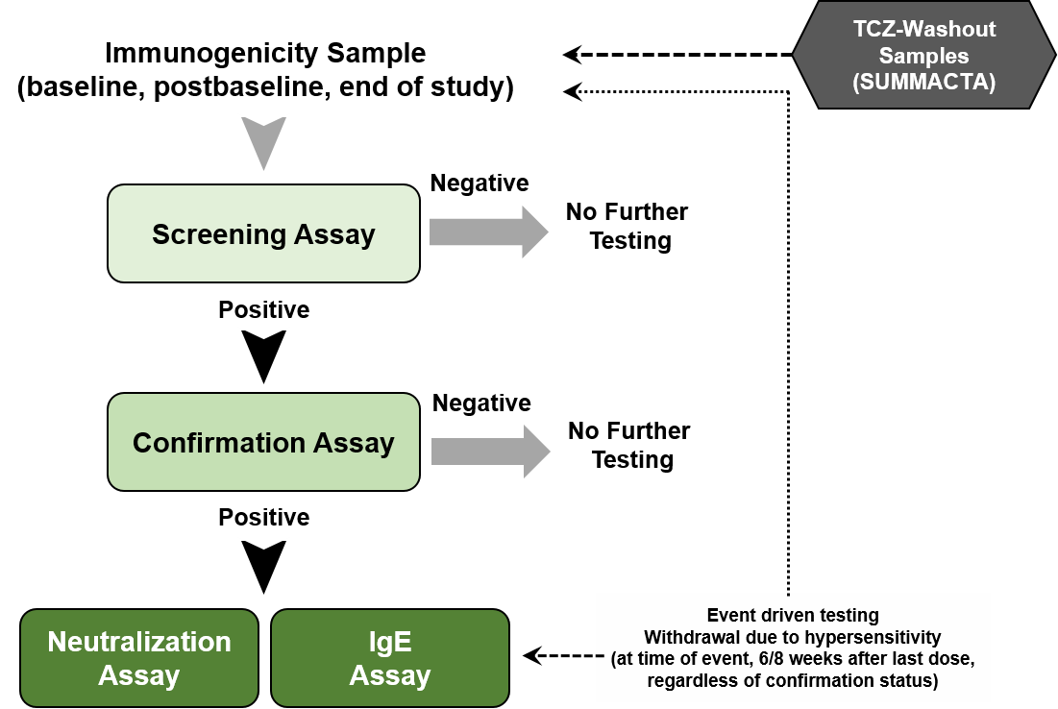
IgE, immunoglobulin E; TCZ, tocilizumab.

Supplement 4. Efficacy over time.*
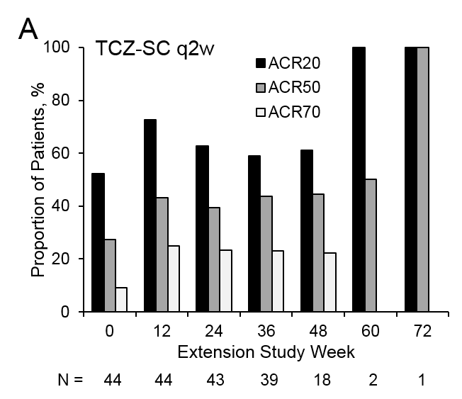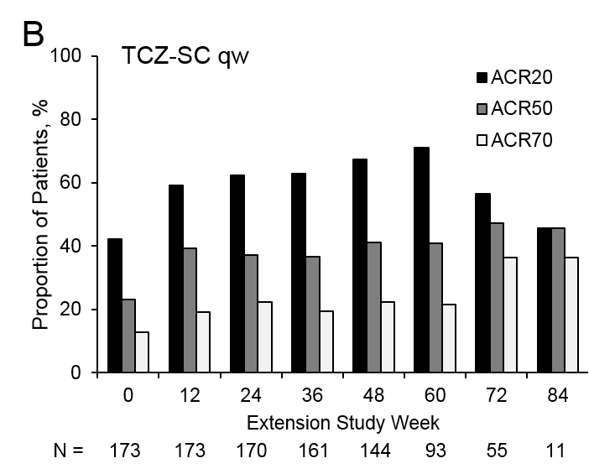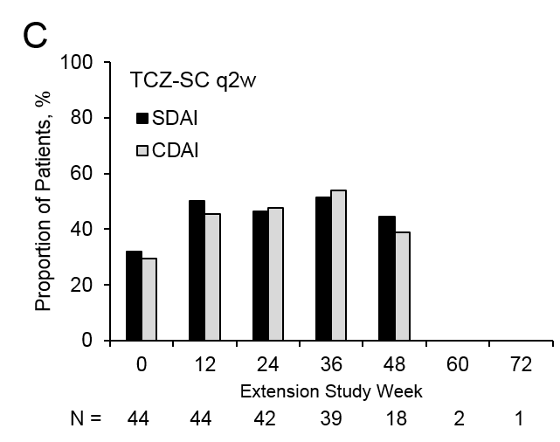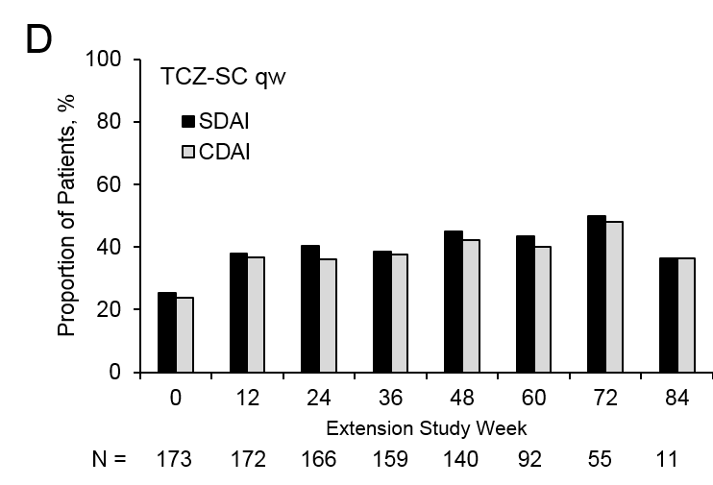
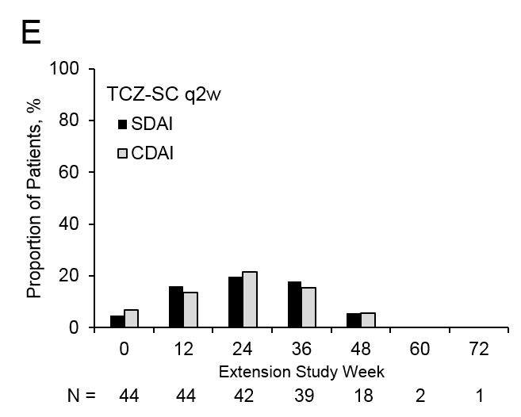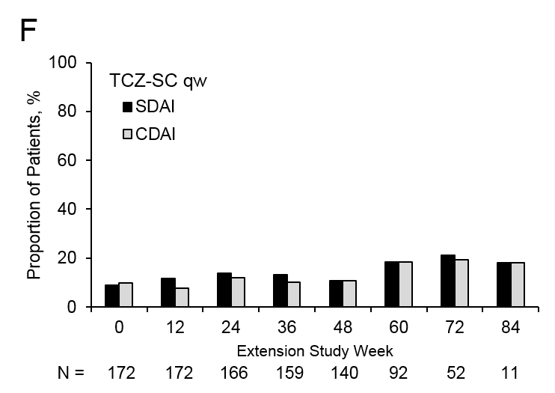

The proportion of patients from the TCZ-SC q2w (A) or TCZ-SC qw (B) groups who achieved ACR20/50/70 is shown at 12-week intervals throughout the study. The proportion of patients from the TCZ-SC q2w (C) or TCZ-SC qw (D) groups who achieved SDAI or CDAI low disease activity (LDA) is shown at 12-week intervals throughout the study. The proportion of patients from the TCZ-SC q2w (E) or TCZ-SC qw (F) groups who achieved SDAI or CDAI remission is shown at 12-week intervals throughout the study.
* Time is shown in weeks from the beginning of the extension study; total TCZ exposure time is the indicated extension study week plus 96 or 97 weeks from the core trial.

