SUPPLEMENTARY MATERIAL

Supplement 1. Study drug discontinuation criteria for individual patients

The investigator was free to terminate a patient’s involvement in the study at any time if the patient’s clinical condition warranted it.
- The patient had to be discontinued from study treatment if any of the following occurred: Patient developed an adverse event (AE) or toxicity where continued administration of study drug was deemed not in the patient’s best interest by the investigator and/or the medical monitor.
- Patient had a CPK level > 10 x ULN confirmed on retest.
- Patient had a symptomatic CPK elevation, defined as CPK > 1.5 x ULN with muscle aching, weakness or severe unusual muscle cramps.
- Patient had any event of myopathy defined as muscle aching, weakness or severe unusual cramps regardless of CPK level that persisted for at least 2 weeks or that worsened rapidly in less than 2 weeks.
- Patient had not achieved a 20% improvement in tender and swollen joint counts (using the day 1 visit of RA21 or RA22 as baseline) by week 13.
- Patient had a serum creatinine increase of > 50% from baseline and an eGFR less than 60 mL/min per 1.73 m² on 2 consecutive visits.
- Patient had not achieved either low disease activity or remission by the most recent visit as determined by any of the following:
- DAS28 with respect to C-reactive protein (DAS28-CRP) < 3.2
- DAS28 with respect to erythrocyte sedimentation rate (DAS28-ESR) < 3.2
- Simplified Disease Activity Index (SDAI) ≤ 11 or, if CRP was not available, CDAI ≤ 10
- After achieving low disease activity or remission, patient experienced moderate or high disease activity for 2 consecutive visits (with relevant data available), as determined by all of the following:
- DAS28-CRP ≥ 3.2 (if CRP available)
- DAS28-ESR ≥ 3.2 (if ESR available)
- SDAI > 11 (if CRP available) or CDAI > 10 (if CRP was not available)
If a patient experienced moderate or high disease activity for 2 consecutive visits after previously achieving low disease activity or remission and subsequently achieved low disease activity or remission, patient’s continuation was discussed with the sponsor’s medical monitor.
Parameters that could not be calculated with available data were assumed to be positive for moderate or high disease activity for the purposes of evaluating discontinuation.
- Patient had a diagnosis of congenital short QT syndrome or showed a QT interval corrected for heart rate (QTc) < 300 ms.

Supplement 2. Kaplan–Meier analysis of patients withdrawing from the study.
- Overall

- Patients from the preceding phase IIb trial with MTX add-on 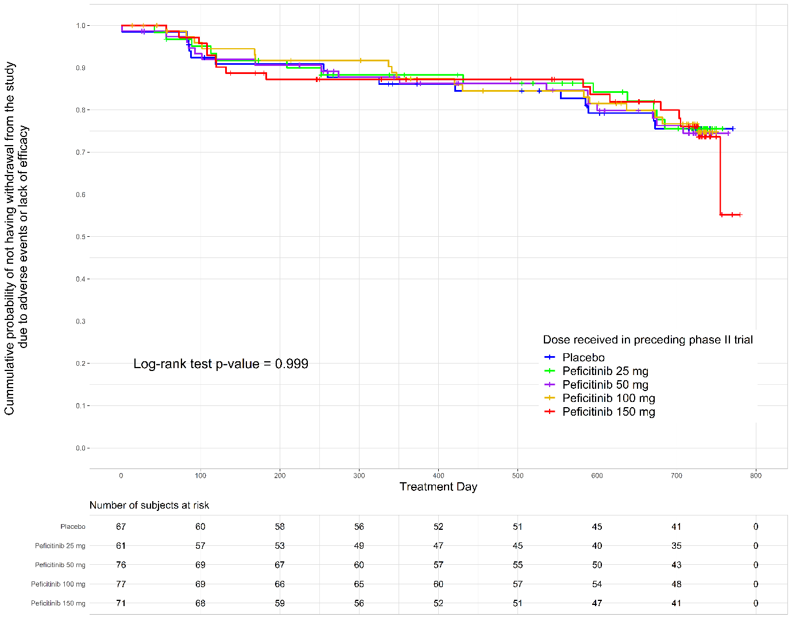

- Patients from the preceding phase IIb trial without MTX add-on

Supplement 3. Serious AEs

 | Dose received in preceding phase II trial |  |  |  |  | Total  (N = 611)
 | Placebo  (n = 116) | Peficitinib 25 mg  (n = 112) | Peficitinib 50 mg  (n = 124) | Peficitinib 100 mg  (n = 128) | Peficitinib 150 mg  (n = 131) | Total  (N = 611)
RA | 1 (0.9) | 0 | 3 (2.4) | 2 (1.6) | 0 | 6 (1.0)
Ovarian cyst | 1 (0.9) | 0 | 0 | 1 (0.8) | 2 (1.5) | 4 (0.7)
Anaemia | 1 (0.9) | 0 | 0 | 2 (1.6) | 0 | 3 (0.5)
Renal failure acute | 0 | 1 (0.9) | 1 (0.8) | 1 (0.8) | 0 | 3 (0.5)
UTI | 0 | 0 | 0 | 3 (2.3) | 0 | 3 (0.5)
Appendicitis | 1 (0.9) | 0 | 0 | 0 | 1 (0.8) | 2 (0.3)
Diverticulitis | 1 (0.9) | 0 | 0 | 0 | 1 (0.8) | 2 (0.3)
Basal cell carcinoma | 0 | 0 | 1 (0.8) | 1 (0.8) | 0 | 2 (0.3)
Uterine leiomyoma | 0 | 1 (0.9) | 0 | 1 (0.8) | 0 | 2 (0.3)
Angina pectoris | 0 | 0 | 0 | 1 (0.8) | 1 (0.8) | 2 (0.3)
Colitis | 0 | 1 (0.9) | 0 | 1 (0.8) | 0 | 2 (0.3)
Chest pain | 0 | 0 | 0 | 1 (0.8) | 1 (0.8) | 2 (0.3)
Cholelithiasis | 1 (0.9) | 0 | 1 (0.8) | 0 | 0 | 2 (0.3)
Bronchitis bacterial | 1 (0.9) | 0 | 0 | 0 | 0 | 1 (0.2)
Cellulitis staphylococcal | 1 (0.9) | 0 | 0 | 0 | 0 | 1 (0.2)
Clostridial infection | 0 | 0 | 0 | 0 | 1 (0.8) | 1 (0.2)
Gastroenteritis | 0 | 0 | 1 (0.8) | 0 | 0 | 1 (0.2)
Herpes zoster ophthalmic | 1 (0.9) | 0 | 0 | 0 | 0 | 1 (0.2)
Pneumonia primary atypical | 0 | 1 (0.9) | 0 | 0 | 0 | 1 (0.2)
Pneumonia bacterial | 0 | 1 (0.9) | 0 | 0 | 0 | 1 (0.2)
Pneumonia staphylococcal | 0 | 0 | 1 (0.8) | 0 | 0 | 1 (0.2)
Viral infection | 0 | 0 | 0 | 0 | 1 (0.8) | 1 (0.2)
Femoral neck fracture | 0 | 0 | 0 | 0 | 1 (0.8) | 1 (0.2)
Hip fracture | 0 | 0 | 0 | 0 | 1 (0.8) | 1 (0.2)
Intentional overdose | 0 | 0 | 0 | 1 (0.8) | 0 | 1 (0.2)
Lower limb fracture | 0 | 0 | 1 (0.8) | 0 | 0 | 1 (0.2)
Operative haemorrhage | 0 | 0 | 0 | 1 (0.8) | 0 | 1 (0.2)
Rib fracture | 0 | 0 | 0 | 1 (0.8) | 0 | 1 (0.2)
Road traffic accident | 0 | 0 | 0 | 0 | 1 (0.8) | 1 (0.2)
Spinal compression fracture | 0 | 0 | 0 | 1 (0.8) | 0 | 1 (0.2)
Subdural haematoma | 0 | 0 | 0 | 0 | 1 (0.8) | 1 (0.2)
Tendon injury | 0 | 0 | 0 | 1 (0.8) | 0 | 1 (0.2)
Upper limb fracture | 0 | 0 | 0 | 0 | 1 (0.8) | 1 (0.2)
Wrist fracture | 0 | 0 | 1 (0.8) | 0 | 0 | 1 (0.2)
Benign salivary gland neoplasm | 0 | 0 | 0 | 1 (0.8) | 0 | 1 (0.2)
Chronic lymphocytic leukemia | 0 | 0 | 0 | 1 (0.8) | 0 | 1 (0.2)
Chronic myeloid leukemia | 0 | 0 | 0 | 1 (0.8) | 0 | 1 (0.2)
Gastrointestinal carcinoma | 0 | 0 | 0 | 0 | 1 (0.8) | 1 (0.2)
Leiomyoma | 1 (0.9) | 0 | 0 | 0 | 0 | 1 (0.2)
Thyroid cancer | 1 (0.9) | 0 | 0 | 0 | 0 | 1 (0.2)
Arrhythmia | 0 | 0 | 0 | 1 (0.8) | 0 | 1 (0.2)
Arrhythmia supraventricular | 0 | 0 | 0 | 0 | 1 (0.8) | 1 (0.2)
Cardiac arrest | 0 | 0 | 0 | 1 (0.8) | 0 | 1 (0.2)
Coronary artery disease | 0 | 0 | 1 (0.8) | 0 | 0 | 1 (0.2)
Myocardial infarction | 0 | 0 | 0 | 1 (0.8) | 0 | 1 (0.2)
Myocardial ischaemia | 1 (0.9) | 0 | 0 | 0 | 0 | 1 (0.2)
Pericarditis | 0 | 0 | 0 | 1 (0.8) | 0 | 1 (0.2)
Ventricular arrhythmia | 0 | 0 | 0 | 0 | 1 (0.8) | 1 (0.2)
Back pain | 1 (0.9) | 0 | 0 | 0 | 0 | 1 (0.2)
Hand deformity | 0 | 0 | 0 | 1 (0.8) | 0 | 1 (0.2)
Intervertebral disc disorder | 0 | 0 | 0 | 1 (0.8) | 0 | 1 (0.2)
Osteoarthritis | 0 | 0 | 0 | 1 (0.8) | 0 | 1 (0.2)
Dysfunctional uterine bleeding | 0 | 0 | 0 | 1 (0.8) | 0 | 1 (0.2)
Endometrial hyperplasia | 0 | 1 (0.9) | 0 | 0 | 0 | 1 (0.2)
Endometriosis | 0 | 0 | 0 | 1 (0.8) | 0 | 1 (0.2)
Menorrhagia | 0 | 1 (0.9) | 0 | 0 | 0 | 1 (0.2)
Metrorrhagia | 0 | 0 | 0 | 1 (0.8) | 0 | 1 (0.2)
Bronchial hyperreactivity | 0 | 0 | 0 | 1 (0.8) | 0 | 1 (0.2)
Bronchospasm | 0 | 0 | 0 | 1 (0.8) | 0 | 1 (0.2)
Epistaxis | 1 (0.9) | 0 | 0 | 0 | 0 | 1 (0.2)
Haemoptysis | 0 | 0 | 1 (0.8) | 0 | 0 | 1 (0.2)
Interstitial lung disease | 1 (0.9) | 0 | 0 | 0 | 0 | 1 (0.2)
Lung infiltration | 0 | 1 (0.9) | 0 | 0 | 0 | 1 (0.2)
Pulmonary embolism | 0 | 0 | 0 | 1 (0.8) | 0 | 1 (0.2)
Pulmonary thrombosis | 0 | 0 | 1 (0.8) | 0 | 0 | 1 (0.2)
Respiratory failure | 0 | 0 | 0 | 1 (0.8) | 0 | 1 (0.2)
Abdominal pain | 0 | 1 (0.9) | 0 | 0 | 0 | 1 (0.2)
Abdominal pain upper | 1 (0.9) | 0 | 0 | 0 | 0 | 1 (0.2)
Diarrhoea haemorrhagic | 0 | 0 | 0 | 1 (0.8) | 0 | 1 (0.2)
Gastritis | 0 | 1 (0.9) | 0 | 0 | 0 | 1 (0.2)
Gastroesophageal sphincter insufficiency | 1 (0.9) | 0 | 0 | 0 | 0 | 1 (0.2)
Pancreatitis acute | 0 | 0 | 0 | 1 (0.9) | 0 | 1 (0.2)
Medical device complication | 0 | 0 | 0 | 0 | 1 (0.8) | 1 (0.2)
Non-cardiac chest pain | 0 | 0 | 0 | 1 (0.8) | 0 | 1 (0.2)
Perforated ulcer | 0 | 0 | 0 | 1 (0.8) | 0 | 1 (0.2)
Pseudocyst | 0 | 0 | 0 | 1 (0.8) | 0 | 1 (0.2)
Cerebral ischaemia | 0 | 0 | 0 | 0 | 1 (0.8) | 1 (0.2)
Cerebrovascular accident | 0 | 0 | 0 | 1 (0.8) | 0 | 1 (0.2)
Headache | 0 | 0 | 1 (0.8) | 0 | 0 | 1 (0.2)
Lacunar infarction | 0 | 1 (0.9) | 0 | 0 | 0 | 1 (0.2)
Syncope | 0 | 0 | 0 | 0 | 1 (0.8) | 1 (0.2)
Leucocytosis | 0 | 0 | 0 | 1 (0.8) | 0 | 1 (0.2)
Abortion induced | 1 (0.9) | 0 | 0 | 0 | 0 | 1 (0.2)
Arthrodesis | 0 | 0 | 0 | 1 (0.8) | 0 | 1 (0.2)
Liposuction | 0 | 0 | 0 | 1 (0.8) | 0 | 1 (0.2)
Deep vein thrombosis | 0 | 0 | 0 | 1 (0.8) | 0 | 1 (0.2)
Peripheral arterial occlusive disease | 0 | 1 (0.9) | 0 | 0 | 0 | 1 (0.2)
Thrombosis | 0 | 0 | 1 (0.8) | 0 | 0 | 1 (0.2)
Drug hypersensitivity | 0 | 0 | 1 (0.8) | 0 | 0 | 1 (0.2)
Blood CPK > 1. 5 × ULN | 0 | 1 (0.9) | 0 | 0 | 0 | 1 (0.2)
Transaminase increased | 0 | 1 (0.9) | 0 | 0 | 0 | 1 (0.2)
Mental status changes | 0 | 0 | 0 | 1 (0.8) | 0 | 1 (0.2)
All data are represented as n (%).
CPK creatine phosphokinase, RA rheumatoid arthritis, ULN upper limit of normal, UTI urinary tract infection

Supplement 4. Maintenance of ACR20 responses by prior treatment group in the previous phase II trials
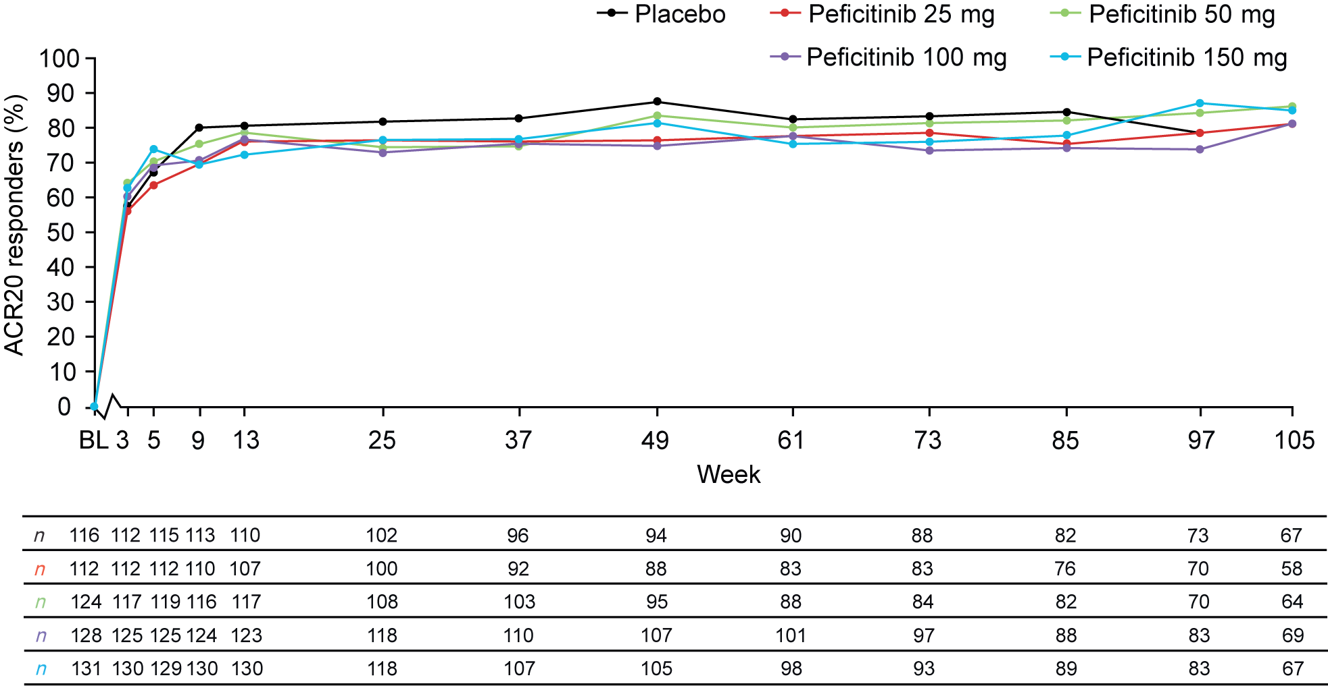
ACR20 responses achieved relative to preceeding phase II trial baselines are shown. Observed data were used for these analyses. Table shows the number of patients for whom an ACR20 assessment was conducted at each visit, segregated by treatment received in the respective previous phase II trial.
ACR20 American College of Rheumatology criteria for 20% improvement, BL baseline

Supplement 5. Summary of change in Clinical Disease Activity Index (CDAI) status from baseline to Week 105

 | Dose received in preceding phase II trial |  |  |  |  | Total  (N = 611)
 | Placebo  (n = 116) | Peficitinib 25 mg  (n = 112) | Peficitinib 50 mg  (n = 124) | Peficitinib 100 mg  (n = 128) | Peficitinib 150 mg  (n = 131) | Total  (N = 611)
Patients with remission score ≤ 2.8
Day 1, n  n (%) | 116  9 (7.8) | 112  8 (7.1) | 124  11 (8.9) | 128  24 (18.8) | 131  18 (13.7) | 611  70 (11.5)
Week 105, n  n (%) | 67  22 (32.8) | 58  20 (34.5) | 64  23 (35.9) | 68  19 (27.9) | 67  19 (28.4) | 324  103 (31.8)
Patients with Low Disease Activity Score (≤ 10)
Day 1, n  n (%) | 116  28 (24.1) | 112  21 (18.8) | 124  41 (33.1) | 128  43 (33.6) | 131  56 (42.7) | 611  189 (30.9)
Week 105, n  n (%) | 67  43 (64.2) | 58  41 (70.7) | 64  46 (71.9) | 68  40 (58.8) | 67  45 (67.2) | 324  215 (66.4)
Patients with Moderate or High Disease Activity (> 10)
Day 1, n  n (%) | 116  88 (75.9) | 112  91 (81.3) | 124  83 (66.9) | 128  85 (66.4) | 131  75 (57.3) | 611  422 (69.1)
Week 105, n  n (%) | 67  24 (35.8) | 58  17 (29.3) | 64  18 (28.1) | 68  28 (41.2) | 67  22 (32.8) | 324  109 (33.6)

Supplement 6. Summary of change in Simplified Disease Activity Index (SDAI) status from baseline to Week 105

 | Dose received in preceding phase II trial |  |  |  |  | Total  (N = 611)
 | Placebo  (n = 116) | Peficitinib 25 mg  (n = 112) | Peficitinib 50 mg  (n = 124) | Peficitinib 100 mg  (n = 128) | Peficitinib 150 mg  (n = 131) | Total  (N = 611)
Patients with remission score ≤ 3.3
Day 1, n  n (%) | 116  7 (6.0) | 112  8 (7.1) | 124  12 (9.7) | 128  22 (17.2) | 131  21 (16.0) | 611  70 (11.5)
Week 105, n  n (%) | 66  22 (33.3) | 58  18 (31.0) | 64  21 (32.8) | 68  17 (25.0) | 67  17 (25.4) | 323  95 (29.4)
Patients with Low Disease Activity Score (≤ 11)
Day 1, n  n (%) | 116  28 (24.1) | 112  21 (18.8) | 124  41 (33.1) | 128  42 (32.8) | 131  58 (44.3) | 611  190 (31.1)
Week 105, n  n (%) | 66  42 (63.6) | 58  43 (74.1) | 64  45 (70.3) | 68  39 (57.4) | 67  46 (68.7) | 323  215 (66.6)
Patients with Moderate or High Disease Activity Score (> 11)
Day 1, n  n (%) | 116  88 (75.9) | 112  91 (81.3) | 124  83 (66.9) | 128  86 (67.2) | 131  73 (55.7) | 611  421 (68.9)
Week 105, n  n (%) | 66  24 (36.4) | 58  15 (25.9) | 64  19 (29.7) | 68  29 (42.6) | 67  21 (31.3) | 323  108 (33.4)

Supplement 7. Institutional ethics committee (IEC)/Institutional review board (IRB) information
Site name and location | IEC/IRB name
Stanford University School of Medicine  Division of Immunology and Rheumatology  1000 Welch Road, Suite 203  Palo Alto, CA 94304, USA  Stanford Health Services  Medical Specialty Clinics  Room A175  300 Pasteur Drive,  Stanford, CA 94305, USA | Stanford University Institutional Review Board  Administrative Panel on Human Subjects in  Medical Research  1501 California Avenue  Palo Alto, CA 94304-5579
The Center for Rheumatology and Bone Research  2730 University Boulevard West, Suite 306  Wheaton, MD 20902, USA | Quorum Review IRB  1601 Fifth Avenue, Suite 1000  Seattle, WA 98101
Altoona Center for Clinical Research  175 Meadowbrook Lane  Duncansville, PA 16635, USA | Quorum Review IRB  1601 Fifth Avenue, Suite 1000  Seattle, WA 98101
Illinois Bone & Joint Institute LLC  9000 Waukegan Road  Morton Grove, IL 60053, USA | Quorum Review IRB  1601 Fifth Avenue, Suite 1000  Seattle, WA 98101
UCSD Perlman Ambulatory Clinic  9350 Campus Point Drive  La Jolla, CA 92037, USA  UCSD Thornton Hospital  9300 Campus Point Drive  La Jolla, CA 92037, USA | Human Research Protections Program  9500 Gilman Drive, Mail Code: 0052  La Jolla, CA 92093-0052
Jacksonville Center for Clinical Research  4085 University Boulevard South, Suite 1  Jacksonville, FL 32216, USA | Quorum Review IRB  1601 Fifth Avenue, Suite 1000  Seattle, WA 98101
Servimed SAS  Calle 51 N° 34-17 Cons 208  Centro Comercial Cabecera Etapa 1  Bucaramanga, Santander, Colombia | Comité de Etica en Investigación de  Servimed EU  Calle 51 N° 34-17 Cons 208 Centro  Comercial Cabecera Etapa 1  Bucaramanga, Santander, Colombia
Szpital Uniwersytecki nr 2 im Dr Jana  Biziela  ul Ujejskiego 75  85-168 Bydgoszcz, Poland | Komisja Bioetyczna Uniwersytetu Mikołaja Kopernika w Toruniu przy Collegium Medicum im Ludwika Rydygiera w Bydgoszczy  ul Skłodowskiej-Curie 9  85-094 Bydgoszcz, Poland
Multiprofile Hospital for Active Treatment  Plovdiv AD Rheumatology Department  234 Bulgaria Boulevard  4003 Plovdiv, Bulgaria | Ethics Committee for Multicenter Trials  5 Sveta Nedelya Square  1000 Sofia, Bulgaria
Achieve Clinical Research, LLC  2017 Canyon Road, Suite 41  Birmingham, AL 35216, USA | Quorum Review IRB  1501 Fourth Avenue, Suite 800  Seattle, WA 98101
Medical Plus sro  Obchodni 1507  686 01 Uherske Hradiste, Czech Republic  Plicni Ambulance  Hradebni 1306  686 01 Uherske Hradiste, Czech Republic  Ordinace Radiodiagnostiky  Frantiskanska 168  686 01 Uherske Hradiste, Czech Republic | Multicentre Ethics Committee Eticka Komise FN Brno Jihlavska 20  625 00 Brno, Czech Republic
Deerbrook Medical Associates  565 Lakeview Parkway, Suite 116  Vernon Hills, IL 60061, USA | Quorum Review IRB  1601 Fifth Avenue, Suite 1000  Seattle, WA 98101
Desert Medical Advances  72855 Fred Waring Drive, No. A-6  Palm Desert, CA 92260, USA | Quorum Review Institutional Review Board  1501 Fourth Avenue, Suite 800  Seattle, WA 98101
Arthritis Associates  324 East Par Street  Orlando, FL 32804, USA | Quorum Review IRB  1601 Fifth Avenue, Suite 1000  Seattle, WA 98101
NZOZ “OSTEO-MEDIC” sc Lidia i Artur  Racewicz, Agnieszka i Jerzy Supronik ul Wiejska 81  15-351 Bialystok, Poland  Zakład Diagnostyki Obrazowej “HEM” sc ul Bema 2/216  15-396 Bialystok, Poland | Komisja Bioetyczna Uniwersytetu Medycznego Mikołaja Kopernika w Toruniu przy Collegium Medicum im Ludwika Rydygiera w Bydgoszczy  ul Skłodowskiej-Curie 9  85-094 Bydgoszcz, Poland
Consultorio Privado  Reforma No. 2491  Col Ladrón de Guevara  44650 Guadalajara, Jalisco, México | Comité de Ética en Investigación de Hospitales  Mac-Bernardette  Hidalgo No 930 Col Centro  44100 Guadalajara, Jalisco, Mexico
Centro de Investigación en Reumatología y Especialidades Médicas SAS (CIREEM SAS)  Carrera 12 No. 97-32 Oficinas 201, 203, 301,  404  Bogotá DC, Colombia | Comité de Ética de la Investigación - Riesgo de Fractura SA  Carrera 13 No 97-25  Bogotá DC, Colombia
PMG Research of Hickory, LLC  221 13th Avenue Place NW, Suite 201  Hickory, NC 28601, USA  PMG Research of Hickory, LLC  225 18th Street SE Hickory, NC 28602, USA | Quorum Review IRB  1501 Fourth Avenue, Suite 800  Seattle, WA 98101
Health Research of Oklahoma  1211 North Shartel Ave, Suites 409 and 700  Oklahoma City, OK 73103, USA | Quorum Review IRB  1601 Fifth Avenue, Suite 1000  Seattle, WA 98101
Budai Irgalmasrendi Hospital  Frankel Leo Street 54  1023 Budapest, Hungary | Egészségügyi Tudományos Tanács Klinikai  Farmakológiai Etikai Bizottsága  Arany János u 6-8, 1051 Budapest, Hungary
University Multiprofile Hospital for Active  Treatment “St Ivan Rislki” EAD  13 Urvich Street  1612 Sofia, Bulgaria | Ethics Committee for Multicenter Trials  5 Sveta Nedelya Square  1000 Sofia, Bulgaria
Clinical Research Center, LLC  2760 Century Boulevard  Wyomissing, PA 19610, USA | Quorum Review IRB  1501 Fourth Avenue, Suite 800  Seattle, WA 98101
Rheumatology Consultants, PLLC  4707 Papermill Drive, Suite 200  Colony Park  Knoxville, TN 37909-1907, USA | Quorum Review IRB  1601 Fifth Avenue, Suite 1000  Seattle, WA 98101
Hospital Civil de Guadalajara Fray Antonio Alcalde Hospital No 278  Col El Retiro  44280 Guadalajara, Jalisco, México | Comité de Enseñanza, Investigación y Ética del Hospital Civil de Guadalajara Fray Antonio Alcalde  Hospital No 278  Col El Retiro  44280 Guadalajara, Jalisco, Mexico
CLIDITER SA de CV Durango 69  Col Roma Deleg Cuauhtémoc  06700 Mexico, DF, México | Comité de Ética en Investigación de México Centre for Clinical Research, S.A. de C.V. Amores No. 709  Col Del Valle  03100 México, DF, México
Hôpital Molière Longchamp  Rue Marconi 142  B-1190 Brussels, Belgium | Comité d’éthique ULB – ULB Erasme  Route de Lennik 808  1070 Brussels, Belgium
Centro de Investigación Clínica de Morelia  Virrey de Mendoza No. 1998 Int 522  Col Félix Ireta  58070 Morelia, Michoacán, México | Comité de Ética en Investigación de México Centre for Clinical Research, S.A. de C.V. Amores No. 709  Col Del Valle  03100 México, DF, México
Austin Rheumatology Research  1301 W 38th Street, Suite 702 and Suite 110  Austin, TX 78705, USA | Quorum Review IRB  1601 Fifth Avenue, Suite 1000  Seattle, WA 98101
Mountain State Clinical Research  395 Emily Drive  Clarksburg, WV 26301, USA | Quorum Review IRB  1601 Fifth Avenue, Suite 1000  Seattle, WA 98101
Centro Integral de Reumatología del Caribe  SAS (CIRCARIBE) SAS  Calle 71 N° 41-46 Consultorios 405-406 y  Piso 5  Barranquilla, Atlántico, Colombia  Centro Integral de Reumatología del Caribe  SAS (CIRCARIBE) SAS Carrera 44 N°72-131 Piso 4  Barranquilla, Atlántico, Colombia | Comité de Ética en Investigación en el Área de la Salud de la Universidad del Norte Kilómetro 5 Vía Puerto Colombia Barranquilla, Atlántico, Colombia
The Center for Arthritis and Rheumatic  Diseases  816 Greenbrier Circle, Suite A Chesapeake, VA 23320, USA  The Center for Arthritis and Rheumatic  Diseases  1033 Champions Way, Suite 100  Suffolk, VA 23435, USA | Quorum Review IRB  1601 Fifth Avenue, Suite 1000  Seattle, WA 98101
Center for Arthritis & Osteoporosis  584 Westport Road, Suite 101  Elizabethtown, KY 42701, USA | Quorum Review IRB  1601 Fifth Avenue, Suite 1000  Seattle, WA 98101
Arthritis Associates & Osteoporosis Center of Colorado Springs  595 Chapel Hills Drive, Suite 201  Colorado Springs, CO 80920, USA | Quorum Review IRB  1601 Fifth Avenue, Suite 1000  Seattle, WA 98101
Pacific Arthritis Center Medical Group  607 East Plaza Drive, Suite A Santa Maria, CA 93454, USA | Quorum Review IRB  1601 Fifth Avenue, Suite 1000  Seattle, WA 98101
Revmatologická Ambulance  Petra Rezka 3  140 00 Praha 4  Czech Republic | Multicentre Ethics Committee  Eticka komise FN Brno  Jihlavska 20  625 00 Brno  Czech Republic
ULB Erasme  Route de Lennik 808  1070 Brussels, Belgium | Comité d’éthique ULB – ULB Erasme  Route de Lennik 808  1070 Brussels, Belgium
Revmatologicky ustav  Na Slupi 4  128 50 Praha 2, Czech Republic  Pneumo-host sro  Lipa Centrum – Poliklinika  Seydlerova 2451  158 00 Praha 5, Nove Butovice, Czech  Republic | Multicentre Ethics Committee Eticka Komise FN Brno Jihlavska 20  625 00 Brno, Czech Republic;  Local Ethics Committee:  Eticka Komise Revmatologickeho ustavu  Na Slipu 4  128 50 Praha 2, Czech Republic
ClinicMed Badurski wspólnicy Spółka jawna  Stołeczna 7/200  15-879 Białystok, Poland | Komisja Bioetyczna Uniwersytetu  Mikołaja Kopernika w Toruniu przy Collegium Medicum im Ludwika Rydygiera w Bydgoszczy  ul Skłodowskiej-Curie 9  85-094 Bydgoszcz, Poland
Rethy Pal Hospital  Gyulai street 18  5600 Békéscsaba, Hungary | Egészségügyi Tudományos Tanács Klinikai  Farmakológiai Etikai Bizottsága  Arany János u 6-8  1051 Budapest, Hungary
Kenézy Kórház Rendelőintézet Egészségügyi  Szolgáltató Nonprofit Kft  Bartók B Street 2-26  4043 Debrecen, Hungary | Egészségügyi Tudományos Tanács Klinikai  Farmakológiai Etikal Bizottsága  Arany János u 6-8  1051 Budapest, Hungary
National Institute of Rheumatology and  Physiotherapy  Frankel Leo Street 25-29  1023 Budapest, Hungary | Egészégügyi Tudományos Tanács Klinikai  Farmakológiai Etikai Bizottsága  Arany János u. 6-8  1051 Budapest, Hungary
PV-Medical sro  Stefanikova 477  760 01 Zlin, Czech Republic  Radiodiagnostic Department  Atlas Hospital tr T Bati 5135  760 01 Zlin, Czech Republic  Pneumology Out-patient Department tr T Bati 5135  760 01 Zlin, Czech Republic | CEC Eticka Komise FN Brno  Jihlavska 20  625 00 Brno, Czech Republic
MEDICITY SAS Carrera 53 N° 46-50  Bucaramanga, Santander, Colombia | Comité de Ética de Investigaciones del Oriente  Carrera 34 N° 46 – 50  Bucaramanga, Santander, Colombia
Centro Medico Julian Coronel  Carrera 59 No. 1E-21  Cali, Valle del Cauca, Colombia | Comité de Ética en Investigacion Biomedica del Centro Medico Julian Coronel  Carrera 59 No. 1E-21  Cali, Valle del Cauca, Colombia
DRC Ltd  Ady E str 12  8230 Balatonfüred, Hungary  MEDNA 2001 Ltd  P Horváth str 17/A  8230 Balatonfüred, Hungary | Egészségügyi Tudományos Tanács Klinikai  Farmakológiai Etikai Bizottsága  Arany János u 6-8  1051 Budapest, Hungary
Revita Clinic  Margit krt 50-52  1027 Budapest, Pest, Hungary | Egészségügyi Tudományos Tanács Klinikai  Farmakológiai Etikai Bizottsága  Arany János u 6-8  1051 Budapest, Pest, Hungary
ARS Rheumatica Sp Zo. o “REUMATIKA-CENTRUM REUMATOLOGII” Niepublicny Zaklad Opiecki Zdrowotnej  Obrzeżna 5  02-691 Warszawa, Poland | Komisja Bioetyczna Uniwersytetu  Mikołaja Kopernika w Toruniu przy Collegium Medicum im Ludwika Rydygiera w Bydgoszczy  ul Skłodowskiej-Curie 9  85-094 Bydgoszcz, Poland
Rheuma Medicus Zespól Opieki Zdrowotnej ul Pruszkowska 6  02-118 Warszawa, Poland | Komisja Bioetyczna Uniwersytetu Medycznego Mikołaja Kopernika w Toruniu przy Collegium Medicum im Ludwika Rydygiera w Bydgoszczy  ul Skłodowskiej-Curie 9  85-094 Bydgoszcz, Poland
Zespół Poradni Specjalistycznych REUMED Filia Nr 2  ul Onyksowa 10  20-582 Lublin, Poland | Komisja Bioetyczna Uniwersytetu Medycznego Mikołaja Kopernika w Toruniu przy Collegium Medicum im Ludwika Rydygiera w Bydgoszczy  ul Skłodowskiej-Curie 9  85-094 Bydgoszcz, Poland
Niepubliczny Zakład Opieki Zdrowotnej Centrum Medyczne ProMiMed sp. zo. o., sp.k.  ul Okulickiego 51/285  31-637 Kraków, Poland | Komisja Bioetyczna Uniwersytetu Medycznego Mikołaja Kopernika w Toruniu przy Collegium Medicum im Ludwika Rydygiera w Bydgoszczy  ul Skłodowskiej-Curie 9  85-094 Bydgoszcz, Poland
“Multiprofile Hospital for Active Treatment - Burgas” AD  Rheumatology Department  73 Stefan Stambolov Boulevard  8000 Burgas, Bulgaria | Ethics Committee for Multicenter Trials  5 Sveta Nedelya square  1000 Sofia, Bulgaria

