Supplementary Fig. 1 Overall study population
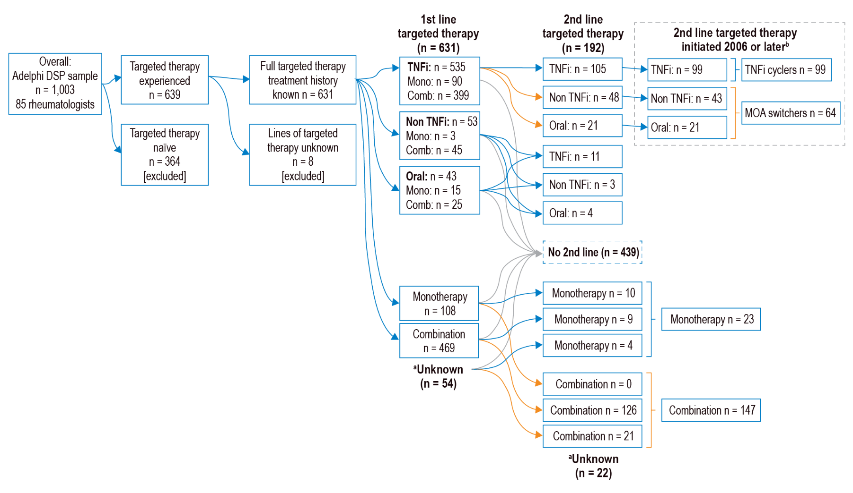
Blue arrows represent flow for the TNFi cyclers and monotherapy patient populations. Orange arrows represent the flow for the MOA switchers and combination therapy patient populations
Oral treatment refers to tofacitinib
ªUnknown whether patients were prescribed monotherapy or combination therapy
^{b}All patients who switched after June 2006 (allowing availability of nonTNFi into the market)

